|  |  |
| --- | --- |
|  | **MINISTRY OF EDUCATION AND TRAINING** |

|  |
| --- |
| **FPT UNIVERSITY** |
| Capstone Project Document |
| Smart City – Autonomous Vehicle with the Camera |

|  |  |
| --- | --- |
| **GSU21SE22** | |
| **Group Members** | Nguyễn Thanh Hòa – SE130135  Triệu Minh Huy - SE130336  Lê Thành Đạt - SE130318  Ngô Văn Sang - SE130361 |
| **Supervisor** | Phạm Công Thành |
| **Ext Supervisor** | Đoàn Nguyễn Thành Hòa |
| **Capstone Project code** | AVC |

- Ho Chi Minh, May 2021 -

**Table of Contents**

Definition and Acronyms 13

I. Project Introduction 14

1. Overview 14

1.1 Project Information 14

1.2 Project Team 14

2. Product Background 15

3. Existing Systems 15

3.1 Tesla Autopilot 15

3.2 Waymo Autonomous Driving 15

4. Business Opportunity 16

5. Software Product Vision 16

6. Project Scope & Limitations 16

6.1 Major Features 16

6.2 Limitations & Exclusions 17

II. Project Management Plan 18

1. Overview 18

1.1 WBS & Estimation 18

1.2 Project Objectives 21

1.3 Project Risks 21

2. Management Approach 21

2.1 Project Process 21

2.2 Quality Management 22

2.3 Training Plan 22

3. Master Schedule 23

4. Project Organization 24

4.1 Team & Structures 24

4.2 Roles & Responsibilities 24

5. Project Communication 25

5.1 Communication Plan 25

5.2 External Interface 25

6. Configuration Management 26

6.1 Tools & Infrastructures 26

6.2 Document Management 26

6.3 Source Code Management 26

III. System Requirement Specification 27

1. Overall Description 27

1.1. Product Overview 27

1.2. Business Rules 28

2. User Requirements 36

2.1. Overview 36

2.2. Unauthenticated User 41

2.3. Authenticated User 46

2.4. Web Application <Admin> 52

2.5. Web Application <Manager> 90

2.6. Mobile Application <Staff> 100

2.7. Training Machine 106

2.8. System Handler 107

2.9. Autonomous Car 108

3. Functional Requirements 118

3.1 System Functional Overview 118

4. Non-Functional Requirements 137

4.1 External Interfaces 137

4.2 Quality Attributes 137

5. Other Requirements 139

5.1 Messages List 139

IV. Software Design Document 143

1. Overall Description 143

1.1 Assumptions 143

1.2 Design Constraints 143

2. System Architecture Design 144

2.1 Overall Architecture 144

2.2 System Architecture 145

2.3 Package Diagram 147

3. System Detailed Design 153

3.1 Overall 153

4. Data & Database Design 177

4.1 Database Design 177

4.2 Data File Design 181

5. Algorithm 182

5.1 Detect Lane 182

5.2 Detect and recognize traffic signs 187

5.3 Detect Obstacle 193

V. Project Management Plan 195

1. Overall Description 195

1.1 Test Model 195

1.2 Testing Levels 195

2. Test Plan 195

2.1 Test Stages 195

2.2 Human Resources 195

2.3 Test Milestones 195

3. Test Cases 196

4. Test Reports 197

VI. Release Package & User Guides 198

1. Deliverable Package 198

1.1 Source codes & documents 198

1.2 Known Issues, Limitations & Restrictions 199

2. Installation Guides 199

2.1 System Requirements 199

2.2 Setup Files 200

2.3 Installation Instruction 201

2.4 Server-side Deployment 201

2.5 Training Machine Environment Setup 204

2.6 Edge Device (Raspberry Pi 4) Environment Setup 213

3. User Manual 217

3.1 Terms and definitions 217

3.2 System Requirements 217

3.3 Application Usage 218

3.4 Troubleshooting 273

VII. Appendix 274

1. Glossary 274

2. References 274

3. Appendix 275

**List of Tables**

Table 1 Definition and Acronyms 13

Table 2 . Supervisors 14

Table 3 . Team Members 14

Table 4 . Project Risks 21

Table 5 . Training Plan 22

Table 6 . Master Schedule 23

Table 7 . Roles & Responsibilities 25

Table 8 . Communication Plan 25

Table 9 . FU Contacts 25

Table 10 . Customer Contacts 26

Table 11 . Tools & Infrastructures 27

Table 12. Business Rule 36

Table 13 . System Actors 40

Table 14 . Use Cases List 42

Table 15 . Web Application Admin Screen Details 129

Table 16 . Web Application Manager Screen Details 133

Table 17 . Mobile Application Staff Screen Details 135

Table 18 . Web Application Screen 136

Table 19 . Mobile Application Screens 136

Table 20 . Non-Screen Functions 137

Table 21 - Web API Package Diagram Description 149

Table 22 - Web Application Package Diagram Description 151

Table 23 - Hardware Controller Application Package Diagram Description 153

Table 24 - <Class Diagram Attributes> Account 155

Table 25 - <Class Diagram Methods> Account 155

Table 26 - <Class Diagram Attributes> AssignCar 156

Table 27 - <Class Diagram Methods> AssignCar 156

Table 28 - <Class Diagram Attributes> Car 156

Table 29 - <Class Diagram Methods> Car 157

Table 30 - <Class Diagram Attributes> CarConfig 157

Table 31 - <Class Diagram Methods> CarConfig 157

Table 32 - <Class Diagram Attributes> Configuration 157

Table 33 - <Class Diagram Methods> Configuration 157

Table 34 - <Class Diagram Attributes> Issue 158

Table 35 - <Class Diagram Methods> Issue 158

Table 36 - <Class Diagram Attributes> IssueType 158

Table 37 - <Class Diagram Methods> IssueType 158

Table 38 - <Class Diagram Attributes> ModelStatus 159

Table 39 - <Class Diagram Methods> ModelStatus 159

Table 40 - <Class Diagram Attributes> ModelVersion 159

Table 41 - <Class Diagram Methods> ModelVersion 160

Table 42 - <Class Diagram Attributes> Role 160

Table 43 - <Class Diagram Methods> Role 160

Table 44 - <Physical Diagram> Account 179

Table 45 - <Physical Diagram> AssignCar 179

Table 46 - <Physical Diagram> Car 180

Table 47 - <Physical Diagram> DefaultConfiguration 180

Table 48 - <Physical Diagram> CarConfig 180

Table 49 - <Physical Diagram> Configuration 181

Table 50 - <Physical Diagram> IssueType 181

Table 51 - <Physical Diagram> ModelStatus 181

Table 52 - <Physical Diagram> ModelVersion 182

Table 53 - <Physical Diagram> Role 182

Table 54 - Data File Design 183

Table 55. Source code and document 199

Table 56. System Hardware Requirement for PC 200

Table 57. System Hardware Requirement for Edge Device 200

Table 58. System Hardware Requirement for Android 201

Table 59. System Hardware Requirement for iOS 201

Table 60. System Hardware Requirement for Training Machine 201

Table 61. Software Requirement 201

Table 62. <User Manual> Hardware Requirements For PC 218

Table 63. <User Manual> Hardware Requirements For Android Devices 219

Table 64 - <User Manual> Software Requirements For PC 219

**List of Figure**

Figure 1. AVC Major Feature 16

Figure 2. SCRUM 21

Figure 3. Team & Structures 24

Figure 4. <Use Case Overview> AVC Web Application 36

Figure 5. <Use Case Overview> AVC Mobile Application 37

Figure 6. <Use Case Overview> AVC Autonomous Car 38

Figure 7. <Unauthenticated User> Overview Use Case Diagram 41

Figure 8. <Unauthenticated User> UC-01 Login 41

Figure 9. <Unauthenticated User> UC-02 Reset password 43

Figure 10. <Authenticated User> Overview Use Case Diagram 45

Figure 11. <Authenticated User> UC-03 Change password 46

Figure 12. <Authenticated User> UC-04 Update profile 47

Figure 13. <Authenticated User> UC-05 Logout 49

Figure 14. <Authenticated User> UC-06 Receive notification 50

Figure 15. <Admin> Overview Use Case Diagram 54

Figure 16. <Admin> UC-07 Deactivate car 54

Figure 17. <Admin> UC-08 Reactivate car 55

Figure 18 . <Admin> UC-09 Register new car 56

Figure 19 . <Admin> UC-10 View cars 58

Figure 20 . <Admin> UC-11 View car detail 59

Figure 21 . <Admin> UC-12 View issues of car 61

Figure 22 . <Admin> UC-13 View issue detail 63

Figure 23 . <Admin> UC-14 View issues history 64

Figure 24 . <Admin> UC-15 Update default car configuration 65

Figure 25 . <Admin> UC-16 Update car configuration 66

Figure 26. <Admin> UC-17 Update car information 67

Figure 27 . <Admin> UC-18 Assign car to manager 68

Figure 28 . <Admin> UC-19 Deactivate staff 70

Figure 29 . <Admin> UC-20 Reactivate staff 71

Figure 30 . <Admin> UC-21 Create new staff 72

Figure 31 . <Admin> UC-22 Update staff 74

Figure 32 . <Admin> UC-23 View staffs 75

Figure 33 . <Admin> UC-24 View staff detail 76

Figure 34 . <Admin> UC-25 Assign staff to manager 77

Figure 35 . <Admin> UC-26 Deactivate manager 78

Figure 36 . <Admin> UC-27 Reactivate manager 80

Figure 37 . <Admin> UC-28 Create new manager 81

Figure 38 . <Admin> UC-29 Update manager 83

Figure 39 . <Admin> UC-30 View managers 84

Figure 40 . <Admin> UC-31 View manager detail 85

Figure 41 . <Admin> UC-32 Create training dataset 86

Figure 42 . <Admin> UC-33 Apply training model 87

Figure 43 . <Admin> UC-34 View training history 88

Figure 44 . <Admin> UC-35 View analysis result 89

Figure 45. <Manager> Overview Use Case Diagram 91

Figure 46 . <Manager> UC-36 View managed cars 91

Figure 47 . <Manager> UC-37 View car detail 92

Figure 48 . <Manager> UC-38 View issues of car 93

Figure 49 . <Manager> UC-39 View issue detail 94

Figure 50. <Manager> UC-40 Update car configuration 95

Figure 51 . <Manager> UC-41 View managed staffs 96

Figure 52 . <Manager> UC-42 View staff detail 97

Figure 53 . <Manager> UC-43 Assign car to staff 98

Figure 54 . <Manager> UC-44 Control managed car 100

Figure 55. <Staff> Overview Use Case Diagram 101

Figure 56 . <Staff> UC-45 View assigned cars 101

Figure 57 . <Staff> UC-46 View car detail 102

Figure 58 . <Staff> UC-47 View issues of car 103

Figure 59 . <Staff> UC-48 View issue detail 104

Figure 60 . <Staff> UC-49 Control assigned car 105

Figure 61. <Training Machine> UC-50 Process training 106

Figure 62. <System Handler> UC-51 Send notification 107

Figure 63. <Autonomous Car> Usecase Overview Diagram 108

Figure 64. <Autonomous Car> UC-52 Recognize traffic light 109

Figure 65. <Autonomous Car> UC-53 Recognize traffic sign 110

Figure 66 . <Autonomous Car> UC-54 Recognize obstacle 111

Figure 67. <Autonomous Car> UC-55 Detect Lane 112

Figure 68. <Autonomous Car> UC-56 Send issue to server 113

Figure 69 . <Autonomous Car> UC-57 Register to AVC system 114

Figure 70 . <Autonomous Car> UC-58 Autonomous drive car 115

Figure 71 . <Autonomous Car> UC-59 Handle control 117

Figure 72. <Admin> Web Application Screen Flow 118

Figure 73. <Manager> Web Application Screen Flow 119

Figure 74. <Staff> Mobile Application Screen Flow 119

Figure 75 – Entity Relationship Diagram 136

Figure 76 - Overall Architecture Design 144

Figure 77 - Web Application Architecture 145

Figure 78 - Mobile Application Architecture 146

Figure 79 - Hardware Controller Architecture 147

Figure 80 - Web API Package Diagram 148

Figure 81 - Web Application and Mobile Application Package Diagram 150

Figure 82- Hardware Controller Application Package Diagram 152

Figure 83- Class Diagram 154

Figure 84 - <Sequence Diagram> Get Manager List 161

Figure 85 - <Sequence Diagram> Get Staff List 162

Figure 86 - <Sequence Diagram> Get Manager Detail 163

Figure 87 - <Sequence Diagram> Get Staff Detail 164

Figure 88 - <Sequence Diagram> Update Account Activation 165

Figure 89 - <Sequence Diagram> Update Staff ManagedBy 166

Figure 90 - <Sequence Diagram> Create Manager 167

Figure 91 - <Sequence Diagram> Create Staff 168

Figure 92 - <Sequence Diagram> Train Model 169

Figure 93 - <Activity Diagram> Login 170

Figure 94 - <Activity Diagram> Forgot Password 171

Figure 95 - <Activity Diagram> Change Password 172

Figure 96 - <Activity Diagram> Update Profile 173

Figure 97 - <Activity Diagram> View Issue Detail 174

Figure 98 - <Activity Diagram> View Car List 175

Figure 99 - <Activity Diagram> View Car Detail 176

Figure 100 - <Activity Diagram> Start Car 177

Figure 101 - <ActivityDiagram> Stop Car 177

Figure 102 - Database Design 178

Figure 103- Lane detection base idea 183

Figure 104- Lane detection parameters 184

Figure 105- Lane detection preprocessing step 185

Figure 106- Lane detection finding C0 step 185

Figure 107- Lane detection finding C1 step 186

Figure 108- Lane detection calculating angle step 187

Figure 109- Lane detection formula calculating based on image 187

Figure 110- Lane detection formula to calculating real angle 187

Figure 111- Servo values safe range 187

Figure 112- Servo values calculate based on alpha angle 188

Figure 113- Base concept of YOLO model 189

Figure 114- Convolution layer example 189

Figure 115- Max pooling layer example 189

Figure 116- Up sampling layer example 190

Figure 117- Relu activation function example 190

Figure 118- Structure of one output grid cell in YOLO 191

Figure 119- IOU 191

Figure 120- YOLO grid divide 192

Figure 121- Non-max suppression example 192

Figure 122- Images dataset 193

Figure 123- Graph result training and test 194

Figure 124- Ultrasonic sensor timing diagram 195

Figure 125 - AVC_Report5_Test Case Document.xlsx 197

Figure 126 - AVC_Report5_Unit Test Case.xls 198

Figure 127 - Prepare Deployment Packages Folders 202

Figure 128 - Prepare Deployment Packages Folders For Web Service 203

Figure 129 - SQL Server 203

Figure 130 - Add Web Service To IIS 204

Figure 131 - Anaconda Installation (Step 2) 205

Figure 132 - Anaconda Installation (Step 3) 206

Figure 133 - Anaconda Installation (Step 4) 207

Figure 134 - Anaconda Installation (Step 5) 207

Figure 135 - Anaconda Installation (Step 6) 208

Figure 136 - Anaconda Installation (Step 7) 209

Figure 137 - Anaconda Installation (Step 8) 209

Figure 138 - Anaconda Installation (Step 9) 210

Figure 139 - Anaconda Install (Step 10) 211

Figure 140 - CUDA Installation (Step 2) 211

Figure 141 - CUDA Installation (Step 3) 211

Figure 142 - CUDA Installation (Step 4) 212

Figure 143 - CUDA Installation (Step 5) 212

Figure 144 - CUDA Installation (Step 6) 213

Figure 145 - Login 220

Figure 146 - Login 220

Figure 147 - Forgot Password 221

Figure 148 - Reset Password 223

Figure 149 - Dashboard 224

Figure 150 - View Manager List 225

Figure 151 - View Manager List 225

Figure 152 - View Manager Detail 226

Figure 153 - View Manager Detail 226

Figure 154 - View Manager Detail Expand 227

Figure 155 - View Manager List 227

Figure 156 - Create Manager 228

Figure 157 - View Manager Detail 228

Figure 158 - Update Manager 229

Figure 159 - View Manager Detail 229

Figure 160 - Deactivate Manager 230

Figure 161 - View Staff List 230

Figure 162 - View Staff List 231

Figure 163 - View Staff Detail 231

Figure 164 - View Staff Detail 232

Figure 165 - View Staff Detail Expand 232

Figure 166 - View Staff List 233

Figure 167 - Create Staff 233

Figure 168 - View Staff Detail 234

Figure 169 - Update Staff 234

Figure 170 - View Staff Detail 235

Figure 171 - Deactivate Staff 235

Figure 172 - View Car List 236

Figure 173 - View Car List 236

Figure 174 - View Car Detail 237

Figure 175 - View Car Detail 237

Figure 176 - View Car Detail Expand 238

Figure 177 - View Unapproved Cars 238

Figure 178 - View Unapproved Cars 239

Figure 179 - Approve/Reject Car 239

Figure 180 - View Car Detail 240

Figure 181 - Update Car 241

Figure 182 - Edit Configuration of Car 241

Figure 183 - View Car Detail 242

Figure 184 - Edit Configuration of Car 242

Figure 185 - View Car Detail 243

Figure 186 - Deactivate Car 243

Figure 187 - View Issue List 244

Figure 188 - View Issue List 244

Figure 189 - View Issue Detail 245

Figure 190 - View Issue Detail Image Dialog 245

Figure 191 - View Train History List 246

Figure 192 - View Train History List 246

Figure 193 - View Train History Detail 247

Figure 194 - View Train History Detail - Statistic 247

Figure 195 - View Train History Detail - Train Log 248

Figure 196 - Train History Detail - Download Train Images 248

Figure 197 - Apply new model 249

Figure 198 - Train by Images - Upload Images 249

Figure 199 - Train by Images - Label Images 250

Figure 200 - Train by Images - Label Image Dialog 250

Figure 201 - Train by ZIP 251

Figure 202 - View & Update Profile 253

Figure 203 - Change Password 253

Figure 204 - View notifications 255

Figure 205 - Log out confirmation 256

Figure 206 - Login 257

Figure 207 - Login 258

Figure 208 - Forgot Password 259

Figure 209 - Reset Password 261

Figure 210 - View Car List 262

Figure 211 - View Car List 263

Figure 212 - View Car Detail 264

Figure 213 - View Car Detail - Issue Detail 265

Figure 214 - View Car Detail - Stop Car 266

Figure 215 - View Car Detail - Start Car 267

Figure 216 - View Car Detail - Receive real-time issue notification 268

Figure 217 - View Car List 269

Figure 218 - View Notifications 270

Figure 219 - View Car List 271

Figure 220 - View & Update Profile 272

Figure 221 - Log out confirmation 273

Figure 222 - View & Update Profile 273

Figure 223 - Change Password 274

# Definition and Acronyms

|  |  |
| --- | --- |
| **Acronym** | **Definition** |
| BR | Business Rule |
| ERD | Entity Relationship Diagram |
| GUI | Graphical User Interface |
| UC | Use Case |
| API | Application Programming Interface |
| FE | Feature |
| LI | Limitation |
| EX | Exclusion |
| WBS | Work Breakdown Structure |
| JSON | JavaScript Object Notation |
| QR | Quick Response |
| CUDA | Compute Unified Device Architecture |
| IIS | Internet Information Services |
| AVC | Smart City-Autonomous Vehicle with the Camera |

Table 1 Definition and Acronyms

# I. Project Introduction

## 1. Overview

### 1.1 Project Information

* Project name: <<Smart City-Autonomous Vehicle with the Camera>>
* Project code: <<AVC>>
* Group name: <<GSU21SE22>>
* Software type: <<Software Type: Artificial Intelligence, Web App, Mobile App>>

### 1.2 Project Team

#### a. Supervisor

|  |  |  |  |
| --- | --- | --- | --- |
| **Full Name** | **Email** | **Phone Number** | **Title** |
| Phạm Công Thành | ThanhPC3@fe.edu.vn |  | Lecturer |
| Đoàn Nguyễn Thành Hòa | HoaDNT@fe.edu.vn |  | Lecturer |

Table 2 . Supervisors

#### b. Team Members

|  |  |  |  |
| --- | --- | --- | --- |
| **Full Name** | **Email** | **Phone Number** | **Title** |
| Nguyễn Thanh Hòa | HoaNTSE130135@fpt.edu.vn |  | Leader |
| Triệu Minh Huy | HuyTMSE130336@fpt.edu.vn |  | Member |
| Lê Thành Đạt | DatLTSE130318@fpt.edu.vn |  | Member |
| Ngô Văn Sang | SangNVSE130361@fpt.edu.vn |  | Member |

Table 3 . Team Members

## 2. Product Background

The application of deep learning in everyday life expands and brings huge potentials for deployment in life. The self-driving car model is being researched and developed by major technology firms such as Google, Tesla. The goal of this topic is to research, and demo test a self-driving car model using a camera with a deep learning model, with basic functions: land road identification, speed sign recognition, object detection, traffic light detection, and traffic light signal detection. The demo will implement a model car and an Edge device.

## 3. Existing Systems

### 3.1 Tesla Autopilot

Tesla cars come standard with advanced hardware capable of providing Autopilot features, and full self-driving capabilities—through software updates designed to improve functionality over time.

Autopilot is an advanced driver assistance system that enhances safety and convenience behind the wheel. When used properly, Autopilot reduces your overall workload as a driver. Each new Tesla vehicle is equipped with 8 external cameras, 12 ultrasonic sensors and a powerful onboard computer providing an additional layer of safety to guide you on your journey. Model 3 and Model Y built for the North American market have transitioned to camera-based Tesla Vision, which are not equipped with radar and instead rely on Tesla’s advanced suite of cameras and neural net processing to deliver Autopilot and related features. Model S and Model X continue to be equipped with radar.

### 3.2 Waymo Autonomous Driving

Waymo, the former Google self-driving project owned by parent company Alphabet, is launching a commercial robo-taxi service in the Phoenix area

Dubbed Waymo One, this milestone for the company and nascent self-driving technology industry comes with caveats.

The Waymo One self-driving car service, and accompanying app, won’t be available to just anyone. And for now, the company says it will have Waymo-trained test drivers behind the wheel (even though the company already has driverless vehicles on public roads in Phoenix).

Waymo will first invite Phoenix residents who are part of its early rider program, which was designed to give a vetted group of people the ability to use an app to hail a self-driving vehicle. The early rider program, which launched in April 2017, had more than 400 participants the last time Waymo shared figures on the program.

## 4. Business Opportunity

The Admissions Department of FPT University desires a self-driving car system to build artificial intelligence initiatives, including, first and foremost, a student competition aimed at learning and encouraging access to the development of new technology. The AVC system is the starter of a series of Smart City projects designed to keep up with the industry 4.0 movement, particularly in artificial intelligence.

## 5. Software Product Vision

For as long as vehicles have been, road safety has been a concern. Every year, millions of people die in traffic accidents throughout the world, the majority of which might have been avoided. Constantly increasing traffic has resulted in a massive rise in commuting time. Not only does this have an influence on people's productivity, but it also has an influence on the environment. In the future, we plan to improve our system to move it from the lab to reality to improve driving efficiency and life quality. The AVC system will be upgraded to have a higher safety, reduced commute time, increased productivity, reduced expenditure, environment-friendly, solution to parking problem, better traffic discipline and potential for a new design.

## 6. Project Scope & Limitations

### 6.1 Major Features

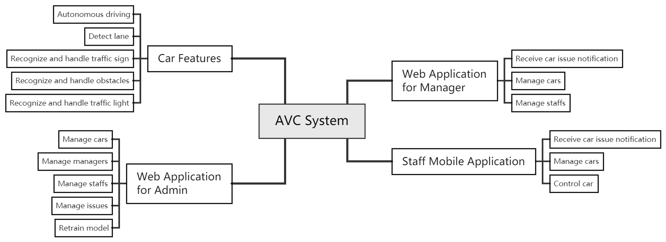

[Figure 1. AVC Major Feature](https://drive.google.com/file/d/1byGnaGSXBkPXOwrzhtkvZcjhjF8rPtPi/view)

#### a. Autonomous Car

* FE-1: Car can detect lane
* FE-2: Car can autonomously drive
* FE-3: Car can recognize and handle traffic sign
* FE-4: Car can recognize and handle obstacles
* FE-5: Car can recognize and handle traffic light

#### b. Website Application

* FE-6: Admin can manage all cars
* FE-7: Admin can manage all managers
* FE-8: Admin can manage all staffs
* FE-9: Admin can manage all issues
* FE-10: Admin can retrain models
* FE-10: Manager can receive car issue notification
* FE-11: Manager can manage assigned staffs
* FE-12: Manager can manage assigned cars

#### c. Mobile Application

* FE-13: Staff can receive car issue notification
* FE-14: Staff can manage assigned cars
* FE-15: Staff can control car

### 6.2 Limitations & Exclusions

LI-01: The use of the AVC car requires the right environment to function correctly, like the brightness, lane width, spacious environment, no flare environment.

LI-02: AVC system needs to manually configure a new car to get the right view of the camera.

LI-03: AVC car cannot run at an absolute speed, depending on the current energy.

LI-04: AVC car can only move properly at low speed, with high speed, the processor has a delay, and the input has noise.

EX-01: AVC system does not apply to real cars.

# II. Project Management Plan

## 1. Overview

### 1.1 WBS & Estimation

|  |  |  |  |
| --- | --- | --- | --- |
| # | WBS Item | Complexity | Est. Effort |
| **1** | **Car Features** |  |  |
| 1.1 | Detect lane |  |  |
| 1.1.1 | Detect lane | Complex | 14 |
| 1.1.2 | Handle no line detection by a pause to watch | Simple | 2 |
| 1.2 | Drive autonomously |  |  |
| 1.2.1 | Steer car base on lane detection | Complex | 5 |
| 1.2.2 | Control speed base on lane detection | Medium | 3 |
| 1.3 | Recognize traffic sign |  |  |
| 1.3.1 | Recognize traffic sign | Complex | 10 |
| 1.3.2 | Control speed base on traffic sign | Simple | 2 |
| 1.3.3 | Steer car base on traffic sign | Medium | 4 |
| 1.3.4 | Handle car state base on traffic sign | Complex | 6 |
| 1.4 | Recognize obstacles |  |  |
| 1.4.1 | Recognize obstacles | Complex | 5 |
| 1.4.2 | Stop when meeting obstacles | Simple | 2 |
| 1.4.3 | Send logs, obstacles image to the server | Medium | 3 |
| 1.5 | Recognize traffic light | Complex | 7 |
| 1.6 | Activate automatically when the power turns on | Complex | 5 |
| 1.7 | Receive control real-time | Medium | 4 |
| **2** | **Web Application for Admin** |  |  |
| 2.1 | Authentication |  |  |
| 2.1.1 | Login | Simple | 1 |
| 2.1.2 | Logout | Simple | 1 |
| 2.1.3 | Reset password | Simple | 1 |
| 2.2 | Manage profile |  |  |
| 2.2.1 | Change password | Simple | 1 |
| 2.2.2 | Update profile | Simple | 1 |
| 2.3 | Manage cars |  |  |
| 2.3.1 | View cars list | Simple | 2 |
| 2.3.2 | View car detail | Simple | 1 |
| 2.3.3 | View issues of a car (stop immediately, facing obstacles, ...) | Simple | 2 |
| 2.4 | Manage managers |  |  |
| 2.4.1 | View managers list | Simple | 2 |
| 2.4.2 | View manager detail | Simple | 1 |
| 2.4.3 | Create manager account | Simple | 1 |
| 2.4.4 | Deactivate/Reactivate manager | Simple | 1 |
| 2.5 | Manage staffs |  |  |
| 2.5.1 | View staffs | Simple | 2 |
| 2.5.2 | View staff detail | Simple | 1 |
| 2.6 | Train model |  |  |
| 2.6.1 | View training history | Complex | 4 |
| 2.6.2 | View analysis result | Complex | 4 |
| **3** | **Web Application for Manager** |  |  |
| 3.1 | Authentication |  |  |
| 3.1.1 | Login | Simple | 1 |
| 3.1.2 | Logout | Simple | 1 |
| 3.1.3 | Reset password | Simple | 1 |
| 3.2 | Manage profile |  |  |
| 3.2.1 | Change password | Simple | 1 |
| 3.2.2 | Update profile | Simple | 1 |
| 3.3 | Receive car issue notification real-time | Medium | 3 |
| 3.4 | Manage cars |  |  |
| 3.4.1 | View cars list | Simple | 2 |
| 3.4.2 | View car detail | Simple | 1 |
| 3.4.3 | Register a new car | Simple | 1 |
| 3.4.4 | Update car information | Simple | 1 |
| 3.4.5 | View issues of a car (stop immediately, facing obstacles, ...) | Simple | 2 |
| 3.4.6 | Deactivate/Reactivate car | Simple | 1 |
| 3.4.7 | Assign car to staff | Medium | 3 |
| 3.5 | Manage staffs |  |  |
| 3.5.1 | View staffs | Simple | 2 |
| 3.5.2 | View staff detail | Simple | 1 |
| 3.5.3 | Create staff account | Simple | 1 |
| 3.5.4 | Deactivate/Reactivate staff | Simple | 1 |
| 3.6 | Train model |  |  |
| 3.6.2 | Label images | Medium | 5 |
| 3.6.3 | Confirm labeled images | Medium | 2 |
| 3.6.4 | View analysis result | Medium | 2 |
| **4** | **Staff Mobile Application** |  |  |
| 4.1 | Authentication |  |  |
| 4.1.1 | Login | Simple | 1 |
| 4.1.2 | Logout | Simple | 1 |
| 4.1.3 | Reset password | Simple | 1 |
| 4.2 | Manage profile |  |  |
| 4.2.1 | Change password | Simple | 1 |
| 4.2.2 | Update profile | Simple | 1 |
| 4.3 | Receive car issue notification real-time | Medium | 2 |
| 4.4 | Manage cars |  |  |
| 4.4.1 | View assigned cars list | Simple | 2 |
| 4.4.2 | View car detail | Simple | 1 |
| 4.4.3 | View issues of a car (stop immediately, facing obstacles, ...) | Simple | 1 |
| 4.5 | Control car |  |  |
| 4.5.1 | Start car | Medium | 2 |
| 4.5.2 | Stop car | Simple | 1 |
|  | *Total Estimated Effort (man-days)* | | 145 |

Table 4. WBS & Estimation

### 1.2 Project Objectives

* Timeliness: > 90%
* Allocated Effort: 4 (members) * 3.5 (months) * 21 (days/month) = 294 man-days
* Estimated total cost: 10 million VND

### 1.3 Project Risks

|  |  |  |  |
| --- | --- | --- | --- |
| **#** | **Risk Description** | **Impact** | **Possibility** |
| 1 | Team member drops out | Critical | Low |
| 2 | Vivid Brightness | Critical | Medium |
| 3 | Network connection errors | Critical | High |
| 4 | Host server gets down | Medium | Low |

Table 4 . Project Risks

## 2. Management Approach

Implementing Scrum - an Agile methodology enables us under a common organization for decision making, allows seeing the product evolve in real-time as we build, adjust, and optimize them.

### 2.1 Project Process

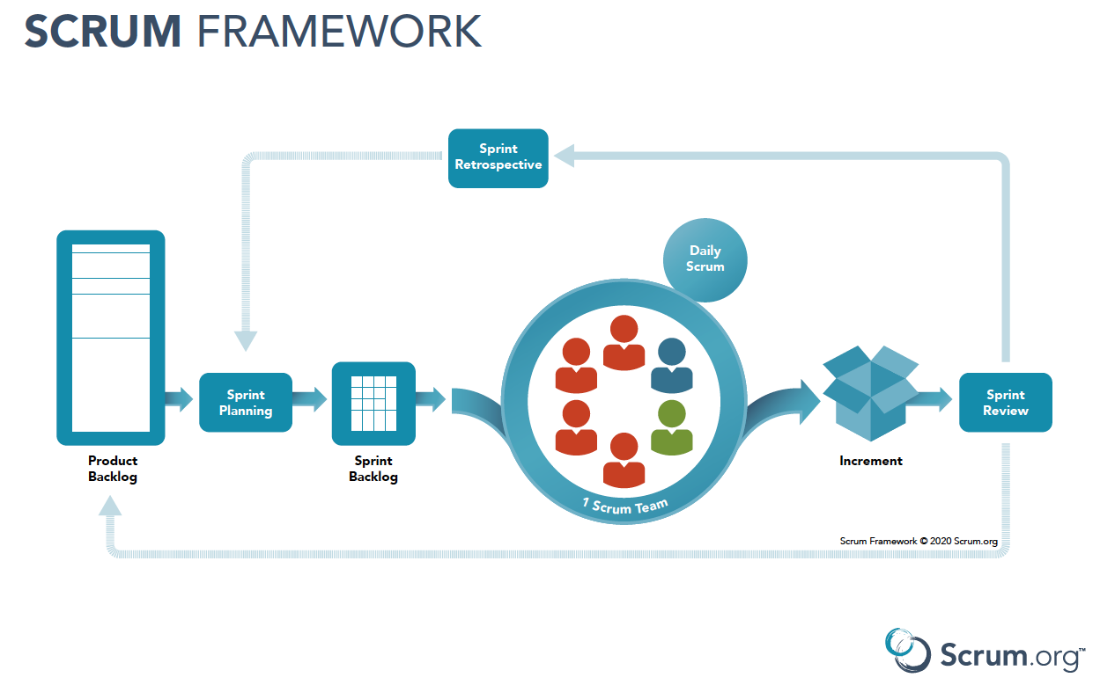

[Figure 2. SCRUM](https://www.scrum.org/resources/scrum-framework-poster)

The AVC team applies Scrum Framework for managing project process for the following reasons:

* It’s suitable for small or medium size project as AVC System.
* Project processes are done by the development team simultaneously, which helps everything be flexible and changeable during the project’s life and even after.
* Better visibility of product progress and minimize risks.

### 2.2 Quality Management

To improve the project quality, the AVC team apply the following schemes:

* Test plans and test cases cover more than 90% in detail.
* Cohere supervisors’ guidance, research, and upgrade incrementally to achieve the best solution.
* Keep daily meetings to follow the project’s tasks and support each other.

### 2.3 Training Plan

|  |  |  |  |
| --- | --- | --- | --- |
| **Training Area** | **Participants** | **Duration** | **Waiver Criteria** |
| Python + OpenCV | Everyone | 5 days | Mandatory |
| Yolo | Everyone | 2 days | Mandatory |
| Angular 11 | Hoa Nguyen, Sang Ngo | 3 days | Mandatory |
| Ionic 5 | Hoa Nguyen, Sang Ngo | 3 days | Mandatory |
| Git, GitHub | Everyone | 1 day | Mandatory |
| Draw.io | Everyone | 1 day | Mandatory |

Table 5 . Training Plan

## 3. Master Schedule

|  |  |  |  |  |
| --- | --- | --- | --- | --- |
| **#** | **Deliverable** | **Effort** | **Due Date** | **Deliverable Scope** |
| 1 | Project Plan | 10 | 12/05/2021 | Make project goal plan |
| 2 | Report 1 | 3 | 15/05/2021 | Project introduction |
| 3 | Report 2 | 5 | 22/05/2021 | Project management plan |
| 4 | Report 3 | 15 | 29/05/2021 | Software requirement specification |
| 5 | Report 4 | 20 | 10/06/2021 | Software design document |
| 6 | Report 5 | 5 | 30/07/2021 | Test case document, test documentation |
| 7 | Report 6 | 5 | 05/08/2021 | Software user guides |
| 8 | Report 7 | 3 | 14/08/2021 | Final project final |
| 9 | Code package 1 | 15 | 05/06/2021 | Code, Unit test case |
| 10 | Code package 2 | 15 | 26/06/2021 | Code, Unit test case |
| 11 | Code package 3 | 15 | 17/07/2021 | Code, Unit test case |
| 12 | Code front-end 1 | 15 | 08/06/2021 | Code, design screen |
| 13 | Code front-end 2 | 15 | 26/06/2021 | Code, design screen |
| 14 | Code front-end 3 | 15 | 17/07/2021 | Code, design screen |
| 15 | Final package | 20 | 13/08/2021 | Final code package and documents |

Table 6 . Master Schedule

## 4. Project Organization

### 4.1 Team & Structures

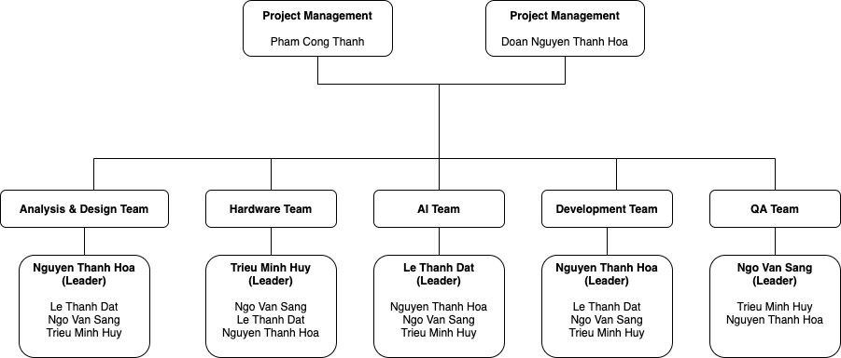

[Figure 3. Team & Structures](https://drive.google.com/file/d/19YYtHIulbXUqyhW6PZGA50C_q1Y8E9xx/view?usp=sharing)

### 4.2 Roles & Responsibilities

|  |  |
| --- | --- |
| **Role** | **Responsibility** |
| Project Manager | Give guidance, monitoring and drive the project in the exact direction. |
| Analysis & Design Leader | Give guidance, gather, analyze the project’s requirements, and make decisions on the priority of a specific requirement. |
| Analysis & Design Members | Analyze, update, design appropriate user stories and user interfaces. |
| Hardware Leader | Give guidance, manage hardware including modules, devices, and make decisions on what technical hardware uses for a specific case. |
| Hardware Members | Support, research, and contribute hardware ideas. |
| AI Leader | Give guidance, analyze algorithms, implement and make decisions on the applied system algorithm. |
| AI Members | Support, research, contribute ideas and implement algorithms. |
| Development Leader | Give guidance, analyze, assign tasks and make decisions on the AVC’s technical stack. |
| Development Members | Discuss, contribute ideas and implement their tasks. |
| QA Leader | Give guidance, analyze, make test case template patterns, and decide what features should be tested and their priority. |
| QA Members | Discuss, support writing test cases, and collect test results. |

Table 7 . Roles & Responsibilities

## 5. Project Communication

### 5.1 Communication Plan

|  |  |  |  |  |
| --- | --- | --- | --- | --- |
| **Communication Item** | **Who/ Target** | **Purpose** | **Frequency** | **Type, Tool, Method(s)** |
| Daily Meeting | Team Members | Internal Communication | Always | Meeting |
| Weekly Report | Supervisors and Team Members | Discuss project’s status, solution, next target | Weekly | Email,  Google Meet |
| Division of duties | Team Members | Control project status | Always | Trello |

Table 8 . Communication Plan

### 5.2 External Interface

#### a. FU Contacts

|  |  |  |  |
| --- | --- | --- | --- |
| **Function** | **Contact Person**  **(name, position)** | **Contact address**  **(email, telephone)** | **Responsibility** |
| Supervisor | Pham Cong Thanh | ThanhPC3@fe.edu.vn | - Provide document template - Instruct the project team - Review deliverables - Supervise project status |
| Supervisor | Doan Nguyen Thanh Hoa | HoaDNT@fe.edu.vn | - Provide document template  - Receive project reports  - Answer questions about the project |

Table 9 . FU Contacts

#### b. Customer Contacts

|  |  |  |  |
| --- | --- | --- | --- |
| **Function** | **Contact Person**  **(name, position)** | **Contact address**  **(email, telephone)** | **Responsibility** |
| Supervisor | Pham Cong Thanh | ThanhPC3@fe.edu.vn | - Provide document template - Instruct the project team - Review deliverables - Supervise project status |
| Supervisor | Doan Nguyen Thanh Hoa | HoaDNT@fe.edu.vn | - Provide document template  - Receive project reports  - Answer questions about the project |

Table 10 . Customer Contacts

## 6. Configuration Management

### 6.1 Tools & Infrastructures

|  |  |
| --- | --- |
| **Programming languages** | C#, TypeScript, Python, Bash |
| **Framework** | .NET Core 3.1, Entity Framework 5.0, Angular 11, Ionic 5, Python 3.8, OpenCV 4.5 |
| **API** | RestfulAPI |
| **DBMS** | Microsoft SQL Server |
| **IDEs/Editors** | Visual Studio, Visual Studio Code |
| **UML tools** | Draw.io |
| **Version Control** | Gitlab |
| **CI/CD** | Azure DevOps, GitlabCI |
| **Deployment server** | IIS |
| **Project management tool** | Google Drive, Trello |

Table 11 . Tools & Infrastructures

### 6.2 Document Management

Google Drive is used to manage project documents.

### 6.3 Source Code Management

Gitlab is used to manage project’s source code.

# III. System Requirement Specification

## 1. Overall Description

### 1.1. Product Overview

**Unauthenticated User Requirements**

An unauthenticated user who has not been identified by AVC System. Unauthenticated user has limited access to the system with the following features:

* Login
* Reset password

**Authenticated User Requirements**

An authenticated user who has been identified by AVC System. An authenticated user has access to the system with the following features:

* Change password
* Update profile
* Logout
* Receive notification
* Control car

**Admin Requirements**

An Admin is a person who accesses the system in an Admin role. Admin can use the following functions:

* Manage cars
* Assign car to manager
* View issues history
* Manage staffs
* Assign staff to manager
* Manage managers
* Manage training model

**Manager Requirements**

Staff is a person who accesses the system as a staff role. Staff can use the following functions:

* View managed cars
* View car detail
* View issues of car
* View issue detail
* Update car configuration
* View managed staffs
* View staff detail
* Assign car to staff

**Staff Requirements**

Staff is a person who accesses the system as a staff role. Staff can use the following functions:

* View assigned cars
* View car detail
* View issues of car
* View issue detail

**Autonomous Car Requirements**

An autonomous car is an actor which can do:

* Recognize traffic light
* Recognize traffic sign
* Recognize obstacle
* Detect lane
* Send issue to server
* Register to AVC system
* Autonomous drive car
* Handle control

**Training Machine Requirements**

Training Machine is an actor which can do:

* Process training

**System Handler Requirements**

System Handler is an actor which can do:

* Push notification

### 1.2. Business Rules

|  |  |
| --- | --- |
| **ID** | **Rule Definition** |
| BR-01 | There are 2 ways to log in to the AVC system.  - Log in as an admin or manager: using AVC web application and logging in by AVC account on system based on email and password.  - Log in as a staff: using AVC mobile application and logging in by AVC account on system based on email and password. |
| BR-02 | Constraints on information of AVC login account:  - Email: text input, must be valid to email format and exist in the AVC system.  - Password: text input, length from 1 to 100 characters. |
| BR-03 | A deactivated account cannot log in to the system. |
| BR-04 | Staff account cannot log in to the web app system. |
| BR-05 | Admin and manager accounts cannot log in to the mobile app system. |
| BR-06 | Constraints on information when user forgot password:  - Email: text input, must be valid to email format and exist in the AVC system. |
| BR-07 | After submitting an email for resetting the password, the AVC system will send an email with a link forward to the reset password page and a random verification code with constraints: 6 digits |
| BR-08 | Constraints on information when user reset password:  - Email: text input, must be valid to email format and exist in the AVC system.  - Verification code: text input, 6 digits number.  - New password: text input, length from 6 to 100 characters.  - Confirm password: text input, length from 6 to 100 characters, must match to new password |
| BR-09 | Constraints on information when user change password:  - Old password: text input.  - New password: text input, length from 6 to 100 characters.  - Confirm password: text input, length from 6 to 100 characters, must match to new password |
| BR-10 | An authenticated user can update their own profile information with following details:  - Avatar: image input  - Phone: text input, phone number format |
| BR-11 | Admin will receive notifications about the status of trained models on the training machine side. |
| BR-12 | Manager will receive notifications:  - Regarding issues of cars managed by them.  - When the admin assigns a car to them.  - When the admin assigns staff to them.  - When a managed car starts/stops. |
| BR-13 | Staff will receive notifications:  - Related to the issues of the car they are assigned.  - When the manager assigns a car to them.  - When the admin assigns them to the manager.  - When the assigned car starts/stops. |
| BR-14 | Admin can see all cars registered in the system to check the number, details, configuration, status of the cars in the system, from which can make decisions on modification, assign the car to the manager or alter the vehicle configuration, information and training model. |
| BR-15 | Manager can see the list of cars assigned by the admin to check the number, details, configuration, status of the cars in the system, from which can make decisions on whether to assign the car to the staff or alter the car configuration. |
| BR-16 | Staff can see the list of cars assigned by the manager to check the number, details, configuration, status of the cars in the system, from which they can make decisions on controlling the car. |
| BR-17 | The car list includes the following information:  - Car name  - Device ID  - Managed by  - Connecting status (Connected/Disconnected)  - Activation status (Active/Inactive) |
| BR-18 | Detail of a car includes the following information:  - Car image  - Car name  - Device ID  - Connecting status (Connected/Disconnected)  - Activation status (Active/Inactive)  - Manage by  - Create at  - Car configuration link  - Car issues list  - Assigned to |
| BR-19 | The issues list includes the following information:  - Type  - Created at  - Description  - Location |
| BR-20 | The car will be registered in the AVC system through the autonomous car system and will be in the unapproved state to wait for admin approval. |
| BR-21 | When the admin clicks approve the car into the system, the admin will also add detailed information to the car. |
| BR-22 | When cars are registered in the AVC system and waiting for admin approval, the admin can view them on the [Register new car] page. |
| BR-23 | The unapproved car list includes the following information: Device ID |
| BR-24 | A car can only be managed by one manager at a time and assigned to a staff member managed by that manager. |
| BR-25 | A staff can be assigned more than 1 car |
| BR-26 | When the car's management right is transferred to a new manager or canceled, if the car is being assigned to a staff member of the old manager, that staff's car control right will also expire. |
| BR-27 | Admins can only mark images with predefined labels in classes.txt |
| BR-28 | Manager has permission to control the cars under his/her management by "Stop car" command. |
| BR-29 | Staff has permission to control the cars assigned by the manager. |
| BR-30 | The car's control functions include [Start car/Stop car] |
| BR-31 | Only the admin can change default car configuration. |
| BR-32 | Admin and manager can update configuration of car directly on car detail |
| BR-33 | Detail of a car includes the following information:  - Car image  - Device ID  - Managed by  - Assign to  - Area text with the detailed configuration of the car as json |
| BR-34 | Only the admin can create new staff and manager accounts. |
| BR-35 | The new account will be created by the new email that the admin has created before based on staff or manager detail information. |
| BR-36 | After the new account is created, it will be assigned the status [isAvailable] is true, the default password is a random 6 digits and will be sent to the registered email of the account. |
| BR-37 | Admin can see all staff exist in the system to check the number, details, status of the staff in the system, from which can make decisions on modification, assign the staff to the manager or alter the staff information. |
| BR-38 | Manager can see the list of staff assigned by the admin to check the number, details, status of the staff in the system, from which can make decisions on assigning the car to the staff. |
| BR-39 | The staff list includes the following information:  - Full name  - Email  - Phone  - Manage by  - Activation status |
| BR-40 | Detail of a staff includes the following information:  - Full name  - Avatar  - Email  - Phone  - Manage by  - Activation status  - Assigned cars |
| BR-41 | When the staff's management right is transferred to a new manager or canceled, that staff's car control right for any assigned car will also expire. |
| BR-42 | Admin can see all managers exist in the system to check the number, details, status of the managers in the system, from which can make decisions on modification, assign the staff to the manager, assign car to the manager or alter the manager information. |
| BR-43 | The manager list includes the following information:  - Full name  - Email  - Phone  - Activation status |
| BR-44 | Detail of a manager includes the following information:  - Full name  - Avatar  - Email  - Phone  - Activation status  - Assigned staffs  - Assigned cars |
| BR-45 | Admin can choose images by file chooser dialog or drag images directly into the web application system for upload images on training models. |
| BR-46 | Admin can choose by file chooser dialog or drag the zip file already labeled according to the structure:  |_imgs  |_*.[jpg/png]  |_labels  |_classes.txt  |_*.txt |
| BR-47 | Constraints in training model:  - Max image size: 500KB.  - Max image count: 50.  - Max zip file size: 50MB. |
| BR-48 | Admin can directly add labels for images on the web application system with 1 or more tag labels for each image. |
| BR-49 | Training model status include:  - Queued.  - Progressing.  - Succeeded.  - Failed. |
| BR-50 | The admin can only apply a training model with status is [Succeeded]. |
| BR-51 | When admin starts training, [Training History] table will add a new model record with training status is [Queued]. |
| BR-52 | When the training machine is training the model, if a new dataset is sent next, it will be put in the queue |
| BR-53 | When the data transmission to the training has a problem or the train processing has a problem, the status will be updated as [Failed]. |
| BR-54 | When the operations in the train processing are completed, the status will be updated as [Succeeded] |
| BR-55 | When the admin applies the new training model, the model will be applied to all cars in the system. |
| BR-56 | If a new model is applied while a car is running, those cars will still use the old model. |
| BR-57 | The system will automatically check and update the new model when the car starts. |
| BR-58 | After the [Training Machine] train model success or fail, admin will be received a notification following information:  - Model name.  - Create at.  - Model status. |
| BR-59 | The training history list includes the following information:  - Model name.  - Loss.  - mAP.  - Image count.  - Epoch count.  - Create at.  - Model status.  - Statistic URL.  - Is Applying. |
| BR-60 | The admin can only view the analysis result of the training model with status is [Succeeded]. |
| BR-61 | The analysis results include the training data graph after the train is successful. |
| BR-62 | Types of traffic signs used to identify as customized signs include:  - Stop.  - Speed up.  - Slow down.  - Turn left.  - Turn right.  - Forward. |
| BR-63 | When the car recognizes the stop sign, the car will be waiting for 3 seconds and then continue running. |
| BR-64 | When the car recognizes the speed up sign, the car will accelerate. |
| BR-65 | When the car recognizes the slow down sign, the car will decelerate. |
| BR-66 | When the car recognizes the navigation sign (turn left, turn right, forward), the car will automatically go in the specified direction |
| BR-67 | Types of traffic lights used for identification include:  - Red traffic light.  - Green traffic light. |
| BR-68 | When the car detects a red traffic light, it enters a waiting mode until the green light turns on. |
| BR-69 | When the car detects a green traffic light, it will accelerate. |
| BR-70 | A navigational sign will be placed in front of each intersection and 3-way junction so that the car can identify and follow it. |
| BR-71 | The car will recognize the lane and automatically follow it. |
| BR-72 | The car will automatically decelerate as it reaches the corner in order to steer. |
| BR-73 | When the car returns to a straight line, it will accelerate automatically. |
| BR-74 | When the car no longer recognizes the lane, it enters waiting mode; after 30 seconds, the car sends the issue to the server, along with an image and log file. |
| BR-75 | When the car detects an obstacle, it enters a waiting mode away 30cm from the obstacle and sends the issue, along with an image and log file, to the server. |
| BR-76 | The obstacle in the ideal environment is a flat obstacle |
| BR-77 | The autonomous car system will communicate registration to the AVC system after it is installed on a new car. |
| BR-78 | The car will respond to the user's control real-time |
| BR-79 | The issue detail includes the following information:  - Image issue  - Type  - Description  - Location  - Car ID device  - Created at |
| BR-80 | After staff has been deactivated, that staff's car control right for any assigned car will also expire. |
| BR-81 | After a manager has been deactivated, that manager's management control for any assigned car or staff will also expire. |
| BR-82 | After the car has been deactivated, if the car is assigned to a staff member, that staff's car control right for this car will also expire. |
| BR-83 | The create staff form includes the following fields:  - Avatar: image input  - First name: text input  - Last name: text input  - Email: text input, email format  - Password: text input, password format  - Phone: text input, phone number format  - Manage by: dropdown select |
| BR-84 | The update staff form includes the following fields:  - First name: text input  - Last name: text input  - Phone: text input, phone number format  - System role: dropdown select  - Manage by: dropdown select |
| BR-85 | The create manager form includes the following fields:  - Avatar: image input  - First name: text input  - Last name: text input  - Email: text input, email format  - Password: text input, password format  - Phone: text input, phone number format |
| BR-86 | The update manager form includes the following fields:  - First name: text input  - Last name: text input  - Phone: text input, phone number format  - System role: dropdown select |
| BR-87 | The car list includes the following information:  - Car thumbnail  - Car name  - Device ID  - Managed by  - Connecting status (Connected/Disconnected) |
| BR-88 | Detail of a car includes the following information:  - Car image  - Car name  - Device ID  - Connecting status (Connected/Disconnected)  - Running status (Stopped/Running)  - Create at  - Car issues list |
| BR-89 | When the admin updates "Manager by" field of a car, notification will be sent to actors related to that car including old manager, new manager and assigned staff. |
| BR-90 | When the admin updates the "Manager by" field of a staff, notification will be sent to actors related to that car including old manager and new manager. |
| BR-91 | When the manager updates the "Assigned to" field of a car, notification will be sent to actors related to that car including old staff and new staff. |
| BR-92 | When an account of staff is deactivated, notification will be sent to actors related to that car including the current manager who is managing staff. |
| BR-93 | When an account of the manager is deactivated, notification will be sent to actors related to that car including the current staff who are managed by that manager. |
| BR-94 | When a car is deactivated, notification will be sent to actors related to that car including assigned manager and assigned staff. |
| BR-95 | When a car encounters an obstacle and creates an issue, notification will be sent to actors related to that car including assigned manager and assigned staff. |
| BR-96 | When a car detects no lane and creates an issue, notification will be sent to actors related to that car including assigned manager and assigned staff. |
| BR-97 | When the training machine trains the model success, notification will be sent to the admin. |
| BR-98 | When the training machine fails on the training model, notification will be sent to the admin. |
| BR-99 | When a car is connected, notification will be sent to actors related to that car including assigned manager and assigned staff. |
| BR-100 | When a car is disconnected, notification will be sent to actors related to that car including assigned manager and assigned staff. |
| BR-101 | When a car is running, notification will be sent to actors related to that car including assigned manager and assigned staff. |
| BR-102 | When a car is stopping, notification will be sent to actors related to that car including assigned manager and assigned staff. |

Table 12. Business Rule

## 2. User Requirements

### 2.1. Overview

#### a. Use Case Diagram

##### a1. Web Application

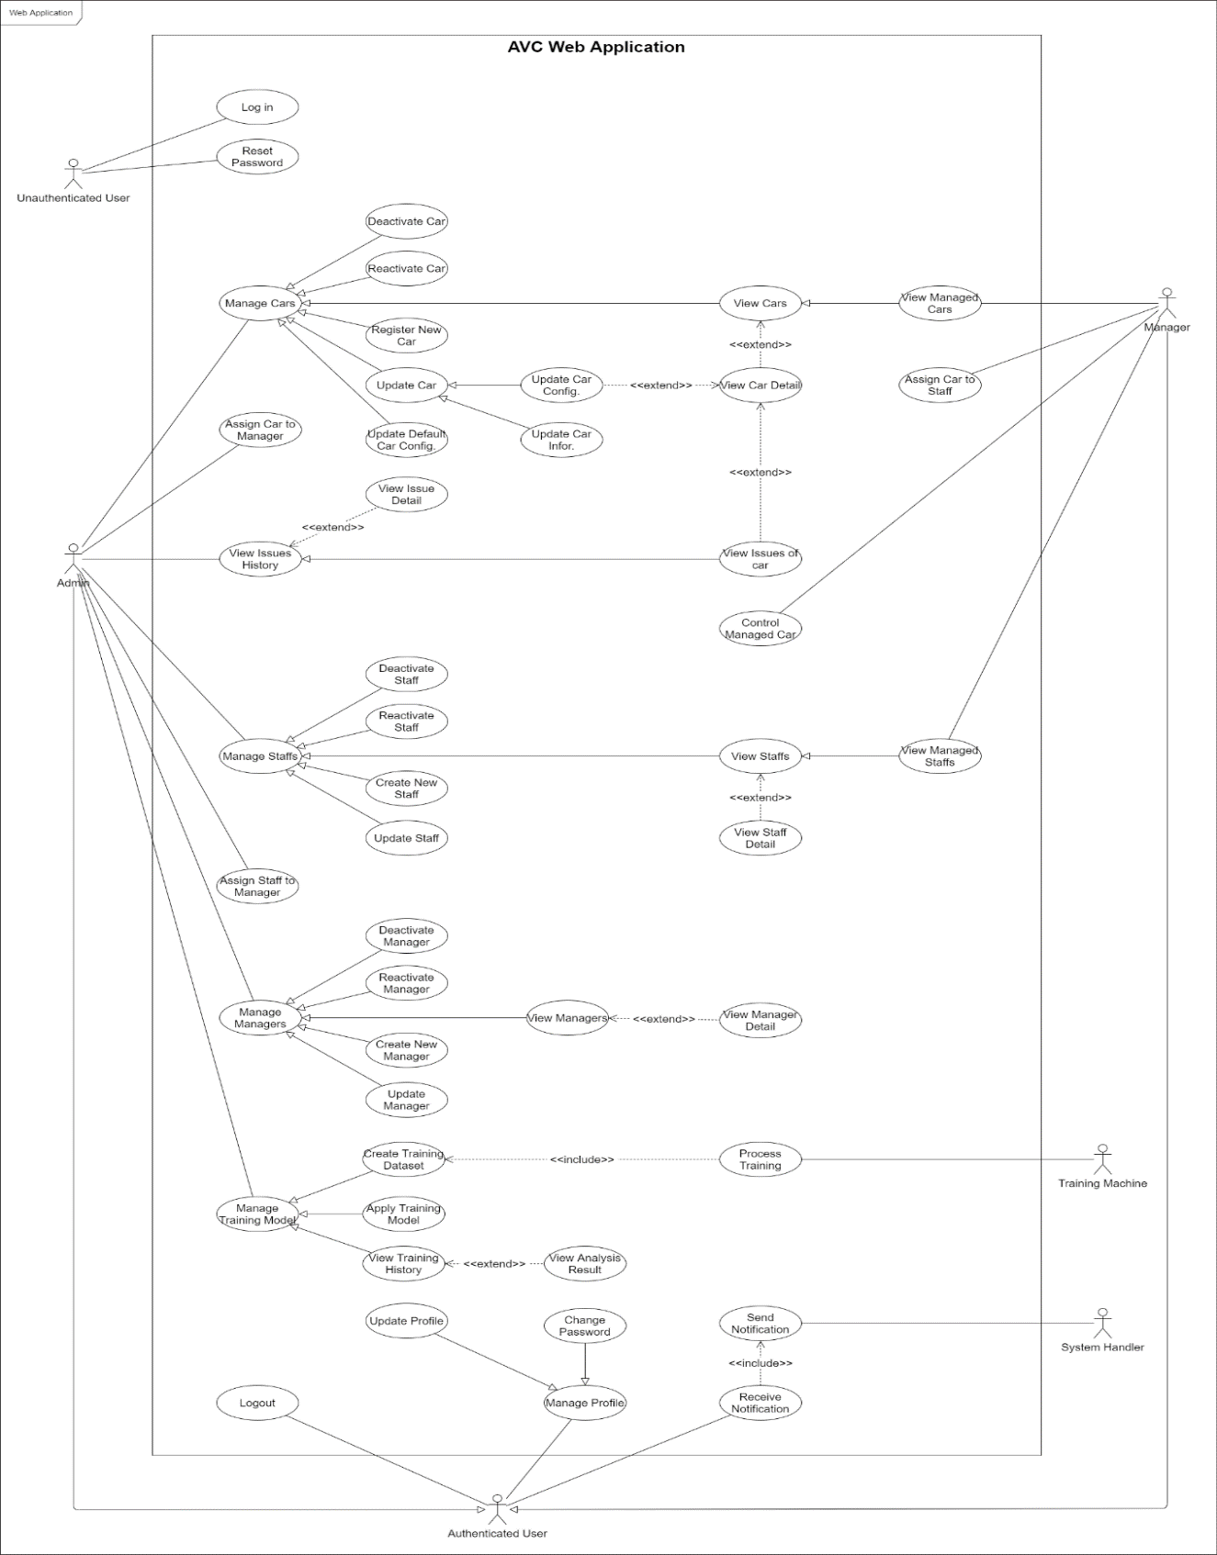

[Figure 4. <Use Case Overview> AVC Web Application](https://drive.google.com/file/d/1zFhJlEgP_85yj58ae63DhL9ydTcMA24G/view?usp=sharing)

##### a2. Mobile Application

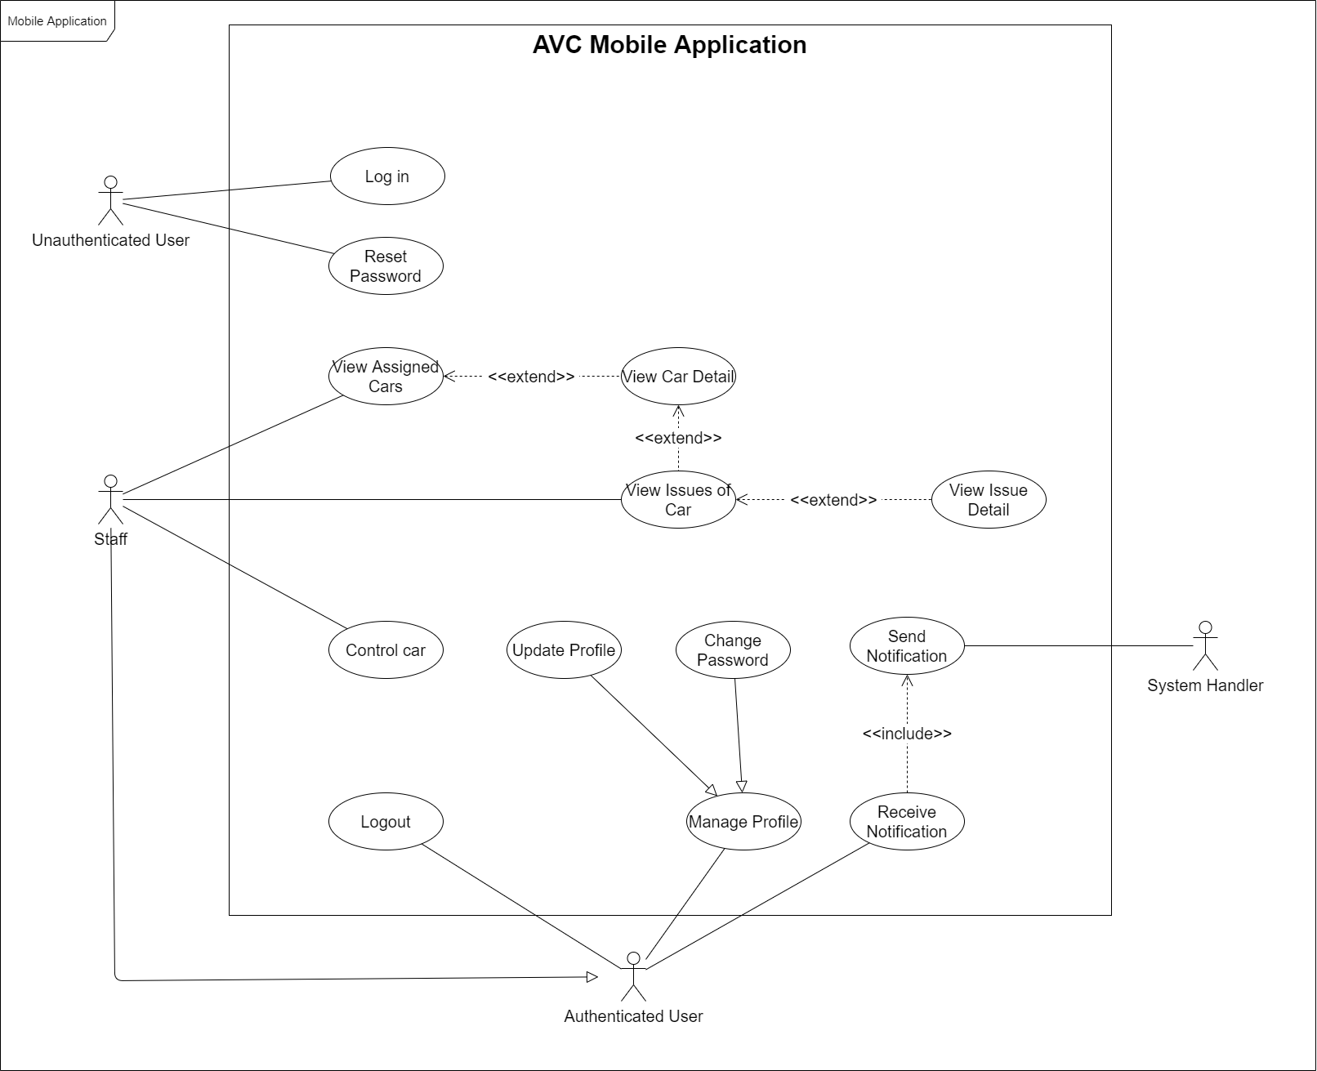

[Figure 5. <Use Case Overview> AVC Mobile Application](https://drive.google.com/file/d/1q662BNHaHVGOYy0rKPG6Y3dbgNoX-HfT/view?usp=sharing)

##### a3. Autonomous Car

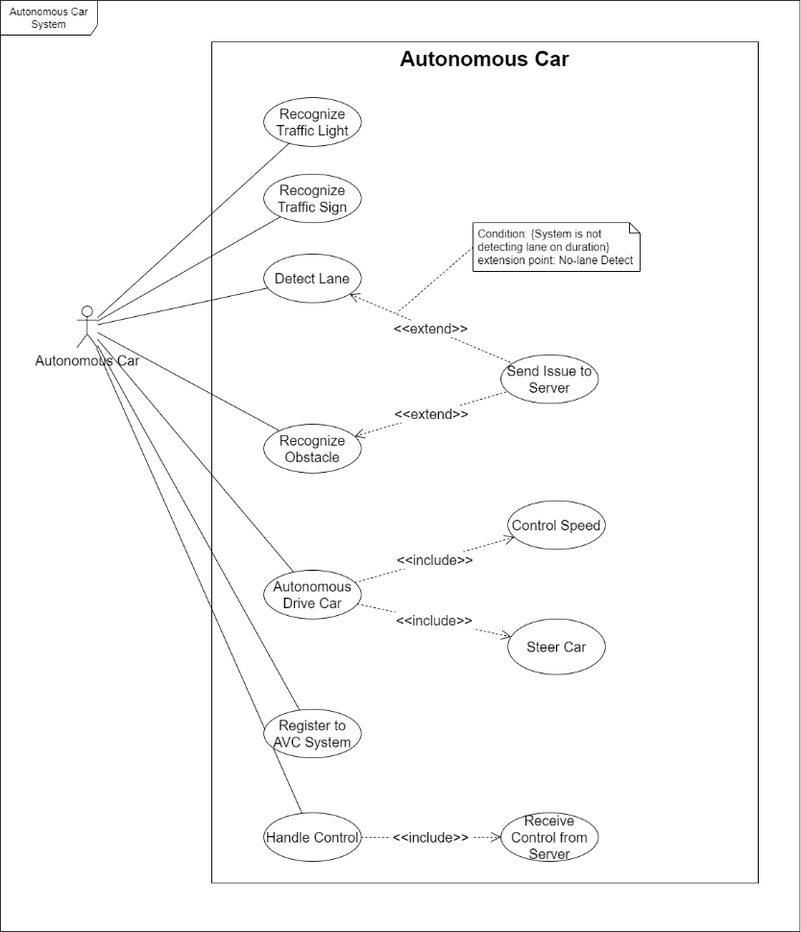

[Figure 6. <Use Case Overview> AVC Autonomous Car](https://drive.google.com/file/d/1XZB-eGfRKW6OJWsF0yuWEHCB1MCLH--K/view?usp=sharing)

#### b. System Actors

|  |  |  |
| --- | --- | --- |
| # | Actor | Description |
| 1 | Unauthenticated User | An unauthenticated user is a person who has no account |
| 2 | Authenticated User | Authenticated User is a person who has an account in the system (staff, manager, admin) |
| 3 | Admin | Admin manages all the system |
| 4 | Manager | Manager manages managed cars and can assign car to staff |
| 5 | Staff | Staff manages assigned cars and controls their basic functionality |
| 6 | Training Machine | A training machine is a machine already set up used for retraining models |
| 7 | Handler System | AVC System deals with internal processes |
| 8 | Autonomous Car | A car autonomous drives, detects, and notify issues when needed |

Table 13 . System Actors

#### c. Use Cases List

|  |  |  |  |
| --- | --- | --- | --- |
| **ID** | **Use Case** | **Primary Actors** | **Secondary Actors** |
| UC-01 | Login | Unauthenticated User | N/A |
| UC-02 | Reset password | Unauthenticated User | N/A |
| UC-03 | Change password | Authenticated User | N/A |
| UC-04 | Update profile | Authenticated User | N/A |
| UC-05 | Logout | Authenticated User | N/A |
| UC-06 | Receive notification | Authenticated User | N/A |
| UC-07 | Deactivate car | Admin | N/A |
| UC-08 | Reactivate car | Admin | N/A |
| UC-09 | Register new car | Admin | N/A |
| UC-10 | View cars | Admin | N/A |
| UC-11 | View car detail | Admin | N/A |
| UC-12 | View issues of car | Admin | N/A |
| UC-13 | View issue detail | Admin | N/A |
| UC-14 | View issues history | Admin | N/A |
| UC-15 | Update default car configuration | Admin | N/A |
| UC-16 | Update car configuration | Admin | N/A |
| UC-17 | Update car information | Admin | N/A |
| UC-18 | Assign car to manager | Admin | N/A |
| UC-19 | Deactivate staff | Admin | N/A |
| UC-20 | Reactivate staff | Admin | N/A |
| UC-21 | Create new staff | Admin | N/A |
| UC-22 | Update staff | Admin | N/A |
| UC-23 | View staffs | Admin | N/A |
| UC-24 | View staff detail | Admin | N/A |
| UC-25 | Assign staff to manager | Admin | N/A |
| UC-26 | Deactivate manager | Admin | N/A |
| UC-27 | Reactivate manager | Admin | N/A |
| UC-28 | Create new manager | Admin | N/A |
| UC-29 | Update manager | Admin | N/A |
| UC-30 | View managers | Admin | N/A |
| UC-31 | View manager detail | Admin | N/A |
| UC-32 | Create training dataset | Admin | N/A |
| UC-33 | Apply training model | Admin | N/A |
| UC-34 | View training history | Admin | N/A |
| UC-35 | View analysis result | Admin | N/A |
| UC-36 | View managed cars | Manager | N/A |
| UC-37 | View car detail | Manager | N/A |
| UC-38 | View issues of car | Manager | N/A |
| UC-39 | View issue detail | Manager | N/A |
| UC-40 | Update car configuration | Manager | N/A |
| UC-41 | View managed staffs | Manager | N/A |
| UC-42 | View staff detail | Manager | N/A |
| UC-43 | Assign car to staff | Manager | N/A |
| UC-44 | Control managed car | Manager | N/A |
| UC-45 | View assigned cars | Staff | N/A |
| UC-46 | View car detail | Staff | N/A |
| UC-47 | View issues of car | Staff | N/A |
| UC-48 | View issue detail | Staff | N/A |
| UC-49 | Control assigned car | Staff | N/A |
| UC-50 | Process training | Training Machine | N/A |
| UC-51 | Send notification | System Handler | Authenticated User |
| UC-52 | Recognize traffic light | Autonomous Car System | N/A |
| UC-53 | Recognize traffic sign | Autonomous Car System | N/A |
| UC-54 | Recognize obstacle | Autonomous Car System | N/A |
| UC-55 | Detect lane | Autonomous Car System | N/A |
| UC-56 | Send issue to server | Autonomous Car System | N/A |
| UC-57 | Register to AVC system | Autonomous Car System | N/A |
| UC-58 | Autonomous drive car | Autonomous Car System | N/A |
| UC-59 | Handle control | Autonomous Car System | N/A |

Table 14 . Use Cases List

### 2.2. Unauthenticated User

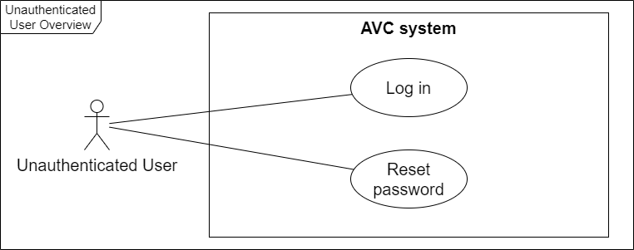

[Figure 7. <Unauthenticated User> Overview Use Case Diagram](https://drive.google.com/file/d/1D3fgIgE9WaH5JFvqyMdXvQgw6-QP09gw/view?usp=sharing)

#### a. UC-01 Login

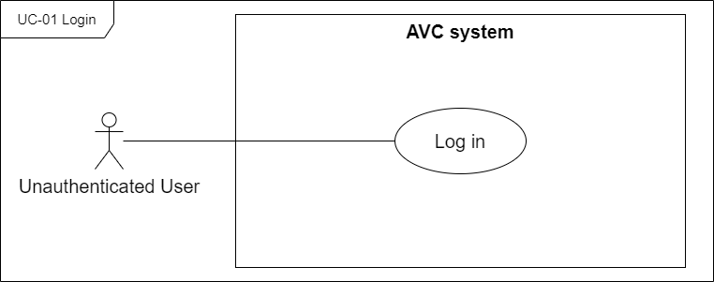

[Figure 8. <Unauthenticated User> UC-01 Login](https://drive.google.com/file/d/1ZOgUuKozXWDTaDEsPBhiNb0wSH-5GZpj/view?usp=sharing)

|  |  |  |  |
| --- | --- | --- | --- |
| ID and Name: | **UC-01 Login** | | |
| Created By: | SangNV | Date Created: | 29/05/2021 |
| Primary Actor: | Unauthenticated User | Secondary Actors: | N/A |
| Description: | Unauthenticated users will be prompted to log in with their AVC account information before they can use the system. | | |
| Trigger: | The user wants to log in to the system | | |
| Pre-conditions: | PRE-01. The user has an AVC account. PRE-02. The user is not already logged in. | | |
| Post-conditions: | POST-01. The user is logged into the AVC system. POST-02. The user has access to the functions of the system. | | |
| Normal Flow: | **1.0 Login into AVC Web Application**  1. The unauthenticated user accesses the login view.  2. The system prompts the user for their AVC account credentials with:  - “Email” text field   - “Password” text field  - “Forgot your password?” link button  - “Log in” button  3. The unauthenticated user enters the required fields.  4. The unauthenticated user presses the "Login" button.  5. AVC system authenticates the login with email and password (see 1.0.E1, 1.0.E2).  6. The user gains access to the functionality of the system.  7. System displays a login success message (MSG09).   8. The AVC system identifies the user's authorization, then redirects the user to the main screen. | | |
| Alternative Flows: | N/A | | |
| Exceptions: | **1.0.E1 Unauthenticated user enters wrong email or password**  1. AVC system informs the unauthenticated user that email or password is not correct (MSG06).  2a. If the unauthenticated user enters again email and password, return to step 3 of normal flow.  2b. Else if the unauthenticated user cancels the login process, then AVC terminates the use case. **1.0.E2 The user account has been deactivated**  1. AVC system informs the unauthenticated user that the current account has been deactivated (MSG07).   2a. If the unauthenticated user enters again another email and password, return to step 3 of normal flow.  2b. Else if the unauthenticated user cancels the login process, then AVC terminates the use case. **1.0.E3 Network disconnected** (MSG15) | | |
| Priority: | High | | |
| Frequency of Use: | Every time the user wants to access the system | | |
| Business Rules: | BR-01, BR-02, BR-03, BR-04, BR-05 | | |
| Other Information: | When the input form is invalid, the "Log in" button will be disabled. | | |
| Assumptions: | N/A | | |

#### b. UC-02 Reset password

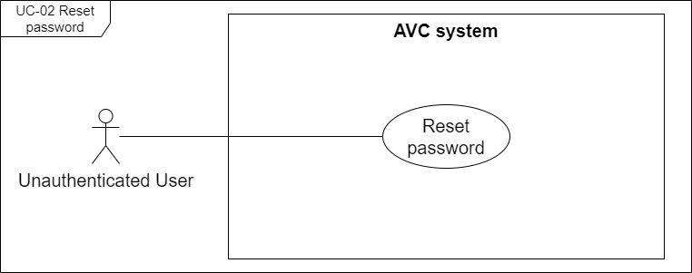

[Figure 9. <Unauthenticated User> UC-02 Reset password](https://drive.google.com/file/d/1jg-rnOxc1sF0umS1Uu-H7cBzIPR4do5V/view?usp=sharing)

|  |  |  |  |
| --- | --- | --- | --- |
| ID and Name: | **UC-02 Reset password** | | |
| Created By: | SangNV | Date Created: | 29/05/2021 |
| Primary Actor: | Unauthenticated User | Secondary Actors: | N/A |
| Description: | An unauthenticated user forgot his/her password and requires a new password for logging in to the system. | | |
| Trigger: | The unauthenticated user wants to reset the password account. | | |
| Pre-conditions: | PRE-01. The user has an AVC account. PRE-02. The user can access the email mailbox used to register the account. PRE-03. The user is on the login screen | | |
| Post-conditions: | POST-01. The password account has been reset and shows a success message. | | |
| Normal Flow: | **2.0 Reset password**  1. The user presses the "Forgot your password?" link.  2. The system redirects the user to the "Forgot Password" screen with following items:  - “Email” text field  - “Send reset link” button  3. The system prompts the user for entering their AVC account email.  3. The user enters their account email.  4. The user presses the "Send reset link" button. (see 2.0.E1)  5. The system displays a success message (MSG04).  6. The user accesses the email mailbox used to register the account for checking the security code and recovery link.  7. The user presses to the recovery link.  8. The link redirects the user to the "Reset Password" screen.  9. The system prompts the user for entering to the form with:  - “Email” text field  - “Security code” text field  - “New password” text field  - “Confirm password” text field  - “Reset your password” button  - “Return to Log in” link button  10. The user enters the required fields.  11. The user presses the "Reset your password" button (see 2.0.E2).  12. The system displays a success message (MGS05). | | |
| Alternative Flows: | **2.1 Return to login from the "Forgot Password" screen.**  4a. The user presses the "Return to Log in" link button.  4a1. The system redirects the user to the "Login" screen.  **2.2 Return to login from the "Reset Password" screen.**  11a. The user presses the "Return to Log in" link button.  11a1. The system redirects the user to the "Login" screen. | | |
| Exceptions: | **2.0.E1 Email account does not exist in the system**  1. AVC system informs the unauthenticated user that the sending recovery link failed (MSG10).  2a. If the unauthenticated user enters again the email account, return to step 3 of normal flow.  2b. Else if the unauthenticated user cancels the reset password process, then AVC terminates the use case. **2.0.E2 Wrong security key**  1. AVC system informs the unauthenticated user that failed to reset password (MSG08).  2a. If the unauthenticated user enters again the email account, return to step 9 of normal flow.  2b. Else if the unauthenticated user cancels the reset password process, then AVC terminates the use case. **2.0.E7 Network disconnected** (MSG15) | | |
| Priority: | Medium | | |
| Frequency of Use: | Every time the user forgot password | | |
| Business Rules: | BR-06, BR-07, BR-08 | | |
| Other Information: | When the input form is invalid, the "Send reset link" button will be disabled. When the input form is invalid, the "Reset your password" button will be disabled. | | |
| Assumptions: | N/A | | |

### 2.3. Authenticated User

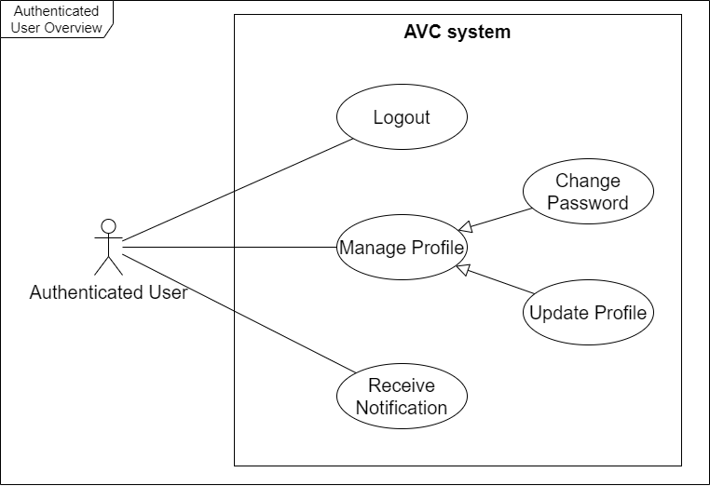

[Figure 10. <Authenticated User> Overview Use Case Diagram](https://drive.google.com/file/d/1ozNVIy--1eEdY59bbA4uKVHjOVl9p8IC/view?usp=sharing)

#### a. UC-03 Change password

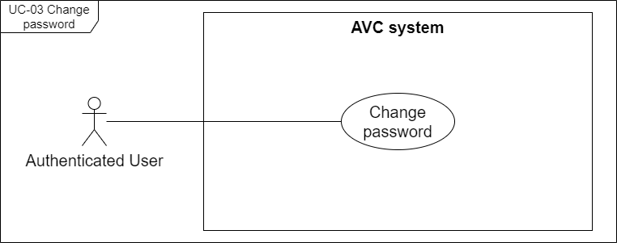

[Figure 11. <Authenticated User> UC-03 Change password](https://drive.google.com/file/d/1-DSPaxg16CyI1FifkmZDB72deC2-fa4t/view?usp=sharing)

|  |  |  |  |
| --- | --- | --- | --- |
| ID and Name: | **UC-03 Change password** | | |
| Created By: | HoaNT | Date Created: | 29/05/2021 |
| Primary Actor: | Authenticated User | Secondary Actors: | N/A |
| Description: | The authenticated user can change their password account. | | |
| Trigger: | The user wants to change their password account. | | |
| Pre-conditions: | PRE-01. The user has logged in to the AVC system. | | |
| Post-conditions: | POST-01. User account password is changed successfully. | | |
| Normal Flow: | **3.0 Change password**  1. User presses on the avatar on the navbar.  2. The system displays a menu box with following items:  - Profile  - Log out  3. The user selects the "Profile" item.  4. The system redirects the user to the "My Profile" popup screen with following items:  - “Full name” label  - “Avatar” image uploader  - “Email” label  - “Role” label  - “Phone” text field  - “Update Profile” button  - “Change Password” button  5. User presses on the "Change Password" button.  6. The system displays the "Change Password" popup screen.  7. The system prompts the user for entering to the form with:   - “Old Password” text field  - “New Password” text field  - “Confirm Password” text field  - “Change” button  8. The user enters the required fields.  9. The user presses on the "Change" button (see 3.0.E1).  10. The system displays a change password success message (MSG11). | | |
| Alternative Flows: | **N/A** | | |
| Exceptions: | **3.0.E1 Wrong old password.**  1. AVC system informs the authenticated user that the old password is wrong (MSG12).  2a. If the unauthenticated user enters again the email account, return to step 8 of normal flow.  2b. Else if the unauthenticated user cancels the change password process, then AVC terminates the use case. **3.0.E2 Network disconnected** (MSG15) | | |
| Priority: | Low | | |
| Frequency of Use: | Each time a user wants to change their password. | | |
| Business Rules: | BR-09 | | |
| Other Information: | When the input form is invalid, the "Change" button will be disabled. | | |
| Assumptions: | The user has logged in to the AVC system. | | |

#### b. UC-04 Update profile

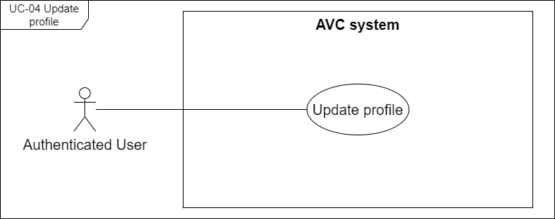

[Figure 12. <Authenticated User> UC-04 Update profile](https://drive.google.com/file/d/1QX8SPKM3advmsLO4OltnjREutf24dqg0/view?usp=sharing)

|  |  |  |  |
| --- | --- | --- | --- |
| ID and Name: | **UC-04 Update profile** | | |
| Created By: | HoaNT | Date Created: | 29/05/2021 |
| Primary Actor: | Authenticated User | Secondary Actors: | N/A |
| Description: | The authenticated user can change their account profile information. | | |
| Trigger: | The authenticated user wants to change their account profile information. | | |
| Pre-conditions: | PRE-01. The user has logged in to the AVC system. | | |
| Post-conditions: | POST-01. User account profile information is changed successfully. | | |
| Normal Flow: | **4.0 Update profile**  1. User presses on the avatar on the navbar.  2. The system displays a menu box with following items:  - Profile  - Log out  3. The user selects the "Profile" item.  4. The system redirects the user to the "My Profile" popup screen with following items:  - “Full name” label  - “Avatar” image uploader  - “Email” label  - “Role” label  - “Phone” text field  - “Update Profile” button  - “Change Password” button  5. User can edit following information details:  6. User presses on the "Update Profile" button. (see 4.0.E1)  7. The system displays an update successfully message (MSG13). | | |
| Alternative Flows: | **N/A** | | |
| Exceptions: | **4.0.E1 Wrong phone number format**  1. AVC system informs the authenticated user that wrong phone number format (MSG14).  2a. If the unauthenticated user enters again the phone number field, return to step 5 of normal flow.  2b. Else if the unauthenticated user cancels the update profile process, then AVC terminates the use case. **4.0.E2 Network disconnected** (MSG15) | | |
| Priority: | Low | | |
| Frequency of Use: | Each time a user wants to change their password. | | |
| Business Rules: | BR-10 | | |
| Other Information: | N/A | | |
| Assumptions: | The user has logged in to the AVC system. | | |

#### c. UC-05 Logout

[Figure 13. <Authenticated User> UC-05 Logout](https://drive.google.com/file/d/1tpZt-yMpkz9OW9D15RsjFHk7PUKH0TIc/view?usp=sharing)

|  |  |  |  |
| --- | --- | --- | --- |
| ID and Name: | **UC-05 Logout** | | |
| Created By: | HoaNT | Date Created: | 29/05/2021 |
| Primary Actor: | Authenticated User | Secondary Actors: | N/A |
| Description: | The authenticated user can log out from the AVC system. | | |
| Trigger: | User want to log out from the AVC system. | | |
| Pre-conditions: | PRE-01. The user has logged in to the AVC system. | | |
| Post-conditions: | POST-01. The login session was canceled. POST-02. The user does not have permission to interact with the system | | |
| Normal Flow: | **5.0 Logout**  1. The user presses on the avatar on the navbar.  2. The system displays a menu box with following items:  - Profile  - Log out  3. The user selects the "Log out" item.  4. The system displays a "Log out confirmation" dialog.  5. The user presses the "Logout" button on the display dialog.  6. The system redirects the user back to the "Login" screen. | | |
| Alternative Flows: | **5.1 Cancel Logout**  5a. The user presses the "Cancel" button on the display dialog.  5a1. The system closes the "Log out confirmation" dialog, then cancels the logout process. | | |
| Exceptions: | **5.0.E1 Network disconnected** (MSG15) | | |
| Priority: | Medium | | |
| Frequency of Use: | Each time a user wants to log out of the AVC system. | | |
| Business Rules: | N/A | | |
| Other Information: | N/A | | |
| Assumptions: | The user has logged in to the AVC system. | | |

#### d. UC-06 Receive notification

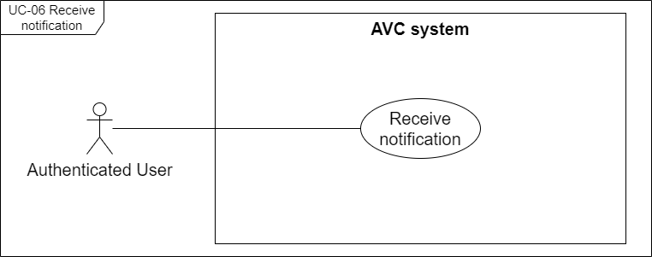

[Figure 14. <Authenticated User> UC-06 Receive notification](https://drive.google.com/file/d/1sKpV9uahqHc07Fhrn-5qUvpVFis2pOv1/view?usp=sharing)

|  |  |  |  |
| --- | --- | --- | --- |
| ID and Name: | **UC-06 Receive notification** | | |
| Created By: | HoaNT | Date Created: | 29/05/2021 |
| Primary Actor: | Authenticated User | Secondary Actors: | N/A |
| Description: | Authenticated users will receive a notification Every time the relevant stakeholders interact with the system. | | |
| Trigger: | The relevant stakeholders interact with the system. | | |
| Pre-conditions: | PRE-01. The user has logged in to the AVC system. PRE-02. The user has relationships with other stakeholders | | |
| Post-conditions: | POST-01. The user receives notifications about relevant stakeholder actions. POST-02. The user can view the list of notifications. | | |
| Normal Flow: | **6.0 Receive notification**  1. The system notifies the user through the app's notification bell.  2. The user presses the bell icon.  3. The system displays a dropdown list notification. | | |
| Alternative Flows: | **N/A** | | |
| Exceptions: | **6.0.E1 Network disconnected** (MSG15) | | |
| Priority: | Medium | | |
| Frequency of Use: | Every time the relevant stakeholders of the user interact with the system. | | |
| Business Rules: | BR-11, BR-12, BR-13 | | |
| Other Information: | Each role of an authenticated user will receive a different notification based on the business rule. | | |
| Assumptions: | The user has logged in to the AVC system. | | |

### 2.4. Web Application <Admin>

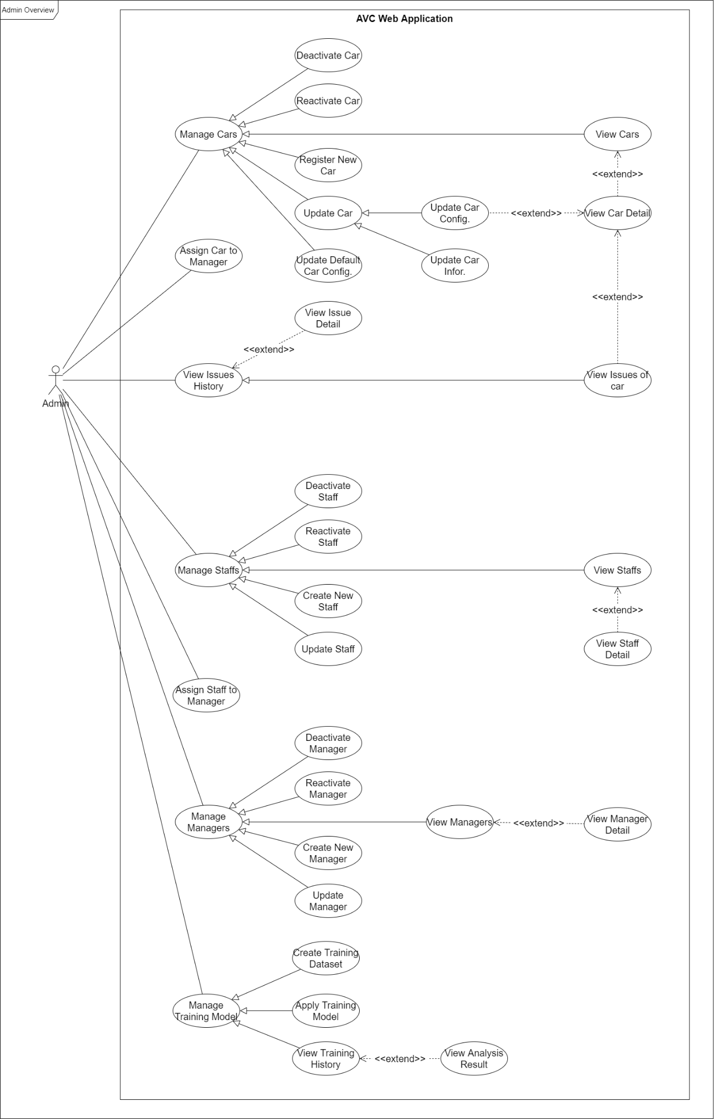

[Figure 15. <Admin> Overview Use Case Diagram](https://drive.google.com/file/d/1kb3ilvaAa30HdKnx4Bqt4XPt1giIUnSZ/view?usp=sharing)

#### a. UC-07 Deactivate car

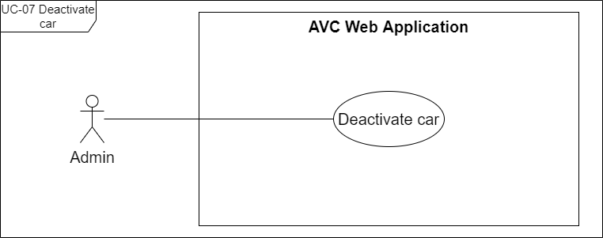

[Figure 16. <Admin> UC-07 Deactivate car](https://drive.google.com/file/d/1fDKNPKxY7bFDiZ3_tpKnDuwliraWcP9x/view?usp=sharing)

|  |  |  |  |
| --- | --- | --- | --- |
| ID and Name: | **UC-07 Deactivate car** | | |
| Created By: | SangNV | Date Created: | 29/05/2021 |
| Primary Actor: | Admin | Secondary Actors: | N/A |
| Description: | The admin can deactivate cars that are temporarily no longer in use due to maintenance or storage. | | |
| Trigger: | Admin wants to deactivate the car which is in maintenance or storage. | | |
| Pre-conditions: | PRE-01. The actor had been authorized as an admin. PRE-02. The selected car has the status of "Active". | | |
| Post-conditions: | POST-01. Status of selected car on "Manage Cars" table and car detail to "Inactive". | | |
| Normal Flow: | **7.0 Deactivate car**  1. The admin selects the "Manage Car" item in the side navigation menu.  2. The system redirects the admin to the "Manage Cars" screen.  3. The admin selects a car whose status is "Active".  4. The system displays the car detail box on the screen.  5. The admin presses on the "Deactivate" button on the car detail.  6. The system displays a "Deactivate car" dialog.  7. The admin presses on the "Deactivate" button on the "Deactivate car" dialog.  8. The system changes the status of the car on the "Manage Cars" table and car detail to "Inactive". | | |
| Alternative Flows: | **7.1 Cancel deactivate car**  7a. The admin presses on the "Cancel" button on the "Deactivate car" dialog.  7a1. The system closes the "Deactivate car" dialog and terminates the use case. | | |
| Exceptions: | **7.0.E1 Network disconnected** (MSG15) | | |
| Priority: | Medium | | |
| Frequency of Use: | Each time the admin wants to deactivate the car which is in maintenance or storage. | | |
| Business Rules: | BR-82 | | |
| Other Information: | N/A | | |
| Assumptions: | The admin has logged in to the AVC system. | | |

#### b. UC-08 Reactivate car

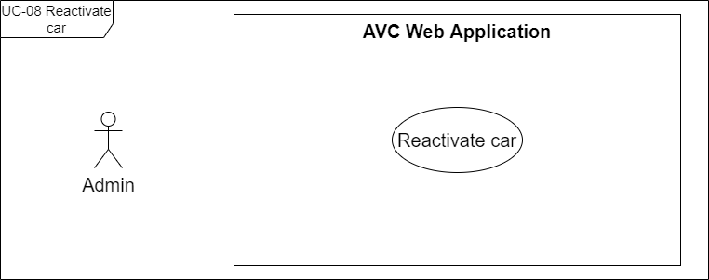

[Figure 17. <Admin> UC-08 Reactivate car](https://drive.google.com/file/d/1Q3SC7TzYAQ6gN5Vvw_RlvAcghSv8y0se/view?usp=sharing)

|  |  |  |  |
| --- | --- | --- | --- |
| ID and Name: | **UC-08 Reactivate car** | | |
| Created By: | SangNV | Date Created: | 29/05/2021 |
| Primary Actor: | Admin | Secondary Actors: | N/A |
| Description: | The admin can reactivate the cars when they need to continue using them after maintenance. | | |
| Trigger: | Admin wants to reactivate the cars when they need to continue using them after maintenance. | | |
| Pre-conditions: | PRE-01. The actor had been authorized as an admin. PRE-02. The selected car has the status of "Inactive". | | |
| Post-conditions: | POST-01. Status of selected car on "Manage Cars" table and car detail to "Active". | | |
| Normal Flow: | **8.0 Reactivate car**  1. The admin selects the "Manage Cars" item in the side navigation menu.  2. The system redirects the admin to the "Manage Cars" screen.  3. The admin selects a car whose status is "Inactive".  4. The system displays the car detail box on the screen.  5. The admin presses on the "Reactivate" button on the car detail.  6. The system displays a "Activate car" dialog.  7. The admin presses on the "Activate" button on the "Activate car" dialog.  8. The system changes the status of the car on the "Manage Cars" table and car detail to "Active". | | |
| Alternative Flows: | **8.1 Cancel reactivate car**  7a. The admin presses on the "Cancel" button on the "Activate car" dialog.  7a1. The system closes the "Activate car" dialog and terminates the use case. | | |
| Exceptions: | **8.0.E1 Network disconnected** (MSG15) | | |
| Priority: | Medium | | |
| Frequency of Use: | Each time the admin wants to reactivate the cars when they need to continue using them after maintenance. | | |
| Business Rules: | N/A | | |
| Other Information: | N/A | | |
| Assumptions: | The admin has logged in to the AVC system. | | |

#### c. UC-09 Register new car

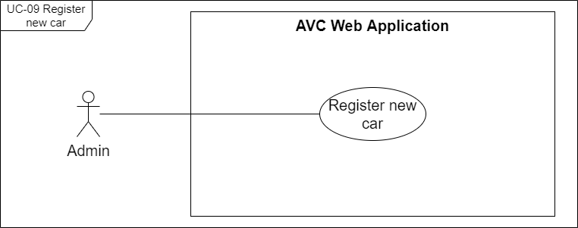

[Figure 18 . <Admin> UC-09 Register new car](https://drive.google.com/file/d/1i-aLfUqtGz4At-0llzkVYZXHE_uCyiCN/view?usp=sharing)

|  |  |  |  |
| --- | --- | --- | --- |
| ID and Name: | **UC-09 Register new car** | | |
| Created By: | SangNV | Date Created: | 29/05/2021 |
| Primary Actor: | Admin | Secondary Actors: | N/A |
| Description: | The admin will not need to create or register a new car because the side of the car will send a registration request to the admin when it is installed and started up for the first time The admin will only need to approve that car and fill in more necessary information. | | |
| Trigger: | The autonomous car sends a registration request to the admin. | | |
| Pre-conditions: | PRE-01. The actor had been authorized as an admin. PRE-02. Exist unregistered cars on the system. | | |
| Post-conditions: | POST-01. The new car is registered successfully and ready for assignment. | | |
| Normal Flow: | **9.0 Register new car**  1. The admin selects the "Manage Cars" item in the side navigation menu.  2. The system redirects the admin to the "Manage Cars" screen.  3. The admin presses on the "Unapproved Cars" button.  4. The system displays a sub-table list of unapproved cars.  5. The admin selects a car on the list.  6. The system displays the “Approve car” form to enter detailed information for the selected car waiting for approval includes following items:  - Car image upload  - “Device ID” label  - “Name” text field  - “Managed by” drop down  - “Approve” button  - “Reject” button  - “Discard” button  7. The admin adds a car image and enters the car name.  8. The admin presses the "Approve" button.  9. The system displays an approved successful message (MSG17).  10. The new car is added to the "Manage Cars" table with the status of "Active". | | |
| Alternative Flows: | **9.1 The admin assigns a car to a manager when approving.** 7a. Admin selects a manager on the dropdown list for assigning.  Use case continues to step 8 of normal flow.  **9.2 Reject car**  8a. The admin presses the "Reject" button.  8a1. The system closes the "Approve car" form and removes the selected car from the “Unapproved Cars” list then terminates the use case.  **9.3 Discard change**  8b. The admin presses the "Discard" button.  8b1. The system closes the "Approve car" form then terminates the use case. | | |
| Exceptions: | **9.0.E1 Network disconnected** (MSG15) | | |
| Priority: | High | | |
| Frequency of Use: | Every time the system has a new car for registering. | | |
| Business Rules: | BR-20, BR-21, BR-22, BR-23 | | |
| Other Information: | When the car name field is not filled, the "Approve" button will be disabled. | | |
| Assumptions: | The admin has logged in to the AVC system. | | |

#### d. UC-10 View cars

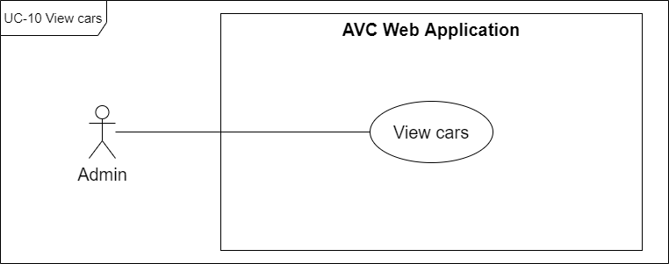

[Figure 19 . <Admin> UC-10 View cars](https://drive.google.com/file/d/1elaqNkb91FPf8ySvwYzp5A6LyevRn39j/view?usp=sharing)

|  |  |  |  |
| --- | --- | --- | --- |
| ID and Name: | **UC-10 View cars** | | |
| Created By: | SangNV | Date Created: | 29/05/2021 |
| Primary Actor: | Admin | Secondary Actors: | N/A |
| Description: | Admin is the one who can see all the cars in the system, whether registered or not. | | |
| Trigger: | Admin wants to see cars exist in the system. | | |
| Pre-conditions: | PRE-01. The actor had been authorized as an admin. | | |
| Post-conditions: | POST-01. All cars are displayed on the screen. | | |
| Normal Flow: | **10.0 View cars**  1. The admin selects the "Manage Cars" item in the side navigation menu.  2. The system redirects the admin to the "Manage Cars" screen with all approved cars (see 10.0.E1). | | |
| Alternative Flows: | N/A | | |
| Exceptions: | **10.0.E1 No car result exist in the system** (MSG18) **10.0.E2 Network disconnected** (MSG15) | | |
| Priority: | High | | |
| Frequency of Use: | Every time the admin wants to see cars exist in the system. | | |
| Business Rules: | BR-14, BR-17 | | |
| Other Information: | N/A | | |
| Assumptions: | The admin has logged in to the AVC system. | | |

#### e. UC-11 View car detail

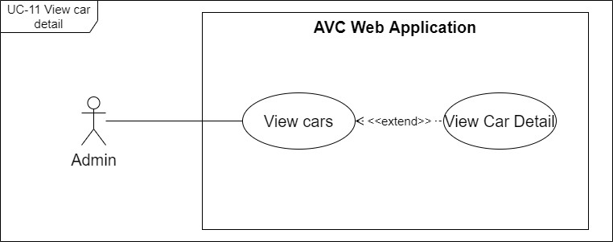

[Figure 20 . <Admin> UC-11 View car detail](https://drive.google.com/file/d/1elaqNkb91FPf8ySvwYzp5A6LyevRn39j/view?usp=sharing)

|  |  |  |  |
| --- | --- | --- | --- |
| ID and Name: | **UC-11 View car detail** | | |
| Created By: | SangNV | Date Created: | 29/05/2021 |
| Primary Actor: | Admin | Secondary Actors: | N/A |
| Description: | The admin can view car details, through which they can know more information about the car, its configuration as well as the model train for the car, in addition, the admin can assign the car to the manager or edit the car configuration. | | |
| Trigger: | The admin wants to see car details. | | |
| Pre-conditions: | PRE-01. The actor had been authorized as an admin. | | |
| Post-conditions: | POST-01. The details of the car are displayed on the screen. | | |
| Normal Flow: | **11.0 View car detail**  1. The admin selects the "Manage Cars" item in the side navigation menu.  2. The system redirects the admin to the "Manage Cars" screen with all approved cars  3. The admin selects a car on the "Manage Cars" table.  4. The system displays a "Car Detail" box on the screen.  5. The admin presses on the "Expand" link/icon on the "Car Detail" box.  6. The system redirects the admin to the "Car Detail" screen with an issues list of the car. | | |
| Alternative Flows: | N/A | | |
| Exceptions: | **11.0.E1 Network disconnected** (MSG15) | | |
| Priority: | High | | |
| Frequency of Use: | Every time the admin wants to see car details. | | |
| Business Rules: | BR-18 | | |
| Other Information: | N/A | | |
| Assumptions: | The admin has logged in to the AVC system.  Exist car on the system. | | |

#### f. UC-12 View issues of car

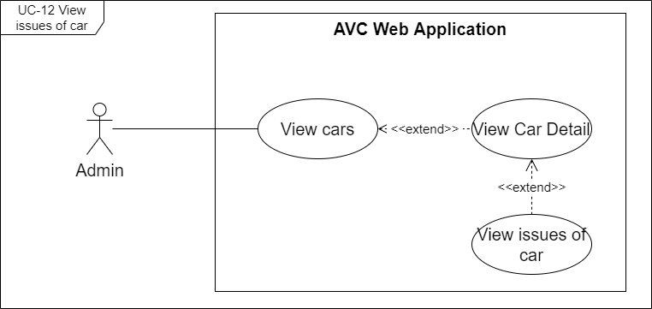

[Figure 21 . <Admin> UC-12 View issues of car](https://drive.google.com/file/d/1aNfz5zklMd6-tdwGVTVs413XhCkDO5WI/view?usp=sharing)

|  |  |  |  |
| --- | --- | --- | --- |
| ID and Name: | **UC-12 View issues of car** | | |
| Created By: | SangNV | Date Created: | 29/05/2021 |
| Primary Actor: | Admin | Secondary Actors: | N/A |
| Description: | Admin can view issues for any of the cars on the list to track and correct car problems. | | |
| Trigger: | The admin wants to view issues of a car. | | |
| Pre-conditions: | PRE-01. The actor had been authorized as an admin. PRE-02. The actor is continuous with the UC-11 View car detail. | | |
| Post-conditions: | POST-01. Issues of the car are displayed on the screen. | | |
| Normal Flow: | **12.0 View issues of car**  1. The admin presses on the "Expand" link/icon on the "Car Detail" box.  2. The system redirects the admin to the "Car Detail" screen.  3. Issues of the car are displayed on the "Car Detail" screen. | | |
| Alternative Flows: | N/A | | |
| Exceptions: | **11.0.E1 Network disconnected** (MSG15) | | |
| Priority: | High | | |
| Frequency of Use: | Every time the admin wants to view issues of a car. | | |
| Business Rules: | N/A | | |
| Other Information: | N/A | | |
| Assumptions: | The admin has logged in to the AVC system. | | |

#### g. UC-13 View issue detail

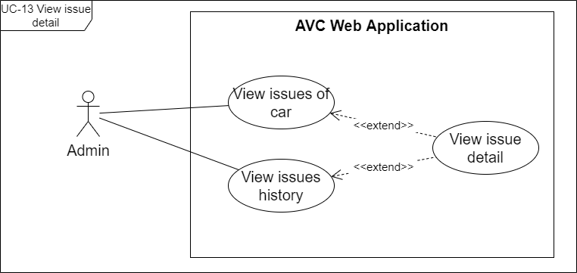

[Figure 22 . <Admin> UC-13 View issue detail](https://drive.google.com/file/d/15jqsbl0w_SkrDBjiZrlTelkweB3Ipa1b/view?usp=sharing)

|  |  |  |  |
| --- | --- | --- | --- |
| ID and Name: | **UC-13 View issue detail** | | |
| Created By: | SangNV | Date Created: | 29/05/2021 |
| Primary Actor: | Admin | Secondary Actors: | N/A |
| Description: | Admin can view issue details of all issues to track and correct car problems. | | |
| Trigger: | The admin wants to view the details of an issue. | | |
| Pre-conditions: | PRE-01. The actor had been authorized as an admin. | | |
| Post-conditions: | POST-01. Details of issues are displayed on the screen. | | |
| Normal Flow: | **13.0 View issue detail on issues history**  1. The admin selects the "Manage Issues" item in the side navigation menu.  2. The system redirects the admin to the "Manage Issues" screen and displays the list of all issues.  3. The admin selects an issue on the "Manage Issues" table.  4. The system displays an "Issues Detail" box on the screen. | | |
| Alternative Flows: | N/A | | |
| Exceptions: | **13.0.E1 Network disconnected** (MSG15) | | |
| Priority: | High | | |
| Frequency of Use: | Every time the admin wants to view the details of an issue. | | |
| Business Rules: | BR-79 | | |
| Other Information: | N/A | | |
| Assumptions: | The admin has logged in to the AVC system. | | |

#### h. UC-14 View issues history

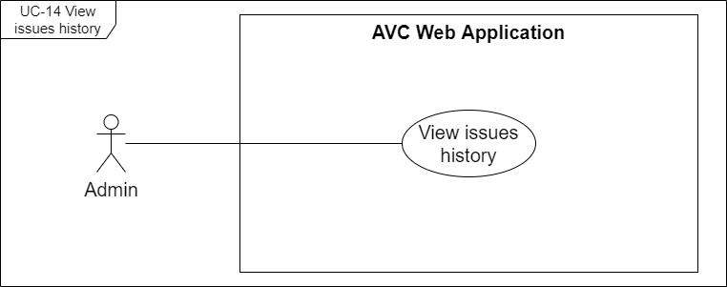

[Figure 23 . <Admin> UC-14 View issues history](https://drive.google.com/file/d/1WQuuQboyoruDvIi_2iFYK2ErIo1GMlRp/view?usp=sharing)

|  |  |  |  |
| --- | --- | --- | --- |
| ID and Name: | **UC-14 View issues history** | | |
| Created By: | SangNV | Date Created: | 29/05/2021 |
| Primary Actor: | Admin | Secondary Actors: | N/A |
| Description: | Admin can view issues history on the system to track and correct car problems. | | |
| Trigger: | The admins want to view all issues | | |
| Pre-conditions: | PRE-01. The actor had been authorized as an admin. | | |
| Post-conditions: | POST-01. All issues are displayed on the screen. | | |
| Normal Flow: | **14.0 View issues history**  1. The admin selects the "Manage Issues" item in the side navigation menu.  2. The system redirects the admin to the "Manage Issues" screen and displays the list of all issues. | | |
| Alternative Flows: | N/A | | |
| Exceptions: | **14.0.E1 Network disconnected** (MSG15) | | |
| Priority: | High | | |
| Frequency of Use: | Every time admin wants to view all issues | | |
| Business Rules: | BR-19 | | |
| Other Information: | N/A | | |
| Assumptions: | The admin has logged in to the AVC system. | | |

#### i. UC-15 Update default car configuration

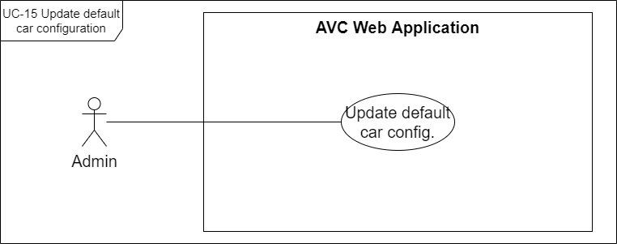

[Figure 24 . <Admin> UC-15 Update default car configuration](https://drive.google.com/file/d/1cKsUb_kUWD_Evd-xENyMkvY70cfD7QJ-/view?usp=sharing)

|  |  |  |  |
| --- | --- | --- | --- |
| ID and Name: | **UC-15 Update default car configuration** | | |
| Created By: | SangNV | Date Created: | 29/05/2021 |
| Primary Actor: | Admin | Secondary Actors: | N/A |
| Description: | Admin can update the parameters inside the default car configuration to better match the updates of the software configuration from the autonomous car system. | | |
| Trigger: | The admin wants to update a default car configuration. | | |
| Pre-conditions: | PRE-01. The actor had been authorized as an admin. | | |
| Post-conditions: | POST-01. Default car configuration has been updated successfully. | | |
| Normal Flow: | **15.0 Update default car configuration**  1. The admin selects the "Manage Cars" item in the side navigation menu.  2. The system redirects the admin to the "Manage Cars" screen.  3. The admin presses on the “Edit Default Config” button on “Manage Cars” Screen.  4. The system redirects the admin to the "Edit Default Configuration" screen with following items:  - Configuration JSON editor area.  - “Save” button  - “Discard” button  3. The admin edits the details on the configuration JSON editor area.  4. The admin presses the "Save" button.  5. The system displays update car configuration success message (MSG24) | | |
| Alternative Flows: | **15.1 Discard change**  4b. The admin presses the "Discard" button.  4b1. The system closes the "Edit Default Configuration" screen and gets back to the “Manage Cars” screen, then terminates the use case. | | |
| Exceptions: | **15.0.E1 Network disconnected** (MSG15) | | |
| Priority: | High | | |
| Frequency of Use: | Every time the admin wants to update default car configuration. | | |
| Business Rules: | BR-31 | | |
| Other Information: | N/A | | |
| Assumptions: | The admin has logged in to the AVC system. | | |

#### j. UC-16 Update car configuration

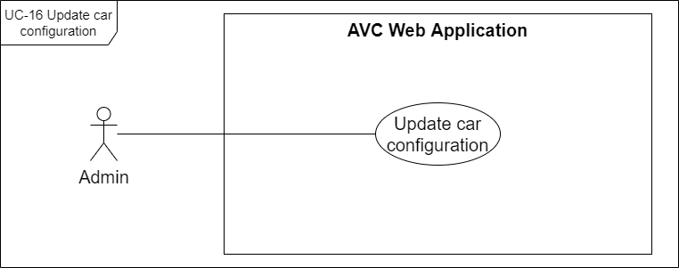

[Figure 25 . <Admin> UC-16 Update car configuration](https://drive.google.com/file/d/1an6i7XOKzX7iq9ZD0RMhGL15oUDAfxWP/view?usp=sharing)

|  |  |  |  |
| --- | --- | --- | --- |
| ID and Name: | **UC-16 Update car configuration** | | |
| Created By: | SangNV | Date Created: | 29/05/2021 |
| Primary Actor: | Admin | Secondary Actors: | N/A |
| Description: | Admin can update the car's configuration from the initial default configuration to match the real car's parameters. | | |
| Trigger: | The admin wants to update a car's configuration. | | |
| Pre-conditions: | PRE-01. The actor had been authorized as an admin. PRE-02. The actor is continuous with UC-11 View car detail. | | |
| Post-conditions: | POST-01. Car's configuration has been updated successfully. | | |
| Normal Flow: | **16.0 Update car configuration**  1. The admin presses on the "Edit configuration" link button on car detail.  2. The system redirects the admin to the "Edit Car Configuration" screen with following items:  - Configuration JSON editor area.  - “Save” button  - “Discard” button  3. The admin edits the details on the configuration JSON editor area.  4. The admin presses the "Save" button.  5. The system displays update car configuration success message (MSG24) | | |
| Alternative Flows: | **16.1 Discard change**  4b. The admin presses the "Discard" button.  4b1. The system closes the "Edit Car Configuration" screen and gets back to the “Manage Cars” screen, then terminates the use case. | | |
| Exceptions: | **16.0.E1 Network disconnected** (MSG15) | | |
| Priority: | High | | |
| Frequency of Use: | Every time the admin wants to update a car's configuration. | | |
| Business Rules: | BR-32, BR-33 | | |
| Other Information: | N/A | | |
| Assumptions: | The admin has logged in to the AVC system. | | |

#### k. UC-17 Update car information

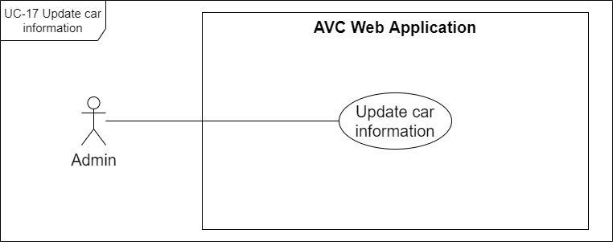

[Figure 26. <Admin> UC-17 Update car information](https://drive.google.com/file/d/1l45FHZEaDeffM_XAmQGr2xxK2krDM12H/view?usp=sharing)

|  |  |  |  |
| --- | --- | --- | --- |
| ID and Name: | **UC-17 Update car information** | | |
| Created By: | SangNV | Date Created: | 29/05/2021 |
| Primary Actor: | Admin | Secondary Actors: | N/A |
| Description: | The admin can update information of car in needed case | | |
| Trigger: | The admin wants to change car information. | | |
| Pre-conditions: | PRE-01. The actor had been authorized as an admin. PRE-02. The actor is continuous with UC-11 View car detail. | | |
| Post-conditions: | POST-01. Car information detail updated successfully. | | |
| Normal Flow: | **17.0 Update car information**  1. The admin presses on the edit icon on the "Car Detail" box.  2. The system displays the "Update Car" form with following items:  - Car image uploader  - “Device ID” label  - “Name” text field  - “Managed by” drop down  - “Save” button  - “Discard” button  3. The admin performs editing information details.  4. The admin presses the "Save" button.  5. The system displays an updated car success message (MSG19). | | |
| Alternative Flows: | **17.1 Discard change**  4b. The admin presses the "Discard" button.  4b1. The system closes the "Update Car" form and gets back to the “Car Detail” box, then terminates the use case. | | |
| Exceptions: | **17.0.E1 Network disconnected** (MSG15) | | |
| Priority: | High | | |
| Frequency of Use: | Every time the admin wants to change car information. | | |
| Business Rules: | N/A | | |
| Other Information: | When the required fields are blank, the "Save" button will be disabled. | | |
| Assumptions: | The admin has logged in to the AVC system. | | |

#### l. UC-18 Assign car to manager

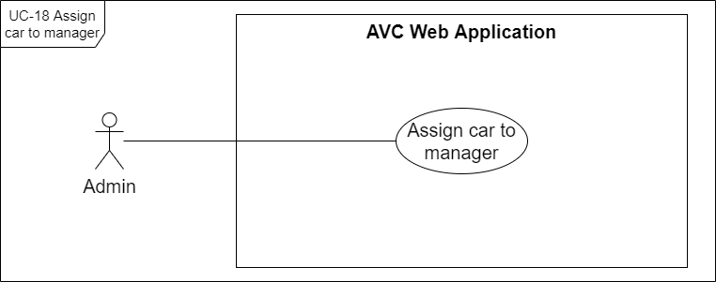

[Figure 27 . <Admin> UC-18 Assign car to manager](https://drive.google.com/file/d/1_VV4abB5vABecVB-DQSbJZcsCUFaQyXw/view?usp=sharing)

|  |  |  |  |
| --- | --- | --- | --- |
| ID and Name: | **UC-18 Assign car to manager** | | |
| Created By: | SangNV | Date Created: | 29/05/2021 |
| Primary Actor: | Admin | Secondary Actors: | N/A |
| Description: | Admin can assign a car to any manager in the system so that the manager can directly manage, monitor, or assign cars to any staff that they manage. | | |
| Trigger: | The admin wants to assign a car to a manager existing in the system. | | |
| Pre-conditions: | PRE-01. The actor had been authorized as an admin.  PRE-02. The actor is continuous with UC-11 View car detail. | | |
| Post-conditions: | POST-01. Car is assigned to a manager. | | |
| Normal Flow: | **18.0 Assign car to manager when update car** 1. The admin presses on the edit icon on the "Car Detail" box.  2. The system displays the "Update Car" form with following items:  - Car image uploader  - “Device ID” label  - “Name” text field  - “Managed by” drop down  - “Save” button  - “Discard” button  3. The admin performs editing “Managed by” drop down.  4. The admin presses the "Save" button.  5. The system displays an updated car success message (MSG19). | | |
| Alternative Flows: | **18.1 Assign car to manager when register new car**  - The admin implements the use case through the UC-09 Register new car. **18.2 Remove assigned manager**  1a. The admin selects an assigned car and presses on the "Edit" icon.  1a1. The system displays the "Update Car" form with a "Managed by" dropdown field.  1a2. The admin presses on the "x" icon on the "Managed by" field.  Continuous with step 4 of normal flow.  **18.3 Discard change**  4b. The admin presses the "Discard" button.  4b1. The system closes the "Update Car" form and gets back to the “Car Detail” box, then terminates the use case. | | |
| Exceptions: | **18.0.E1 Network disconnected** (MSG15) | | |
| Priority: | High | | |
| Frequency of Use: | Every time an admin wants to assign a car to a manager exists in the system. | | |
| Business Rules: | BR-24, BR-25, BR-26 | | |
| Other Information: | N/A | | |
| Assumptions: | The admin has logged in to the AVC system. | | |

#### m. UC-19 Deactivate staff

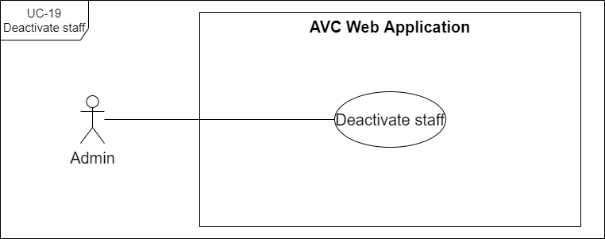

[Figure 28 . <Admin> UC-19 Deactivate staff](https://drive.google.com/file/d/1yXZHdgl4T57Pz_pA4n-ih7uhDTVEGMaL/view?usp=sharing)

|  |  |  |  |
| --- | --- | --- | --- |
| ID and Name: | **UC-19 Deactivate staff** | | |
| Created By: | HoaNT | Date Created: | 29/05/2021 |
| Primary Actor: | Admin | Secondary Actors: | N/A |
| Description: | The admin can deactivate a staff member in case that the staff member quits or is temporarily suspended. | | |
| Trigger: | The admin wants to deactivate a staff member. | | |
| Pre-conditions: | PRE-01. The actor had been authorized as an admin. PRE-02. The selected staff has the status of "Active". | | |
| Post-conditions: | POST-01. Status of selected staff on "Manage Staffs" table and staff detail to "Inactive". | | |
| Normal Flow: | **19.0 Deactivate staff**  1. The admin selects the "Manage Staffs" item in the side navigation menu.  2. The system redirects admin to the "Manage Staffs" screen.  3. The admin selects a staff whose status is "Active".  4. The system displays the staff detail box on the screen.  5. The admin presses on the "Deactivate" button on the staff detail.  6. The system displays a "Deactivate staff" dialog.  7. The admin presses on the "Deactivate" button on "Deactivate staff" dialog.  8. The system changes the status of the car on the "Manage Staffs" table and car detail to "Inactive". | | |
| Alternative Flows: | **19.1 Cancel deactivate staff**  7a. The admin presses on the "Cancel" button on the "Deactivate staff" dialog.  7a1. The system closes the "Deactivate staff" dialog and terminates the use case. | | |
| Exceptions: | **19.0.E1 Network disconnected** (MSG15) | | |
| Priority: | Medium | | |
| Frequency of Use: | Each time the admin wants to deactivate a staff. | | |
| Business Rules: | BR-80 | | |
| Other Information: | N/A | | |
| Assumptions: | The admin has logged in to the AVC system. | | |

#### n. UC-20 Reactivate staff

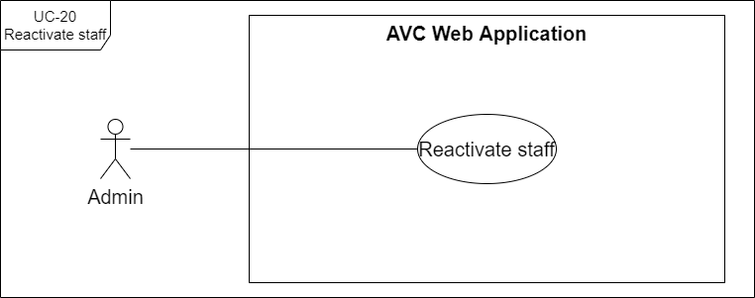

[Figure 29 . <Admin> UC-20 Reactivate staff](https://drive.google.com/file/d/1lk39OPiG7CirLmWwJzCZDRHylTExrrRT/view?usp=sharing)

|  |  |  |  |
| --- | --- | --- | --- |
| ID and Name: | **UC-20 Reactivate staff** | | |
| Created By: | HoaNT | Date Created: | 29/05/2021 |
| Primary Actor: | Admin | Secondary Actors: | N/A |
| Description: | The administrator can reactivate an employee in case that the employee returns or the suspension expires. | | |
| Trigger: | The admin wants to reactivate the staff. | | |
| Pre-conditions: | PRE-01. The actor had been authorized as an admin. PRE-02. The selected staff has the status of "Inactive". | | |
| Post-conditions: | POST-01. Status of selected staff on "Manage Staffs" table and staff detail to "Active". | | |
| Normal Flow: | **20.0 Reactivate staff**  1. The admin selects the "Manage Staffs" item in the side navigation menu.  2. The system redirects admin to the "Manage Staffs" screen.  3. The admin selects a staff whose status is "Inactive".  4. The system displays the staff detail box on the screen.  5. The admin presses on the "Reactivate" button on the staff detail.  6. The system displays a "Activate staff" dialog.  7. The admin presses on the "Activate" button on "Activate staff" dialog.  8. The system changes the status of the car on the "Manage Staffs" table and car detail to "Active". | | |
| Alternative Flows: | **20.1 Cancel reactivate staff**  7a. The admin presses on the "Cancel" button on the "Activate staff" dialog.  7a1. The system closes the "Activate staff" dialog and terminates the use case. | | |
| Exceptions: | **20.0.E1 Network disconnected** (MSG15) | | |
| Priority: | Medium | | |
| Frequency of Use: | Each time the admin wants to reactivate a staff member. | | |
| Business Rules: | N/A | | |
| Other Information: | N/A | | |
| Assumptions: | The admin has logged in to the AVC system. | | |

#### o. UC-21 Create new staff

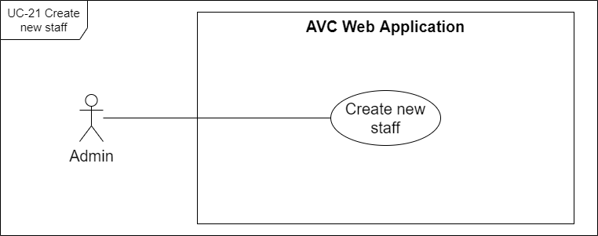

[Figure 30 . <Admin> UC-21 Create new staff](https://drive.google.com/file/d/19AnNzcDpvtQfpHGmwP3SwkXJh5h9HZyl/view?usp=sharing)

|  |  |  |  |
| --- | --- | --- | --- |
| ID and Name: | **UC-21 Create new staff** | | |
| Created By: | HoaNT | Date Created: | 29/05/2021 |
| Primary Actor: | Admin | Secondary Actors: | N/A |
| Description: | The admin can create new staff accounts on the AVC system and manage them. | | |
| Trigger: | The admin wants to create a new staff. | | |
| Pre-conditions: | PRE-01. The actor had been authorized as an admin. | | |
| Post-conditions: | POST-01. A new staff has been created on the AVC system in "Active" status. | | |
| Normal Flow: | **21.0 Create new staff**  1. The admin selects the "Manage Staffs" item in the side navigation menu.  2. The system redirects admin to the "Manage Staffs" screen.  3. The admin presses the "Create new" button.  4. The system displays the "Create Staff" form with following items:  - “Avatar” image uploader  - “First name” text field  - “Last name” text field  - “Email” text field  - “Phone” text field  - “Managed by” drop down  - “Create” button  - “x” close icon  5. The admin enters all the required fields.  6. The admin presses the "Create" button. (see 21.0.E2)  7. The system displays a create staff success message (MSG20). | | |
| Alternative Flows: | **21.1 Cancel create**  6a. The admin presses the "x" close icon.  6a1. The system displays the “Unsaved Changes” dialog with:  - “Discard Changes” button  - “Keep me here” button  6a2. The admin presses the “Discard Changes” button.  6a3. The system closes the "Create Staff" form and terminates the use case.  6b2. The admin presses the “Keep me here” button.  6b3. The system gets back to the "Create Staff" form and continues on step 6 of normal flow. | | |
| Exceptions: | **21.0.E1 Network disconnected** (MSG15) **21.0.E2 Email is duplicated with email in the system**  1. AVC system informs the actor that fails to create a new staff (MSG56).  2a. If the actor enters again the required fields, return to step 5 of normal flow.  2b. Else if the actor cancels the create staff process, then AVC terminates use case. | | |
| Priority: | High | | |
| Frequency of Use: | Every time the admin wants to create a new staff. | | |
| Business Rules: | BR-34, BR-35, BR-36, BR-83 | | |
| Other Information: | When the required fields are blank, the "Create" button will be disabled. | | |
| Assumptions: | The admin has logged in to the AVC system. | | |

#### p. UC-22 Update staff

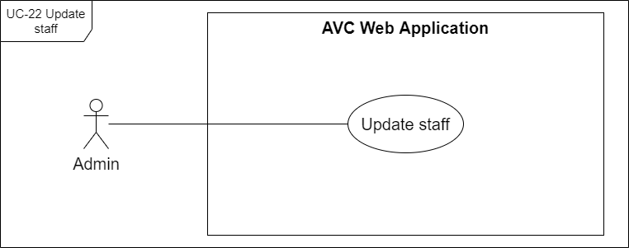

[Figure 31 . <Admin> UC-22 Update staff](https://drive.google.com/file/d/1ZhKIbdYlL7IjkphOXxSd9GaVFUQCaOGA/view?usp=sharing)

|  |  |  |  |
| --- | --- | --- | --- |
| ID and Name: | **UC-22 Update staff** | | |
| Created By: | HoaNT | Date Created: | 29/05/2021 |
| Primary Actor: | Admin | Secondary Actors: | N/A |
| Description: | The admin can update information of staff in needed cases. | | |
| Trigger: | The admin wants to change staff information. | | |
| Pre-conditions: | PRE-01. The actor had been authorized as an admin. PRE-02. The actor is continuous with UC-24 View staff detail. | | |
| Post-conditions: | POST-01. staff information detail updated successfully. | | |
| Normal Flow: | **22.0 Update staff**  1. The admin presses on the edit icon on the "Staff Detail" box.  2. The system displays the "Update Staff" form with following information items:  - “First name” text field  - “Last name” text field  - “Phone” text field  - “System Role” drop down  - “Managed by” drop down  - “Save” button  - “Discard” button  3. The admin performs editing the information of staff.  4. The admin presses the "Save" button.  5. The system displays an updated staff success message (MSG19). | | |
| Alternative Flows: | **22.1 Cancel update staff information**  4a. The admin presses the "Discard" button.  4a1. The system closes the "Update Staff" form then terminates the use case. | | |
| Exceptions: | **22.0.E1 Network disconnected** (MSG15) | | |
| Priority: | High | | |
| Frequency of Use: | Every time the admin wants to change staff information. | | |
| Business Rules: | BR-84 | | |
| Other Information: | When the required fields are blank, the "Save" button will be disabled. | | |
| Assumptions: | The admin has logged in to the AVC system. | | |

#### q. UC-23 View staffs

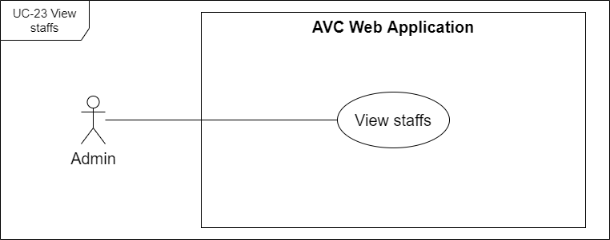

[Figure 32 . <Admin> UC-23 View staffs](https://drive.google.com/file/d/1Vw_wXCDcqniUQRwfnQqe_8-AqZ-70wHC/view?usp=sharing)

|  |  |  |  |
| --- | --- | --- | --- |
| ID and Name: | **UC-23 View staffs** | | |
| Created By: | HoaNT | Date Created: | 29/05/2021 |
| Primary Actor: | Admin | Secondary Actors: | N/A |
| Description: | Admin is the one who can see all the staff in the system. | | |
| Trigger: | Admin wants to see staff exist in the system. | | |
| Pre-conditions: | PRE-01. The actor had been authorized as an admin. | | |
| Post-conditions: | POST-01. All staff are displayed on the screen. | | |
| Normal Flow: | **23.0 View staffs**  1. The admin selects the "Manage Staffs" item in the side navigation menu.  2. The system redirects admin to "Manage Staffs" screen with all staffs (see 23.0.E1). | | |
| Alternative Flows: | N/A | | |
| Exceptions: | **23.0.E1 No staff result exist in the system** (MSG18) **23.0.E2 Network disconnected** (MSG15) | | |
| Priority: | High | | |
| Frequency of Use: | Every time the admin wants to see staff exist in the system. | | |
| Business Rules: | BR-37, BR-39 | | |
| Other Information: | N/A | | |
| Assumptions: | The admin has logged in to the AVC system. | | |

#### r. UC-24 View staff detail

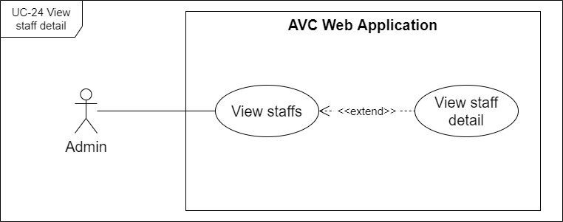

[Figure 33 . <Admin> UC-24 View staff detail](https://drive.google.com/file/d/1oyT7dLqAiwcCHYw1PTm7cH_zqZ4UsQdS/view?usp=sharing)

|  |  |  |  |
| --- | --- | --- | --- |
| ID and Name: | **UC-24 View staff detail** | | |
| Created By: | HoaNT | Date Created: | 29/05/2021 |
| Primary Actor: | Admin | Secondary Actors: | N/A |
| Description: | The admin can view staff details, through which they can know more information about the staff, in addition, the admin can assign the staff to the manager. | | |
| Trigger: | The admin wants to see staff details. | | |
| Pre-conditions: | PRE-01. The actor had been authorized as an admin. | | |
| Post-conditions: | POST-01. Detail of staff is displayed on the screen. | | |
| Normal Flow: | **24.0 View staff detail**  1. The admin selects the "Manage Staffs" item in the side navigation menu.  2. The system redirects admin to "Manage Staffs" screen with all staff.  3. The admin selects a staff member on the "Manage Staffs" table.  4. The system displays a "Staff Detail" box on the screen.  5. The admin presses on the "Expand" link/icon on the "Staff Detail" box.  6. The system redirects admin to "Staff Detail" screen. | | |
| Alternative Flows: | N/A | | |
| Exceptions: | **24.0.E1 Network disconnected** (MSG15) | | |
| Priority: | High | | |
| Frequency of Use: | Every time the admin wants to see staff details. | | |
| Business Rules: | BR-40 | | |
| Other Information: | N/A | | |
| Assumptions: | The admin has logged in to the AVC system.  Exist staff on the system. | | |

#### s. UC-25 Assign staff to manager

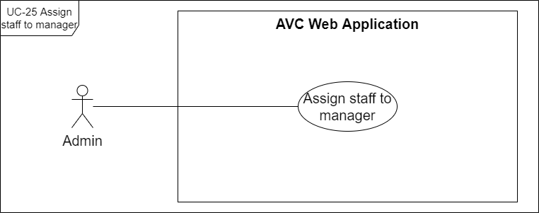

[Figure 34 . <Admin> UC-25 Assign staff to manager](https://drive.google.com/file/d/1Msb39YKQ33Jaq-HAs7KXwFz_SkPcy0vP/view?usp=sharing)

|  |  |  |  |
| --- | --- | --- | --- |
| ID and Name: | **UC-25 Assign staff to manager** | | |
| Created By: | HoaNT | Date Created: | 29/05/2021 |
| Primary Actor: | Admin | Secondary Actors: | N/A |
| Description: | Admin can assign a staff to any manager in the system so that the manager can directly assign cars to any staff that they manage. | | |
| Trigger: | The admin wants to assign a staff member to a manager existing in the system. | | |
| Pre-conditions: | PRE-01. The actor had been authorized as an admin. | | |
| Post-conditions: | POST-01. staff is assigned to a manager. | | |
| Normal Flow: | **25.0 Assign staff to manager when update staff**  1. The admin presses on the edit icon on the "Staff Detail" box.  2. The system displays the "Update Staff" form with following information items:  - “First name” text field  - “Last name” text field  - “Phone” text field  - “System Role” drop down  - “Managed by” drop down  - “Save” button  - “Discard” button  3. The admin performs editing the”Managed by” drop down.  4. The admin presses the "Save" button.  5. The system displays an updated staff success message (MSG19). | | |
| Alternative Flows: | **25.1 Assign staff to manager when create new staff**  The admin implements the use case through UC-21 Create new staff. **25.2 Remove assigned manager**  1a. The admin selects an assigned car and presses on the "Edit" icon.  1a1. The system displays the "Update Car" form with a "Managed by" dropdown field.  1a2. The admin presses on the "x" icon on the "Managed by" field.  Continuous with step 4 of normal flow.  **25.3 Discard change**  4b. The admin presses the "Discard" button.  4b1. The system closes the "Update Staff" form and gets back to the “Staff Detail” box, then terminates the use case. | | |
| Exceptions: | **25.0.E1 Network disconnected** (MSG15) | | |
| Priority: | High | | |
| Frequency of Use: | Every time an admin wants to assign a staff to a manager exists in the system. | | |
| Business Rules: | BR-41 | | |
| Other Information: | N/A | | |
| Assumptions: | The admin has logged in to the AVC system. | | |

#### t. UC-26 Deactivate manager

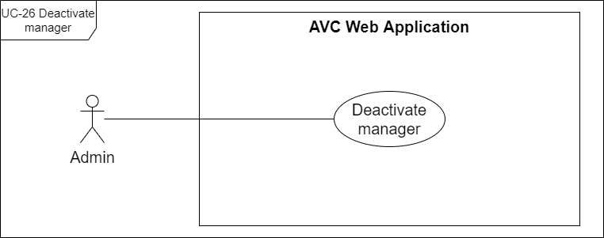

[Figure 35 . <Admin> UC-26 Deactivate manager](https://drive.google.com/file/d/1Uv-FZkErqUPNbphvAivq_WyQY5LTlAbs/view?usp=sharing)

|  |  |  |  |
| --- | --- | --- | --- |
| ID and Name: | **UC-26 Deactivate manager** | | |
| Created By: | HuyTM | Date Created: | 29/05/2021 |
| Primary Actor: | Admin | Secondary Actors: | N/A |
| Description: | The admin can deactivate a manager member in case that the manager member quits or is temporarily suspended. | | |
| Trigger: | The admin wants to deactivate a manager. | | |
| Pre-conditions: | PRE-01. The actor had been authorized as an admin. PRE-02. The selected manager has the status of "Active". | | |
| Post-conditions: | POST-01. Status of selected manager on "Manage Managers" table and manager detail to "Inactive". | | |
| Normal Flow: | **26.0 Deactivate manager**  1. The admin selects the "Manage Managers" item in the side navigation menu.  2. The system redirects admin to "Manage Managers" screen.  3. The admin selects a manager whose status is "Active".  4. The system displays the manager detail box on the screen.  5. The admin presses on the "Deactivate" button on the manager detail.  6. The system displays a "Deactivate manager" dialog.  7. The admin presses on the "Deactivate" button on "Deactivate manager" dialog.  8. The system changes the status of the car on the "Manage managers" table and car detail to "Inactive". | | |
| Alternative Flows: | **26.1 Cancel deactivate staff**  7a. The admin presses on the "Cancel" button on the "Deactivate manager" dialog.  7a1. The system closes the "Deactivate manager" dialog and terminates the use case. | | |
| Exceptions: | **26.0.E1 Network disconnected** (MSG15) | | |
| Priority: | Medium | | |
| Frequency of Use: | Each time the admin wants to deactivate a manager. | | |
| Business Rules: | BR-81 | | |
| Other Information: | N/A | | |
| Assumptions: | The admin has logged in to the AVC system. | | |

#### u. UC-27 Reactivate manager

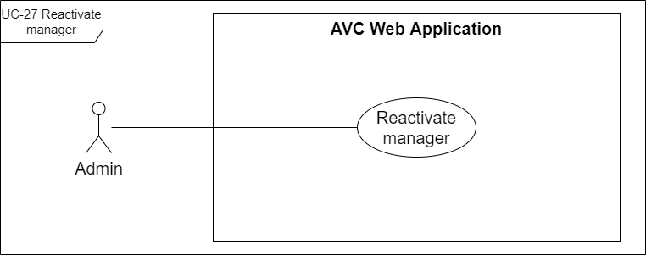

[Figure 36 . <Admin> UC-27 Reactivate manager](https://drive.google.com/file/d/1UeVvCENhC0urCsKm_fftP4wWFG5hXePD/view?usp=sharing)

|  |  |  |  |
| --- | --- | --- | --- |
| ID and Name: | **UC-27 Reactivate manager** | | |
| Created By: | HuyTM | Date Created: | 29/05/2021 |
| Primary Actor: | Admin | Secondary Actors: | N/A |
| Description: | The administrator can reactivate an employee in case that the employee returns or the suspension expires. | | |
| Trigger: | The admin wants to reactivate a manager. | | |
| Pre-conditions: | PRE-01. The actor had been authorized as an admin. PRE-02. The selected manager has the status of "Inactive". | | |
| Post-conditions: | POST-01. Status of selected manager on "Manage managers" table and manager detail to "Active". | | |
| Normal Flow: | **27.0 Reactivate manager**  1. The admin selects the "Manage Managers" item in the side navigation menu.  2. The system redirects admin to "Manage Managers" screen.  3. The admin selects a manager whose status is "Inactive".  4. The system displays the manager detail box on the screen.  5. The admin presses on the "Reactivate" button on the manager detail.  6. The system displays a "Activate Manager" dialog.  7. The admin presses on the "Activate" button on the "Activate Manager" dialog.  8. The system changes the status of the car on the "Manage Managers" table and car detail to "Active". | | |
| Alternative Flows: | **27.1 Cancel reactivate staff**  7a. The admin presses on the "Cancel" button on the "Activate manager" dialog.  7a1. The system closes the "Activate manager" dialog and terminates the use case. | | |
| Exceptions: | **27.0.E1 Network disconnected** (MSG15) | | |
| Priority: | Medium | | |
| Frequency of Use: | Each time the admin wants to reactivate a manager. | | |
| Business Rules: | N/A | | |
| Other Information: | N/A | | |
| Assumptions: | The admin has logged in to the AVC system. | | |

#### v. UC-28 Create new manager

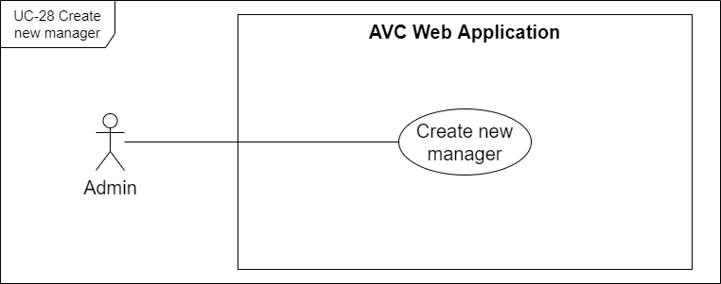

[Figure 37 . <Admin> UC-28 Create new manager](https://drive.google.com/file/d/1syzci1EJ7meU7_2Uz9LSDzbUHNQrW2V6/view?usp=sharing)

|  |  |  |  |
| --- | --- | --- | --- |
| ID and Name: | **UC-28 Create new manager** | | |
| Created By: | HuyTM | Date Created: | 29/05/2021 |
| Primary Actor: | Admin | Secondary Actors: | N/A |
| Description: | The admin can create new manager accounts on the AVC system and manage them. | | |
| Trigger: | The admin wants to create a new manager. | | |
| Pre-conditions: | PRE-01. The actor had been authorized as an admin. | | |
| Post-conditions: | POST-01. A new manager has been created on the AVC system in "Active" status. | | |
| Normal Flow: | **28.0 Create new manager**  1. The admin selects the "Manage Managers" item in the side navigation menu.  2. The system redirects admin to "Manage Managers" screen.  3. The admin presses the "Create new" button.  4. The system displays the "Create Manager" form with following items:  - “Avatar” image uploader  - “First name” text field  - “Last name” text field  - “Email” text field  - “Phone” text field  - “Create” button  - “x” close icon  5. The admin enters all the required fields.  6. The admin presses the "Create" button. (see 28.0.E2).  7. The system displays a create manager success message (MSG22). | | |
| Alternative Flows: | **28.1 Cancel create**  6a. The admin presses the "x" close icon.  6a1. The system displays the “Unsaved Changes” dialog with:  - “Discard Changes” button  - “Keep me here” button  6a2. The admin presses the “Discard Changes” button.  6a3. The system closes the "Create Staff" form and terminates the use case.  6b2. The admin presses the “Keep me here” button.  6b3. The system gets back to the "Create Staff" form and continues on step 6 of normal flow. | | |
| Exceptions: | **28.0.E1 Network disconnected** (MSG15) **28.0.E2 Email is duplicated with email in the system** 1. AVC system informs the actor that fails to create a new manager (MSG56).  2a. If the actor enters again the required fields, return to step 5 of normal flow.  2b. Else if the actor cancels the create manager process, then AVC terminates use case. | | |
| Priority: | High | | |
| Frequency of Use: | Every time the admin wants to create a new manager. | | |
| Business Rules: | BR-34, BR-35, BR-36, BR-85 | | |
| Other Information: | When the required fields are blank, the "Create" button will be disabled. | | |
| Assumptions: | The admin has logged in to the AVC system. | | |

#### w. UC-29 Update manager

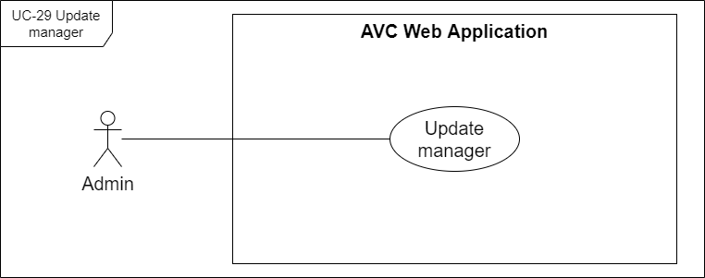

[Figure 38 . <Admin> UC-29 Update manager](https://drive.google.com/file/d/1zXMKSbsE70mdq-21kiQMvvniSgYZtvKJ/view?usp=sharing)

|  |  |  |  |
| --- | --- | --- | --- |
| ID and Name: | **UC-29 Update manager** | | |
| Created By: | HuyTM | Date Created: | 29/05/2021 |
| Primary Actor: | Admin | Secondary Actors: | N/A |
| Description: | The admin can update information of the manager in needed cases. | | |
| Trigger: | The admin wants to change manager information. | | |
| Pre-conditions: | PRE-01. The actor had been authorized as an admin. PRE-02. The actor is continuous with UC-31 View manager detail. | | |
| Post-conditions: | POST-01. manager information detail updated successfully. | | |
| Normal Flow: | **29.0 Update manager**  1. The admin presses on the edit icon on the "Manager Detail" box.  2. The system displays the "Update Manager" form with following information details:  - “First name” text field  - “Last name” text field  - “Phone” text field  - “System Role” drop down  - “Save” button  - “Discard” button  3. The admin performs editing information of the manager.  4. The admin presses the "Save" button.  5. The system displays an update manager success message (MSG27). | | |
| Alternative Flows: | **29.1 Discard change**  4a. The admin presses the "Discard" button.  4a1. The system closes the "Update Manager" form then terminates the use case. | | |
| Exceptions: | **29.0.E1 Network disconnected** (MSG15) | | |
| Priority: | High | | |
| Frequency of Use: | Every time the admin wants to change manager information. | | |
| Business Rules: | BR-86 | | |
| Other Information: | When the required fields are blank, the "Save" button will be disabled. | | |
| Assumptions: | The admin has logged in to the AVC system. | | |

#### x. UC-30 View managers

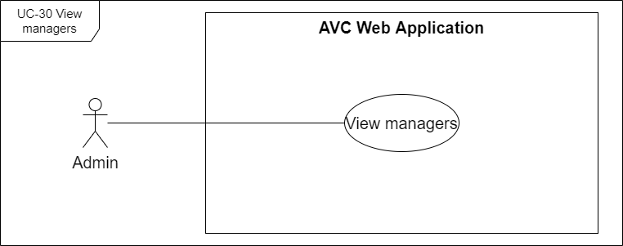

[Figure 39 . <Admin> UC-30 View managers](https://drive.google.com/file/d/1uGdq7wFxd7yJQ_yl-riskSloDw_qTmT5/view?usp=sharing)

|  |  |  |  |
| --- | --- | --- | --- |
| ID and Name: | **UC-30 View managers** | | |
| Created By: | HuyTM | Date Created: | 29/05/2021 |
| Primary Actor: | Admin | Secondary Actors: | N/A |
| Description: | Admin is the one who can see all the managers in the system. | | |
| Trigger: | Admin wants to see managers exist in the system. | | |
| Pre-conditions: | PRE-01. The actor had been authorized as an admin. | | |
| Post-conditions: | POST-01. All managers are displayed on the screen. | | |
| Normal Flow: | **30.0 View managers**  1. The admin selects the "Manage Managers" item in the side navigation menu.  2. The system redirects admin to "Manage Managers" screen with all managers (see 30.0.E1). | | |
| Alternative Flows: | N/A | | |
| Exceptions: | **30.0.E1 No manager result exist in the system** (MSG18) **30.0.E2 Network disconnected** (MSG15) | | |
| Priority: | High | | |
| Frequency of Use: | Every time an admin wants to see managers exist in the system. | | |
| Business Rules: | BR-42, BR-43 | | |
| Other Information: | N/A | | |
| Assumptions: | The admin has logged in to the AVC system. | | |

#### y. UC-31 View manager detail

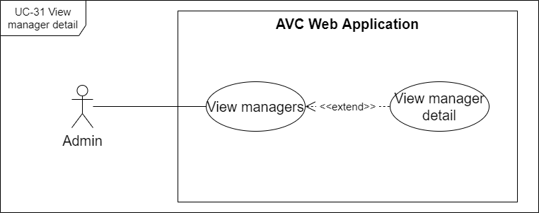

[Figure 40 . <Admin> UC-31 View manager detail](https://drive.google.com/file/d/1DjWajbbssGI3mjqooPPA1o6Djz5TOn2c/view?usp=sharing)

|  |  |  |  |
| --- | --- | --- | --- |
| ID and Name: | **UC-31 View manager detail** | | |
| Created By: | HuyTM | Date Created: | 29/05/2021 |
| Primary Actor: | Admin | Secondary Actors: | N/A |
| Description: | The admin can view manager details, through which they can know more information about the manager, in addition, the admin can assign staff to the manager. | | |
| Trigger: | The admin wants to see the manager in detail. | | |
| Pre-conditions: | PRE-01. The actor had been authorized as an admin. | | |
| Post-conditions: | POST-01. Details of the manager are displayed on the screen. | | |
| Normal Flow: | **31.0 View manager detail**  1. The admin selects the "Manage Managers" item in the side navigation menu.  2. The system redirects admin to "Manage Managers" screen with all managers.  3. The admin selects a manager on the "Manage Managers" table.  4. The system displays a "Manager Detail" box on the screen.  5. The admin presses on the "Expand" link/icon on the "Manager Detail" box.  6. The system redirects the admin to the "Manager Detail" screen. | | |
| Alternative Flows: | N/A | | |
| Exceptions: | **31.0.E1 Network disconnected** (MSG15) | | |
| Priority: | High | | |
| Frequency of Use: | Every time the admin wants to see the manager detail. | | |
| Business Rules: | BR-44 | | |
| Other Information: | N/A | | |
| Assumptions: | The admin has logged in to the AVC system. | | |

#### z. UC-32 Create training dataset

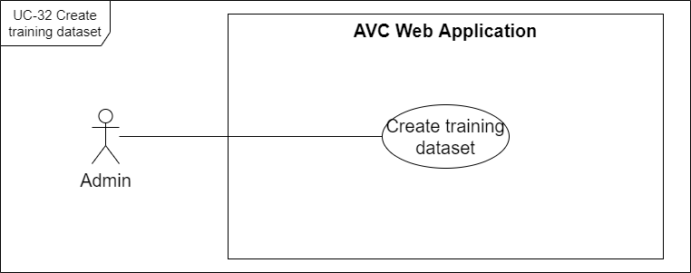

[Figure 41 . <Admin> UC-32 Create training dataset](https://drive.google.com/file/d/1QN_pqiNIe0rB5DadsMeLpsJVEvKnothH/view?usp=sharing)

|  |  |  |  |
| --- | --- | --- | --- |
| ID and Name: | **UC-32 Create training dataset** | | |
| Created By: | HuyTM | Date Created: | 29/05/2021 |
| Primary Actor: | Admin | Secondary Actors: | N/A |
| Description: | The admin can create datasets for training models including images and labels mark of those images. | | |
| Trigger: | The admin wants to create a dataset for retraining an applying trained model. | | |
| Pre-conditions: | PRE-01. The actor had been authorized as an admin. | | |
| Post-conditions: | POST-01. Dataset for training is prepared with images and labels and sent to the server. | | |
| Normal Flow: | **32.0 Create training dataset base on uploaded images**  1. The admin selects the "Train by images" item in the side navigation menu.  2. The system displays the "Train by images" screen.  3. The admin uploads images up to the max image count and size of the AVC system (see 32.1.E1, 32.1.E2, 32.0.E3).  4. The admin presses the "Label Images" button.  5. The system displays a "Label Images" screen.  6. The admin selects and adds labels for each image.  7. The admin presses the "Go train" button.  8. The system displays a successful message (MSG29). | | |
| Alternative Flows: | **32.1 Create training dataset base on uploaded zip file**  1a. The admin selects the "Train by ZIP" item in the side navigation menu.  2a. The system displays the "Train Model by ZIP" screen.  3a. The admin uploads a ZIP file up to the max file size required of the AVC system (see 32.1.E1, 32.1.E2).  Continuous to step 7 of normal flow. | | |
| Exceptions: | **32.0.E1 Image count reach max number** (MSG34) **32.0.E2 Image size is larger than the specified maximum size** (MSG31) **32.0.E3 Duplicate image** (MSG30) **32.0.E4 Network disconnected** (MSG15) **32.1.E1 ZIP file size is larger than the specified maximum size** (MSG33) **32.1.E2 The compressed structure inside the ZIP file is in the wrong format compared to the specified structure** (MSG32) | | |
| Priority: | High | | |
| Frequency of Use: | Every time the admin wants to create a dataset for retraining an applying trained model. | | |
| Business Rules: | BR-45, BR-47, BR-48, BR-51, BR-27 | | |
| Other Information: | N/A | | |
| Assumptions: | The admin has logged in to the AVC system. | | |

#### aa. UC-33 Apply training model

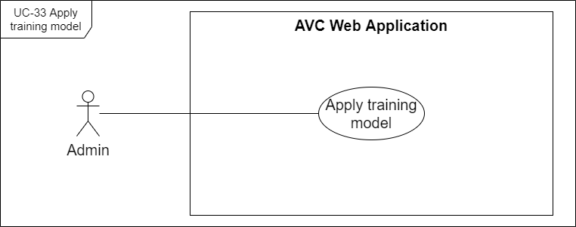

[Figure 42 . <Admin> UC-33 Apply training model](https://drive.google.com/file/d/1lbxFfjgWQJ8pLMEFh3YrCkpjPDDTrDHW/view?usp=sharing)

|  |  |  |  |
| --- | --- | --- | --- |
| ID and Name: | **UC-33 Apply training model** | | |
| Created By: | HuyTM | Date Created: | 29/05/2021 |
| Primary Actor: | Amin | Secondary Actors: | N/A |
| Description: | Admin can apply models from the training history for all cars on the AVC system. | | |
| Trigger: | The admin wants to apply another model for cars on the system. | | |
| Pre-conditions: | PRE-01. The actor had been authorized as an admin. | | |
| Post-conditions: | POST-01. New selected model has been applied for all car on the system. | | |
| Normal Flow: | **33.0 Apply training model**  1. The admin selects the "History" item in the side navigation menu.  2. The system displays the "Training History" screen with list details about trained models.  3. The admin selects a model on the "Training History" screen with status "Success".  4. The admin presses the "Apply model" button.  5. The system displays an applied model success message (MSG55). | | |
| Alternative Flows: | N/A | | |
| Exceptions: | **33.0.E1 Network disconnected** (MSG15) | | |
| Priority: | High | | |
| Frequency of Use: | Every time the admin wants to apply another model for the car. | | |
| Business Rules: | BR-50, BR-55, BR-56, BR-57 | | |
| Other Information: | N/A | | |
| Assumptions: | The admin has logged in to the AVC system. | | |

#### ab. UC-34 View training history

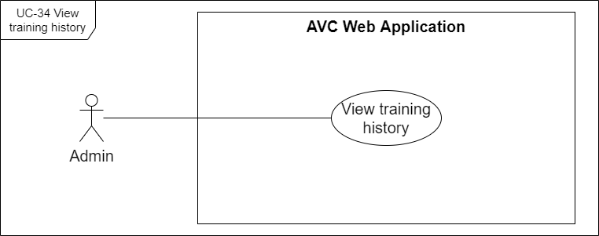

[Figure 43 . <Admin> UC-34 View training history](https://drive.google.com/file/d/1smQ3w3lT3YZ7UrJI5VzjMKBvgdvHJ6S2/view?usp=sharing)

|  |  |  |  |
| --- | --- | --- | --- |
| ID and Name: | **UC-34 View training history** | | |
| Created By: | HuyTM | Date Created: | 29/05/2021 |
| Primary Actor: | Admin | Secondary Actors: | N/A |
| Description: | Admin can view all the models on training history for choosing and applying models or view the analysis result of the model. | | |
| Trigger: | The admin wants to view the training history of the model on the system for choosing a model to apply on the system. | | |
| Pre-conditions: | PRE-01. The actor had been authorized as an admin. | | |
| Post-conditions: | POST-01. All trained models with any status have been displayed on the screen. | | |
| Normal Flow: | **UC-34 View training history**  1. The admin selects the "History" item in the side navigation menu.  2. The system displays the "Training History" screen with list details about trained models.  3. The admin selects a record train model on the "Training History" screen.  4. The system displays the “Model Detail” box detail of the model. | | |
| Alternative Flows: | N/A | | |
| Exceptions: | **34.0.E1 Network disconnected** (MSG15) | | |
| Priority: | High | | |
| Frequency of Use: | Every time the admin wants to view the training history of the model on the system for choosing a model to apply on the system. | | |
| Business Rules: | BR-49, BR-59 | | |
| Other Information: | N/A | | |
| Assumptions: | The admin has logged in to the AVC system. | | |

#### ac. UC-35 View analysis result

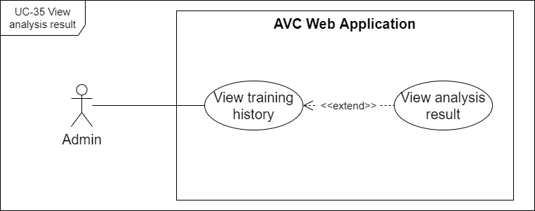

[Figure 44 . <Admin> UC-35 View analysis result](https://drive.google.com/file/d/16CckFeeItwqEHDoHcjj75RUkPvD_onRh/view?usp=sharing)

|  |  |  |  |
| --- | --- | --- | --- |
| ID and Name: | **UC-35 View analysis result** | | |
| Created By: | HuyTM | Date Created: | 29/05/2021 |
| Primary Actor: | Admin | Secondary Actors: | N/A |
| Description: | Admin can view the analysis result of trained models with training status as "Succeeded". | | |
| Trigger: | Admin wants to view the analysis result of a successful trained model. | | |
| Pre-conditions: | PRE-01. The actor had been authorized as an admin. PRE-02. The actor is continuous with UC-34 View training history | | |
| Post-conditions: | POST-01. The analysis result of the model has been displayed on the screen. | | |
| Normal Flow: | **35.0 View analysis result based on statistic**  1. The admin selects the "History" item in the side navigation menu.  2. The system displays the "Training History" screen with list details about trained models.  3. The admin selects a successful trained model on the "Training History" screen.  4. The admin presses the "Click to view statistic" link button.  5. The system displays the "Statistic" popup screen. | | |
| Alternative Flows: | **35.1 View analysis result based on training logs**  4a. The admin presses the "Click to open" link button of the “Training Logs” field.  4a1. The system displays the "Training Logs" popup screen. | | |
| Exceptions: | **35.0.E1 Network disconnected** (MSG15) | | |
| Priority: | Medium | | |
| Frequency of Use: | Each time the admin wants to view the analysis result of a successful trained model. | | |
| Business Rules: | BR-60, BR-61 | | |
| Other Information: | N/A | | |
| Assumptions: | The admin has logged in to the AVC system. | | |

### 2.5. Web Application <Manager>

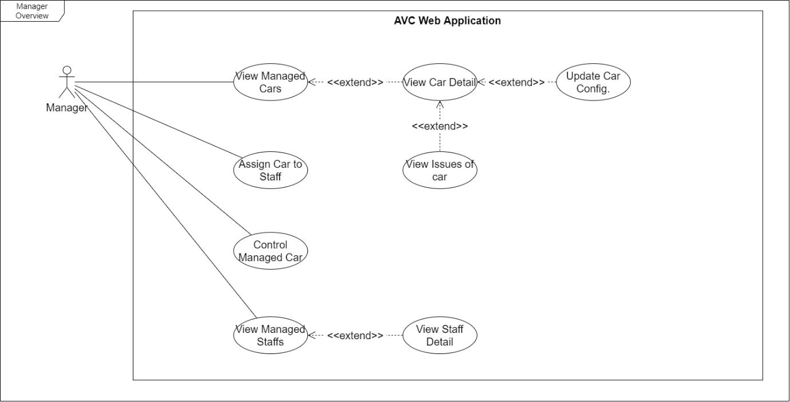

[Figure 45. <Manager> Overview Use Case Diagram](https://drive.google.com/file/d/170blDK8DKN5U_ZNso7wWPqJpgNsXCz18/view?usp=sharing)

#### a. UC-36 View managed cars

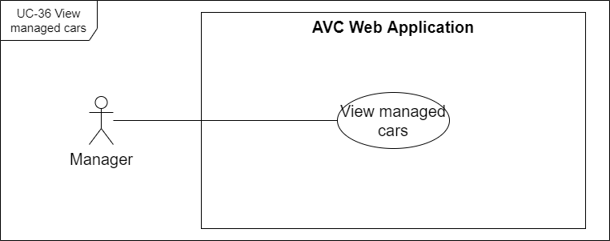

[Figure 46 . <Manager> UC-36 View managed cars](https://drive.google.com/file/d/1iakCjGi8ERfcRqkhP8pYGhfwa9QfNFwn/view?usp=sharing)

|  |  |  |  |
| --- | --- | --- | --- |
| ID and Name: | **UC-36 View managed cars** | | |
| Created By: | HoaNT | Date Created: | 30/05/2021 |
| Primary Actor: | Manager | Secondary Actors: | N/A |
| Description: | Manager can see all the managed cars in the system. | | |
| Trigger: | Manager wants to see managed cars exist. | | |
| Pre-conditions: | PRE-01. The actor had been authorized as a manager. | | |
| Post-conditions: | POST-01. All cars are displayed on the screen. | | |
| Normal Flow: | **36.0 View cars**  1. The manager selects the "Manage Cars" item in the side navigation menu.  2. The system redirects the manager to the "Manage Cars" screen with all managed cars (see 36.0.E1). | | |
| Alternative Flows: | N/A | | |
| Exceptions: | **36.0.E1 No car result exist in the system** (MSG18) **36.0.E2 Network disconnected** (MSG15) | | |
| Priority: | High | | |
| Frequency of Use: | Every time a manager wants to see cars exist in the system. | | |
| Business Rules: | BR-15, BR-17 | | |
| Other Information: | N/A | | |
| Assumptions: | The manager has logged in to the AVC system. | | |

#### b. UC-37 View car detail

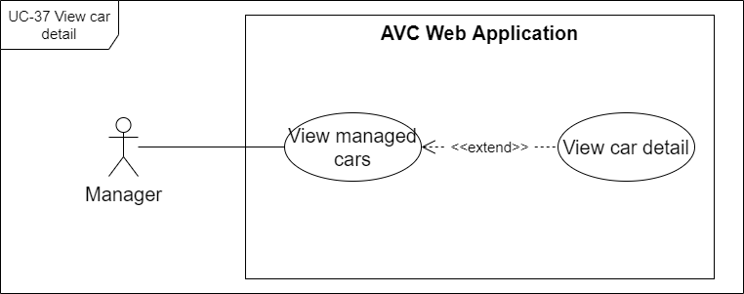

[Figure 47 . <Manager> UC-37 View car detail](https://drive.google.com/file/d/1h2GimyeB8V236m1qNX9docAwJlVbeKK3/view?usp=sharing)

|  |  |  |  |
| --- | --- | --- | --- |
| ID and Name: | **UC-37 View car detail** | | |
| Created By: | HoaNT | Date Created: | 30/05/2021 |
| Primary Actor: | Manager | Secondary Actors: | N/A |
| Description: | The manager can view car details, through which they can know more information about the car, its configuration, in addition, the manager can assign the car to the staff or edit the car configuration. | | |
| Trigger: | The manager wants to see car details. | | |
| Pre-conditions: | PRE-01. The actor had been authorized as a manager. | | |
| Post-conditions: | POST-01. Details of the car are displayed on the screen. | | |
| Normal Flow: | **37.0 View car detail**  1. The manager selects the "Manage Cars" item in the side navigation menu.  2. The system redirects the manager to the "Manage Cars" screen with all managed cars.  3. The manager selects a car on the "Manage Cars" table.  4. The system displays a "Car Detail" box on the screen.  5. The manager presses on the "Expand" link/icon on the "Car Detail" box.  6. The system redirects the manager to the "Car Detail" screen. | | |
| Alternative Flows: | N/A | | |
| Exceptions: | **37.0.E1 Network disconnected** (MSG15) | | |
| Priority: | High | | |
| Frequency of Use: | Every time the manager wants to see car details. | | |
| Business Rules: | BR-18 | | |
| Other Information: | N/A | | |
| Assumptions: | The manager has logged in to the AVC system. | | |

#### c. UC-38 View issues of car

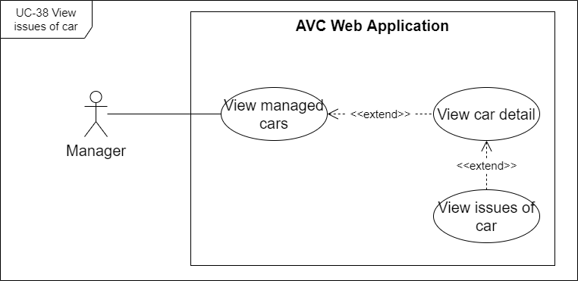

[Figure 48 . <Manager> UC-38 View issues of car](https://drive.google.com/file/d/1ut-xn-YXdNoaQs7Vr8YcDwfIyaOvSZw-/view?usp=sharing)

|  |  |  |  |
| --- | --- | --- | --- |
| ID and Name: | **UC-38 View issues of car** | | |
| Created By: | HoaNT | Date Created: | 30/05/2021 |
| Primary Actor: | Manager | Secondary Actors: | N/A |
| Description: | The manager can view issues for any of the cars on the list to track and correct car problems. | | |
| Trigger: | The manager wants to view issues of a car. | | |
| Pre-conditions: | PRE-01. The actor had been authorized as a manager. PRE-02. The actor is continuous with the UC-37 View car detail. | | |
| Post-conditions: | POST-01. Issues of cars are displayed on the screen. | | |
| Normal Flow: | **38.0 View issues of car**  1. The manager presses on the "Expand" link/icon on the "Car Detail" box.  2. The system redirects the manager to the "Car Detail" screen.  3. Issues of the car are displayed on the "Car Detail" screen. | | |
| Alternative Flows: | N/A | | |
| Exceptions: | **38.0.E1 Network disconnected** (MSG15) | | |
| Priority: | High | | |
| Frequency of Use: | Every time a manager wants to view issues of a car. | | |
| Business Rules: | N/A | | |
| Other Information: | N/A | | |
| Assumptions: | The manager has logged in to the AVC system. | | |

#### d. UC-39 View issue detail

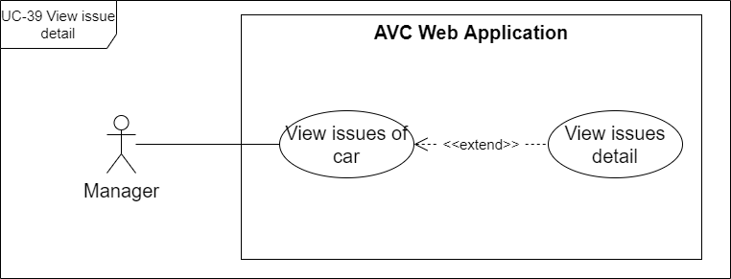

[Figure 49 . <Manager> UC-39 View issue detail](https://drive.google.com/file/d/18pj-8kdSQg0K2m1G4TIcXnOEDbIsEVH1/view?usp=sharing)

|  |  |  |  |
| --- | --- | --- | --- |
| ID and Name: | **UC-39 View issue detail** | | |
| Created By: | HoaNT | Date Created: | 30/05/2021 |
| Primary Actor: | Manager | Secondary Actors: | N/A |
| Description: | The manager can view details of all issues to track and correct car problems. | | |
| Trigger: | The manager wants to view the details of an issue. | | |
| Pre-conditions: | PRE-01. The actor had been authorized as a manager. PRE-02. The actor is continuous with UC-38 View issues of car. | | |
| Post-conditions: | POST-01. Details of issues are displayed on the screen. | | |
| Normal Flow: | **39.0 View issue detail on**  1. The manager selects an issue on the table if issues.  2. The system displays an "Issues Detail" box on the screen. | | |
| Alternative Flows: | N/A | | |
| Exceptions: | **39.0.E1 Network disconnected** (MSG15) | | |
| Priority: | High | | |
| Frequency of Use: | Every time the manager wants to view the details of an issue. | | |
| Business Rules: | BR-79 | | |
| Other Information: | N/A | | |
| Assumptions: | The manager has logged in to the AVC system. | | |

#### e. UC-40 Update car configuration

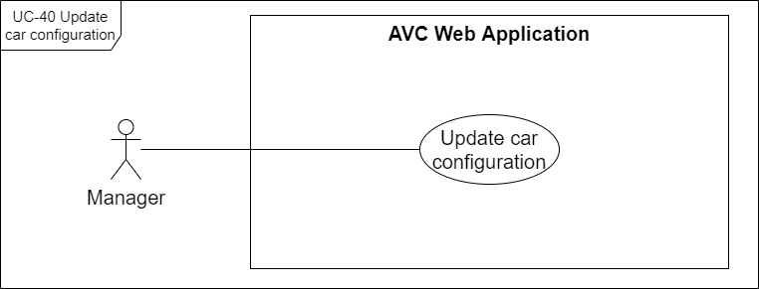

[Figure 50. <Manager> UC-40 Update car configuration](https://drive.google.com/file/d/1ESp5BbKwD6Iw6DJjMLTtE0LrHjQ9PYOn/view?usp=sharing)

|  |  |  |  |
| --- | --- | --- | --- |
| ID and Name: | **UC-40 Update car configuration** | | |
| Created By: | HoaNT | Date Created: | 30/05/2021 |
| Primary Actor: | Manager | Secondary Actors: | N/A |
| Description: | Manager can update the car's configuration from the initial default configuration to match the real car's parameters. | | |
| Trigger: | The manager wants to update a car's configuration. | | |
| Pre-conditions: | PRE-01. The actor had been authorized as a manager. PRE-02. The actor is continuous with UC-37 View car detail. | | |
| Post-conditions: | POST-01. Car's configuration has been updated successfully. | | |
| Normal Flow: | **40.0 Update car configuration**  1. The manager presses on the "Edit configuration" link button on car detail.  2. The system redirects the manager to the "Edit Car Configuration" screen with following items:  - Configuration JSON editor area.  - “Save” button  - “Discard” button  3. The manager edits the details on the configuration JSON editor area.  4. The manager presses the "Save" button.  5. The system displays update car configuration success message (MSG24) | | |
| Alternative Flows: | **40.1 Discard change**  4b. The manager presses the "Discard" button.  4b1. The system closes the "Edit Car Configuration" screen and gets back to the “Manage Cars” screen, then terminates the use case. | | |
| Exceptions: | **40.0.E1 Network disconnected** (MSG15) | | |
| Priority: | High | | |
| Frequency of Use: | Every time the manager wants to update a car's configuration. | | |
| Business Rules: | BR-32, BR-33 | | |
| Other Information: | N/A | | |
| Assumptions: | The manager has logged in to the AVC system. | | |

#### f. UC-41 View managed staffs

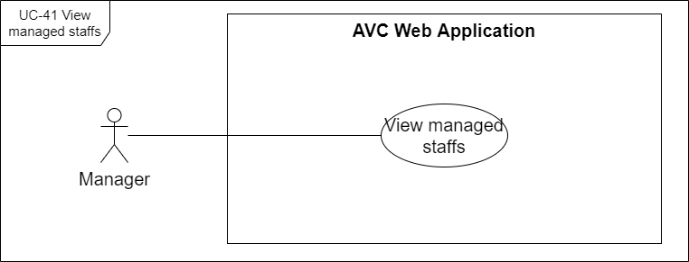

[Figure 51 . <Manager> UC-41 View managed staffs](https://drive.google.com/file/d/1d07Zpj3Z07ARyjxdfleM40bxx8z6I1_1/view?usp=sharing)

|  |  |  |  |
| --- | --- | --- | --- |
| ID and Name: | **UC-41 View managed staffs** | | |
| Created By: | HuyTM | Date Created: | 30/05/2021 |
| Primary Actor: | Manager | Secondary Actors: | N/A |
| Description: | The manager is the one who can see all the staff in the system. | | |
| Trigger: | The manager wants to see staff exist in the system. | | |
| Pre-conditions: | PRE-01. The actor had been authorized as a manager. | | |
| Post-conditions: | POST-01. All managed staff are displayed on the screen. | | |
| Normal Flow: | **41.0 View staffs**  1. The manager selects the "Manage Staffs" item in the side navigation menu.  2. The system redirects the manager to the "Manage Staffs" screen with all staffs (see 41.0.E1). | | |
| Alternative Flows: | N/A | | |
| Exceptions: | **41.0.E1 No staff result exist in the system** (MSG18) **41.0.E2 Network disconnected** (MSG15) | | |
| Priority: | High | | |
| Frequency of Use: | Every time a manager wants to see staff exist in the system. | | |
| Business Rules: | BR-38, BR-39 | | |
| Other Information: | N/A | | |
| Assumptions: | The manager has logged in to the AVC system. | | |

#### g. UC-42 View staff detail

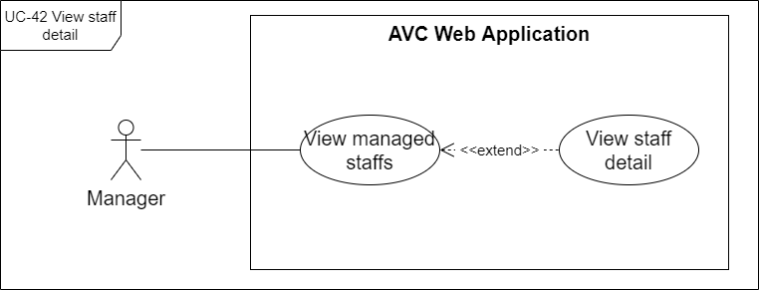

[Figure 52 . <Manager> UC-42 View staff detail](https://drive.google.com/file/d/1Q1A81PpGL8M8wx8akg4VYkyjzlRPlc0b/view?usp=sharing)

|  |  |  |  |
| --- | --- | --- | --- |
| ID and Name: | **UC-42 View staff detail** | | |
| Created By: | HuyTM | Date Created: | 30/05/2021 |
| Primary Actor: | Manager | Secondary Actors: | N/A |
| Description: | The manager can view staff details, through which they can know more information about the staff, in addition, the manager can assign the car to the staff. | | |
| Trigger: | The manager wants to see staff details. | | |
| Pre-conditions: | PRE-01. The actor had been authorized as a manager. | | |
| Post-conditions: | POST-01. Detail of staff is displayed on the screen. | | |
| Normal Flow: | **42.0 View staff detail**  1. The manager selects the "Manage Staffs" item in the side navigation menu.  2. The system redirects the manager to the "Manage Staffs" screen with all staffs  3. The manager selects the staff on the "Manage Staffs" table.  4. The system displays a "Staff Detail" box on the screen.  5. The manager presses on the "Expand" link/icon on the "Staff Detail" box.  6. The system redirects the manager to the "Staff Detail" screen. | | |
| Alternative Flows: | N/A | | |
| Exceptions: | **42.0.E1 Network disconnected** (MSG15) | | |
| Priority: | High | | |
| Frequency of Use: | Every time the manager wants to see the staff detail. | | |
| Business Rules: | BR-40 | | |
| Other Information: | N/A | | |
| Assumptions: | The manager has logged in to the AVC system. | | |

#### h. UC-43 Assign car to staff

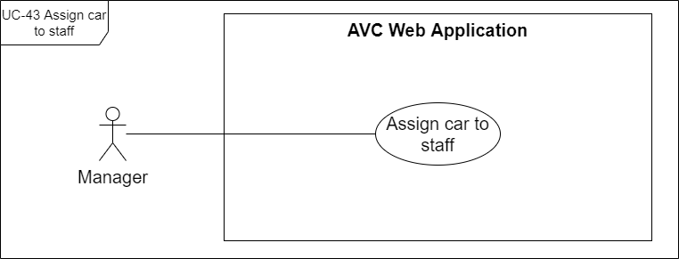

[Figure 53 . <Manager> UC-43 Assign car to staff](https://drive.google.com/file/d/1CyYHaQaXuKPyW0GqwWvJHxD8jgoqC3Yl/view?usp=sharing)

|  |  |  |  |
| --- | --- | --- | --- |
| ID and Name: | **UC-43 Assign car to staff** | | |
| Created By: | HuyTM | Date Created: | 30/05/2021 |
| Primary Actor: | Manager | Secondary Actors: | N/A |
| Description: | The manager can directly assign cars to any staff that they manage. | | |
| Trigger: | The manager wants to assign a staff member to a manager existing in the system. | | |
| Pre-conditions: | PRE-01. The actor had been authorized as a manager. PRE-02. The actor is continuous with UC-37 View car detail. | | |
| Post-conditions: | POST-01. Car is assigned to a staff. | | |
| Normal Flow: | **43.0 Assign car to staff**  1. The manager presses on the "Edit" icon.  2. The system displays the "Update Car" form with following items:  - “Device ID” label  - “Assigned to” drop down  - “Save” button  - “Discard” button  3. The manager presses on the "Assigned to" dropdown and selects a managed staff.  4. The manager presses on the "Save" button.  5. The system displays an updated car successful message (MSG19). | | |
| Alternative Flows: | **43.1 Remove assigned staff**  1a. The manager selects an assigned car and presses on the "Edit" icon.  1a1. The system displays the "Update Car" form with an "Assigned to" dropdown field.  1a2. The manager presses on the "x" icon on the "Assigned to" field.  Continuous with step 4 of normal flow.  **43.2 Discard change**  4a. The admin presses the "Discard" button.  4a1. The system closes the "Update Car" form and gets back to the “Car Detail” box, then terminates the use case. | | |
| Exceptions: | **43.0.E1 Network disconnected** (MSG15) | | |
| Priority: | High | | |
| Frequency of Use: | Every time the manager wants to assign a car to a managed staff. | | |
| Business Rules: | BR-24, BR-25, BR-26 | | |
| Other Information: | N/A | | |
| Assumptions: | The manager has logged in to the AVC system. | | |

#### i. UC-44 Control managed car

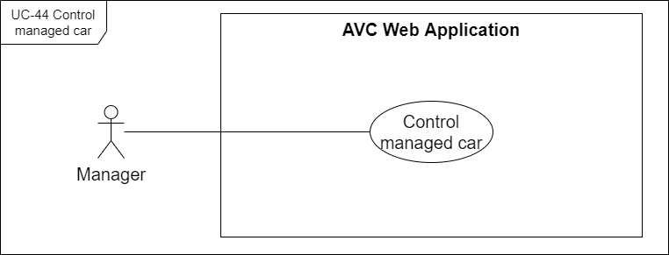

[Figure 54 . <Manager> UC-44 Control managed car](https://drive.google.com/file/d/1-7a7jeYFO5n3-9NmXqG_7SrlCNQgIgyG/view?usp=sharing)

|  |  |  |  |
| --- | --- | --- | --- |
| ID and Name: | **UC-44 Control managed car** | | |
| Created By: | HuyTM | Date Created: | 30/05/2021 |
| Primary Actor: | Manager | Secondary Actors: | N/A |
| Description: | The manager can send the "Stop car" command to any managed cars with connecting status "Connected" when emergency. | | |
| Trigger: | The car of the manager is connected to the server. | | |
| Pre-conditions: | PRE-01. The actor had been authorized as a manager. PRE-02. The actor is continuous with UC-37 View car detail. | | |
| Post-conditions: | POST-01. The car receives and does the command. | | |
| Normal Flow: | **44.0 Control managed car**  1. The manager views a car detail with status is "Connected" and running status is "Running".  2. The manager presses the "Stop car" button.  3. The system receives and sends commands though the selected car.  4. The car does stop commands.  5. The system updates the running status of the car to "Stopped". | | |
| Alternative Flows: | N/A | | |
| Exceptions: | **44.0.E1 Network disconnected** (MSG15) **44.0.E2 Car is disconnected** (MSG52) | | |
| Priority: | High | | |
| Frequency of Use: | Each time the manager needs to stop the car in the required case. | | |
| Business Rules: | BR-28 | | |
| Other Information: | N/A | | |
| Assumptions: | The manager has logged in to the AVC system. | | |

### 2.6. Mobile Application <Staff>

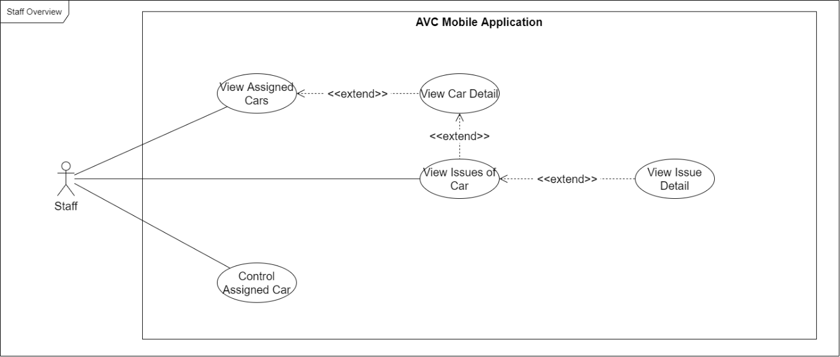

[Figure 55. <Staff> Overview Use Case Diagram](https://drive.google.com/file/d/18Ezny1kDIsTi1oSUaZfA_ldHLxK3l71O/view?usp=sharing)

#### a. UC-45 View assigned cars

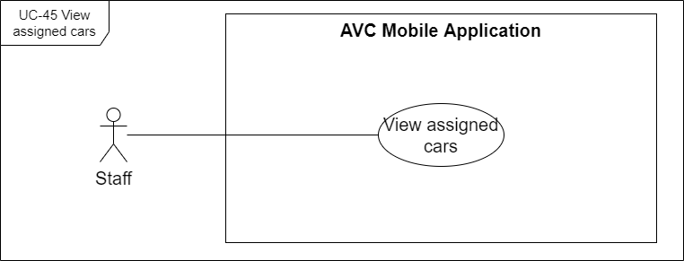

[Figure 56 . <Staff> UC-45 View assigned cars](https://drive.google.com/file/d/1HL1GcBM-ApAWdFLRxj2IqyReuLJZ_DAz/view?usp=sharing)

|  |  |  |  |
| --- | --- | --- | --- |
| ID and Name: | **UC-45 View assigned cars** | | |
| Created By: | DatLT | Date Created: | 30/05/2021 |
| Primary Actor: | Staff | Secondary Actors: | N/A |
| Description: | Staff can see all the assigned cars in the system. | | |
| Trigger: | The staff wants to see assigned cars exist. | | |
| Pre-conditions: | PRE-01. The actor had been authorized as a staff member. | | |
| Post-conditions: | POST-01. All cars are displayed on the screen. | | |
| Normal Flow: | **45.0 View assigned cars**  1. The staff selects the "Cars" item in the bottom navigation menu.  2. The system redirects staff to the "Assigned Cars" screen with all assigned cars (see 36.0.E1). | | |
| Alternative Flows: | N/A | | |
| Exceptions: | **45.0.E1 No assigned car result exist in the system** (MSG35, MSG36) **45.0.E2 Network disconnected** (MSG15) | | |
| Priority: | High | | |
| Frequency of Use: | Every time staff wants to see assigned cars in the system. | | |
| Business Rules: | BR-16, BR-87 | | |
| Other Information: | N/A | | |
| Assumptions: | The staff has logged in to the AVC system. | | |

#### b. UC-46 View car detail

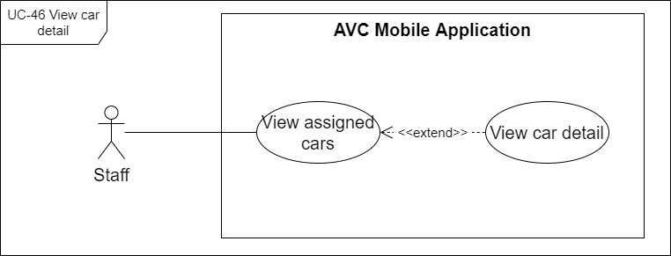

[Figure 57 . <Staff> UC-46 View car detail](https://drive.google.com/file/d/1e_dOxzxUgZA1SSNKxkj2dXDW_wXt3W0T/view?usp=sharing)

|  |  |  |  |
| --- | --- | --- | --- |
| ID and Name: | **UC-46 View car detail** | | |
| Created By: | DatLT | Date Created: | 30/05/2021 |
| Primary Actor: | Staff | Secondary Actors: | N/A |
| Description: | The staff can view car details, through which they can know more information about the car, its configuration, in addition, the staff can send control commands to the car. | | |
| Trigger: | The staff wants to see car details. | | |
| Pre-conditions: | PRE-01. The actor had been authorized as a staff member. | | |
| Post-conditions: | POST-01. Details of the car are displayed on the screen. | | |
| Normal Flow: | **46.0 View car detail**  1. The staff selects the "Cars" item in the bottom navigation menu.  2. The system redirects staff to the "Assigned Cars" screen with all assigned cars  3. The staff selects a car on the "Assigned Cars" list.  4. The system redirects staff to the "Car Detail" screen. | | |
| Alternative Flows: | N/A | | |
| Exceptions: | **46.0.E1 Network disconnected** (MSG15) | | |
| Priority: | High | | |
| Frequency of Use: | Every time the staff wants to see car details. | | |
| Business Rules: | BR-88 | | |
| Other Information: | N/A | | |
| Assumptions: | The staff has logged in to the AVC system.  Exist assigned car on the staff. | | |

#### c. UC-47 View issues of car

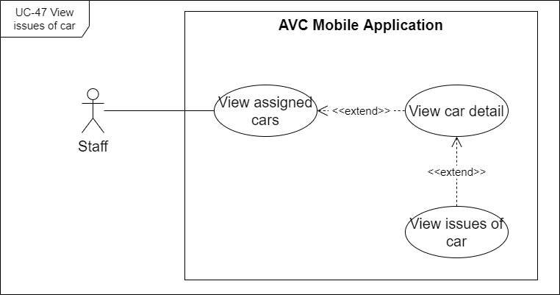

[Figure 58 . <Staff> UC-47 View issues of car](https://drive.google.com/file/d/10w8A9bmut7ysBoaqhyboSN3maFH9U-ap/view?usp=sharing)

|  |  |  |  |
| --- | --- | --- | --- |
| ID and Name: | **UC-47 View issues of car** | | |
| Created By: | DatLT | Date Created: | 30/05/2021 |
| Primary Actor: | Staff | Secondary Actors: | N/A |
| Description: | The staff can view issues for any of the cars on the list to track and correct car problems. | | |
| Trigger: | The staff want to view issues of a car. | | |
| Pre-conditions: | PRE-01. The actor had been authorized as a staff member. | | |
| Post-conditions: | POST-01. Issues of cars are displayed on the screen. | | |
| Normal Flow: | **47.0 View issues of car**  The admin implements use cases through UC-46 View car detail. | | |
| Alternative Flows: | N/A | | |
| Exceptions: | **38.0.E1 Network disconnected** (MSG15) | | |
| Priority: | High | | |
| Frequency of Use: | Every time staff want to view issues of a car. | | |
| Business Rules: | N/A | | |
| Other Information: | N/A | | |
| Assumptions: | The staff has logged in to the AVC system. | | |

#### d. UC-48 View issue detail

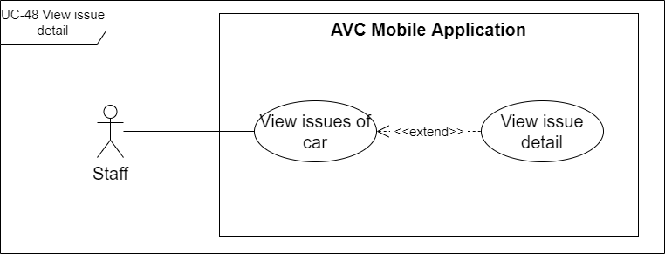

[Figure 59 . <Staff> UC-48 View issue detail](https://drive.google.com/file/d/1a1bJ2iEAU6hWBexxbPmLKNKvybmLLtI2/view?usp=sharing)

|  |  |  |  |
| --- | --- | --- | --- |
| ID and Name: | **UC-48 View issue detail** | | |
| Created By: | DatLT | Date Created: | 30/05/2021 |
| Primary Actor: | staff | Secondary Actors: | N/A |
| Description: | The staff can view details of all issues to track and correct car problems. | | |
| Trigger: | The staff wants to view the details of an issue. | | |
| Pre-conditions: | PRE-01. The actor had been authorized as a staff member. PRE-02. The actor is continuous with UC-47 View issues of car. | | |
| Post-conditions: | POST-01. Details of issues are displayed on the screen. | | |
| Normal Flow: | **48.0 View issue detail**  1. The staff selects an issue on a list of issues.  2. The system displays an "Issues Detail" screen. | | |
| Alternative Flows: | N/A | | |
| Exceptions: | **39.0.E1 Network disconnected** (MSG15) | | |
| Priority: | High | | |
| Frequency of Use: | Every time staff wants to view the details of an issue. | | |
| Business Rules: | BR-79 | | |
| Other Information: | N/A | | |
| Assumptions: | The staff has logged in to the AVC system. | | |

#### e. UC-49 Control assigned car

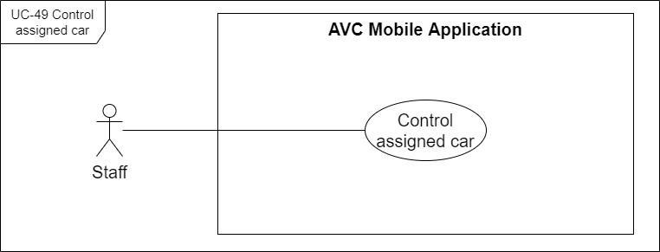

[Figure 60 . <Staff> UC-49 Control assigned car](https://drive.google.com/file/d/1gf6EuYAoG996AAJio-6FSW5V3wYx_sqd/view?usp=sharing)

|  |  |  |  |
| --- | --- | --- | --- |
| ID and Name: | **UC-49 Control managed car** | | |
| Created By: | DatLT | Date Created: | 30/05/2021 |
| Primary Actor: | Staff | Secondary Actors: | N/A |
| Description: | The staff can send the "Start car" and "Stop car" commands to any assigned cars with connecting status is "Connected". | | |
| Trigger: | An assigned car of staff is connected to the server. | | |
| Pre-conditions: | PRE-01. The actor had been authorized as a staff member. PRE-02. The actor is continuous with UC-46 View car detail. | | |
| Post-conditions: | POST-01. The car receives and does the command. | | |
| Normal Flow: | **49.0 Control managed car by "Start car"**  1. The staff view a car detail with status is "Connected" and running status is "Stopped".  2. The staff presses the "Start car" button.  3. The system receives and sends commands to the selected car.  4. The car does the "Start car" command.  5. The system updates the running status of the car to "Running". | | |
| Alternative Flows: | **49.1 Control managed car by "Stop car"**  1a. The staff view a car detail with status is "Connected" and running status is "Running".  2a. The staff presses the "Stop car" button.  3a. The system receives and sends commands to the selected car.  4a. The car does the "Stop car" command.  5a. The system updates the running status of the car to "Stopped". | | |
| Exceptions: | **44.0.E1 Network disconnected** (MSG15) **44.0.E2 Car is disconnected** (MSG37) | | |
| Priority: | High | | |
| Frequency of Use: | Each time staff need to stop the car in the required case. | | |
| Business Rules: | BR-29, BR-30 | | |
| Other Information: | N/A | | |
| Assumptions: | The staff has logged in to the AVC system. | | |

### 2.7. Training Machine

#### a. UC-50 Process training

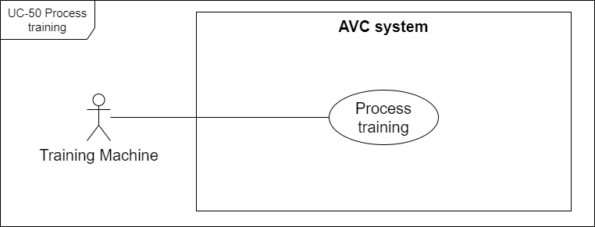

[Figure 61. <Training Machine> UC-50 Process training](https://drive.google.com/file/d/1ZkWMdfaqgAzMaHevXlBAVE2lMqxoLMh1/view?usp=sharing)

|  |  |  |  |
| --- | --- | --- | --- |
| ID and Name: | **UC-50 Process training** | | |
| Created By: | SangNV | Date Created: | 30/05/2021 |
| Primary Actor: | Training Machine | Secondary Actors: | N/A |
| Description: | The training machine will train the received dataset from the server base on the current applying model. | | |
| Trigger: | The server sends the dataset to the training machine. | | |
| Pre-conditions: | PRE-01. The training machine is running. | | |
| Post-conditions: | POST-01. The new model is trained successfully. | | |
| Normal Flow: | **50.0 Process training (see 50.0.E1, 50.0.E2)**  1. The training machine receives the dataset and training command.  2. The training machine processes training data. | | |
| Alternative Flows: | N/A | | |
| Exceptions: | **50.0.E1 The training machine is disrupted.** **50.0.E2 Error occurred during processing.** | | |
| Priority: | High | | |
| Frequency of Use: | Frequency | | |
| Business Rules: | BR-51, BR-52, BR-53, BR-54 | | |
| Other Information: | N/A | | |
| Assumptions: | The training machine is running | | |

### 2.8. System Handler

#### a. UC-51 Send notification

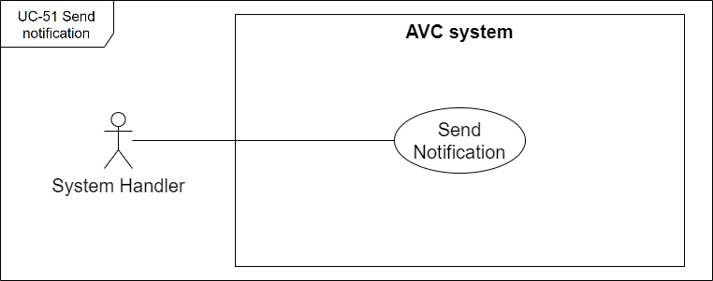

[Figure 62. <System Handler> UC-51 Send notification](https://drive.google.com/file/d/1DjRz5g4bCifqbgAX-EBOdybDgRb8xeFK/view?usp=sharing)

|  |  |  |  |
| --- | --- | --- | --- |
| ID and Name: | **UC-51 Send notification** | | |
| Created By: | HuyTM | Date Created: | 30/05/2021 |
| Primary Actor: | System Handler | Secondary Actors: | N/A |
| Description: | The system handler takes on the role of sending notifications about an event to the actor involved or affected by that event. | | |
| Trigger: | The event affecting the AVC system occurs. | | |
| Pre-conditions: | N/A | | |
| Post-conditions: | POST-01. The notification was successfully received by the receiver. | | |
| Normal Flow: | **51.0 Send notification when admin changes "Managed by" of car (****MSG42****,** **MSG49****)** | | |
| Alternative Flows: | **51.1 Send notification when admin changes "Managed by" of staff (****MSG4****0,** **MSG4****1,** **MSG****50) 51.2 Send notification when manager change assigned car (****MSG****39,** **MSG4****9) 51.3 Send notification when account is deactivated (****MSG4****3,** **MSG4****4) 51.4 Send notification when car is deactivated (****MSG4****5,** **MSG4****6) 51.5 Send notification when issue is created (****MSG****38) 51.6 Send notification when model status change (****MSG4****7,** **MSG4****8) 51.7 Send notification when car is connected (****MSG****51) 51.8 Send notification when car is disconnected (****MSG52****) 51.9 Send notification when car is running (****MSG****53) 51.10 Send notification when car is stopping (****MSG****54)** | | |
| Exceptions: | N/A | | |
| Priority: | High | | |
| Frequency of Use: | Every time events affecting the AVC system occur. | | |
| Business Rules: | BR-89, BR-90, BR-91, BR-92, BR-93, BR-94, BR-95, BR-96, BR-97, BR-98, BR-99, BR-100, BR-101, BR-102 | | |
| Other Information: | N/A | | |
| Assumptions: | N/A | | |

### 2.9. Autonomous Car

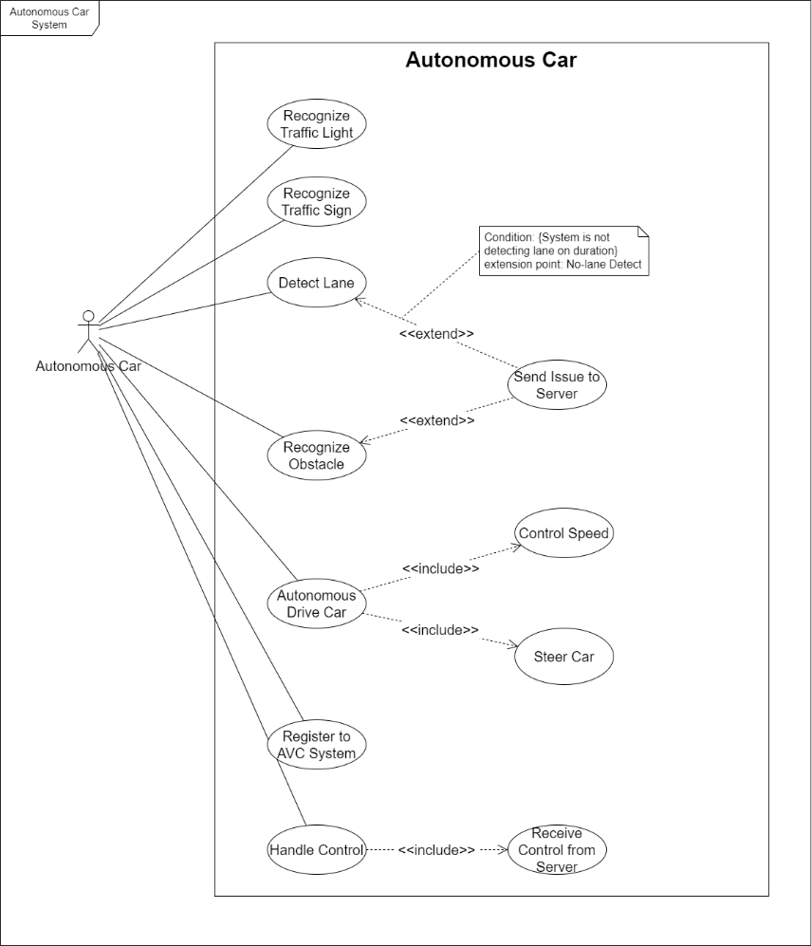

[Figure 63. <Autonomous Car> Usecase Overview Diagram](https://drive.google.com/file/d/1XZB-eGfRKW6OJWsF0yuWEHCB1MCLH--K/view?usp=sharing)

#### a. UC-52 Recognize traffic light

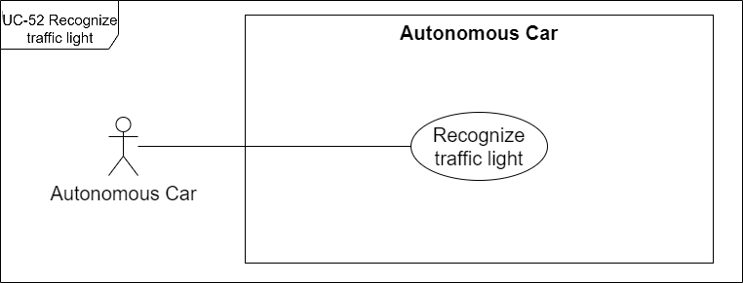

[Figure 64. <Autonomous Car> UC-52 Recognize traffic light](https://drive.google.com/file/d/1OJ3YRK4PLqnOHa2a2cH2xwKWD0aeQvaD/view?usp=sharing)

|  |  |  |  |
| --- | --- | --- | --- |
| ID and Name: | **UC-52 Recognize traffic light** | | |
| Created By: | DatLT | Date Created: | 31/05/2021 |
| Primary Actor: | Autonomous Car | Secondary Actors: | N/A |
| Description: | The autonomous car can recognize traffic light signals appearing on the road through the camera so that it can respond during driving. | | |
| Trigger: | The autonomous car encounters a traffic light. | | |
| Pre-conditions: | PRE-01. The autonomous car is running. | | |
| Post-conditions: | POST-01. The signal traffic light is detected. | | |
| Normal Flow: | **52.0 Recognize traffic lights.**  1. The car encounters a traffic light.  2. The car recognizes the traffic light.  3. The autonomous car system processes response to the signal at UC-58 Autonomous drive car. | | |
| Alternative Flows: | N/A | | |
| Exceptions: | **52.0.E1 The autonomous car is disrupted.** | | |
| Priority: | High | | |
| Frequency of Use: | Every time the autonomous car encounters a traffic light. | | |
| Business Rules: | BR-67 | | |
| Other Information: | N/A | | |
| Assumptions: | The autonomous car is connecting. | | |

#### b. UC-53 Recognize traffic sign

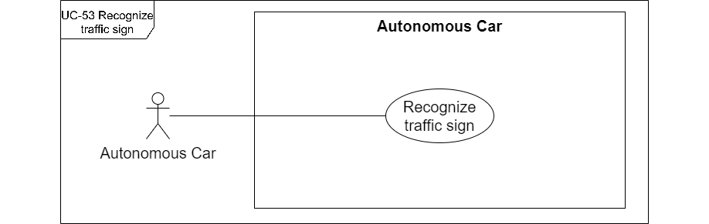

[Figure 65. <Autonomous Car> UC-53 Recognize traffic sign](https://drive.google.com/file/d/1SmN6KPYYRCy3g9mjm9wGD34R7PvDnBqV/view?usp=sharing)

|  |  |  |  |
| --- | --- | --- | --- |
| ID and Name: | **UC-53 Recognize traffic sign** | | |
| Created By: | DatLT | Date Created: | 31/05/2021 |
| Primary Actor: | Autonomous Car | Secondary Actors: | N/A |
| Description: | The autonomous car can recognize traffic signs appearing on the road through the camera to be able to respond during driving. | | |
| Trigger: | The autonomous car encounters a traffic sign. | | |
| Pre-conditions: | PRE-01. The autonomous car is running. | | |
| Post-conditions: | POST-01. The signal traffic sign is detected. | | |
| Normal Flow: | **53.0 Recognize traffic signs.**  1. The car encounters a traffic sign.  2. The car recognizes the traffic sign.  3. The autonomous car system processes response to the signal at UC-58 Autonomous drive car. | | |
| Alternative Flows: | N/A | | |
| Exceptions: | **53.0.E1 The autonomous car is disrupted.** | | |
| Priority: | High | | |
| Frequency of Use: | Every time the autonomous car encounters a traffic sign. | | |
| Business Rules: | BR-62 | | |
| Other Information: | N/A | | |
| Assumptions: | The autonomous car is connecting. | | |

#### c. UC-54 Recognize obstacle

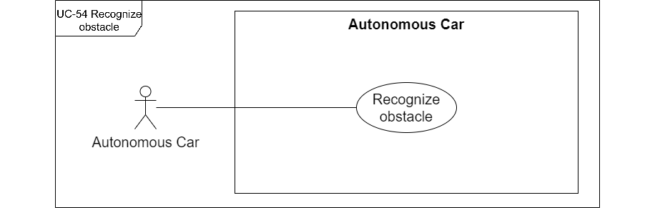

[Figure 66 . <Autonomous Car> UC-54 Recognize obstacle](https://drive.google.com/file/d/1fTyjRyGhRe9tULK-BiFzsQLNwD3eFN8P/view?usp=sharing)

|  |  |  |  |
| --- | --- | --- | --- |
| ID and Name: | **UC-54 Recognize obstacle** | | |
| Created By: | DatLT | Date Created: | 31/05/2021 |
| Primary Actor: | Autonomous Car | Secondary Actors: | N/A |
| Description: | The autonomous car can recognize obstacles appearing on the road through the camera and sensor so that it can respond during driving. | | |
| Trigger: | The autonomous car encounters an obstacle. | | |
| Pre-conditions: | PRE-01. The autonomous car is running. | | |
| Post-conditions: | POST-01. The obstacle is detected. | | |
| Normal Flow: | **54.0 Recognize obstacles.**  1. The car encounters an obstacle.  2. The car recognizes the obstacle.  3. The autonomous car system processes response to the signal at UC-58 Autonomous drive car. | | |
| Alternative Flows: | N/A | | |
| Exceptions: | **54.0.E1 The autonomous car is disrupted.** | | |
| Priority: | High | | |
| Frequency of Use: | Every time the autonomous car encounters an obstacle. | | |
| Business Rules: | BR-76 | | |
| Other Information: | N/A | | |
| Assumptions: | The autonomous car is connecting. | | |

#### d. UC-55 Detect Lane

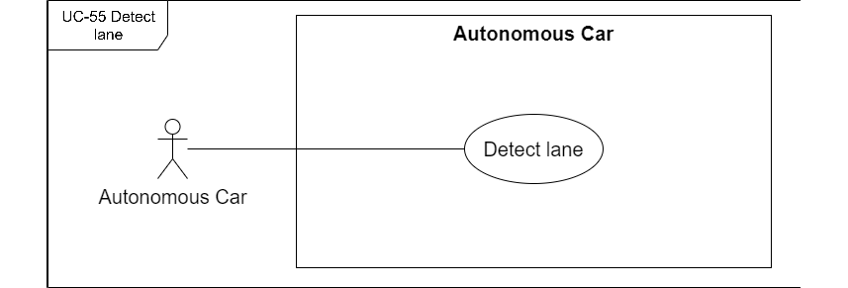

[Figure 67. <Autonomous Car> UC-55 Detect Lane](https://drive.google.com/file/d/146PaaaHcfTmjdVst1654Wx7ew3Y6gqr2/view?usp=sharing)

|  |  |  |  |
| --- | --- | --- | --- |
| ID and Name: | **UC-55 Detect lane** | | |
| Created By: | DatLT | Date Created: | 31/05/2021 |
| Primary Actor: | Autonomous Car | Secondary Actors: | N/A |
| Description: | The autonomous car can detect the lane, so that the driver can follow the available lane. | | |
| Trigger: | The autonomous car is running | | |
| Pre-conditions: | PRE-01. The autonomous car is running. | | |
| Post-conditions: | POST-01. The lane is detected. | | |
| Normal Flow: | **55.0 Detect Lane.**  1. The car detects the lane available.  2. The autonomous car system processes response to the signal at UC-58 Autonomous drive car. | | |
| Alternative Flows: | **55.1 Detect no-lane.**  1a. The car detects the lane is not available.  Continuous to step 2 of normal flow. | | |
| Exceptions: | **55.0.E1 The autonomous car is disrupted.** | | |
| Priority: | High | | |
| Frequency of Use: | Continuously while the autonomous car is running | | |
| Business Rules: | BR-71 | | |
| Other Information: | N/A | | |
| Assumptions: | The autonomous car is connecting. | | |

#### e. UC-56 Send issue to server

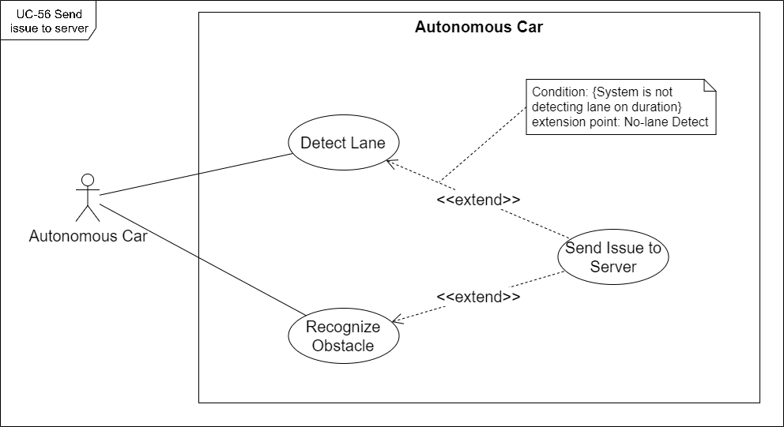

[Figure 68. <Autonomous Car> UC-56 Send issue to server](https://drive.google.com/file/d/1EDKdUvbZrPSU79FUjL3qHyC7DmqQSpOq/view?usp=sharing)

|  |  |  |  |
| --- | --- | --- | --- |
| ID and Name: | **UC-56 Send issue to server** | | |
| Created By: | DatLT | Date Created: | 31/05/2021 |
| Primary Actor: | Autonomous Car | Secondary Actors: | N/A |
| Description: | When encountering problems during driving such as losing lanes or encountering obstacles, the autonomous car will automatically stop and send an issue with pictures and logs to the server to notify users of the problems. | | |
| Trigger: | The autonomous car encounters an obstacle or detects a no-lane. | | |
| Pre-conditions: | PRE-01. The autonomous car is running. | | |
| Post-conditions: | POST-01. The issue has been received on the server. | | |
| Normal Flow: | **56.0 Send issue to server when car encounters an obstacle** 1. The autonomous car sends the issue package with an image and log text file to the server.  2. The system creates an issue with type "Encounter obstacle". | | |
| Alternative Flows: | **56.1 Send issue to server when car detects no-lane** 2a. The system creates an issue with type "No-lane detected". | | |
| Exceptions: | **56.0.E1 The autonomous car is disrupted.** | | |
| Priority: | High | | |
| Frequency of Use: | Every time the autonomous car encounters an obstacle or detects a no-lane. | | |
| Business Rules: | N/A | | |
| Other Information: | N/A | | |
| Assumptions: | The autonomous car is connecting. | | |

#### f. UC-57 Register to AVC system

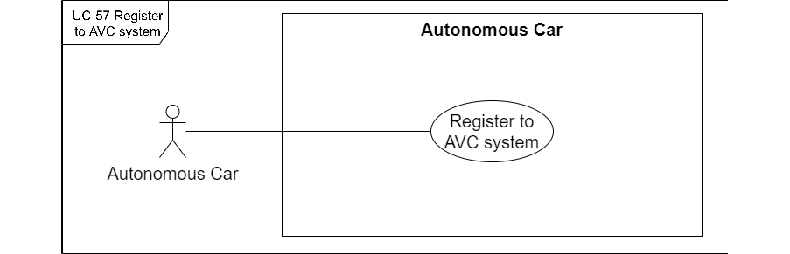

[Figure 69 . <Autonomous Car> UC-57 Register to AVC system](https://drive.google.com/file/d/1VZNqY-dccuPJva4g7FtoZziSPBEyNr58/view?usp=sharing)

|  |  |  |  |
| --- | --- | --- | --- |
| ID and Name: | **UC-57 Register to AVC system** | | |
| Created By: | DatLT | Date Created: | 31/05/2021 |
| Primary Actor: | Autonomous Car | Secondary Actors: | N/A |
| Description: | When the autonomous car is first installed and started, it sends a signal to the server to register the vehicle with the AVC system. | | |
| Trigger: | The autonomous car is starting, | | |
| Pre-conditions: | PRE-01. The autonomous car is first installed PRE-02. The autonomous car is starting, | | |
| Post-conditions: | POST-01. The autonomous car is registered on the AVC system. | | |
| Description: | **57.0 Register to AVC system**  1. The autonomous car started successfully.  2. The autonomous car sends a notification with "Device ID" to the server.  3. The server checks the "Device ID" of the car for first identification.  4. The server creates a register car on the server. | | |
| Alternative Flows: | **57.1 Update car status when a car exists on the system.**  3a. The server checks if the "Device ID" of the car is already existing on the system.  4a. The server updates the status of car to "Connecting" | | |
| Exceptions: | **57.0.E1 The autonomous car is disrupted.** | | |
| Priority: | High | | |
| Frequency of Use: | Each time the autonomous car is starting, | | |
| Business Rules: | BR-77 | | |
| Other Information: | N/A | | |
| Assumptions: | N/A | | |

#### g. UC-58 Autonomous drive car

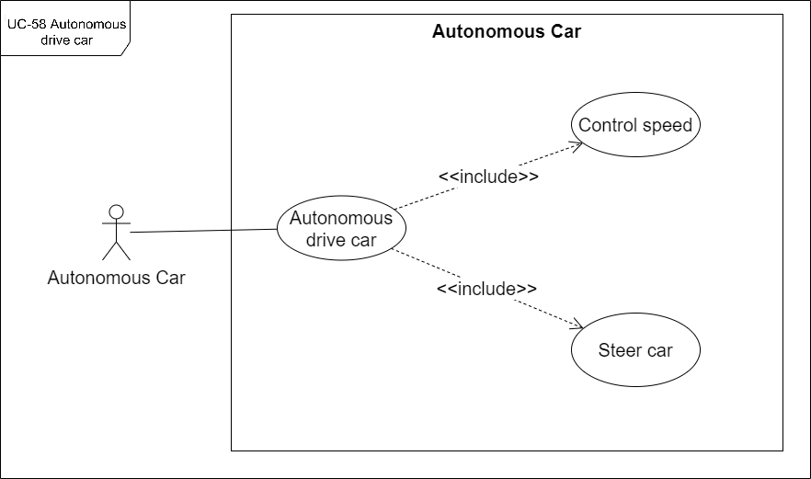

[Figure 70 . <Autonomous Car> UC-58 Autonomous drive car](https://drive.google.com/file/d/1btPNPToLYBDjrm1XPYp8nohmUq7lVdyq/view?usp=sharing)

|  |  |  |  |
| --- | --- | --- | --- |
| ID and Name: | **UC-58 Autonomous drive car** | | |
| Created By: | DatLT | Date Created: | 31/05/2021 |
| Primary Actor: | Autonomous Car | Secondary Actors: | N/A |
| Description: | The autonomous car will operate on autonomous driving, control speed and steer the car based on the responses from the detect lane, recognize traffic lights, recognize traffic signs, recognize obstacles. | | |
| Trigger: | The autonomous car receives the signal response from the detection lane, recognizes traffic lights, recognizes traffic signs, and recognizes obstacles. | | |
| Pre-conditions: | PRE-01. The autonomous car is running. PRE-02. The detection response is processing | | |
| Post-conditions: | POST-01. The autonomous car takes action based on the processed response | | |
| Normal Flow: | **58.0 Autonomous drive car when the car detects lane**  1. The autonomous car receives lane detection.  2. The autonomous car follows the lane. | | |
| Alternative Flows: | **58.1 Autonomous drive car when the car detects no-lane**  1a. The autonomous car receives no-lane detection response.  2a. The autonomous car waits for 30 seconds.  3a. The autonomous car re-detects the lane before 30 seconds then keeps following the lane.  3b. The autonomous car does not detect lane for 30 second then send issue to server at UC-56 Send issue to server. **58.2 Autonomous drive car when the car recognizes traffic light "Red"**  1a. The autonomous car receives traffic light "Red" response.  2a. The autonomous car changes to waiting mode and stops until the traffic light goes "Green". **58.3 Autonomous drive car when the car recognize traffic light "Green"**  1a. The autonomous car receives a traffic light "Green" response.  2a. The autonomous car is in running mode and keeps running. **58.4 Autonomous drive car when the car recognizes traffic sign "Stop"**  1a. The autonomous car receives a traffic light "Stop" response.  2a. The autonomous car changes to waiting mode and stops in front of the traffic sign. **58.5 Autonomous drive car when the car recognizes traffic sign "Speed up"**  1a. The autonomous car receives traffic light "Speed up" response.  2a. The autonomous car accelerates the speed. **58.6 Autonomous drive car when the car recognizes traffic sign "Slow down"**  1a. The autonomous car receives traffic light "Slow down" response.  2a. The autonomous car decelerates the speed. **58.7 Autonomous drive car when the car recognizes traffic sign "Go forward"**  1a. The autonomous car receives a traffic light "Go forward" response.  2a. The autonomous car runs forward when it encounters the intersection. **58.8 Autonomous drive car when the car recognizes traffic sign "Turn left"**  1a. The autonomous car receives a traffic light "Turn left" response.  2a. The autonomous car steers to the left when encountering the intersection 3-way junction. **58.9 Autonomous drive car when the car recognizes traffic sign "Turn right"**  1a. The autonomous car receives a traffic light "Turn right" response.  2a. The autonomous car steers to the right when encountering the intersection 3-way junction. **58.10 Autonomous drive car when the car detects no-lane**  1a. The autonomous car receives recognized obstacle response.  2a. The autonomous car changes to waiting mode.  3a. The autonomous send issue to server at UC-56 Send issue to server. **58.11 Autonomous drive car when the car encounters the corner**  1a. The autonomous car encounters the corner.  2a. The autonomous car decelerates the speed. | | |
| Exceptions: | **58.0.E1 The autonomous car is disrupted.** | | |
| Priority: | High | | |
| Frequency of Use: | Every time while car is running | | |
| Business Rules: | BR-62, BR-63, BR-64, BR-65, BR-66, BR-67, BR-68, BR- 69, BR-70, BR-71, BR-72, BR-73, BR-74, BR-75, BR-76 | | |
| Other Information: | N/A | | |
| Assumptions: | The autonomous car is connecting. | | |

#### h. UC-59 Handle control

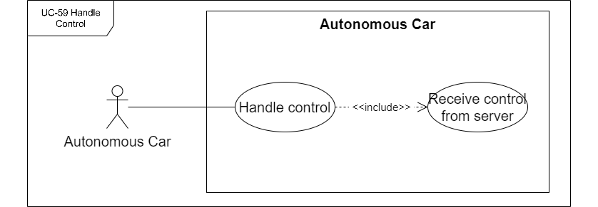

[Figure 71 . <Autonomous Car> UC-59 Handle control](https://drive.google.com/file/d/1JHqO2S9O_Nv9QRI1ztPhJqSe934Hp48E/view?usp=sharing)

|  |  |  |  |
| --- | --- | --- | --- |
| ID and Name: | **UC-59 Handle control** | | |
| Created By: | DatLT | Date Created: | 31/05/2021 |
| Primary Actor: | Autonomous Car | Secondary Actors: | N/A |
| Description: | The autonomous car will receive commands from the user who is the staff or manager managing it to start or stop according to the wishes of the controller. | | |
| Trigger: | The staff or manager sends a control command. | | |
| Pre-conditions: | PRE-01. The autonomous car is connecting. | | |
| Post-conditions: | POST-01. The autonomous car is a response to the control command. | | |
| Normal Flow: | **59.0 Handle control "Start car"**  1. The autonomous car receives the "Start car" command.  2. The autonomous car is starting. | | |
| Alternative Flows: | **59.1 Handle control "Stop car"**  1a. The autonomous car receives the "Stop car" command.  2a. The autonomous car is stopping. | | |
| Exceptions: | **59.0.E1 The autonomous car is disrupted.** | | |
| Priority: | High | | |
| Frequency of Use: | Every time the staff or manager sends a control command. | | |
| Business Rules: | BR-78 | | |
| Other Information: | N/A | | |
| Assumptions: | The autonomous car is connecting. | | |

## 3. Functional Requirements

### 3.1 System Functional Overview

#### a. Screen Flow

##### a1. <Admin> Web Application Screen Flow

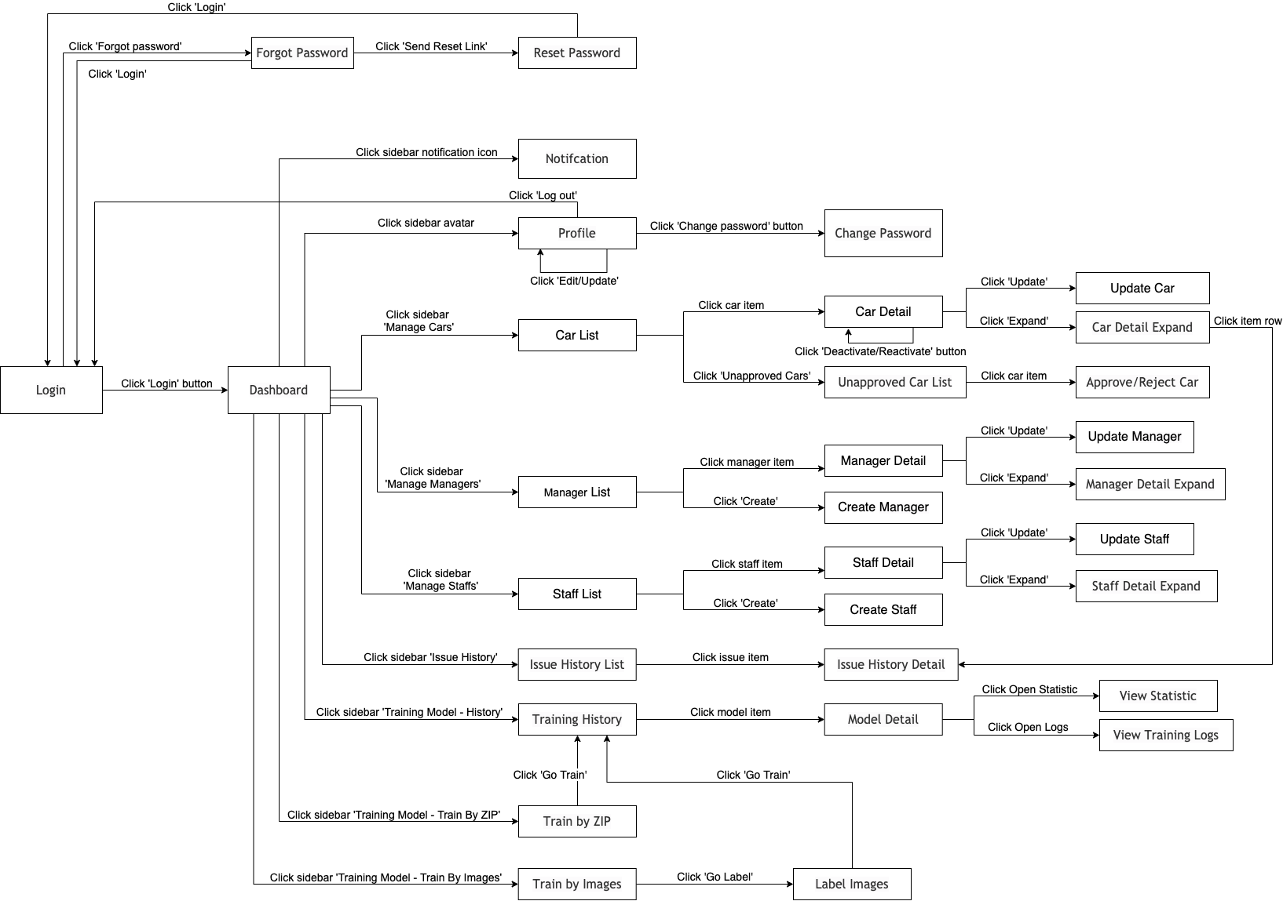

[Figure 72. <Admin> Web Application Screen Flow](https://drive.google.com/file/d/1nbMPPhcOUAVQCH5bWpJfmW5qkPKr85sT/view?usp=sharing)

##### a2. <Manager> Web Application Screen Flow

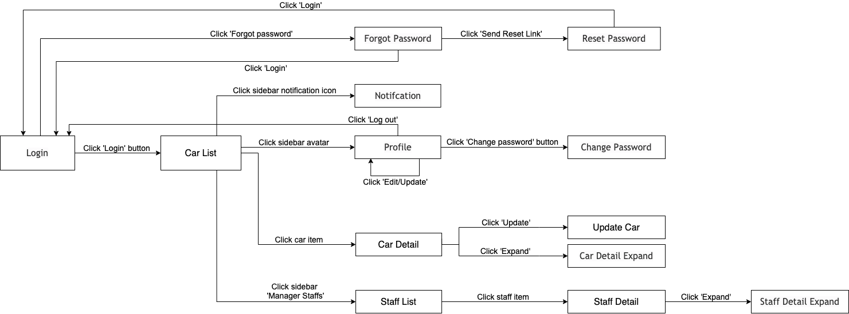

[Figure 73. <Manager> Web Application Screen Flow](https://drive.google.com/file/d/1x70lYexOT_hGctm0JDMHxQOi5oZh8Evp/view?usp=sharing)

##### a3. <Staff> Mobile Application Screen Flow

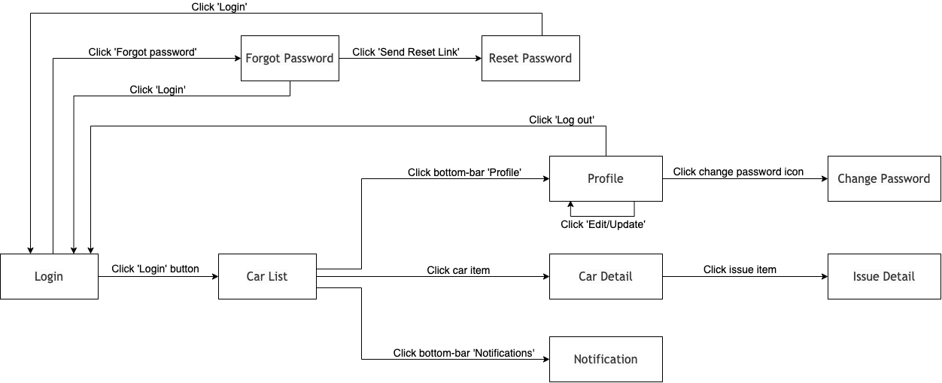

[Figure 74. <Staff> Mobile Application Screen Flow](https://drive.google.com/file/d/1P5ek5ADlBzu7fsUFtKAJxf1ceK3XjCjt/view?usp=sharing)

#### b. Screen Details

##### b1. Web Application Admin Screen Details

|  |  |  |  |
| --- | --- | --- | --- |
| **Id** | **Feature** | **Screen** | **Description** |
| 1 | Login | Login | Login screen includes:  - "Login" title  - Username text-input  - Password password-input  - Hide/unhide icon  - "Login" button  - "Forgot password" button |
| 2 | Reset Password | Forgot Password | Forgot Password screen includes:  - "Forgot Password" title  - Email input  - "Send reset link" button  - "Return to Login" button |
| 3 | Reset Password | Reset Password | Reset Password screen includes:  - "Reset Password" title  - Recover code text-input  - New password password-input  - Hide/unhide icon for new password  - Confirmed password password-input  - Hide/unhide icon for confirmed password  - "Reset password" button  - "Return to Login" button |
| 4 |  | Dashboard | Dashboard screen includes:  - "Dashboard" title  - Sidebar:  + Big avatar image, user full name, role  + Notification icon  + "Dashboard" button  + "Manage Managers" button  + "Manage Staffs" button  + "Manage Cars" button  + "Issue History" button  + "Training Model" button  + "History" button  + "Train by ZIP" button  + "Train by Images" button  - System Overview section (includes total numbers)  - Most Problematic Cars Summary (includes line chart)  - Most Latest Occured Issues (includes latest issues)  - Car Types Summary (includes pie charts) |
| 5 | Update Profile | Profile | Profile dialog includes:  - "My Profile" title  - Full name label  - Full name  - Avatar image  - Upload image button  - Email label  - Email  - Role label  - Role  - Phone label  - Phone input  - "Update Profile" button  - "Change password" button |
| 6 | Change Password | Change Password | Change Password dialog includes:  - "Change Password" title  - Old password label  - Old password password-input  - Hide/unhide icon for old password  - New password label  - New password password-input  - Hide/unhide icon for new password  - Confirmed password label  - Confirmed password password-input  - Hide/unhide icon for confirmed password  - "Change" button |
| 7 | View car list | Car List | Car List screen includes:  - "Manage Cars" title  - Unapproved Car button  - Edit Default Config button  - Search by car name input  - Activation Status select-box  - Table of cars:  + Columns:Index, name, device ID, managed by, connecting status, activation status  - Pagination |
| 8 | View car detail | Car Detail | Car Detail screen includes:  - "Car Detail" title  - Expand icon button  - Edit icon button  - Close icon button  - Name label  - Name  - Car image  - Device ID label  - Device ID  - Configuration label  - Edit configuration button  - Managed by label  - Manager name  - Assigned to label  - Staff name  - Issues label  - Expand to view full car issues button  - Created at label  - Created at  - Connecting Status label  - Connecting Status badge  - Activation Status label  - Activation Status badge  - Deactivate/Reactivate button |
| 9 | View car detail | Car Detail Expand | Car Detail screen includes:  - "Car Detail" title  - Name label  - Name  - Car image  - Device ID label  - Device ID  - Configuration label  - Edit configuration button  - Managed by label  - Manager name  - Assigned to label  - Staff name  - Issues label  - Expand to view full car issues button  - Created at label  - Created at  - Connecting Status label  - Connecting Status badge  - Activation Status label  - Activation Status badge  - Deactivate/Reactivate button  - Table of cars:  + Columns:Index, type, created at, description.  - Pagination |
| 10 | Update car | Update car | Update car screen includes:  - "Update Car" title  - Choose an avatar image-drop-input or avatar with upload button  - Device ID label  - Device ID  - Name label  - Name  - Managed by label  - Manager select-box  - "Save" button  - "Discard" button |
| 11 | Update car | Edit Default Car Configuration | Edit Car Configuration screen includes:  - "Edit Car Configuration" title  - "Save" button  - "Discard" button  - JSON editor |
| 12 | Update car | Edit Selected Car Configuration | Edit Car Configuration screen includes:  - "Edit Car Configuration" title  - "Save" button  - "Discard" button  - Selected car information (includes car image, device ID, managed by manager)  - JSON editor |
| 13 | Approve Car | Unapproved Cars | Unapproved Cars screen includes:  - "Unapproved Cars" title  - Search by car name input  - Table of cars includes index and device ID columns  - Pagination |
| 14 | Approve Car | Approve Car | Approve Car screen includes:  - "Approve Car" title  - Choose an car image-drop-input  - Device ID label  - Device ID  - Name label  - Name input  - Managed by label  - Manager select-box  - "Approve" button  - "Reject" button  - "Discard" button |
| 15 | View Manager List | Manager List | Manager List screen includes:  - "Manage Managers" title  - "Create new" button  - Search by manager name input  - Activation Status select-box  - Table of managers:  + Columns:index, full name, email, phone, activation status  - Pagination |
| 16 | View Manager Detail | Manager Detail | Manager Detail screen includes:  - "Manager Detail" title  - Expand icon button  - Edit icon button  - Close icon button  - Full name label  - Full name  - Avatar  - Email label  - Email  - Phone label  - Phone  - Activation Status label  - Activation Status badge  - Deactivate/Reactivate button  - Assigned Cars list  - Assigned Staff list |
| 17 | View Manager Detail | Manager Detail Expand | Manager Detail Expand screen includes:  - "Manager Detail" title  - Full name label  - Full name  - Avatar  - Email label  - Email  - Phone label  - Phone  - Activation Status label  - Activation Status badge  - Deactivate/Reactivate button  - Table of assigned cars (includes index, name, device ID, created at, assigned to, connecting status)  - Table of assigned staff (includes index, full name, email, phone, activation status) |
| 18 | Create Manager | Create Manager | Create manager screen includes:  - "Create Manager" title  - Close icon button  - Choose an avatar image-drop-input  - First name label  - First name input  - Last name label  - Last name input  - Email label  - Email input  - Phone label  - Phone input  - Clear when creating succeeded check-box  - "Create" button |
| 19 | Update Manager | Update Manager | Update Manager screen includes:  - "Update Manager" title  - Close icon button  - Avatar  - First name label  - First name input  - Last name label  - Last name input  - Phone label  - Phone input  - System Role label  - System Role select-box  - "Save" button  - "Discard" button |
| 20 | View Staff List | Staff List | Staff List screen includes:  - "Manage Staffs" title  - "Create new" button  - Search by staff name input  - Activation Status select-box  - Table of staffs:  + Columns:index, full name, email, phone, activation status  - Pagination |
| 21 | View Staff Detail | Staff Detail | Staff Detail screen includes:  - "Staff Detail" title  - Expand icon button  - Edit icon button  - Close icon button  - Full name label  - Full name  - Avatar  - Email label  - Email  - Phone label  - Phone  - Managed by label  - Manager name  - Activation Status label  - Activation Status badge  - Deactivate/Reactivate button  - Assigned Cars list |
| 22 | View Staff Detail | Staff Detail Expand | Staff Detail screen includes:  - "Staff Detail" title  - Full name label  - Full name  - Avatar  - Email label  - Email  - Phone label  - Phone  - Managed by label  - Manager name  - Activation Status label  - Activation Status badge  - Deactivate/Reactivate button  - Table of assigned cars (includes index, name, device ID, created at, connecting status) |
| 23 | Create Staff | Create Staff | Create Staff screen includes:  - "Create Staff" title  - Close icon button  - Choose an avatar image-drop-input  - First name label  - First name input  - Last name label  - Last name input  - Email label  - Email input  - Phone label  - Phone input  - Managed by label  - Managers select-box  - Clear when creating succeeded check-box  - "Create" button |
| 24 | Update Staff | Update Staff | Update Staff screen includes:  - "Update Staff" title  - Close icon button  - Avatar  - First name label  - First name input  - Last name label  - Last name input  - Phone label  - Phone input  - System Role label  - System Role select-box  - Managed by label  - Managers select-box  - "Save" button  - "Discard" button |
| 25 | View Issue List | Issue List | Issue List screen includes:  - "Manage Issues" title  - Search by issue description input  - Table of issues (includes columns:index, type, created at, description)  - Pagination |
| 26 | View Issue Detail | Issue Detail | Issue Detail screen includes:  - "Issue Detail" title  - Close icon button  - Issue image  - Type label  - Type  - Description label  - Description  - Car label  - Car belonged to  - Occurred at label  - Occurred at date |
| 27 | View Training History | Model List | Model List screen includes:  - "Manage Models" title  - "View Applying Model" button  - Search by model name input  - Table of models (includes columns:index,name, image count, created at, status, applying status)  - Pagination |
| 28 | View Training History | Model Detail | Model Detail screen includes:  - "Model Detail" title  - Close icon button  - Name label  - Name  - Trained Images Count label  - Trained Images Count  - Statistic label  - "Click to view statistic" button  - Created at label  - Created at date  - Training Logs label  - "Click to open" button  - Training Images label  - "Click to download" button  - Training Status label  - Training Status badge  - Applying Status label  - Applying Status badge  - "Apply for all" button |
| 29 | View Training History | Model Statistic | Model Statistic dialog includes:  - "[Model Name]" title  - Close icon button  - Line chart mAP and Loss as image |
| 30 | View Training History | Training Logs | Training Logs dialog includes:  - "Training Logs" title  - Download button  - Close icon button  - Logs |
| 31 | Training Model | Train by ZIP | Train by ZIP screen includes:  - "Train Model by ZIP" title  - Feature description  - "Go Train" button  - The sample ZIP file structure  - Illustration image  - File-drop-input |
| 32 | Training Model | Upload Images | Upload images screen includes:  - "Train Model by images" title  - "Upload Images" subtitle  - Feature description  - "Label Images" button  - Total images count  - Illustration image  - File-drop-input |
| 33 | Training Model | Label images | Label images screen includes:  - "Train Model by images" title  - "Label Images" subtitle  - Feature description  - "Upload more" button  - "Download package" button  - "Go Train" button  - Total images count  - Label Hint section  - Images list |
| 34 | Training Model | Label image | Label image dialog includes:  - "[Image name]" title  - Accepted tags list  - "Save" button  - "Discard" button  - Image  - Drag tool to label |

Table 15 . Web Application Admin Screen Details

##### b2. Web Application Manager Screen Details

|  |  |  |  |
| --- | --- | --- | --- |
| **Id** | **Feature** | **Screen** | **Description** |
| 1 | Login | Login | Login screen includes:  - "Login" title  - Username text-input  - Password password-input  - Hide/unhide icon  - "Login" button  - "Forgot password" button |
| 2 | Reset Password | Forgot Password | Forgot Password screen includes:  - "Forgot Password" title  - Email input  - "Send reset link" button  - "Return to Login" button |
| 3 | Reset Password | Reset Password | Reset Password screen includes:  - "Reset Password" title  - Recover code text-input  - New password password-input  - Hide/unhide icon for new password  - Confirmed password password-input  - Hide/unhide icon for confirmed password  - "Reset password" button  - "Return to Login" button |
| 4 | Update Profile | Profile | Profile dialog includes:  - "My Profile" title  - Full name label  - Full name  - Avatar image  - Upload image button  - Email label  - Email  - Role label  - Role  - Phone label  - Phone input  - "Update Profile" button  - "Change password" button |
| 5 | Change Password | Change Password | Change Password dialog includes:  - "Change Password" title  - Old password label  - Old password password-input  - Hide/unhide icon for old password  - New password label  - New password password-input  - Hide/unhide icon for new password  - Confirmed password label  - Confirmed password password-input  - Hide/unhide icon for confirmed password  - "Change" button |
| 6 | View car list | Car List | Car List screen includes:  - "Manage Cars" title  - Search by car name input  - Table of cars:  + Columns:Index, name, device ID, managed by, connecting status  - Pagination |
| 7 | View car detail | Car Detail | Car Detail screen includes:  - "Car Detail" title  - Expand icon button  - Edit icon button  - Close icon button  - Name label  - Name  - Car image  - Device ID label  - Device ID  - Configuration label  - Edit configuration button  - Managed by label  - Manager name  - Assigned to label  - Staff name  - Issues label  - Expand to view full car issues button  - Created at label  - Created at  - Connecting Status label  - Connecting Status badge |
| 8 | View car detail | Car Detail Expand | Car Detail screen includes:  - "Car Detail" title  - Name label  - Name  - Car image  - Device ID label  - Device ID  - Configuration label  - Edit configuration button  - Managed by label  - Manager name  - Assigned to label  - Staff name  - Issues label  - Expand to view full car issues button  - Created at label  - Created at  - Connecting Status label  - Connecting Status badge  - Table of cars:  + Columns:Index, type, created at, description.  - Pagination |
| 9 | Update car | Update car | Update car screen includes:  - "Update Car" title  - Device ID label  - Device ID  - Assigned to label  - Staff select-box  - "Save" button  - "Discard" button |
| 10 | Update car | Edit Selected Car Configuration | Edit Car Configuration screen includes:  - "Edit Car Configuration" title  - "Save" button  - "Discard" button  - Selected car information (includes car image, device ID, managed by manager)  - JSON editor |
| 11 | View Staff List | Staff List | Staff List screen includes:  - "Manage Staffs" title  - Search by staff name input  - Table of staffs:  + Columns:index, full name, email, phone, managed by  - Pagination |
| 12 | View Staff Detail | Staff Detail | Staff Detail screen includes:  - "Staff Detail" title  - Expand icon button  - Close icon button  - Full name label  - Full name  - Avatar  - Email label  - Email  - Phone label  - Phone  - Managed by label  - Manager name  - Assigned Cars list |
| 13 | View Staff Detail | Staff Detail Expand | Staff Detail screen includes:  - "Staff Detail" title  - Full name label  - Full name  - Avatar  - Email label  - Email  - Phone label  - Phone  - Managed by label  - Manager name  - Table of assigned cars (includes index, name, device ID, created at, connecting status) |

Table 16 . Web Application Manager Screen Details

##### b3. Mobile Application Staff Screen Details

|  |  |  |  |
| --- | --- | --- | --- |
| **Id** | **Feature** | **Screen** | **Description** |
| 1 | Login | Login | Login screen includes:  - "Login" title  - Username text-input  - Password password-input  - Hide/unhide icon  - "Login" button  - "Forgot password" button |
| 2 | Reset Password | Forgot Password | Forgot Password screen includes:  - "Forgot Password" title  - Email input  - "Send reset link" button  - "Return to Login" button |
| 3 | Reset Password | Reset Password | Reset Password screen includes:  - "Reset Password" title  - Recover code text-input  - New password password-input  - Hide/unhide icon for new password  - Confirmed password password-input  - Hide/unhide icon for confirmed password  - "Reset password" button  - "Return to Login" button |
| 4 | Update Profile | Profile | Profile screen includes:  - "My Profile" title  - Bottom bar (includes Cars icon, Notification icon, Profile icon)  - Change password icon button  - Full name label  - Full name  - Avatar image  - Upload image button  - Email label  - Email  - Role label  - Role  - Managed by label  - Manager name  - Phone label  - Phone input  - "Update Profile" button  - "Log out" button |
| 5 | Change Password | Change Password | Change Password screen includes:  - "Change Password" title  - Back button  - Old password label  - Old password password-input  - Hide/unhide icon for old password  - New password label  - New password password-input  - Hide/unhide icon for new password  - Confirmed password label  - Confirmed password password-input  - Hide/unhide icon for confirmed password  - "Change" button |
| 6 | View car list | Car List | Car List screen includes:  - "Assigned Cars" title  - Search your car by name input  - "Connecting" subtitle  - List of connecting cars  - "Disconnected" subtitle  - List of disconnected cars |
| 7 | View car detail | Car Detail | Car Detail screen includes:  - "[Car name]" title  - Back button  - Avatar  - Name label  - Name  - Device ID label  - Device ID  - Created at label  - Created at date  - Connecting Status label  - Connecting Status badge  - Running Status label  - Running Status badge  - "Issues" subtitle  - Issue list (includes image, type, description and created at)  - "Start" button when connecting  - "Stop" button when running  - "Not connecting" disabled button when not connecting. |
| 8 | Issue Detail | Issue Detail | Issue detail screen includes:  - "[Issue type]" title  - Issue image  - Back button  - Type label  - Type of issue  - Created at label  - Created at date  - Description label  - Description |
| 9 | View notification | View notification | View notification screen includes:  - "Notification" title  - Find your missed notifications input  - List of notifications (includes image, type, description and time ago) |

Table 17 . Mobile Application Staff Screen Details

#### c. Screen Authorization

##### c1. Web Application

|  |  |  |  |  |  |
| --- | --- | --- | --- | --- | --- |
| **Index** | **Screen** | **Unauthenticated User** | **Authenticated User** | **Admin** | **Manager** |
| 1 | Login | x |  |  |  |
| 2 | Forgot Password | x |  |  |  |
| 3 | Reset Password | x |  |  |  |
| 4 | Change Password |  | x | x | x |
| 5 | Profile |  | x | x | x |
| 6 | Dashboard |  |  | x |  |
| 7 | Car List |  | x | x | x |
| 8 | Car Detail |  | x | x | x |
| 9 | Car Detail Expand |  | x | x | x |
| 10 | Car Update |  | x | x | x |
| 11 | Unapproved Cars |  |  | x |  |
| 12 | Approve Car |  |  | x |  |
| 13 | Edit Default Car Configuration |  |  | x |  |
| 14 | Edit Selected Car Configuration |  | x | x | x |
| 15 | Manager List |  |  | x |  |
| 16 | Manager Detail |  |  | x |  |
| 17 | Manager Detail Expand |  |  | x |  |
| 18 | Create Manager |  |  | x |  |
| 19 | Manager Update |  |  | x |  |
| 20 | Staff List |  | x | x | x |
| 21 | Staff Detail |  | x | x | x |
| 22 | Staff Detail Expand |  | x | x | x |
| 23 | Create Staff |  |  | x |  |
| 24 | Staff Update |  |  | x |  |
| 25 | Issue List |  |  | x |  |
| 26 | Issue Detail |  |  | x |  |
| 27 | Training Model - Model List |  |  | x |  |
| 28 | Training Model - Model Detail |  |  | x |  |
| 29 | Training Model - Model Statistic |  |  | x |  |
| 30 | Training Model - Training Logs |  |  | x |  |
| 31 | Training Model - Train by ZIP |  |  | x |  |
| 32 | Training Model - Upload images |  |  | x |  |
| 33 | Training Model - Label images |  |  | x |  |
| 34 | Training Model - Label image |  |  | x |  |

Table 18 . Web Application Screen

##### c2. Mobile Application

|  |  |  |  |
| --- | --- | --- | --- |
| **Index** | **Screen** | **Unauthenticated User** | **Staff** |
| 1 | Login | x |  |
| 2 | Forgot Password | x |  |
| 3 | Reset Password | x |  |
| 4 | Change Password |  | x |
| 5 | Profile |  | x |
| 6 | Car List |  | x |
| 7 | Car Detail |  | x |
| 8 | Issue Detail |  | x |
| 9 | Notification List |  | x |

Table 19 . Mobile Application Screens

In which:

* Unauthenticated User: The user has no account or has not logged in system
* Authenticated User: The user who has logged in system successfully
* Admin: The user who manages managers, cars, staff, and statistical information.
* Manager: The user who manages staff, cars, training model process.
* Staff: The user who controls basic functions of the car.

#### d. Non-Screen Functions

|  |  |  |
| --- | --- | --- |
| **#** | **System Function** | **Description** |
| 1 | Train model | AVC system automatically assigns labelled images to registered training machines and pulls back progress. |
| 2 | Detect lanes, traffic signs, traffic lights, obstacles | Autonomous Car detects lanes, traffic signs, traffic lights, obstacles with processing within their CPU. |
| 3 | Activate car | Autonomous Car sends activated signals to AVC systems. |
| 4 | Handle notification | AVC receives issues notifications from Autonomous Car, then logs and sends notification to staff and managers when an issue occurs. |
| 5 | Control car | Staff sends start/stop commands to AVC system and AVC system forwards that signals to specific car immediately. |

Table 20 . Non-Screen Functions

#### e. Entity Relationship Diagram

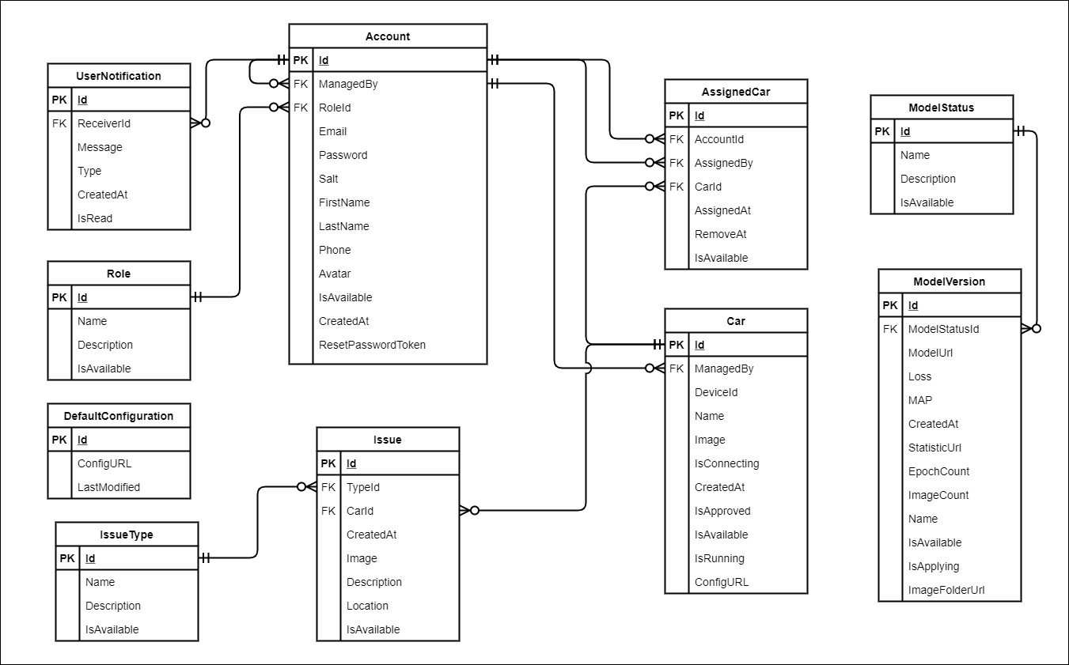

[Figure 75 – Entity Relationship Diagram](https://drive.google.com/file/d/1jX0lpvq5sirZo1q16elJ5utL-uECwvml/view?usp=sharing)

|  |  |  |
| --- | --- | --- |
| **#** | **Entity** | **Description** |
| 1 | Account | Account is an entity represents system member information that includes Admin, Manager and Staff |
| 2 | Role | Role is an entity represents role information |
| 3 | Car | Car is an entity represents system autonomous car |
| 4 | AssignedCar | AssignedCar is an entity represents the relationship of Staff and Car |
| 5 | ModelVersion | ModelVersion is an entity represents deep-learning model for detection |
| 6 | Issue | Issue is an entity represents car’s issue |
| 7 | UserNotification | UserNotifications an entity represents user’s notification |
| 8 | IssueType | IssueType is an entity represents type of car issue |
| 9 | ModelStatus | ModelStatus is an entity represents status of model version |
| 10 | DefaultConfiguration | Configuration is an entity represents car’s default configuration |

## 4. Non-Functional Requirements

### 4.1 External Interfaces

#### a. User Interfaces

UI-1: GUI has to be friendly to use.

UI-2: Languages used in the application is English and Vietnamese.

UI-3: UI can be responsive on multiple screen sizes.

UI-4: Mobile application follows Ant Design.

UI-5: Web applications follow Ant Design.

#### b. Software Interfaces

SI-1: File Storage Service

SI-1.1: AVC integrates with Firebase Storage and uses its file upload API

SI-2: Real-time Message Transform Service

SI-2.1: AVC can integrate with SignalR Real-time Message Transform Service to transform messages between web applications, mobile applications and Raspberry Pi.

#### c. Hardware Interfaces

AVC System requires a car model to drive autonomously and send issues notification. AVC System also requires an ongoing machine (computer or laptop) with GPU and a strong network connection for training models. Like other systems, AVC just requires basic devices for input, output as a personal computer or laptop and smartphone. All devices must have internet permission for smartphones.

#### d. Communications Interfaces

AVC System’s communication interfaces depend on sending and retrieving data through online protocol to connect between applications.

### 4.2 Quality Attributes

#### a. Usability

* Web Applications and Mobile Application UI/UX follows Ant Design to be user-friendly and consistent throughout the system.
* Admin, Manager and Staff can use AVC with less than a day of guidance.

#### b. Reliability

* AVC failure is less than 5% and availability of the system is over 80%.
* Mean time to hotfix and deploy is less than 6 hours.

#### c. Performance

* Staff’s mobile application transforms stop or start car real-time signals through SignalR needs under 3 seconds.
* Autonomous Car pushes issue notifications Manager Web Application and Staff Mobile Application under 3 seconds.
* AVC needs under 100ms to detect and self-drive.
* All common response time is under 3 seconds.

#### d. Dependability

##### d1. Security

* AVC always checks authorization
* Each role can only access its own functions
* Account must be unique, password must be encrypted

##### d2. Safety

* Staff can not update car information.
* No one can remove or change the central detection model.

#### e. Supportability

* AVC system supports handy controlled functions for staff on the mobile application.

#### f. Design Constraints

* Application language is English and Vietnamese
* The application uses TypeScript to increase maintainability, integrated.

#### g. Support Documents

* AVC supports online user documentation for each role.

#### h. Purchased Components

* Azure Web Service
* Azure SignalR Service
* Azure Database
* Firebase Storage

## 5. Other Requirements

### 5.1 Messages List

|  |  |  |  |  |
| --- | --- | --- | --- | --- |
| **#** | **Message code** | **Message Type** | **Context** | **Content** |
| 1 | MSG01 | In red, hint box | Input-required fields are empty. | The * field is required! |
| 2 | MSG02 | In red, hint box | Input email field is invalid. | Please enter a valid email address! |
| 3 | MSG03 | In red, hint box | Input password confirm field is not match to value in password field. | Password confirm must match to your password! |
| 4 | MSG04 | Inline, in green | Sending password reset request successfully | We sent recovery link to your mailbox. Please check to receive the token. |
| 5 | MSG05 | Inline, in green | Resetting password successfully | You have reset your password. Let's log in with new password |
| 6 | MSG06 | Toast message, in red | Email or password is not correct when clicking login | Your email or password is seem to be wrong. Please try again. |
| 7 | MSG07 | Toast message, in red | The user's account was deactivated | Your account is deactivated |
| 8 | MSG08 | Toast message, in red | The security key for resetting password is not correct | Reset Password failed. Sorry, please try again later. |
| 9 | MSG09 | Toast message, in green | Login successfully | You're logged in. Have a good time. |
| 10 | MSG10 | Toast message, in red | Email account does not exist in the system | Forgot Password failed. Sorry, please try again later. |
| 11 | MSG11 | Toast message, in green | Change password successfully | Your password has been changed successfully. |
| 12 | MSG12 | Toast message, in red | The old password is incorrect | Your current password seem to be incorrect. Let's try again. |
| 13 | MSG13 | Toast message, in green | Update profile information successfully | Account has been created successfully. |
| 14 | MSG14 | In red, hint box | Phone number value is incorrect | Wrong phone number format! |
| 15 | MSG15 | Toast message, in red | Network disconnected | Network disconnected. You are offline. All actions will be discarded. Please reconnect as soon as possible. |
| 16 | MSG16 | Toast message, in green | Network reconnected | Network connected You are reconnected. Please refresh your site to continue. |
| 17 | MSG17 | Toast message, in green | Approving car successfully | Approve Car. Car has been updated successfully. |
| 18 | MSG18 | Inline, in green | Don't have result exist in system. | There is no matching result! |
| 19 | MSG19 | Toast message, in green | Update car detail successfully | Update Car Car has been updated successfully. |
| 20 | MSG20 | Toast message, in green | Create staff successfully | Create Staff @Name has been created successfully. |
| 21 | MSG21 | Toast message, in red | Create staff failed | Create Staff Create staff failed. Sorry, please try again later. |
| 22 | MSG22 | Toast message, in green | Create manager successfully | Create Manager @Name has been created successfully. |
| 23 | MSG23 | Toast message, in red | Create manager failed | Create Manager Create manager failed. Sorry, please try again later. |
| 24 | MSG24 | Toast message, in green | Update car configuration successfully | Update Configuration successful Your configuration has been updated successful. |
| 25 | MSG25 | Toast message, in green | Update staff successfully | Update Staff @Name has been updated successfully. |
| 26 | MSG26 | Toast message, in red | Update staff failed | Update Staff @Name has been updated failed. |
| 27 | MSG27 | Toast message, in green | Update manager successfully | Update Manager @Name has been updated successfully. |
| 28 | MSG28 | Toast message, in red | Update manager failed | Update Manager @Name has been updated failed. |
| 29 | MSG29 | Toast message, in green | Send dataset successfully. | Send dataset successfully. |
| 30 | MSG30 | Toast message, in red | Duplicated image | Oops! Invalid Image @Filename (@Filesize) File already uploaded. |
| 31 | MSG31 | Inline, in red | File exceeds maximum size | File exceeds size 512 KB |
| 32 | MSG32 | Inline, in red | Wrong file format | Wrong file format |
| 33 | MSG33 | Inline, in red | File exceeds maximum size | File exceeds size 51.2 MB |
| 34 | MSG34 | Toast message, in red | Image reach maximum count | Upload failed, image count reach maximum number |
| 35 | MSG35 | Inline, in black | No car in connecting state found | No car in connecting state |
| 36 | MSG36 | Inline, in black | No car in disconnecting state found | No car in disconnecting state |
| 37 | MSG37 | Toast message, in red | The autonomous car is disconnecting. | Car is disconnected. |
| 38 | MSG38 | Toast message, in red | Car got issue | The car @Name has just got an issue, please check for details. |
| 39 | MSG39 | Toast message, in green | Manager assigns car | You have just been assigned a car from your manager, please check for details. |
| 40 | MSG40 | Toast message, in green | Admin assign staff to manager | You have been assigned to manager @Name. |
| 41 | MSG41 | Toast message, in green | Admin assign staff to manager | Staff @Name has been assigned to you, please check for detail. |
| 42 | MSG42 | Toast message, in green | Admin assign car to manager | A car has been assigned to you, please check for detail. |
| 43 | MSG43 | Toast message, in red | Deactivate account | Staff @Name has been deactivated and removed from your management list. |
| 44 | MSG44 | Toast message, in red | Deactivate account | Manager @Name has been deactivated, any car assigned to you by that account will be removed. |
| 45 | MSG45 | Toast message, in red | Deactivate car | Car @Name has been deactivated and removed from your assigned list. |
| 46 | MSG46 | Toast message, in red | Deactivate car | Car @Name has been deactivated and removed from your management list. |
| 47 | MSG47 | Toast message, in green | Training model succeeded | New model is trained succeeded |
| 48 | MSG48 | Toast message, in red | Training model failed | New model is trained failed |
| 49 | MSG49 | Toast message, in red | Remove or change staff/manager manage the car | A car @Name has been removed from you, please check for detail. |
| 50 | MSG50 | Toast message, in red | Remove or change manager manage the staff | Staff @Name has been removed from you, please check for detail. |
| 51 | MSG51 | Toast message, in green | Car connected | Car @Name has been connected, please check for detail. |
| 52 | MSG52 | Toast message, in red | Car disconnected | Car @Name has been disconnected. |
| 53 | MSG53 | Toast message, in green | Running car | Car @Name is running now. |
| 54 | MSG54 | Toast message, in red | Stopping car | Car @Name has been stopped. |
| 55 | MSG55 | Toast message, in green | Apply model succeeded | Apply model update succeeded. |
| 56 | MSG56 | Toast message, in red | Email existed | Email has already existed. Sorry, please enter another one. |

# IV. Software Design Document

## 1. Overall Description

### 1.1 Assumptions

This system is designed basing on these following assumptions:

* Windows 10.
* Mac OS X 10.6
* Google Chrome 88.
* Android 6 or higher.
* SSMS 18.
* End-user has basic mobile and website knowledge.

### 1.2 Design Constraints

This system depends on network connection.

## 2. System Architecture Design

### 2.1 Overall Architecture

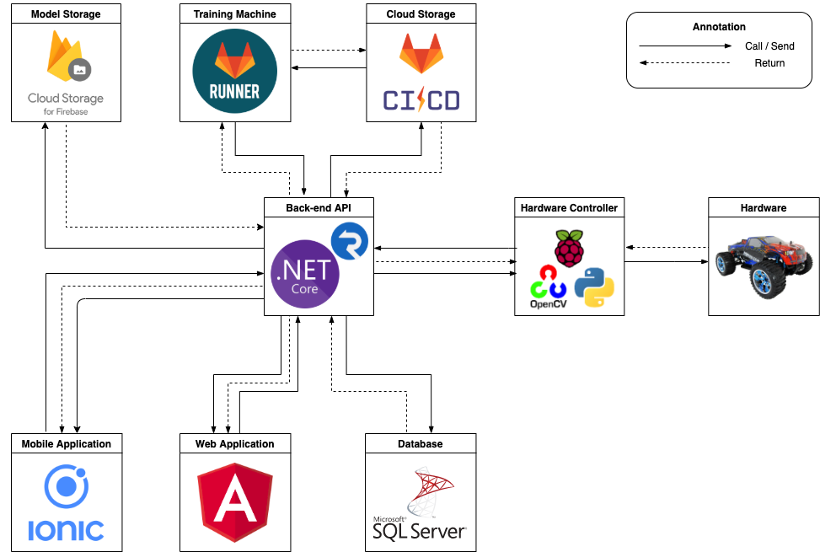

[Figure 76 - Overall Architecture Design](https://drive.google.com/file/d/1m4zlHKquiTgWzwn1sIiPghdjpfLJuakB/view?usp=sharing)

* The AVC system consists of four components. The important part of the system is that the Hardware Controller handles car models to drive autonomously. The .NET Core web server provides APIs and messaging service through SignalR. Angular framework is used for both web and mobile applications. The mobile application utilizes Ionic with Angular codebase used for reusing web components to build a hybrid application. The mobile application is used by the staff. The web application is provided for the admin and the managers only.
* The AVC System uses several third-party services such as Firebase Storage to store avatar and car images, Gitlab as secondary file storage includes versions of training models, GitlabCI for utilizing registering & remoting mechanism to train models by a local machine through internet.
* The AVC System uses Bash command and Python under the hood for edge devices with Linux-based OS connecting to the API server.

### 2.2 System Architecture

#### a. Web Application Architecture

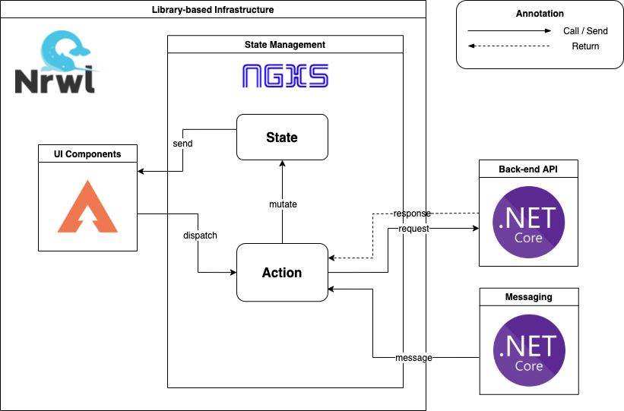

[Figure 77 - Web Application Architecture](https://drive.google.com/file/d/1xxcfkZ1NRiKcidroB0R8BIdd0UcEMe-s/view?usp=sharing=sharing)

Using Nrwl Workspace to develop projects faster and stronger with shareable libraries, improving scalability and maintainability. Setting up a workspace includes both the web application and mobile application in one place, a component or a specific business logic no more sharing alone, it makes those reusing among the applications in higher level. Taiga UI library improves UI/UX with less focus with NGXS State Management system allowing us to organize AVC Web Application.

#### b. Mobile Application Architecture

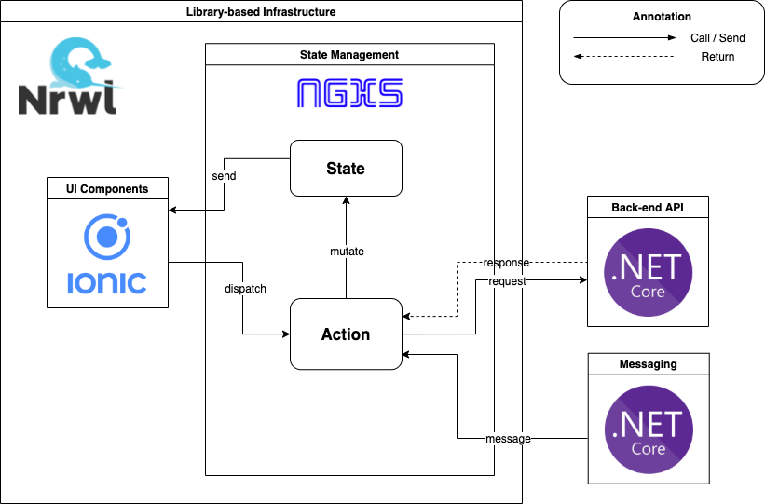

[Figure 78 - Mobile Application Architecture](https://drive.google.com/file/d/1ACLOBN4cyFYZKXW57hJ5eALDJsRQWKXj/view?usp=sharing)

#### c. Hardware Controller Architecture

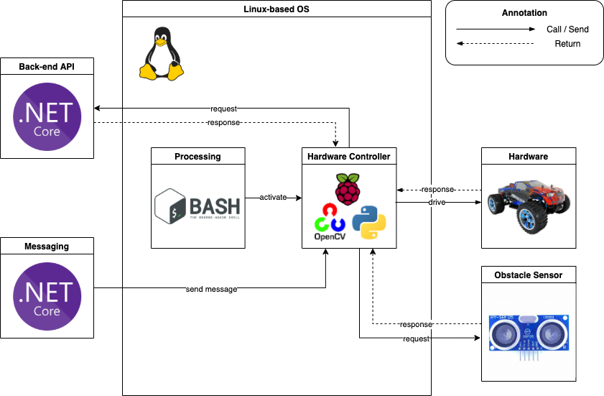

[Figure 79 - Hardware Controller Architecture](https://drive.google.com/file/d/1kqVZe5cT2iM2HoRCtfz5cMbEEvcv_oeD/view?usp=sharing)

### 2.3 Package Diagram

#### a. Web API Package Diagram

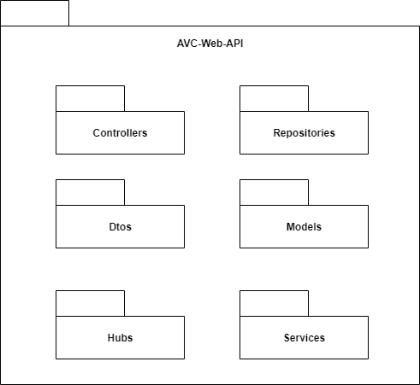

[Figure 80 - Web API Package Diagram](https://drive.google.com/file/d/1WhshszoeoLEje_HuwdZZ4STe3673K99V/view?usp=sharing)

|  |  |  |
| --- | --- | --- |
| **No** | **Package** | **Description** |
| 01 | Controller | * Package contains classes responsible for handling Http request and returning responses with values. |
| 02 | Service | * Package contains classes responsible for handling business logic, validation and communicate with repository. |
| 03 | Models | * Package contains classes represents the business logic entities, also responsible for entity framework database first. |
| 04 | DTOs | * Package contains classes responsible for sharping the data to return to clients. |
| 05 | Hubs | * Package contains classes responsible for open socket to mobile app, web app and car. |
| 06 | Repositories | * Package contains classes responsible for executing query and communicate with database. |

Table 21 - Web API Package Diagram Description

#### b. Web Application and Mobile Application Package Diagram

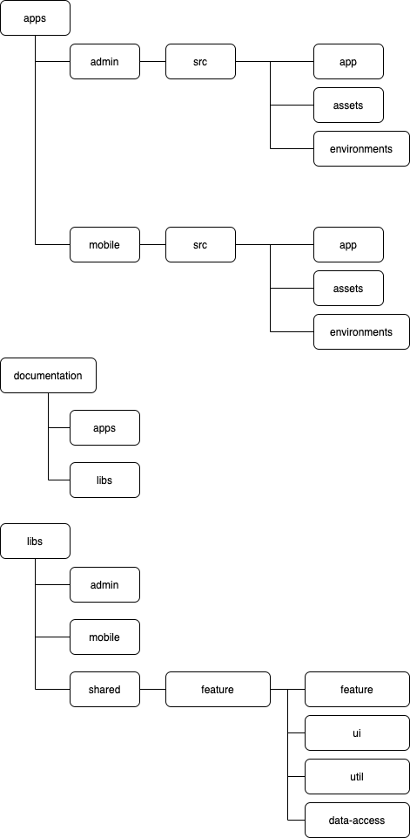

[Figure 81 - Web Application and Mobile Application Package](https://drive.google.com/file/d/1POLQaYzUgaprH3DbWE9vEyNyilZ8cDz9/view?usp=sharing) Diagram

By using Nx Workspace, maximize reusability and maintainability, Web Application and Mobile Application are integrated into 1 workspace and 1 repository management.

|  |  |  |
| --- | --- | --- |
| **No** | **Package** | **Description** |
| 01 | apps | Contains 2 projects: admin stands for the Web Application, mobile stands for Mobile Application |
| 02 | src | Contains all source codes or any kind of project code-related assets. |
| 03 | app | Contains initialized code for that project. |
| 04 | assets | Contains local images, icons, fonts, kinds of static files. |
| 05 | environments | Contains pre-configuration constant for using throughout the app. |
| 06 | documentation | Contains generated documents for each project or library based on intentional exported API. |
| 07 | libs | Contains specific application folders and a shared folder that provides shareable libraries |
| 08 | shared/admin/mobile | Contains feature folders for each project |
| 09 | feature | Contains libraries for specific feature, splitted into 4 kinds of library such as feature, ui, util, data-access |
| 10 | feature | Contains routes and related dependencies for that feature |
| 11 | ui | Contains components or pages that are used in the feature library. |
| 12 | util | Contains business logic processing, functions, helper classes. |
| 13 | data-access | Contains a store known as State Management for that feature, which includes state, state model, and feature-related actions. |

Table 22 - Web Application Package Diagram Description

#### c. Hardware Controller Application Package Diagram

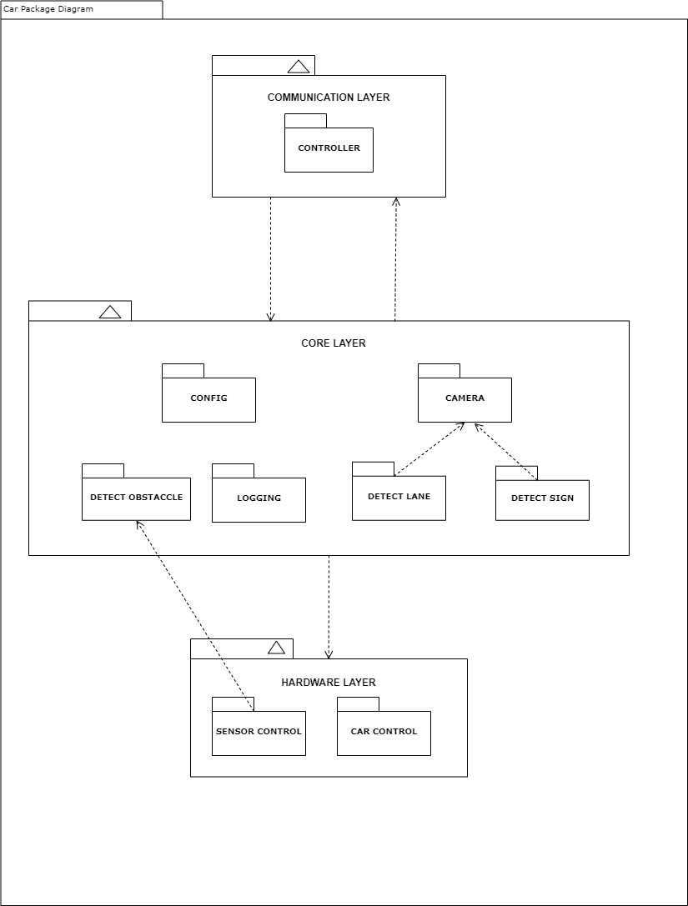

[Figure 82- Hardware Controller Application Package Diagram](https://drive.google.com/file/d/1oLZCHc9QZITzx9C6fa0yaArtpuwAXb9V/view?usp=sharing)

|  |  |  |
| --- | --- | --- |
| **No** | **Package** | **Description** |
| 01 | Controller | Package contains classes responsible for communicating with API. |
| 02 | Config | Package contains all configuration of system |
| 03 | Detect Lane | Package contains classes responsible for process and predict result for lane detection. |
| 04 | Detect Sign | Package contains classes responsible for process and predict results for traffic sign detection and traffic light detection. |
| 05 | Detect Obstacle | Package contains classes responsible for detecting obstacles and providing distance from obstacles to the car. |
| 06 | Logging | Package contains logging files such and images. |
| 07 | Camera | Package contains classes responsible for getting images from the camera. |
| 08 | Car Control | Package contains classes responsible for controlling signal of electric circuit, that controls speed and servo of car |
| 09 | Sensor Control | Package contains classes responsible for getting signals from sensors. |

Table 23 - Hardware Controller Application Package Diagram Description

## 3. System Detailed Design

### 3.1 Overall

#### a. Class Diagram

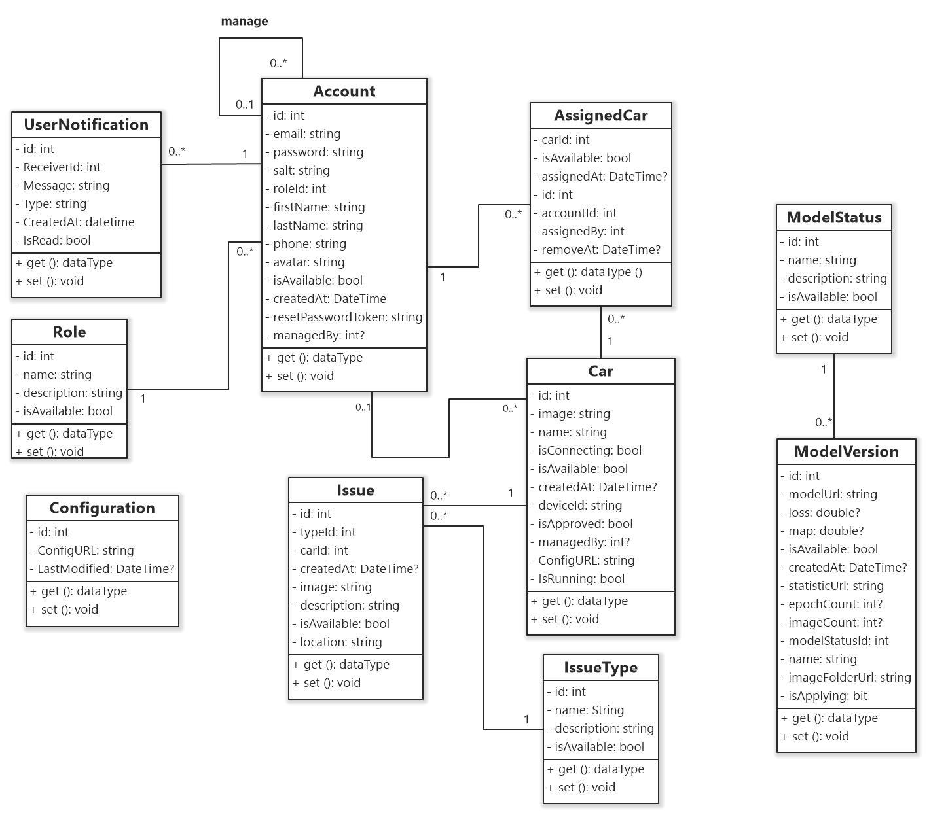

[Figure 83- Class Diagram](https://drive.google.com/file/d/15yaVKG7JghE6_b1WTbSBx7VdvmShnrsk/view?usp=sharing)

#### b. Class Specification

##### b1. Account

|  |  |  |
| --- | --- | --- |
| **Field name** | **Type** | **Description** |
| Id | int | Unique identifier of Account |
| Email | string | Contains email information of account |
| Password | string | Contains password of account |
| Salt | string | Contains salt to hash password of account |
| RoleId | int | The identifier of Role |
| FirstName | string | Contains First-name information of account |
| LastName | string | Contains Last-name information of account |
| Phone | string | Contains Phone information of account |
| Avatar | string | Contains Avatar information of account |
| IsAvailable | bool | Contains Available status of account |
| CreateAt | DateTime | Contains Created time information of account |
| ResetPasswordToken | string | Contains verify token to reset password information of account |
| Managedby | int? | The identifier of staff’s manager account |

Table 24 - <Class Diagram Attributes> Account

|  |  |  |
| --- | --- | --- |
| **Method** | **Return type** | **Description** |
| get | data type | Get attribute value |
| set | void | Set value of attribute |

Table 25 - <Class Diagram Methods> Account

##### b2. AssignCar

|  |  |  |
| --- | --- | --- |
| **Field name** | **Type** | **Description** |
| CarId | int | The Identifier of Car |
| IsAvailable | bool | Contains available status of assign car |
| AssignedAt | DateTime | Contains record created time information of assign car |
| Id | int | Unique identifier of assign car |
| AccountId | int | The identifier of account |
| AssignedBy | int | The identifier of assigner account |
| RemoveAt | DateTime? | Contains removed time information of assign car |

Table 26 - <Class Diagram Attributes> AssignCar

|  |  |  |
| --- | --- | --- |
| **Method** | **Return type** | **Description** |
| get | data type | Get attribute value |
| set | void | Set value of attribute |

Table 27 - <Class Diagram Methods> AssignCar

##### b3. Car

|  |  |  |
| --- | --- | --- |
| **Field name** | **Type** | **Description** |
| Id | int | Unique identifier of Car |
| Image | string | Contains image url information of car |
| Name | string | Contains name information of car |
| IsConnecting | Bool | Contains connection status information of car |
| IsAvailable | Bool | Contains available status information of car |
| CreatedAt | DateTime | Contains created time information of car |
| DeviceId | string | Contains unique device id information of car |
| IsApproved | bool | Contains approval status information of car |
| ManagedBy | int? | Contains car’s manager account identifier |
| IsRunning | bit | Contain running status information of car |
| ConfigURL | string | Contains car’s configuration link |

Table 28 - <Class Diagram Attributes> Car

|  |  |  |
| --- | --- | --- |
| **Method** | **Return type** | **Description** |
| get | data type | Get attribute value |
| set | void | Set value of attribute |

Table 29 - <Class Diagram Methods> Car

##### b4. UserNotification

|  |  |  |
| --- | --- | --- |
| **Field name** | **Type** | **Description** |
| Id | int | Unique identifier of User Notification |
| ReceiverId | int | The identifier of account |
| Message | string | Contains notification’s message |
| Type | string | Contains notification’s type |
| IsRead | bit | Contains read status information of notification |
| CreatedAt | datetime | Contains create time information of notification |

Table 30 - <Class Diagram Attributes> CarConfig

|  |  |  |
| --- | --- | --- |
| **Method** | **Return type** | **Description** |
| get | data type | Get attribute value |
| set | void | Set value of attribute |

Table 31 - <Class Diagram Methods> CarConfig

##### b5. DefaultConfiguration

|  |  |  |
| --- | --- | --- |
| **Field name** | **Type** | **Description** |
| Id | int | Unique identifier of configuration |
| ConfigUrl | string | Contains file url of configuration |
| LastModified | DateTime | Contains last modified time information of configuration |

Table 32 - <Class Diagram Attributes> Configuration

|  |  |  |
| --- | --- | --- |
| **Method** | **Return type** | **Description** |
| get | data type | Get attribute value |
| set | void | Set value of attribute |

Table 33 - <Class Diagram Methods> Configuration

##### b6. Issue

|  |  |  |
| --- | --- | --- |
| **Field name** | **Type** | **Description** |
| Id | int | Unique identifier of issue |
| TypeId | int | The identifier of issue type |
| CarId | int | The identifier of car |
| CreatedAt | DateTime | Contains create time of issue |
| Image | string | Contains illustrating image url information of issue |
| Description | string | Contains description information of issue |
| IsAvailable | bool | Contains available status information of issue |
| Location | string | Contains location description information of issue |

Table 34 - <Class Diagram Attributes> Issue

|  |  |  |
| --- | --- | --- |
| **Method** | **Return type** | **Description** |
| get | data type | Get attribute value |
| set | void | Set value of attribute |

Table 35 - <Class Diagram Methods> Issue

##### b7. IssueType

|  |  |  |
| --- | --- | --- |
| **Field name** | **Type** | **Description** |
| Id | int | Unique identifier of issue type |
| Name | string | Contains name information of issue type |
| Description | string | Contains description information of issue type |
| IsAvailable | bool | Contains available status information of issue type |

Table 36 - <Class Diagram Attributes> IssueType

|  |  |  |
| --- | --- | --- |
| **Method** | **Return type** | **Description** |
| get | data type | Get attribute value |
| set | void | Set value of attribute |

Table 37 - <Class Diagram Methods> IssueType

##### b8. ModelStatus

|  |  |  |
| --- | --- | --- |
| **Field name** | **Type** | **Description** |
| Id | int | Unique identifier of model status |
| Name | string | Contains name information of model status |
| Description | string | Contains description information of model status |
| IsAvailable | bool | Contains available status information of model status |

Table 38 - <Class Diagram Attributes> ModelStatus

|  |  |  |
| --- | --- | --- |
| **Method** | **Return type** | **Description** |
| get | data type | Get attribute value |
| set | void | Set value of attribute |

Table 39 - <Class Diagram Methods> ModelStatus

##### b9. ModelVersion

|  |  |  |
| --- | --- | --- |
| **Field name** | **Type** | **Description** |
| Id | int | Unique identifier of Model Version |
| IsApplying | bit | Contains apply status of Model Version |
| ModelUrl | string | Contains model file url information of model version |
| Loss | double? | Contains loss information of model version |
| Map | double? | Contains mean Average Precision information of model version |
| IsAvailable | bool | Contains available status of model version |
| CreatedAt | DateTime | The create time information of model version |
| StatisticUrl | string | Contains statistic url information of model version |
| EpochCount | int? | Contains number of epoch information of model version |
| ImageCount | int? | Contains number of image information of model version |
| ModelStatusId | int | The identifier of model status |
| Name | string | Contains name information of model version |
| ImageFolderUrl | string | Contains images folder url information of model version |

Table 40 - <Class Diagram Attributes> ModelVersion

|  |  |  |
| --- | --- | --- |
| **Method** | **Return type** | **Description** |
| get | data type | Get attribute value |
| set | void | Set value of attribute |

Table 41 - <Class Diagram Methods> ModelVersion

##### b10. Role

|  |  |  |
| --- | --- | --- |
| **Field name** | **Type** | **Description** |
| Id | int | Unique identifier of role |
| Name | string | Contains name information of role |
| Description | string | Contains description information of role |
| IsAvailable | bool | Contains available status information of role |

Table 42 - <Class Diagram Attributes> Role

|  |  |  |
| --- | --- | --- |
| **Method** | **Return type** | **Description** |
| get | data type | Get attribute value |
| set | void | Set value of attribute |

Table 43 - <Class Diagram Methods> Role

#### c. Sequence Diagram(s)

##### c1 <Admin> Sequence Diagram(s)

###### c1.1 <Admin> Get Staff List

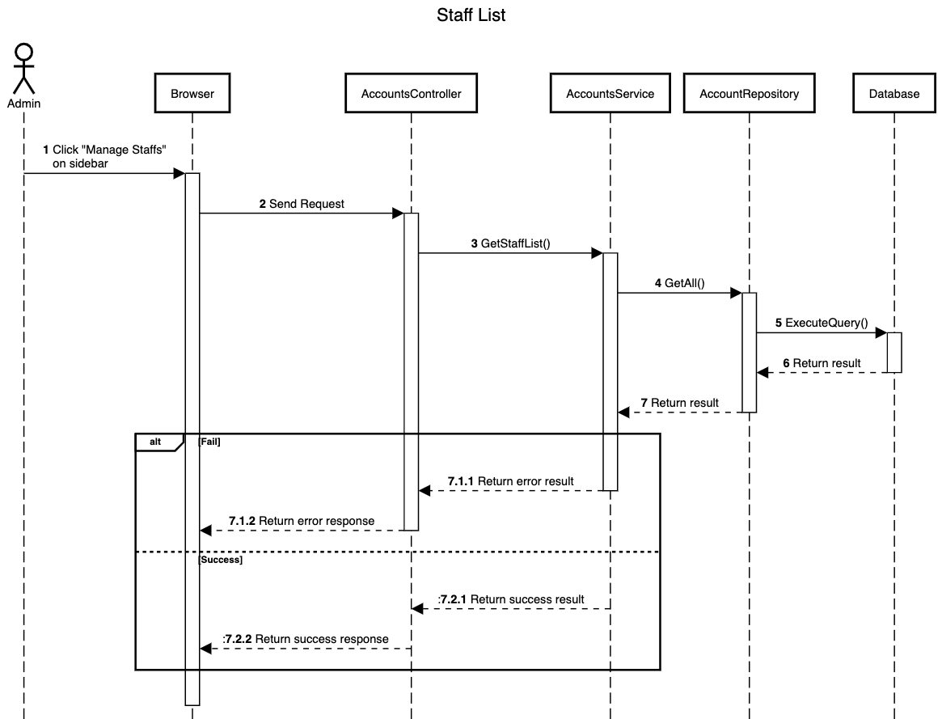

[Figure 84 - <Sequence Diagram> Get Manager List](https://drive.google.com/file/d/1pHjMqSlOc8HObZHzgHg8U5YTayVI2-Rl/view?usp=sharing)

###### c1.2 <Admin> Get Manager list

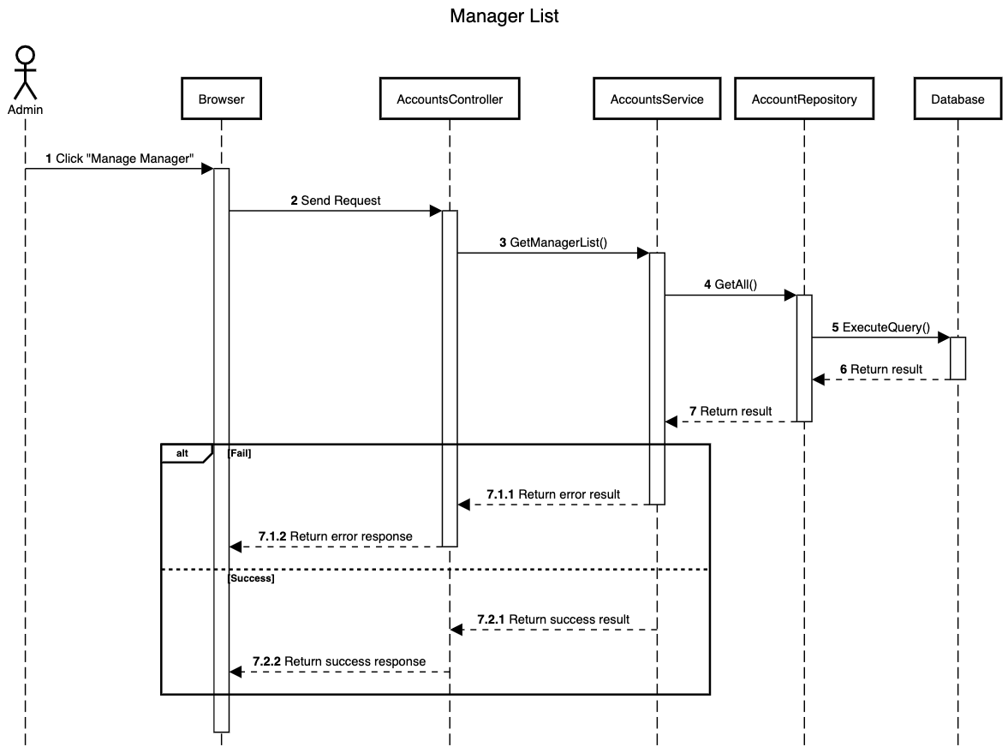

[Figure 85 - <Sequence Diagram>](https://drive.google.com/file/d/1tnSoo38gjcdsbv6XpAhGT4caWCT3MaPx/view?usp=sharing) Get Staff List

###### c1.3 <Admin> Get Manager Detail

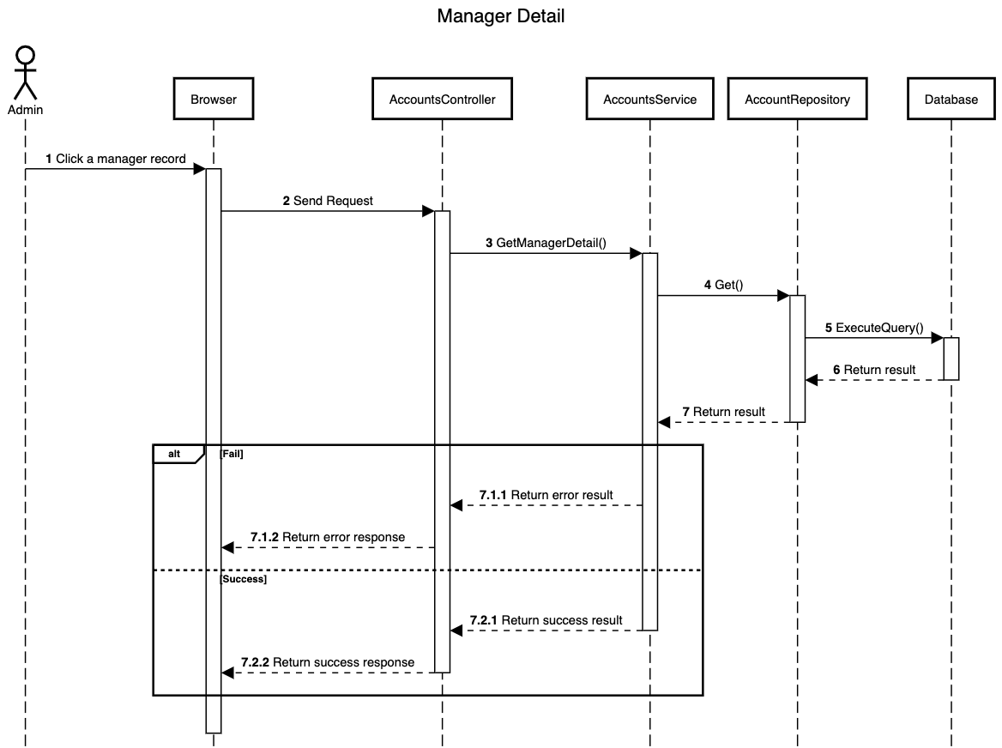

[Figure 86 - <Sequence Diagram> Get Manager Detail](https://drive.google.com/file/d/1mRNVYL1oLuT_5yyC62VSfCrs9copqGWZ/view?usp=sharing)

###### c1.4 <Admin> Get Staff Detail

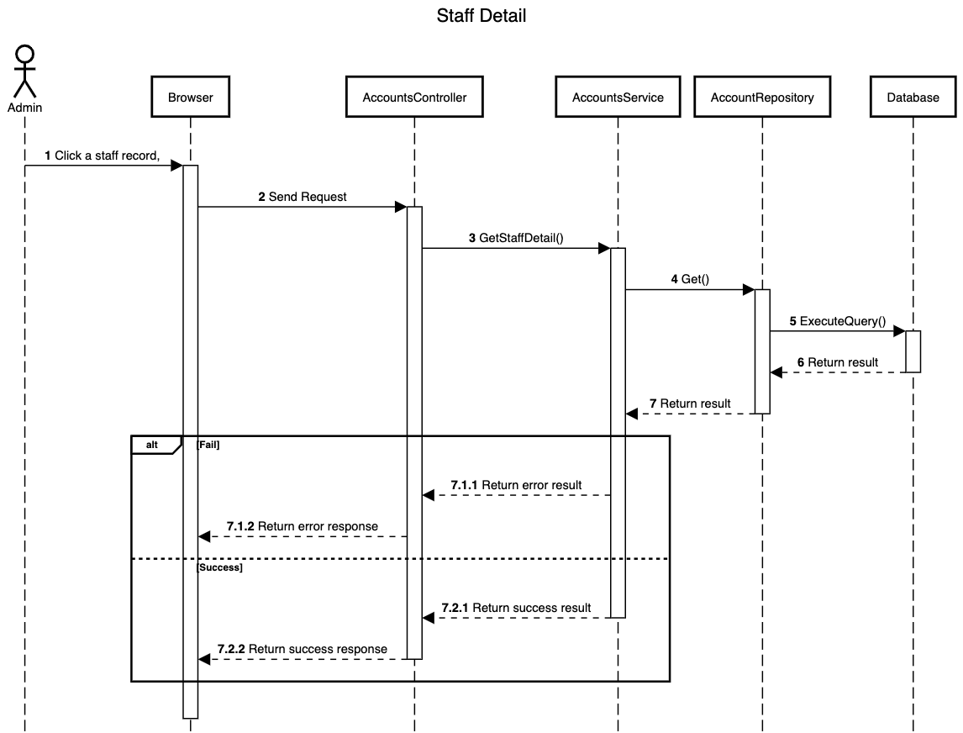

[Figure 87 - <Sequence Diagram> Get Staff Detail](https://drive.google.com/file/d/1hbBD3pTlfT3hRJ0iD5UojU00_KuYkzm1/view?usp=sharing)

###### c1.5 <Admin> Update Account Activation

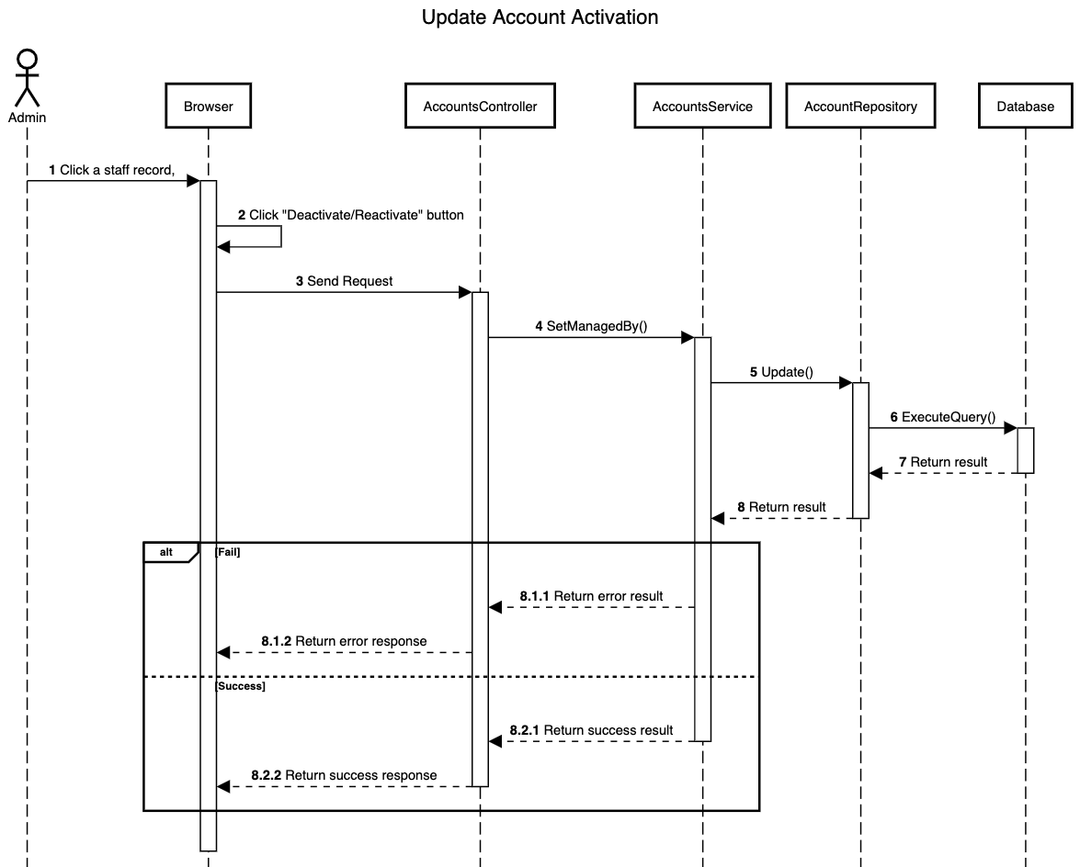

[Figure 88 - <Sequence Diagram> Update Account Activation](https://drive.google.com/file/d/1IZsMjZgWRNLMMxBOOkqYXKcqjlIKg9ps/view?usp=sharing)

###### c1.6 <Admin> Update Staff ManagedBy

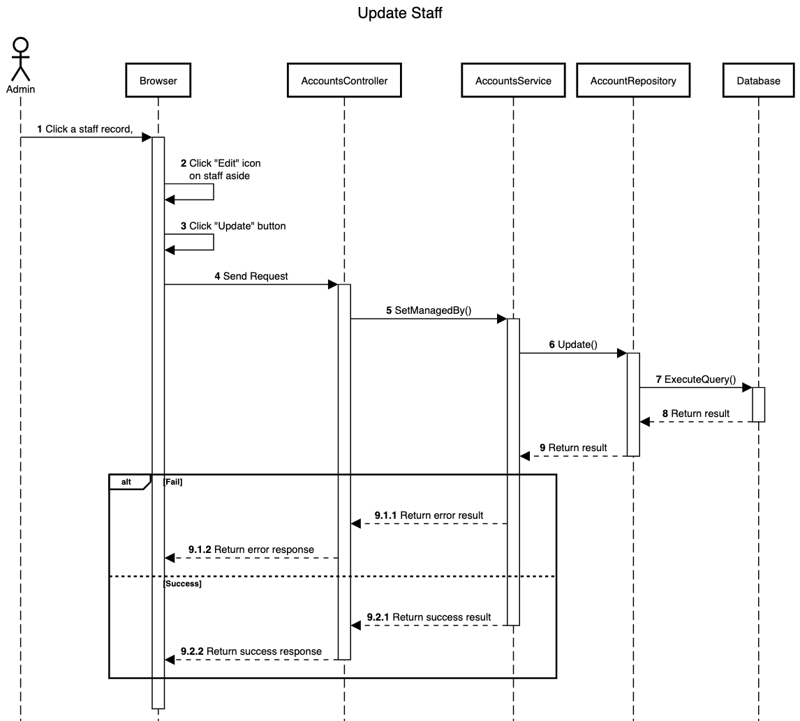

[Figure 89 - <Sequence Diagram> Update Staff ManagedBy](https://drive.google.com/file/d/1W_bofEdYnalYNQFHdBxiKlLJEfkNoEt5/view?usp=sharing)

###### c1.7 <Admin> Create Manager

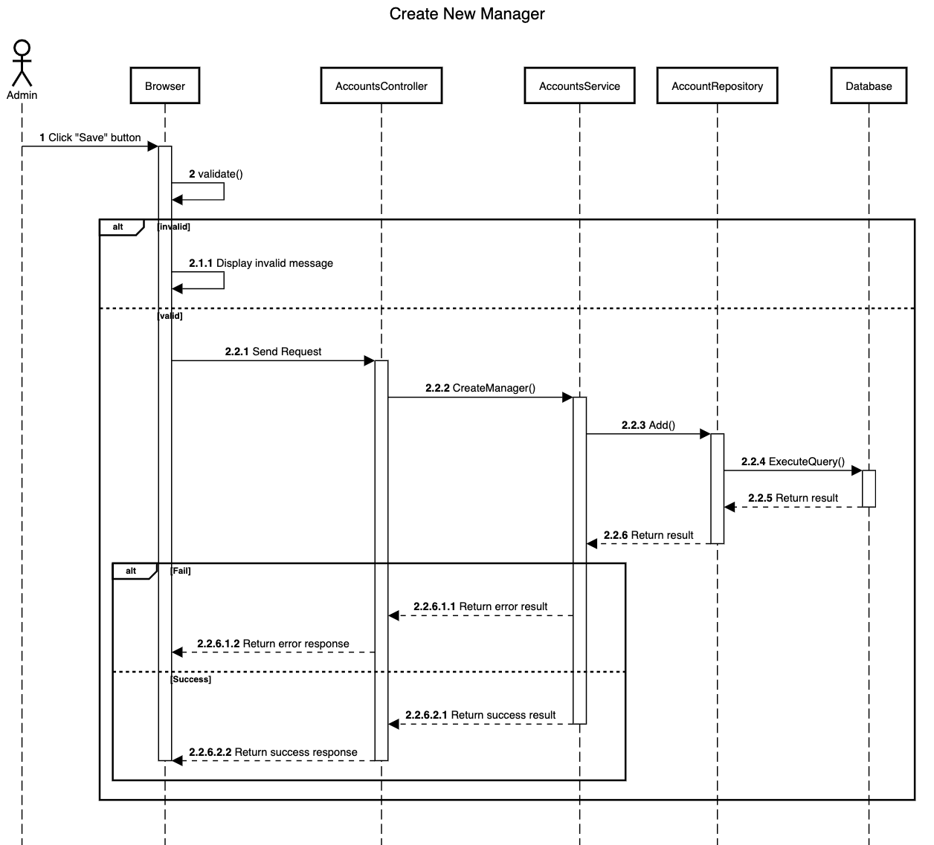

[Figure 90 - <Sequence Diagram> Create Manager](https://drive.google.com/file/d/1AeZjH1iYFqNFNOd9-Uq2kLA1H61CRUPC/view?usp=sharing)

###### c1.8 <Admin> Create Staff

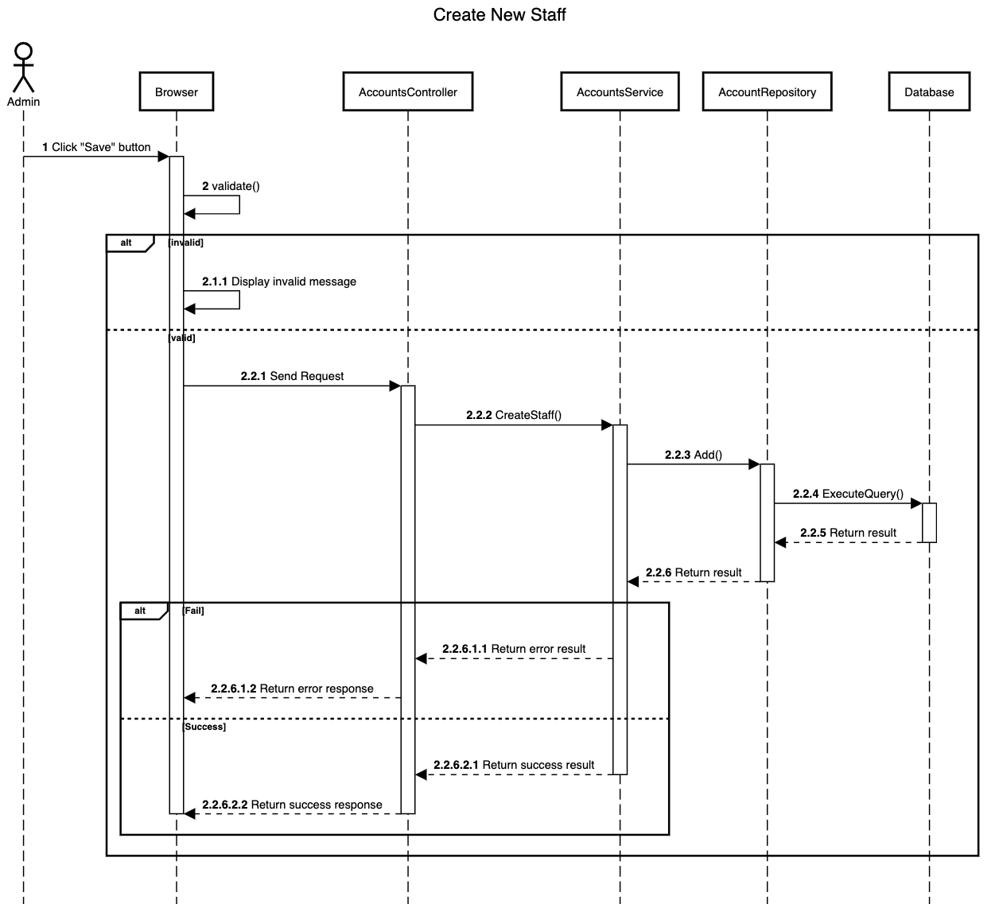

[Figure 91 - <Sequence Diagram> Create Staff](https://drive.google.com/file/d/1E5f_-S31THujHJ_OiueEJeQowtPIGhLK/view?usp=sharing)

###### c1.9 <Admin> Train Model

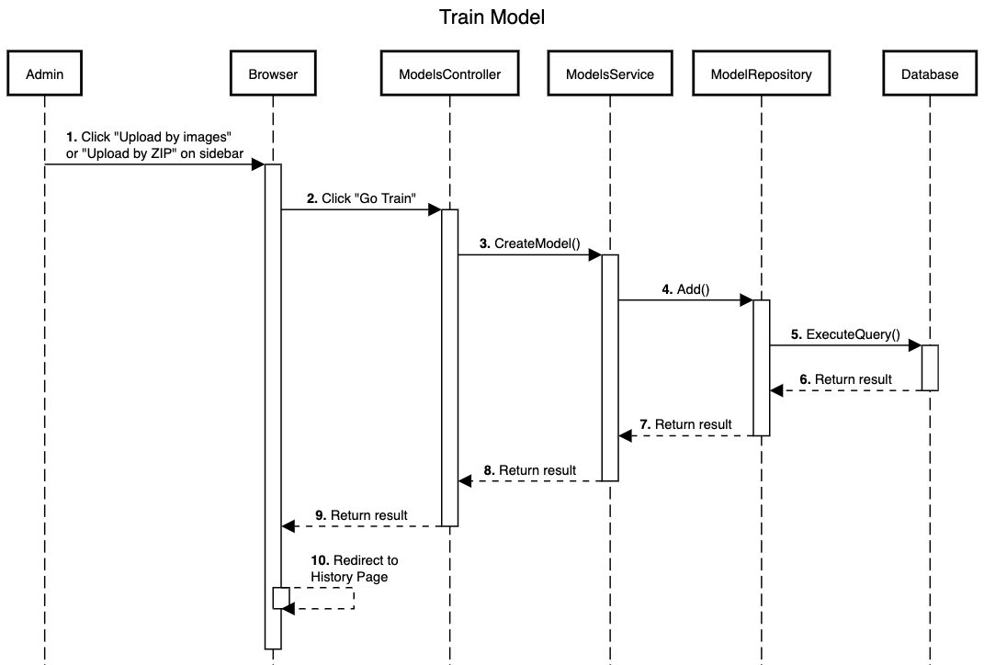

[Figure 92 - <Sequence Diagram> Train Model](https://drive.google.com/file/d/1Hz9FlSM7H5mZEq4SBhBXaWTbDsLmSKAx/view?usp=sharing)

#### d. Activity Diagram(s)

##### d1. <Unauthenticated User> Activity Diagram(s)

###### d1.1 <Unauthenticated User> Login

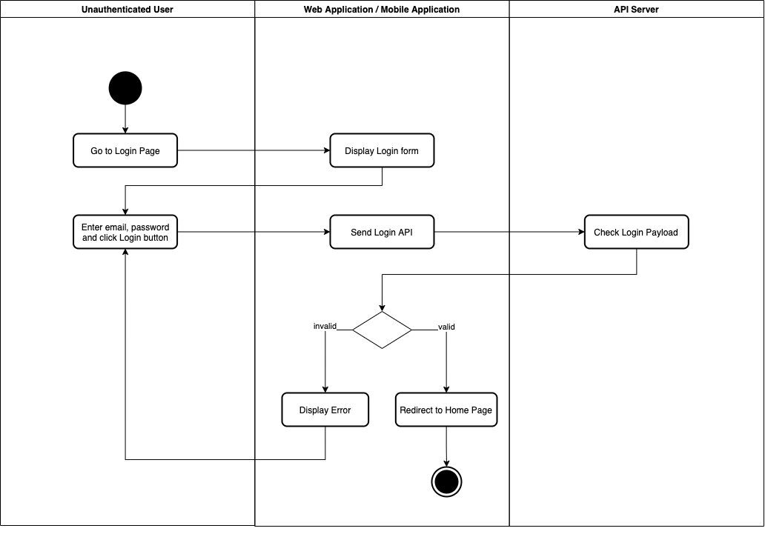

[Figure 93 - <Activity Diagram> Login](https://drive.google.com/file/d/1B_U0N1EB59xTgXuXcEwPGuxbfbDBskg5/view?usp=sharing)

###### d1.2 <Unauthenticated User> Forgot Password

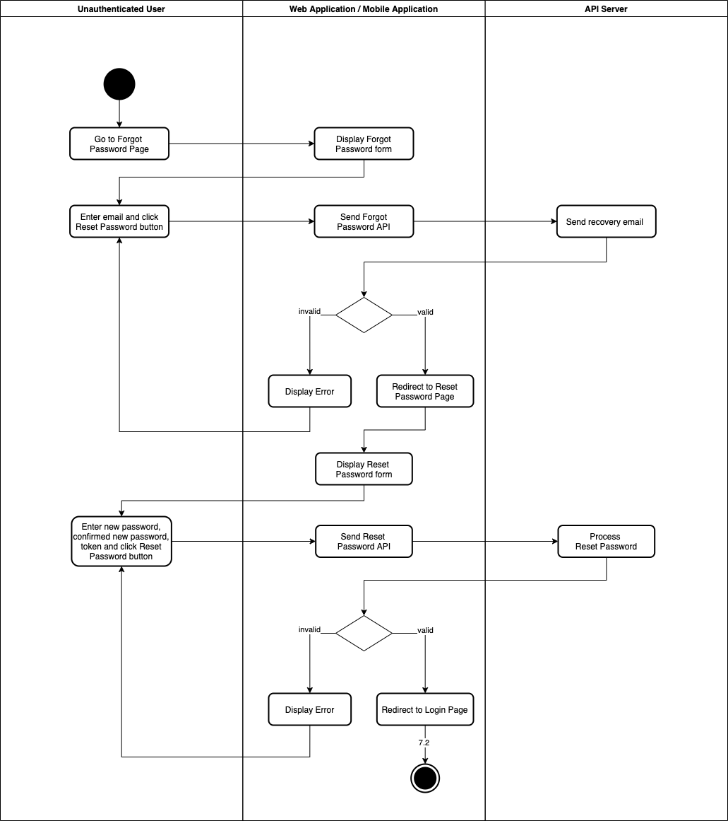

[Figure 94 - <Activity Diagram> Forgot Password](https://drive.google.com/file/d/1_njMey7hJjAkunwNB9TBs4Ahw1YrTxVd/view?usp=sharing)

##### d2. <Staff> Activity Diagram(s)

###### d2.1 <Staff> Change Password

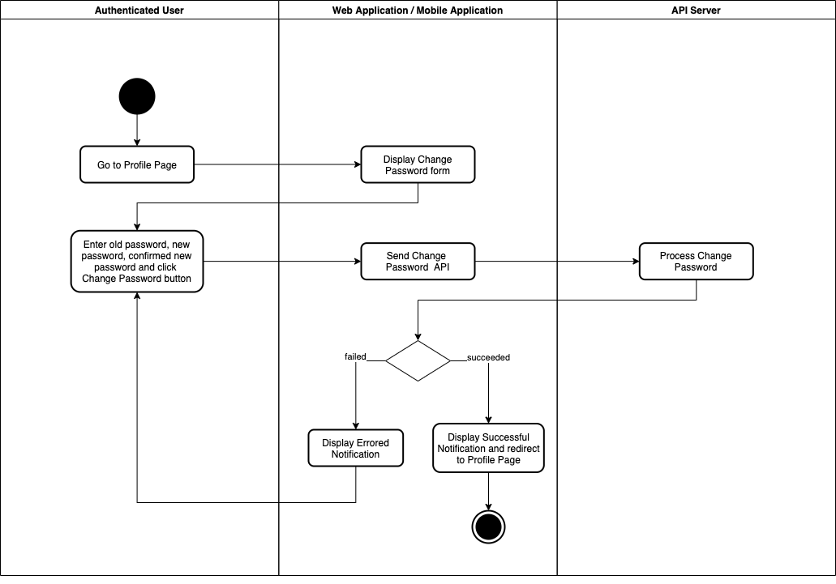

[Figure 95 - <Activity Diagram> Change Password](https://drive.google.com/file/d/1FNn1v-yfqilkK2kOrvfEsZBLh4DUFJ-5/view?usp=sharing)

###### d2.2 <Staff> Update Profile

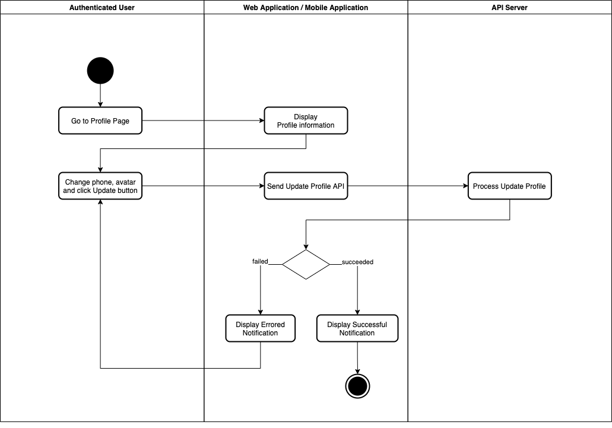

[Figure 96 - <Activity Diagram> Update Profile](https://drive.google.com/file/d/12igb9IljYGYA2WYFaRBD3Zgy-qQ5miP7/view?usp=sharing)

###### d2.3 <Staff> View Issue Detail

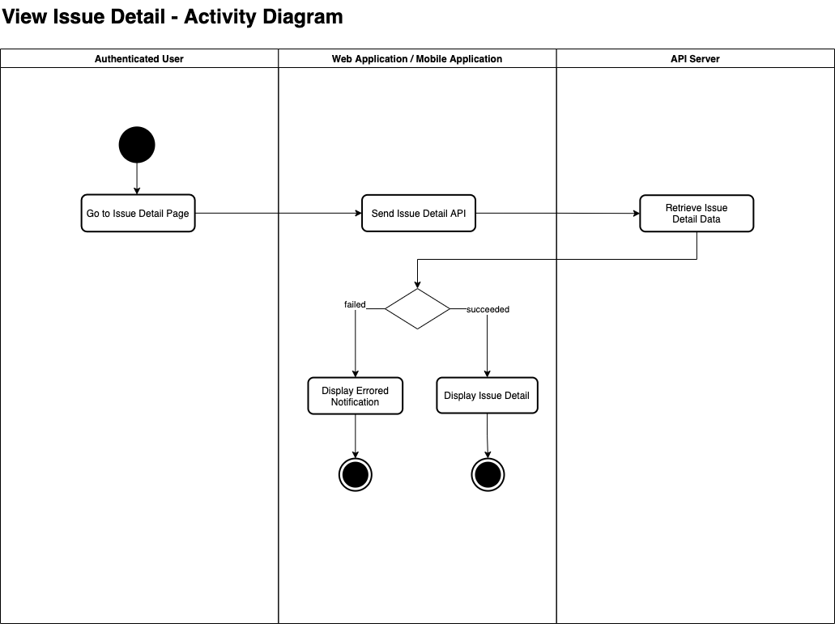

[Figure 97 - <Activity Diagram> View Issue Detail](https://drive.google.com/file/d/1TP1ZoLYTqKKOpL8QO-YKMYg5mIxGO9fW/view?usp=sharing)

###### d2.4 <Staff> View Car List

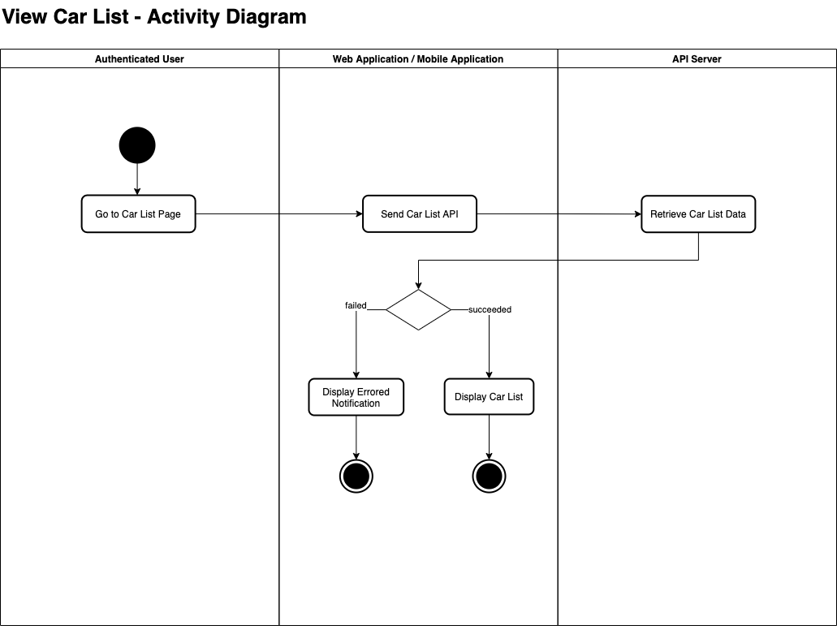

[Figure 98 - <Activity Diagram> View Car List](https://drive.google.com/file/d/1YkW7zO-5kRtjJbAEvJKk-J8OXKLhH0y-/view?usp=sharing)

###### d2.5 <Staff> View Car Detail

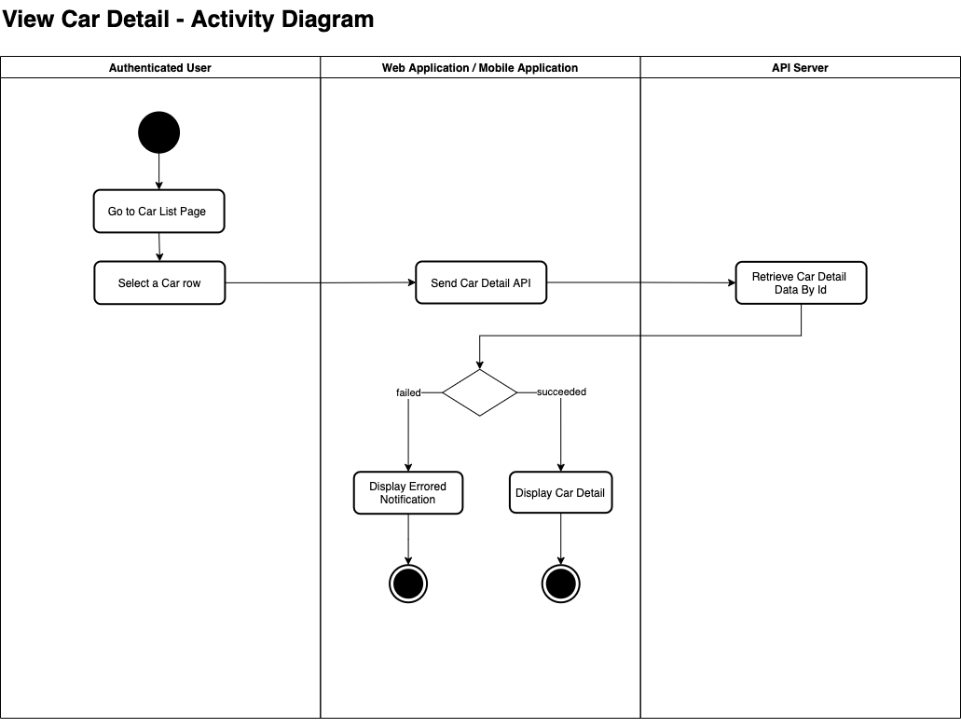

[Figure 99 - <Activity Diagram> View Car Detail](https://drive.google.com/file/d/1J1ouQChPBMQSbGyPAwF0zIpwl2UYeDao/view?usp=sharing)

###### d2.6 <Staff> Start Car

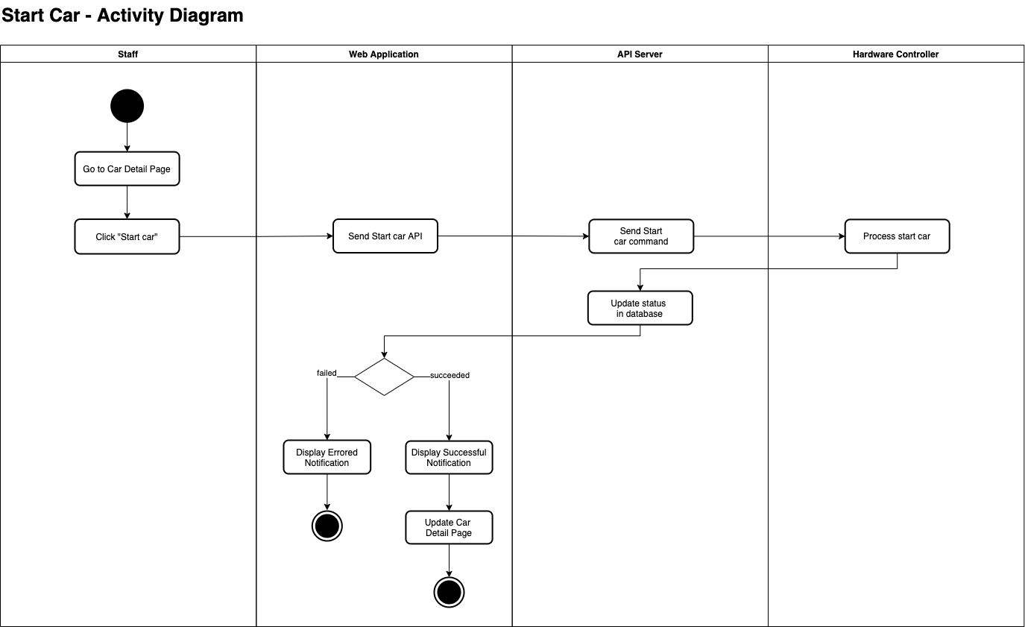

[Figure 100 - <Activity Diagram> Start Car](https://drive.google.com/file/d/1cbdp0St3_cxusrTEluIQzQdxepwKjqD5/view?usp=sharing)

###### d2.7 <Staff> Stop Car

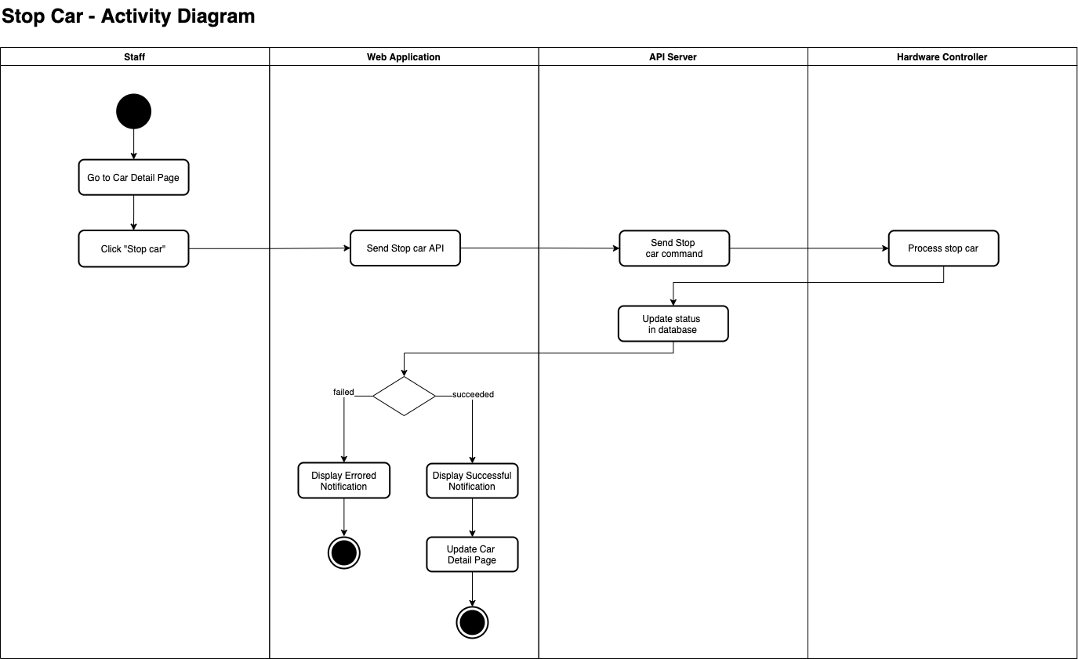

[Figure 101 - <ActivityDiagram> Stop Car](https://drive.google.com/file/d/1tnyuOjXEQ09lRzSrUjFBMF28_Zp9bzXp/view?usp=sharing)

## 4. Data & Database Design

### 4.1 Database Design

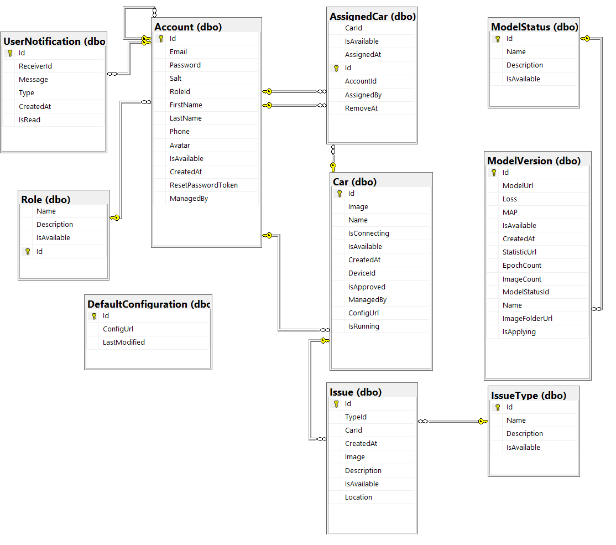

[Figure 102 - Database Design](https://drive.google.com/file/d/12-bFcAIOLYQ7_xqnC0ofAyLE-scpIAgI/view?usp=sharing)

#### a. Account

|  |  |  |  |  |  |
| --- | --- | --- | --- | --- | --- |
| **Field name** | **Type** | **Unique** | **Allow Nulls** | **PK/FK** | **Notes** |
| Id | int | X |  | PK |  |
| Email | varchar(255) | X |  |  |  |
| Password | varchar(100) |  |  |  |  |
| Salt | varchar(50) |  |  |  |  |
| RoleId | int |  |  | FK |  |
| FirstName | nvarchar(100) |  | X |  |  |
| LastName | nvarchar(100) |  | X |  |  |
| Phone | varchar(11) |  | X |  |  |
| Avatar | nvarchar(4000) |  | X |  |  |
| ResetPasswordToken | varchar(6) |  | X |  |  |
| ManagedBy | int |  | X | FK |  |
| IsAvailable | bit |  |  |  |  |
| CreatedAt | datetime |  |  |  |  |

Table 44 - <Physical Diagram> Account

#### b. AssignedCar

|  |  |  |  |  |  |
| --- | --- | --- | --- | --- | --- |
| **Field name** | **Type** | **Unique** | **Allow Nulls** | **PK/FK** | **Notes** |
| Id | int | X |  | PK |  |
| AccountId | int |  |  | FK |  |
| AssignedBy | int |  |  | FK |  |
| RemoveAt | datetime |  | X |  |  |
| CarId | int |  |  | FK |  |
| IsAvailable | bit |  |  |  |  |
| AssignedAt | datetime |  |  |  |  |

Table 45 - <Physical Diagram> AssignCar

#### c. Car

|  |  |  |  |  |  |
| --- | --- | --- | --- | --- | --- |
| **Field name** | **Type** | **Unique** | **Allow Nulls** | **PK/FK** | **Notes** |
| DeviceId | varchar(50) | X |  |  |  |
| ManagedBy | int |  | X | FK |  |
| Id | int | X |  | PK |  |
| Image | nvarchar(4000) |  | X |  |  |
| Name | nvarchar(4000) |  | X |  |  |
| IsConnecting | bit |  |  |  |  |
| IsApproved | bit |  |  |  |  |
| IsAvailable | bit |  |  |  |  |
| CreatedAt | datetime |  |  |  |  |
| IsRunning | bit |  |  |  |  |
| ConfigURL | string |  | X |  |  |

Table 46 - <Physical Diagram> Car

#### d. DefaultConfiguration

|  |  |  |  |  |  |
| --- | --- | --- | --- | --- | --- |
| **Field name** | **Type** | **Unique** | **Allow Nulls** | **PK/FK** | **Notes** |
| Id | int | X |  | PK |  |
| ConfigURL | string |  |  |  |  |
| LastModified | datetime |  | X |  |  |

Table 47 - <Physical Diagram> DefaultConfiguration

#### e. UserNotification

|  |  |  |  |  |  |
| --- | --- | --- | --- | --- | --- |
| **Field name** | **Type** | **Unique** | **Allow Nulls** | **PK/FK** | **Notes** |
| Id | int | X |  | PK |  |
| ReceiverId | int |  | X | FK |  |
| Message | nvarchar(4000) |  | X |  |  |
| Type | nvarchar(50) |  |  |  |  |
| IsRead | bit |  |  |  |  |
| CreatedAt | datetime |  |  |  |  |

Table 48 - <Physical Diagram> CarConfig

#### f. Issue

|  |  |  |  |  |  |
| --- | --- | --- | --- | --- | --- |
| **Field name** | **Type** | **Unique** | **Allow Nulls** | **PK/FK** | **Notes** |
| Image | nvarchar(4000) |  | X |  |  |
| Description | nvarchar(4000) |  | X |  |  |
| Location | nvarchar(100) |  | X |  |  |
| Id | int | X |  | PK |  |
| TypeId | int |  |  | FK |  |
| CarId | int |  |  | FK |  |
| IsAvailable | bit |  |  |  |  |
| CreatedAt | datetime |  |  |  |  |

Table 49 - <Physical Diagram> Configuration

#### g. IssueType

|  |  |  |  |  |  |
| --- | --- | --- | --- | --- | --- |
| **Field name** | **Type** | **Unique** | **Allow Nulls** | **PK/FK** | **Notes** |
| Id | int | X |  | PK |  |
| Name | varchar(50) |  |  |  |  |
| Description | nvarchar(4000) |  | X |  |  |
| IsAvailable | bit |  |  |  |  |

Table 50 - <Physical Diagram> IssueType

#### h. ModelStatus

|  |  |  |  |  |  |
| --- | --- | --- | --- | --- | --- |
| **Field name** | **Type** | **Unique** | **Allow Nulls** | **PK/FK** | **Notes** |
| Id | int | X |  | PK |  |
| Name | nvarchar(255) |  |  |  |  |
| Description | nvarchar(4000) |  | X |  |  |
| IsAvailable | bit |  |  |  |  |

Table 51 - <Physical Diagram> ModelStatus

#### i. ModelVersion

|  |  |  |  |  |  |
| --- | --- | --- | --- | --- | --- |
| **Field name** | **Type** | **Unique** | **Allow Nulls** | **PK/FK** | **Notes** |
| Id | int | X |  | PK |  |
| ModelUrl | nvarchar(4000) |  | X |  |  |
| Loss | float |  | X |  |  |
| MAP | float |  | X |  |  |
| StatisticUrl | nvarchar(4000) |  | X |  |  |
| EpochCount | int |  | X |  |  |
| ImageCount | int |  | X |  |  |
| Name | nvarchar(255) |  | X |  |  |
| ImageFolderUrl | nvarchar(4000) |  | X |  |  |
| IsApplying | bit |  |  |  |  |
| ModelStatusId | int |  |  | FK |  |
| IsAvailable | bit |  |  |  |  |
| CreatedAt | datetime |  |  |  |  |

Table 52 - <Physical Diagram> ModelVersion

#### j. Role

|  |  |  |  |  |  |
| --- | --- | --- | --- | --- | --- |
| **Field name** | **Type** | **Unique** | **Allow Nulls** | **PK/FK** | **Notes** |
| Name | varchar(50) |  |  |  |  |
| Description | nvarchar(4000) |  | X |  |  |
| Id | int | X |  | PK |  |
| IsAvailable | bit |  |  |  |  |

Table 53 - <Physical Diagram> Role

### 4.2 Data File Design

We use Firebase Storage to store images.

|  |  |  |  |
| --- | --- | --- | --- |
| **#** | **File Name** | **Type** | **Notes** |
| 1 | Account Avatar | Image | path: “/Avatar/{account-image-name}” |
| 2 | Issue image | Image | path: “/Issue/{uid}-{image-name}” |
| 3 | Car Image | Image | path: “/Car/{car-image-name}” |

Table 54 - Data File Design

## 5. Algorithm

### 5.1 Detect Lane

#### a. Define Problem

* If the delay time is not fast enough, it will make the car run out of the lane and then the camera will not see the lane.
* The camera’s image has the ratio distance of the lane different from a real because the camera is a spherical camera.

#### b. Requirement

* Real-time processing
* The algorithm must return an angle that is suitable for the car.

#### c. Solution

##### c1. Base Concept

* We decided to design one algorithm to detect lane based on two midpoints of a two-lane segment. Then, we use a simple trigonometric formula to compute the angle for the car.

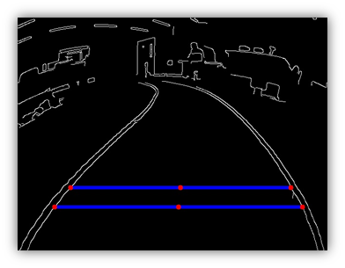

[Figure 103- Lane detection base idea](https://drive.google.com/file/d/10JWTMzZHnpA7Bpgv9eHPfxFc326jxWfK/view?usp=sharing)

##### c2. Terminology and parameters.

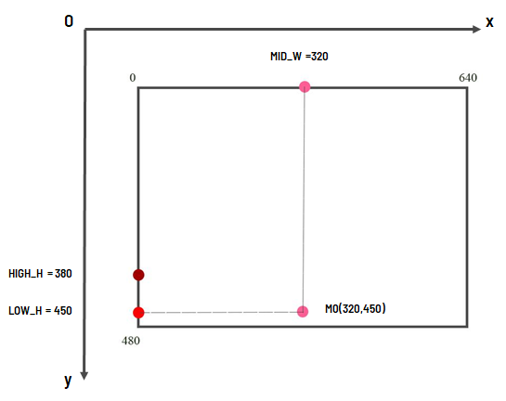

[Figure 104- Lane detection parameters](https://drive.google.com/file/d/12ngcKeFffff-3XQH45LE-zNXsE4wdR96/view?usp=sharing)

* Image coordinate system has the y-axis with top to bottom direction.
* We have x-max = 640 and y-max = 480 corresponding to max width and max height of input image.
* MID_W = x-max/2
* LOW_H and HIGH_H are get from configuration, it represents two points on the lane we want to choose midpoints.
* M0 has x value of MID_W and y value of LOW_H

##### c3. Process

**Preprocessing image:**

* We use the edge detect algorithm to find edges and result is an image with edges filled by white color.

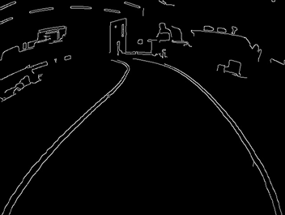

[Figure 105- Lane detection preprocessing step](https://drive.google.com/file/d/1yA7DxoyDySSiC7JMDNdbNUQH7yuCum3v/view?usp=sharing)

**Find C0:**

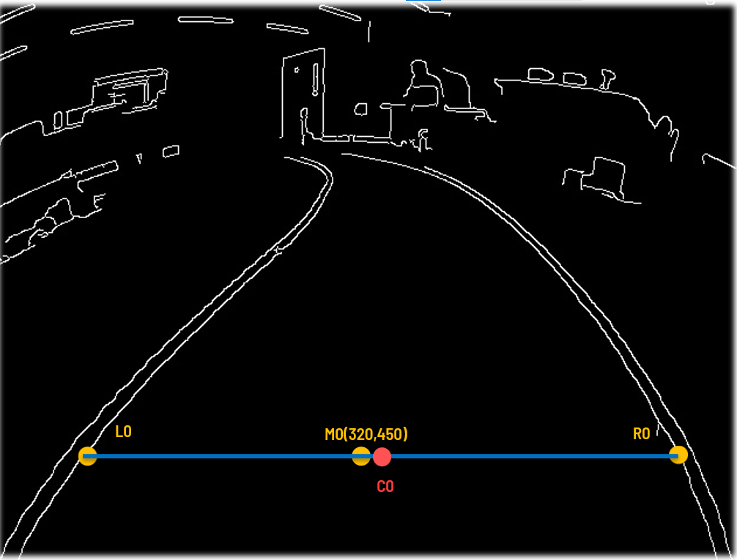

[Figure 106- Lane detection finding C0 step](https://drive.google.com/file/d/1RBTxF9k8Solptn-VgBZx_1jMBFi2nDZS/view?usp=sharing)

* From M0 (Pink point) slide each 1 px to left until find the white value point, that point is L0
* From M0 (Pink point) slide each 1 px to right until find the white value point, that point is R0
* The midpoint of the L0R0 line segment is C0.

**Find C1:**

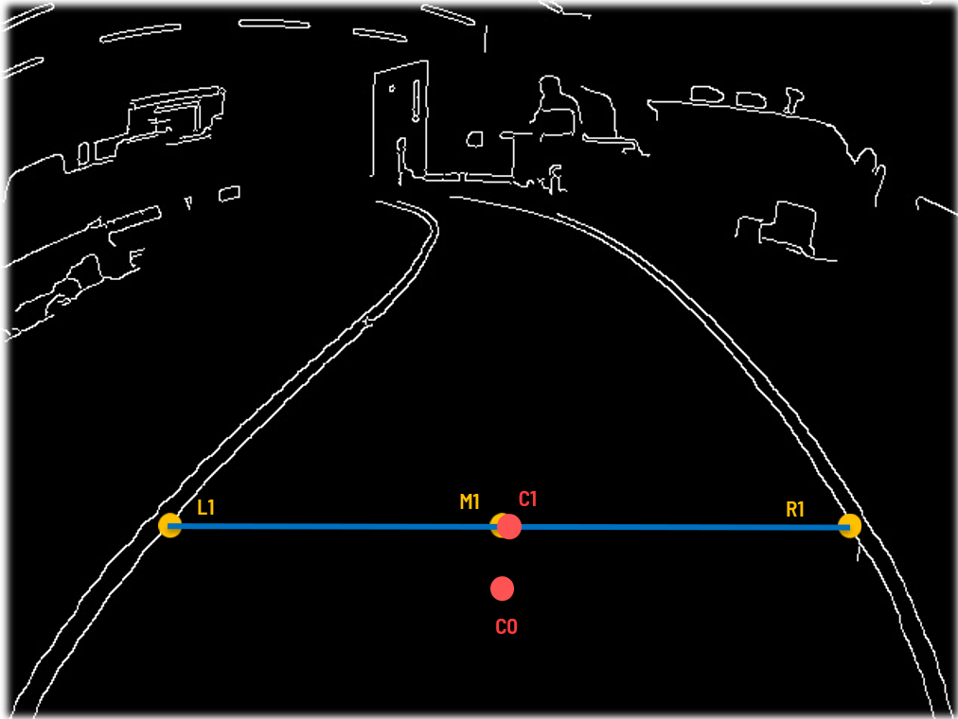

[Figure 107- Lane detection finding C1 step](https://drive.google.com/file/d/1zsVFGgfDSWoHT9o6es5MsL-HXEd0vwEP/view?usp=sharing)

* From C0 we move up and we have M1 with x value is x value of C0 and y value is value of HIGH_H. M1(C0x,HIGH_H)
* As C0, we slide left and right to find L1,R1. And C1 is the midpoint of the L1R1 line segment.

**Find Angle:**

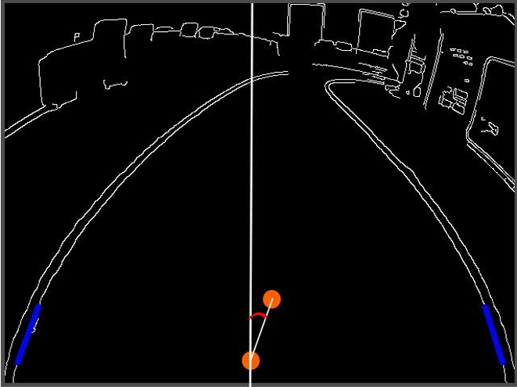

[Figure 108- Lane detection calculating angle step](https://drive.google.com/file/d/11fVzlDiqmftE5qt5UxTos0QA9a_9Sti5/view?usp=sharing)

* From C0, C1 we can compute the alpha angle



[Figure 109- Lane detection formula calculating based on image](https://drive.google.com/file/d/19mtDXF-Qj-DnVRRDK5zJ4slKZdUgewo1/view?usp=sharing)

* However, the max servo angle of the car is 26° and the camera’s image has the ratio distance of the lane different from a real because the camera is a spherical camera. So, we use the test and experiments to find the suitable angle for the car.
  + We find max 26° corresponding to 35px in y = HIGH_H line
  + We have 26° ≈ $arctan(35/70)$
  + We proposed and used this formula, we tested 100 times and it passed 97/100 times.



[Figure 110- Lane detection formula to calculating real angle](https://drive.google.com/file/d/1oPob1-saPVgvzern_MtEfy41lc7KP5YW/view?usp=sharing)

**Compute value for servo:**

* Our servo has PWM value turn right and left as following image:

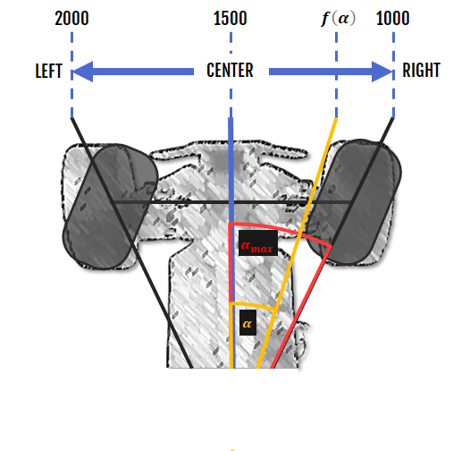

[Figure 111- Servo values safe range](https://drive.google.com/file/d/1wudXkba7Gov3mNpv-PcjVRTxntldoKwG/view?usp=sharing)

* Then the PWM value of servo is calculated by this formula:

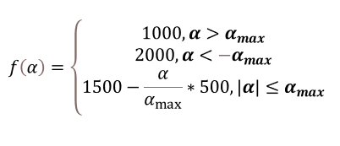

[Figure 112- Servo values calculate based on alpha angle](https://drive.google.com/file/d/1ENHQdQWDVvmTEoybiDmETYMwsim5nWqx/view?usp=sharing)

### 5.2 Detect and recognize traffic signs

#### a. Define Problem

- Detects and recognizes traffic signs with the car’s camera in real time.

- Before, we used Raspberry pi 4 with many limitations about process time. Though, we tried to use some light models to detect and recognize traffic signs, such as SSD Mobile Net v1 and v2 and machine learning methods combined with a classify model. However, the accuracy in box detection and recognition is not good, the mAP in the test dataset is about ~40-50%.

#### b. Requirement

- The algorithm must be run real-time, the process time must be less than 0.2 second (at least 5 FPS)

- The accuracy must be high, it includes F1 score and mAP. If the model recognizes the wrong sign, it will lead the car to the wrong way.

#### c. Solution

- To solve this problem, we decided to use coral Edge TPU, it is the hardware that helps Pi process the TensorFlow Lite Quantize model faster. To detect and recognize traffic signs we use the YOLO v3 tiny (You Only Look Once) model then convert to tflite quantized tpu model.

- YOLO (You Only Look Once) is an effective real-time object recognition.

##### c1. Base Concept

- Yolo will process input images by deep models and return the results about location of traffic sign in image, what sign at that location.

##### c2. Concept in YOLO

* The base architecture YOLO includes 2-part base network and extra layers.

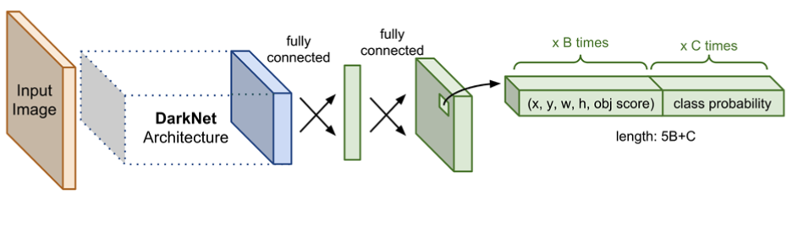

[Figure 113- Base concept of YOLO model](https://drive.google.com/file/d/1BQpGqnvaKfk0du3VvN4OK9HyHO1zPP9v/view?usp=sharing)

* **Base Network (DarkNet Architecture**) is a convolution neural network, which is used to extract feature maps.
* **Extra Layers** are used to predict information from the feature map output of the base network.
* **CNN (Convolutional Neural Network)** is the neural network using convolution layers to extract features in the image.
* In CNN, three main components: Convolution layer, Pooling layer and ReLu activation.
* **Conv (Convolutional Layer)**: This layer is used for extracting image features by a filter (matrix). Input will pass through filters to extract the main features and reduce unnecessary features. 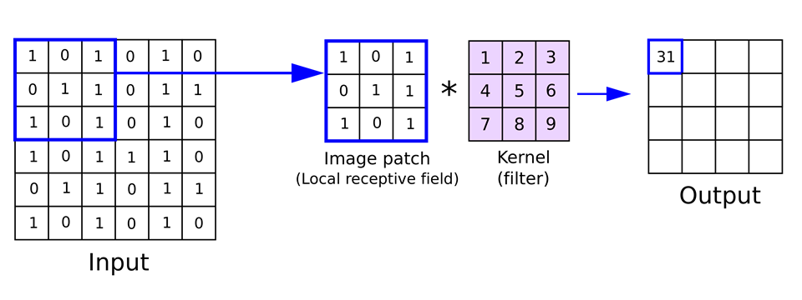

[Figure 114- Convolution layer example](https://drive.google.com/file/d/17Q7zC9Egmj-Xd8sO1nv4IBM3FnJVPUjI/view?usp=sharing)

* **Pooling (Pooling Layer)** The layer is used for downscaling the dimension of features but still holds the main features.

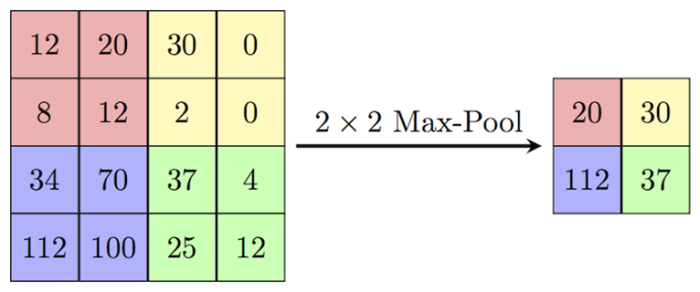

[Figure 115- Max pooling layer example](https://drive.google.com/file/d/1ksqfVpWdZ6VJaVLrFRVXhtKBv_aiIyWX/view?usp=sharing)

* **Up Sampling layer:** The layer is used for upscaling the dimension of features. The purpose of this layer is to help obtain more information of features in the next layers or next operations.

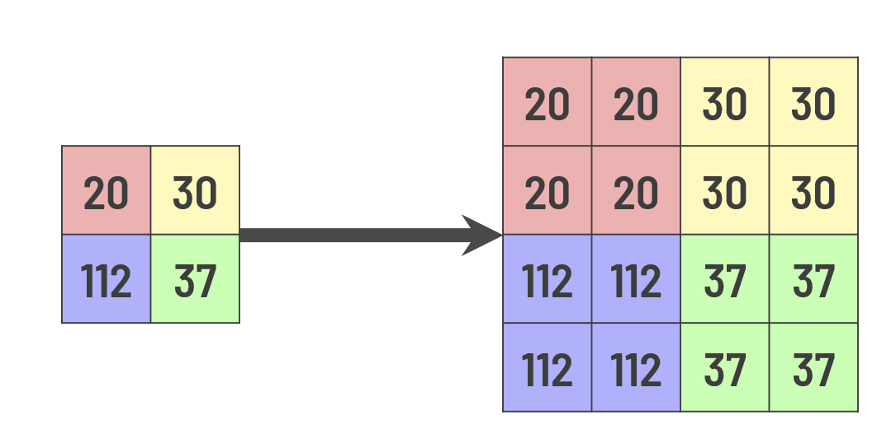

[Figure 116- Up sampling layer example](https://drive.google.com/file/d/1ebgSOIV7VNmOdKAiHrPQHEHH2vKs7ZtA/view?usp=sharing)

* **ReLu (Rectified Linear Unit):** The transform class adopts the ReLu trigger function to activate the nonlinearity, used to replace negative numbers by zero.

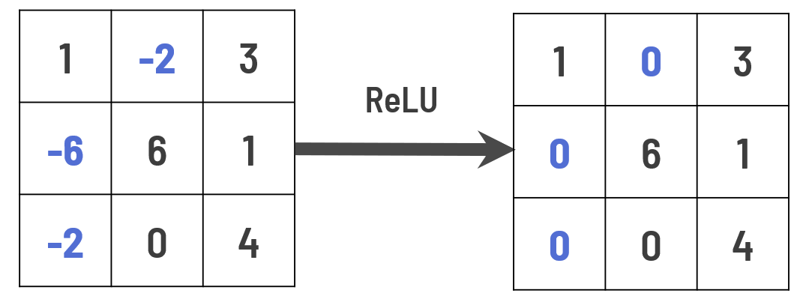

[Figure 117- Relu activation function example](https://drive.google.com/file/d/1hmnqQjSl-sUiuTFF1--VjAPrx782TByQ/view?usp=sharing)

* **Fully Connected:** is used to predict, detect, and classify through connection of neurons.
* **Feature map:** is a matrix that per grid contains information of a bounding box, confidence scores.

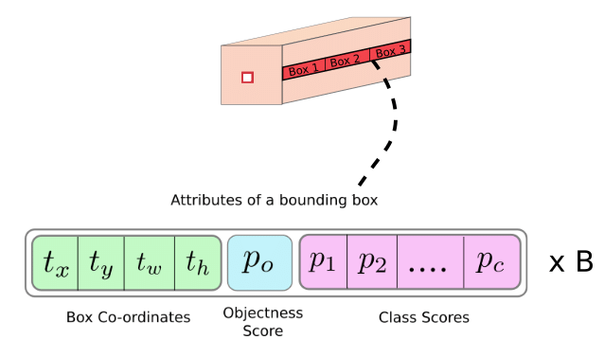

[Figure 118- Structure of one output grid cell in YOLO](https://drive.google.com/file/d/1vAX0qOKOqxeL746Tqv0YQ8R6QXEWV5_n/view?usp=sharing)

* **Non-max suppression** is used to reduce redundant bounding boxes.
* **IOU (Intersection Over Union):**  is the ratio measuring the level of intersection between two bounding boxes. It is used to reduce redundant bounding boxes and evaluate the model.

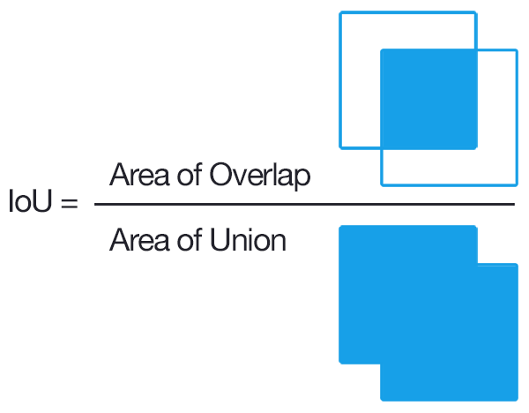

[Figure 119- IOU](https://drive.google.com/file/d/1IGwfDcXiq23_UM86ljMNICvadEf8zhcv/view?usp=sharing)

##### c3. Process in YOLO

* YOLO divides an image to SxS grid Example we divide to matrix grid size 13x13.

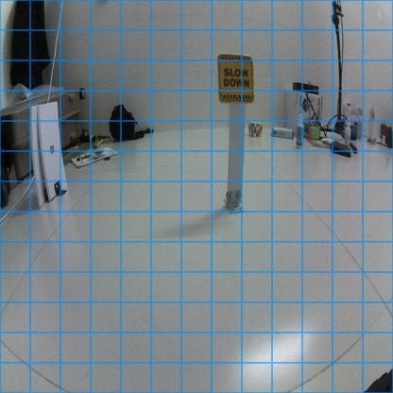

[Figure 120- YOLO grid divide](https://drive.google.com/file/d/1nHtZUG5kGwbOZK4sRDKxacZfIaSP4h-g/view?usp=sharing)

* On each grid will be processed YOLO model to get a feature map.
* Based on the feature map will predict objects in the image and extract anchor boxes (start Extra Layer).
* Non-max suppression to reduce redundant anchor box and return box (position) and class of the object:

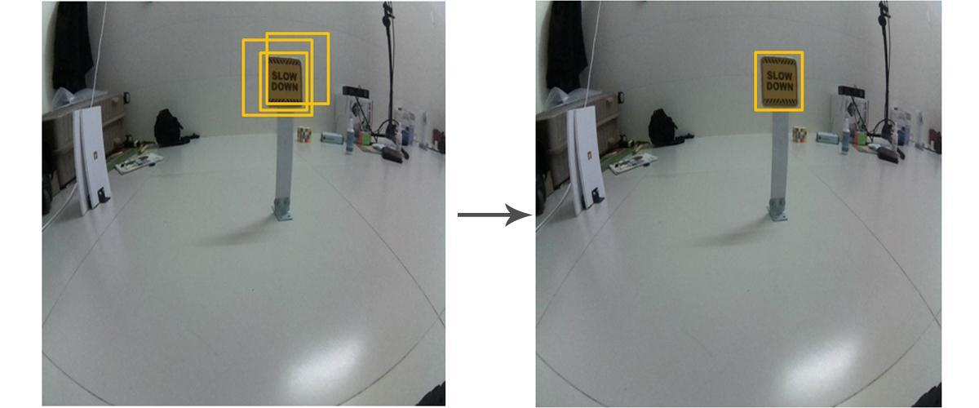

[Figure 121- Non-max suppression example](https://drive.google.com/file/d/1KSN8qZnLYoydwsc6fLKc-tdqT4eVglwz/view?usp=sharing)

##### c4. Prepare data and train process

* The data we collect will have:
  + 6 Traffic Sign: Stop, Speed Up, Slow Down, Turn Left, Turn Right, Forward
  + 2 Traffic lights: Green and Red

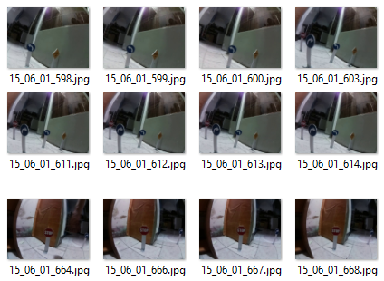

[Figure 122- Images dataset](https://drive.google.com/file/d/1rNZchjMHzbVX5KfTR_9i89vAXeecQkIx/view?usp=sharing)

* About 3228 images for train (70%), 1383 images for test (30%), total 4611 images
* Train 7000 steps in 8 hours in NVIDIA GeForce GTX 1050 Ti

##### c5. Evaluate Model

* We evaluate the model based on mAP, loss.
* mAP (mean Average Precision): it is used for evaluating the ability to predict the correct object.
  + Precision: number of correct predictions out of the total number of predictions.
  + mAP_0.5 is mAP based on IOU = 0.5.
* **Loss:** Error functions in YOLO are calculated in prediction and label the model for calculation. More specifically, it is the total error rate of the following 3 subcomponents:
  + **cls_loss:** the degree error of the classification.
  + **box_loss (Localization loss):** the degree of error of the limit box position degree.
  + **obj_loss:** the degree error of the prediction has the object.

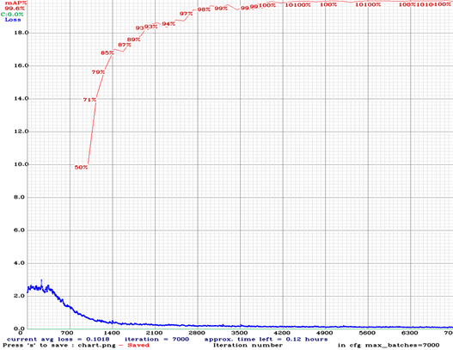

[Figure 123- Graph result training and test](https://drive.google.com/file/d/1Mf0W1yNA8jROSz_spsW6ZJafpWFVphMO/view?usp=sharing)

* **After train:**
  + mAP = 0.99
  + total_loss: 0.195568
  + avg loss: 0.101767
* **Conclusion:** In conclusion our model achieves about 99 percent accuracy at this acceptable precision. The loss parameters are at 0.1 so the error is not too high

### 5.3 Detect Obstacle

#### a. Define Problem

- Many obstacles or some other things like other cars, walls may appear in front of the car when it is running, we need to detect obstacles in real time.

- We used AI to solve this problem, however it just detects some specific obstacle. We need to stop at any obstacle.

#### b. Solution

##### b1. Concept

- We use the ultrasonic sensor to detect obstacles, it will calculate the distance of the obstacle from the car based on ultrasonic sound.

- We use the ultrasonic sensor HC-SRF05.

Method:

* The trigger sends an audio signal forward to the object.
* When the signal reaches the object, it is reflected to the sensor.
* The sensor will receive the reflected signal if there is an obstacle in front.

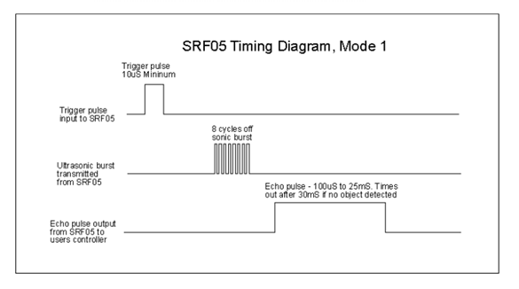

[Figure 124- Ultrasonic sensor timing diagram](https://drive.google.com/file/d/1XRG7Mb_0g3Gqdm76c7TDvC7Xek-JsRRv/view?usp=sharing)

* And then we can compute distance to obstacle by formula:

$$D = \frac{v*t}{2}$$

**D**: is distance (cm)

**v**: is speed of the sound

**t**: is the time difference between the time when the transmitter sends the signal and the time when the receiver picks up the signal.

# V. Project Management Plan

## 1. Overall Description

### 1.1 Test Model

In AVC Project, we apply Agile testing for many purposes:

- We believe that continuous testing will detect errors in the system early to quickly provide solutions and avoid the consequences that follow.

- Suitable for the constantly changing requirements.

### 1.2 Testing Levels

There are some testing levels that is applied in AVC:

* Unit testing: use for participation flow such as Login, Approve Car, Create Model, Create Manager, Create Staff.
* Acceptance testing: we work thoroughly with the Admissions Department of FPT University to determine whether the system reaches a stable level for release.

## 2. Test Plan

### 2.1 Test Stages

|  |  |  |  |  |
| --- | --- | --- | --- | --- |
| **Type of Test** | **Stage of Test** | | | |
| ***Unit*** | ***Integration*** | ***System*** | ***Acceptance*** |
| Function Testing | X |  |  |  |
| User Interface Testing |  |  |  | X |

### 2.2 Human Resources

|  |  |  |
| --- | --- | --- |
| **Worker/Doer** | **Role** | **Specific Responsibilities/Comments** |
| Nguyễn Thanh Hòa | Leader | Planning, verifying test deliverables |
| Triệu Minh Huy | Member | Do unit testing/interface testing as planned |
| Ngô Văn Sang | Member | Do unit testing/interface testing as planned |
| Lê Thành Đạt | Member | Do unit testing/interface testing as planned |

### 2.3 Test Milestones

|  |  |  |  |
| --- | --- | --- | --- |
| **Milestone Task** | **Effort (md)** | **Start Date** | **End Date** |
| Create Test Plan | 3 | 21/07/2021 | 21/07/2021 |
| Unit test | 2 | 22/07/2021 | 23/07/2021 |
| Detect Lane | 2 | 26/07/2021 | 27/07/2021 |
| Recognize Traffic Sign | 2 | 28/07/2021 | 29/07/2021 |
| Recognize Traffic Light | 2 | 30/07/2021 | 02/08/2021 |
| Recognize Obstacle | 2 | 03/08/2021 | 04/08/2021 |
| Authentication | 1 | 05/08/2021 | 05/08/2021 |
| Manage Model | 1 | 05/08/2021 | 05/08/2021 |
| Manage Car | 2 | 06/08/2021 | 07/08/2021 |
| Manage Staff | 1 | 06/08/2021 | 06/08/2021 |
| Manage Manager | 1 | 07/08/2021 | 07/08/2021 |
| Manage Issues | 1 | 08/08/2021 | 08/08/2021 |
| Control Car | 1 | 08/08/2021 | 08/08/2021 |
| Auto-activate Car | 1 | 09/08/2021 | 09/08/2021 |

## 3. Test Cases

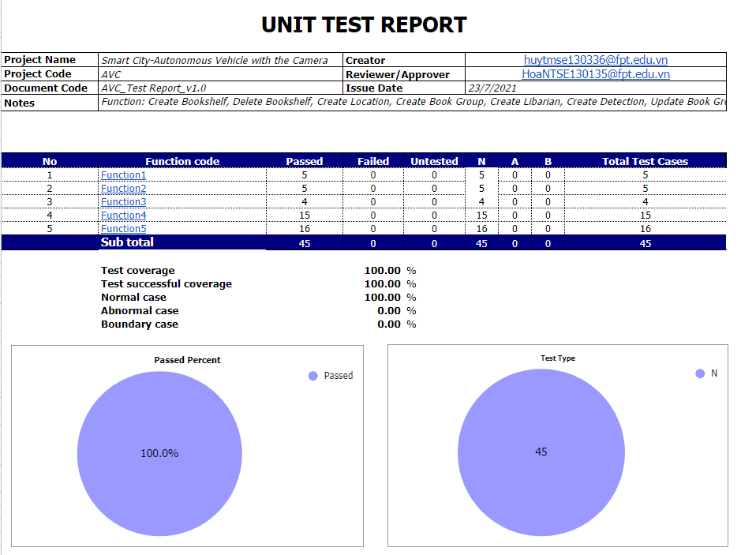

[Figure 125 - AVC_Report5_Test Case Document.xlsx](https://docs.google.com/spreadsheets/d/1SVly9Yq7G14GrVkYlvpVRbdNEqNs0KEO/edit?usp=sharing&ouid=113651123942621004962&rtpof=true&sd=true)

## 4. Test Reports

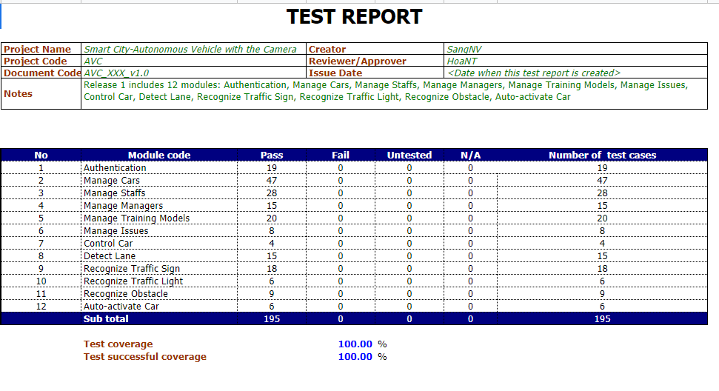

[Figure 126 - AVC_Report5_Unit Test Case.xls](https://docs.google.com/spreadsheets/d/1BR-WRpJ5SVCxzUNo4u_K2EiNiyR8iaFk/edit?usp=sharing&ouid=113651123942621004962&rtpof=true&sd=true)

# VI. Release Package & User Guides

## 1. Deliverable Package

### 1.1 Source codes & documents

|  |  |  |  |  |
| --- | --- | --- | --- | --- |
| **No.** | **Items** | **Sub-Items** | **Type** | **Version** |
| ***Code Package*** | | | | |
| 1 | .NET API and Messaging | avc_webapi | New | 1.0 |
| 2 | Mobile App + Web App | avc_web_and_mobile_app | New | 1.0 |
| 3 | Python-OpenCV Detection | avc_python | New | 1.0 |
| 4 | Bash Training Model | avc_bash | New | 1.0 |
| ***Database*** | | | | |
| 1 | Tables | ModelStatus.sql | New | 1.0 |
| Issue.sql | New | 1.0 |
| ModelVersion.sql | New | 1.0 |
| DefaultConfiguration.sql | New | 1.0 |
| Car.sql | New | 1.0 |
| UserNotification.sql | New | 1.0 |
| Account.sql | New | 1.0 |
| Role.sql | New | 1.0 |
| AssignedCar.sql | New | 1.0 |
| IssueType.sql | New | 1.0 |
| ***Documents*** | | | | |
| 1 | Introduction | AVC_Report1_Project Introduction.docx | New | 1.0 |
| 2 | Management Plan | AVC_Report2_Project Management Plan.docx | New | 1.0 |
| 3 | Requirement Specification | AVC_Report3_System Requirement Specification.docx | New | 1.0 |
| 4 | Software Design | AVC_Report4_Software Design Document.docx | New | 1.0 |
| 5 | Testing | AVC_Report5_Test Case Document.xlsx | New | 1.0 |
| AVC_Report5_Test Documentation.docx | New | 1.0 |
| AVC_Report5_Unit Test Case.xls | New | 1.0 |
| 6 | User Guides | AVC_Report6_Software User Guides.docx | New | 1.0 |
| 7 | Final | AVC_Report7_Final Project Report.docx | New | 1.0 |

Table 55. Source code and document

### 1.2 Known Issues, Limitations & Restrictions

- The camera of an AVC car must be configured manually.

## 2. Installation Guides

### 2.1 System Requirements

#### a. Hardware requirements

**For PC**

|  |  |  |
| --- | --- | --- |
| **PC** | **Minimum Requirements** | **Recommended** |
| Internet Connection | Cable, Wi-Fi (4 Mbps) | Cable, Wi-Fi (8 Mbps) |
| Operating System | Windows 7 | Windows 10 |
| Computer Processor | Intel® Core i3 1.4GHz | Intel® Core i5 2.50GHz |
| Computer Memory | 1GB RAM | 2GB RAM or more |
| Web Browser | Chromes (v69 or higher) | Chrome latest stable version |

Table 56. System Hardware Requirement for PC

**For Edge Device**

|  |  |  |
| --- | --- | --- |
| **Edge Device** | **Minimum Requirements** | **Recommended** |
| Internet Connection | Wi-Fi (4 Mbps) | Wi-Fi (8 Mbps) |
| Operating System | Raspbian | Linux for Tegra® |
| Computer Processor | Broadcom BCM2711, Quad core Cortex-A72 (ARM v8) 64-bit SoC @ 1.5GHz | Quad-core ARM® A57 |
| Computer Memory | 2GB RAM | 4 GB 64-bit LPDDR4; 25.6 gigabytes/second |
| Camera | Min camera | MIPI CSI-2 DPHY lanes, 12x (Module) and 1x (Developer Kit) |
| SD Card | 128MB | 256MB |

Table 57. System Hardware Requirement for Edge Device

**For Android Devices:**

|  |  |
| --- | --- |
| **Operating system** | Android 6.0 or higher |
| **Processor** | Intel Atom® Processor Z2520 1.2 GHz, or faster processor |
| **Storage** | Between 850 MB and 1.2 GB, depending on the language version |
| **RAM** | Minimum of 1 GB, 2 GB is recommended |
| **Hard Disk** | Minimum of 50MB for installation |

Table 58. System Hardware Requirement for Android

**For iOS Devices:**

|  |  |
| --- | --- |
| **Operating system** | iOS 6 or higher |
| **CPU/GPU** | Dual-core 1.3 GHz Swift (ARM v7-based), PowerVR SGX 543MP3 (triple-core graphics) or higher |
| **RAM** | Minimum of 1 GB, 2 GB is recommended |
| **Hard Disk** | Minimum of 50MB for installation |

Table 59. System Hardware Requirement for iOS

**For Training machine:**

|  |  |
| --- | --- |
| **Operating system** | Windows 10 |
| **CPU** | Dual-core 1.3 GHz Swift (ARM v7-based), PowerVR SGX 543MP3 (triple-core graphics) or higher |
| **GPU** | NVIDIA GeForce GTX 1050 Ti 4GB |
| **RAM** | Minimum of 8GB, 16GB is recommended |
| **Hard Disk** | Minimum of 100GB for installation |

Table 60. System Hardware Requirement for Training Machine

#### b. Software requirements

|  |  |  |
| --- | --- | --- |
| **Software** | **Name / Version** | **Description** |
| Operation System | Windows 7, Windows 10, macOS 10.0 or higher | Operating system and platform for development |
| Web browser | Chrome 69 or above | For web app |
| Android OS | Android 6.0 or higher | For mobile app |
| iOS | iOS 6 or higher | For mobile app |

Table 61. Software Requirement

### 2.2 Setup Files

**

We will copy this file to install our application into the Android device.

### 2.3 Installation Instruction

We guide how to installation mobile app with file apk release:

1. Download and open “avc.apk” in the **File Explorer** application
2. Press “Install” and waiting for installation.
3. Back to Home
4. Find an AVC icon application with the name “AVC” and click to open



### 2.4 Server-side Deployment

#### a. Prepare deployment packages

* Create a folder to contains deployment packages, for example C:\Users\<USER>\Documents\Capstone
* Copy the Web Service deployment package (about 161MB) to a folder, for exa

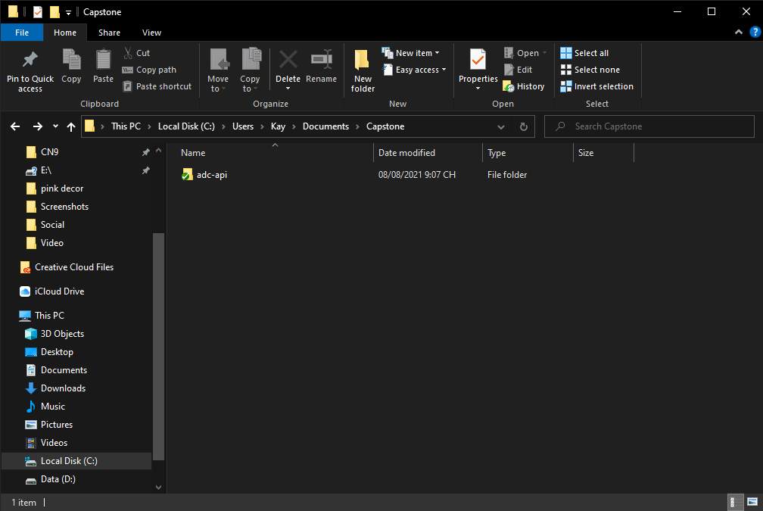

[Figure 127 - Prepare Deployment Packages Folders](https://drive.google.com/file/d/1nvmsS-6vESfgzgKJC0Kp2ppMpbCm_wod/view?usp=sharing)

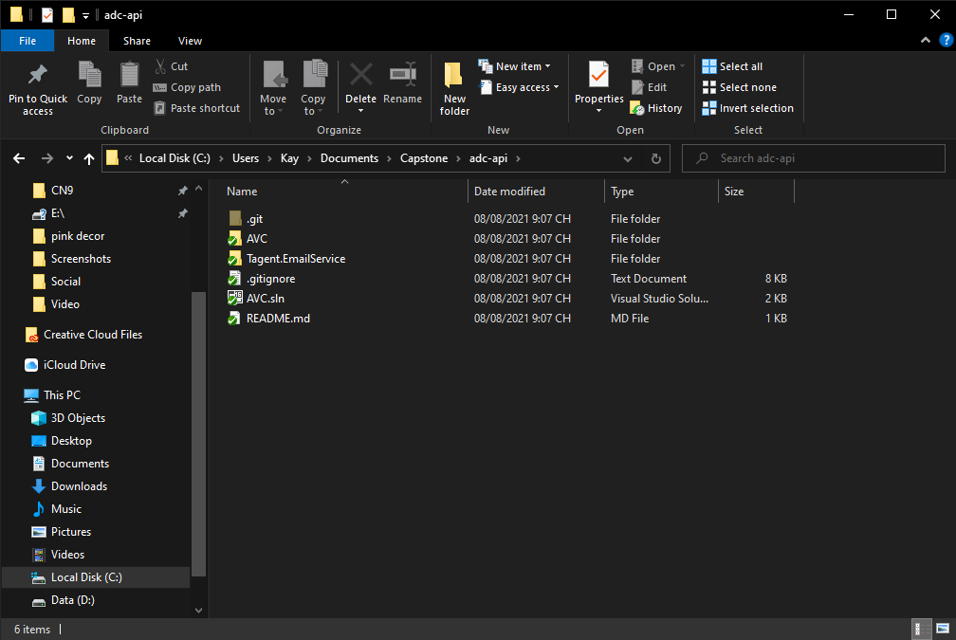

[Figure 128 - Prepare Deployment Packages Folders For Web Service](https://drive.google.com/file/d/1qP_neSY-AVicxruXAHc246muol_QHamE/view?usp=sharing)

#### b. Deploy SQL Server

* Open Microsoft SQL Server Management Studio.
* Server name: default server name is your computer name or the host server IPv4 address or SQL instance name of the computer.
* Login: username of the account.
* Password: password of the account.

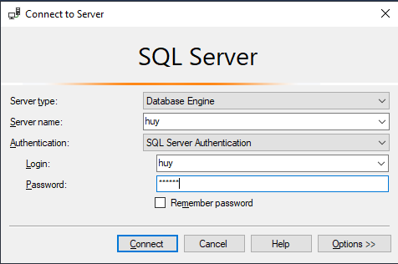

[Figure 129 - SQL Server](https://drive.google.com/file/d/1ft3dOgF5PccjaIHupAsMQ73__QGvaM8_/view?usp=sharing)

* Open avc.script file.
* Execute script file.
* Check the database named Capstone with 22 tables to complete.

#### c.. Deploy web service on the server

* Open the Internet Information Services (IIS) Manager.
* Right-click at Sites. Choose “Add Website…”.
* Enter site name. Choose Application Pool as .NET v4.5.
* In the physical path, select the path as the folder C:\Users\<USER>\Documents\Capstone\adc-api
* Change the port if needed.

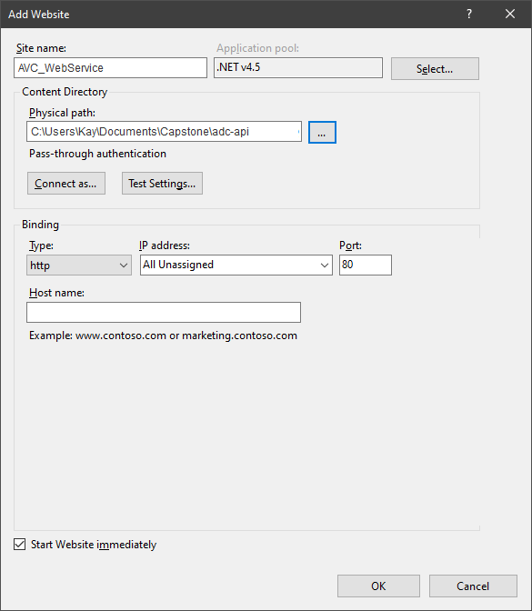

[Figure 130 - Add Web Service To IIS](https://drive.google.com/file/d/1BD16bjwtYPXNSNumJjzwuRMos6EiHqCo/view?usp=sharing)

* Press ok to finish the process.

#### d. Prepare environment at client side

* The client devices need to have Google Chrome browsers to access the website.

### 2.5 Training Machine Environment Setup

#### a. Install environment Anaconda

1. Download the Anaconda installer.
2. Double click the installer to launch.

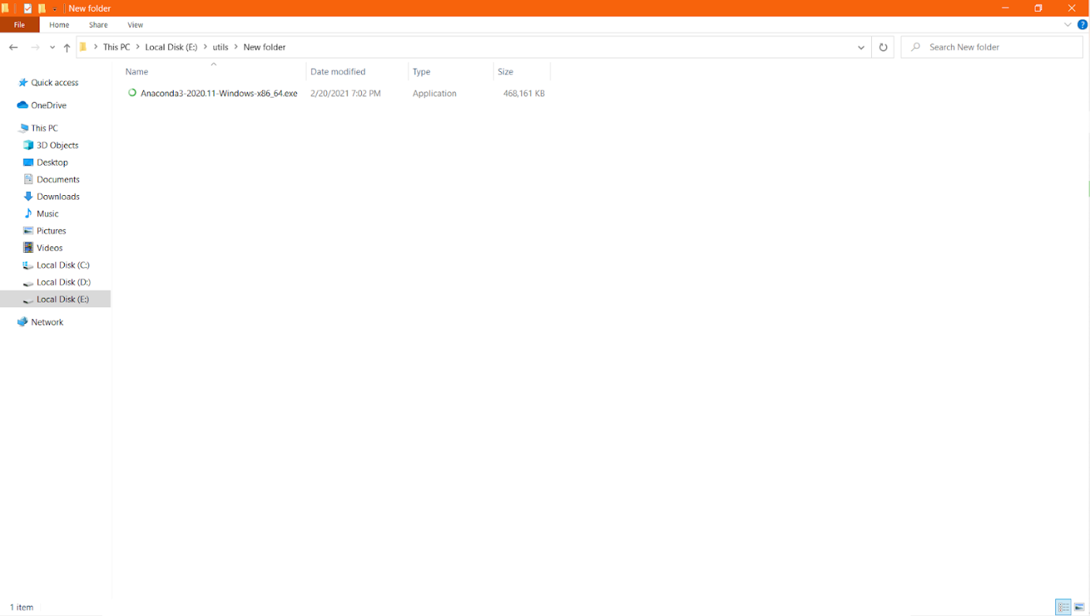

[Figure 131 - Anaconda Installation (Step 2](https://drive.google.com/file/d/12mqwlxFq_BAYuqLLphX__GQT1hmcH7s4/view?usp=sharing))

1. Click Next.

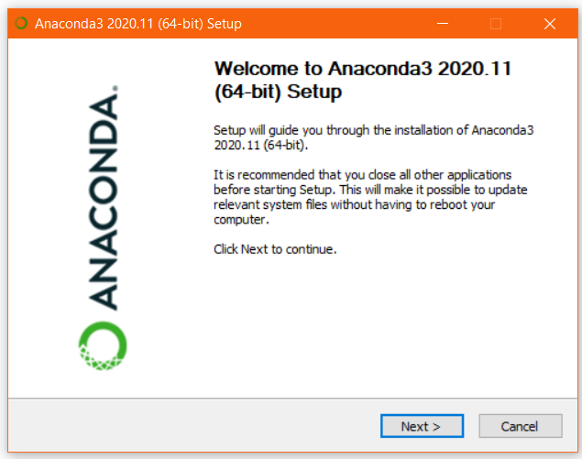

[Figure 132 - Anaconda Installation (Step 3](https://drive.google.com/file/d/1yZiSvy4SryrGJMVjG4v1ycQxsR4lFsFo/view?usp=sharing))

1. Read the licensing terms and click “I Agree”.

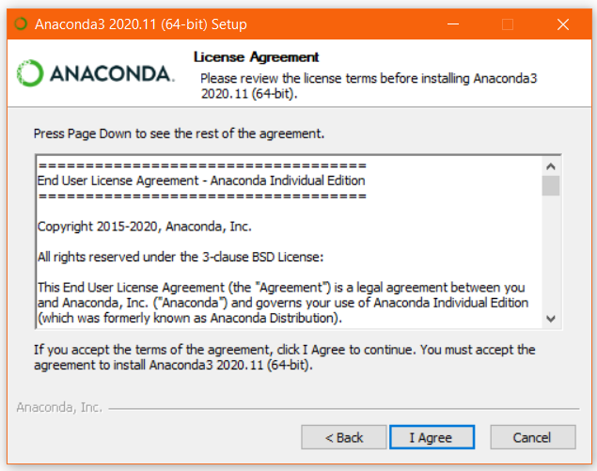

[Figure 133 - Anaconda Installation (Step 4](https://drive.google.com/file/d/19zPjF7OQlxO6-h0QJOV24V_UrDq8yqLj/view?usp=sharing))

1. Select an install for “Just Me” and click Next.

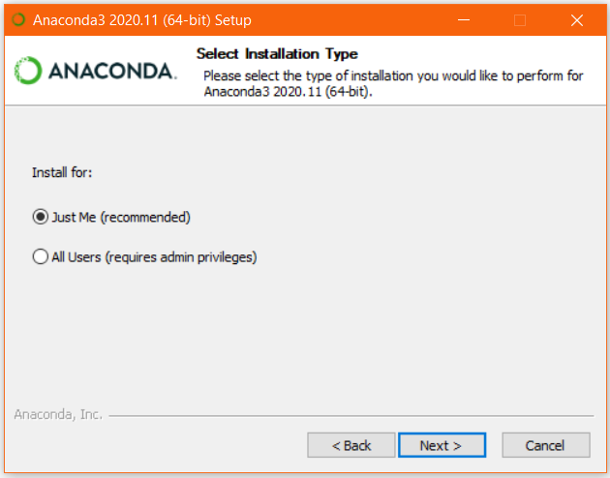

[Figure 134 - Anaconda Installation (Step 5](https://drive.google.com/file/d/1EYy_OxkF0yAz5jBuI9YmQkQHZL38aEIL/view?usp=sharing))

1. Select save folder

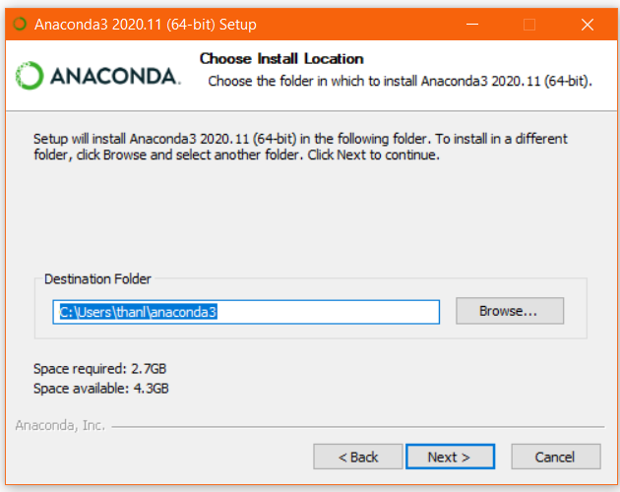

[Figure 135 - Anaconda Installation (Step 6](https://drive.google.com/file/d/1jiBo3nmwfEuWvNoE3kv2HpBOGv_wme9j/view?usp=sharing))

1. Select “Register Anaconda3 as my default Python 3.8” my python version is 3.8

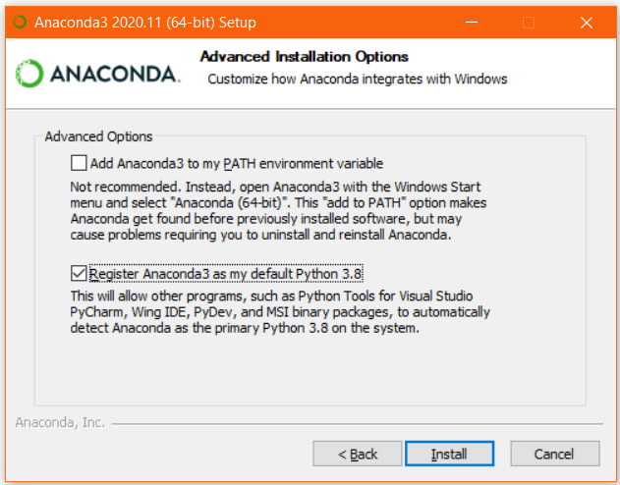

[Figure 136 - Anaconda Installation (Step 7](https://drive.google.com/file/d/10mHeqawEKMkfNp6FQp8fNgG5xxPYSOvO/view?usp=sharing))

1. Wait for complete

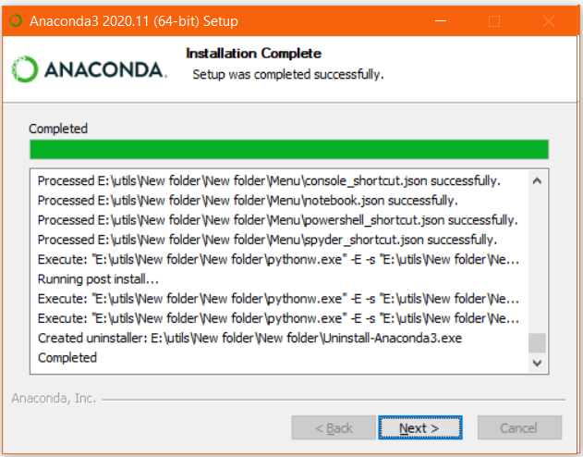

[Figure 137 - Anaconda Installation (Step 8](https://drive.google.com/file/d/11fvNDMLidejXfHEErRj2gMPchr-_DZdJ/view?usp=sharing))

1. Click “Next”.

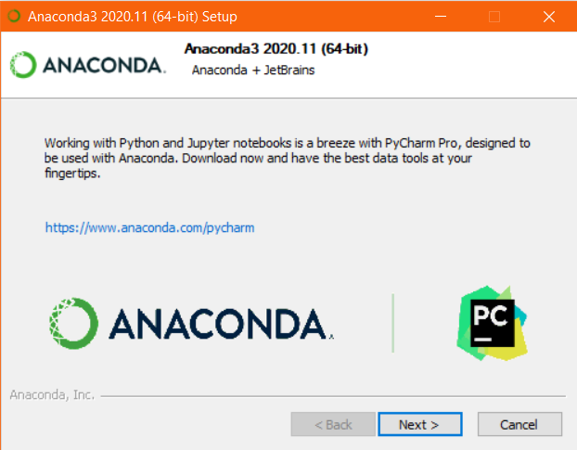

[Figure 138 - Anaconda Installation (Step 9](https://drive.google.com/file/d/1bHcVZYCv6AKssJuw5uWa_yVW-ZpyPk5S/view?usp=sharing))

1. Click “Finish”.

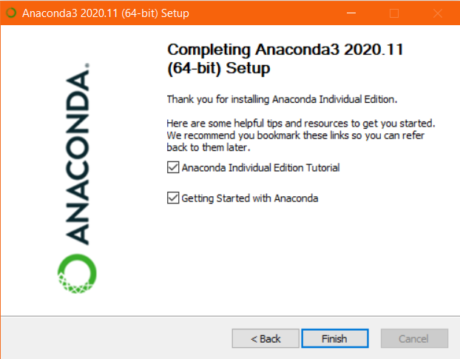

[Figure 139 - Anaconda Install (Step 10](https://drive.google.com/file/d/1-HjpgJRnfBj4_dZrZv6ETk2e1z-Teav0/view?usp=sharing))

#### b. Setting Run NVIDIA GPU

##### b1. Requirements

* Have GPU NVIDIA support CUDA core.
* Upgrade to the latest version driver for GPU.

##### b2. Install CUDA Toolkit

1. Download the CUDA Toolkit v11.3 for Win10.
2. Double click the installer to launch.

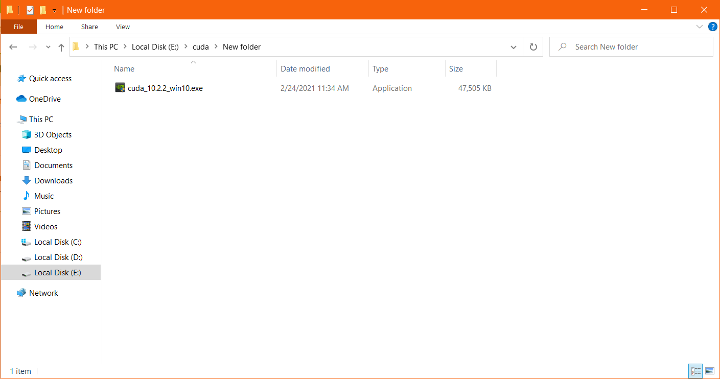

[Figure 140 - CUDA Installation (Step 2](https://drive.google.com/file/d/1l6hzTfkl4m6Y2vr-cigCg8DECZwOk8eS/view?usp=sharing))

1. Choose the save folder and click “OK”.

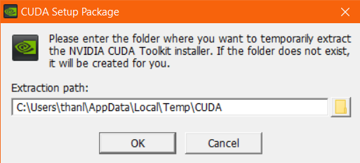

[Figure 141 - CUDA Installation (Step 3](https://drive.google.com/file/d/1qc6b_vKChh8g2hrJnylmpST_PV1MhNjt/view?usp=sharing))

1. Click “AGREE AND CONTINUE”.

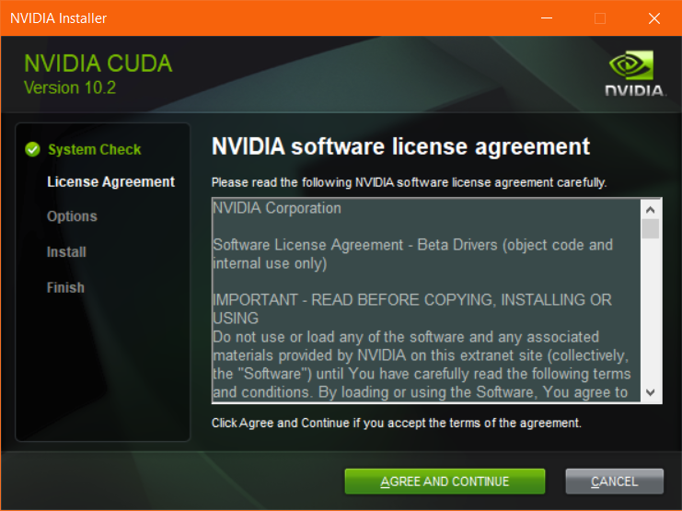

[Figure 142 - CUDA Installation (Step 4](https://drive.google.com/file/d/1CTkknzqppJahd4shOm5PeAc0ubeMOS9g/view?usp=sharing))

1. Choose “Express” and click “NEXT”.

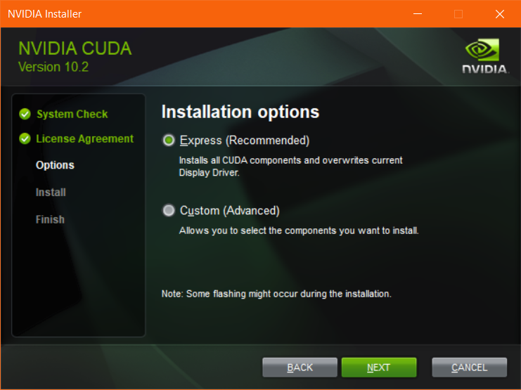

[Figure 143 - CUDA Installation (Step 5](https://drive.google.com/file/d/1sP8mbcTJpfzt-p6hhLFpnMOTZaBVeLZ3/view?usp=sharing))

1. Click “INSTALL” and wait for it to be installed.

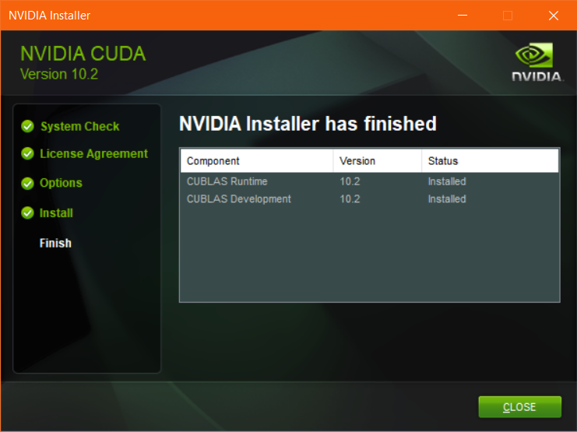

[Figure 144 - CUDA Installation (Step 6](https://drive.google.com/file/d/16nsLGUv7-o9Vl07Vn4tJpKyeQHMKle3a/view?usp=sharing))

##### b3. Download CuDnn

1. Go to <https://developer.nvidia.com/cudnn>
2. Download CuDnn: cudnn-11.3-windows-x64-v8.2.1.32.zip
3. Extracting and Inspecting the Files Manually
4. Copy and overwrite folders from CuDNN to CUDA_PATH

#### c.  Setting GitLab-Runner

* Download and Install: <https://docs.gitlab.com/runner/install/windows.html>
* Open Gitlab Storage for training model to get registration token:  
  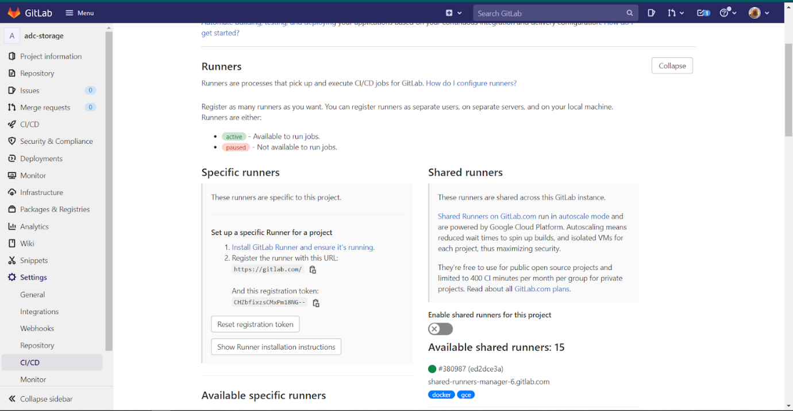
* Run register: <https://docs.gitlab.com/runner/register/>

#### d. Setup package for running

1. Install Docker: <https://docs.docker.com/docker-for-windows/install/>
2. Clone git: <https://gitlab.com/foolishcrown/edgetpu-compiler.git>
3. Run this command at clone folder:  
   **docker build --tag edgetpu_compiler** [**https://gitlab.com/foolishcrown/edgetpu-compiler.git**](https://gitlab.com/foolishcrown/edgetpu-compiler.git)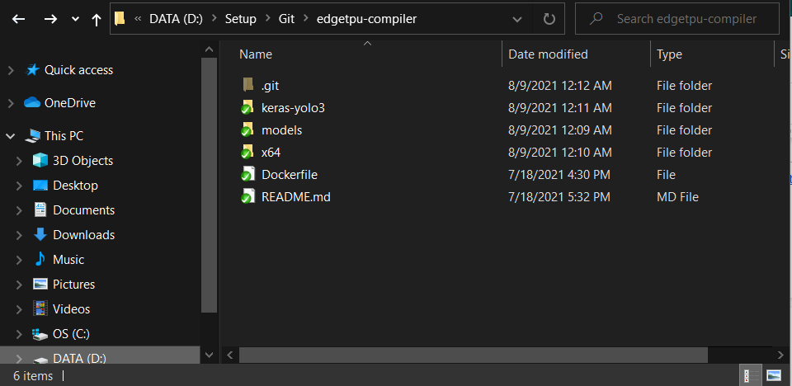

### 2.6 Edge Device (Raspberry Pi 4) Environment Setup

#### a. Install & Set up OS for Raspberry Pi

Recommend: Using [Raspberry Pi Imager](https://www.raspberrypi.org/software/) (works on Mac OS, Ubuntu 18.04 and Windows)

1. Connect an SD card with the installation machine.
2. Open **Raspberry Pi Imager**
3. If you have already downloaded the image (through USB or download directly), choose **Custom** at the bottom of the list and pick the downloaded image. If not, choose the **FIRST** OS from the list.
4. Choose the SD card you wish to write your image to.
5. Click **WRITE** to begin writing data to the SD card.
6. Add a file name ssh without extension to boot/ (root folder in your SD Card) by opening your SD Card in Terminal and running the command.

 echo > ssh

7. Plug **SD Card** into Raspberry Pi 4 and power it up.

8. Plug LAN wire to connect from your Installation Machine to Raspberry Pi 4

9. Open terminal (Mac) or CMD (Windows), then run the following command:

ssh pi@raspberrypi.local (password: **raspberry**)

    9.1 If you see an error unable to connect host, please try to install PuTTY to connect through SSH.

    9.2 Open **PuTTY**

9.3 Input HostName IP: **raspberrypi.local**

9.4 Click **Open**

9.5 New Terminal pops up, fill username with **pi** and password with **raspberry** (password will be inputted silently)

**Notes**:

Connected when pi@raspberrypi:~/... at the start of the your terminal line.

If still has an error, re-plug SD Card.

10. To config enable **Wireless connection** by commands:

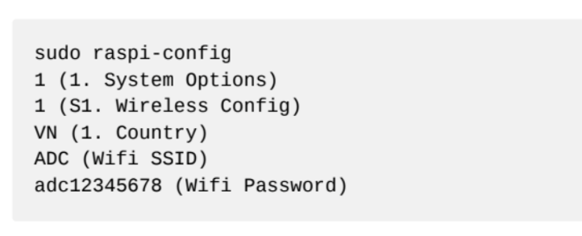

11. To config enable **Camera** by commands:

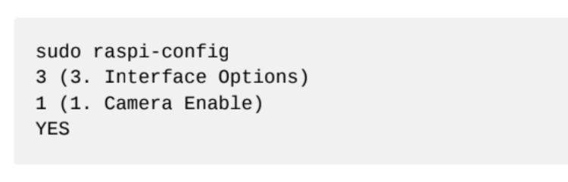

12. To config enable **SSH Connection** by commands:

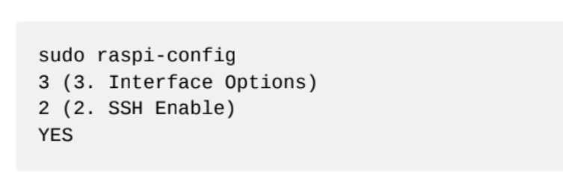

13. To config enable **VNC Connection** by commands:

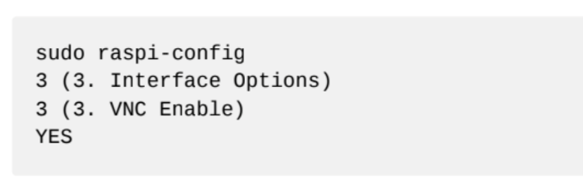

14. To config enable **Remote GPIO** (to permit Pi controls GPIO) by commands:

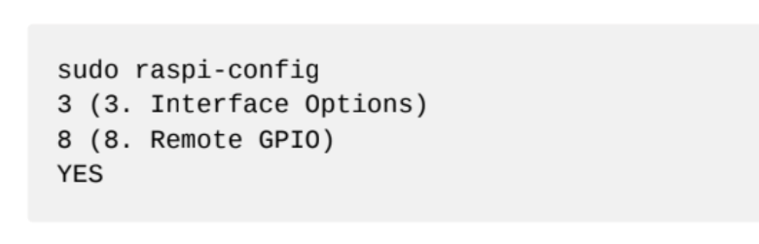

15. To config **Display Resolution** (to have ability to remote desktop through VNC Connection) by commands:

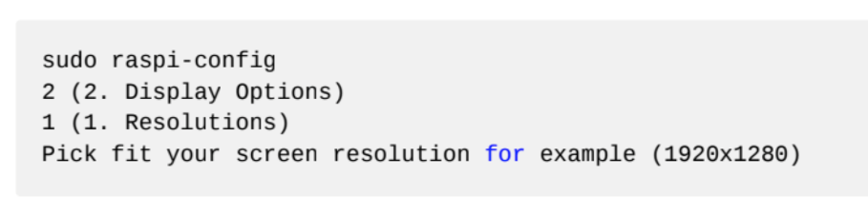

16. Close Terminal, then install VNC Viewer for remoting Pi desktop (plug Pi with your own screen to use if available)

hostname: **raspberrypi.local**

username: **pi**

password: **raspberry**

**Notes**: if you see error cannot currently show the desktop, it's wrong resolution issue, please try go to step config Display Resolution to set another value in order to fit your current screen and remember to **reboot Pi** by command

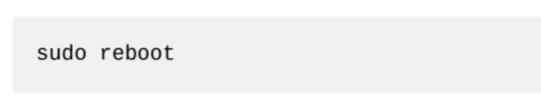

#### b. Install ADC - Autonomous Detect Car application for detection

1. Install python3 at the root.

sudo apt install python3 idle3

2. Install pip3 at the root.

sudo apt-get install python3-pip

3. Install virtualenv at the root.

pip3 install virtualenv

4. Add /home/pi/.local/bin to your PATH in ~/.bashrc

echo "export PATH=\$PATH:/home/pi/.local/bin" >> ~/.bashrc

5. Activate executor in .bashrc

source ~/.bashrc

6. Open Terminal in Desktop

cd ~/Desktop

7. Download project to desktop.

curl https://thanhhoa214.gitlab.io/teaching-resources/docs/assets/adc.zip --output adc.zip

8. Extract project by **Extract Here** to desktop and open **adc** in Terminal by 1 of 2 ways below:

8.1 Right-click on folder **adc** and open Terminal.

8.2 Open Terminal and run command:

cd ~/Desktop/adc

9. Create your virtualenv at the root.

virtualenv adc_env

10. Start your virtualenv at the root.

source adc_env/bin/activate

11. Install dependencies into your environment.

pip install -r requirements.txt

12. Enable pigpiod (What is gpio?) to auto-start on boot.

sudo systemctl enable pigpiod

13. Start pigpiod immediately if needed:

sudo pigpiod

     14. Install root libraries, copy & paste all :

sudo apt-get install libhdf5-dev -y

sudo apt-get install libhdf5-serial-dev -y

sudo apt-get install libatlas-base-dev -y

sudo apt-get install libjasper-dev -y

sudo apt-get install libqtgui4 -y

sudo apt-get install libqt4-test -y

 15. Reboot by command.

sudo reboot

#### c. Start ADC application for detection

1. Open **adc** in Terminal in 1 of 2 ways below:

1.1 Right-click on folder **adc** and open Terminal.

1.2 Open Terminal and run command:

cd ~/Desktop/adc

2. Always remember to start your virtualenv by opening the root folder & running the following command.

source adc_env/bin/activate

3. Make sure the power is turned on. Running your car with:

python test.py

**Notes:**

If you see an error that can't connect the camera or meaning like that, please first check **Setup Raspberry Pi 4** in step **8. Config Camera** is enabled, and reboot your Raspberry Pi 4.

If you see this error, please re-run step 7 and 8.

Traceback (most recent call last):

 File "test.py", line 12, in <module>

 pi.set_servo_pulsewidth(12, 0) *# off*

File ".../adc-detect-lane/adc_env/lib/python3.8/site-packages/pigpio.py", line 1678, in set_servo_pulsewidth

 return _u2i(_pigpio_command(

 File ".../adc-detect-lane/adc_env/lib/python3.8/site-packages/pigpio.py", line 1025, in _pigpio_command

 sl.s.send(struct.pack('IIII', cmd, p1, p2, 0))

AttributeError: 'NoneType' object has no attribute 'send'

## 3. User Manual

### 3.1 Terms and definitions

* AVC Mobile Application is installed in mobile or tablet devices. It uses for staff only.
* AVC Web Application is used by Admin, Manager. AVC Web Application also can be installed on PC, Mac or Mobile as standalone application.

### 3.2 System Requirements

#### a. Hardware Requirements

* **For PC:**

|  |  |  |
| --- | --- | --- |
| **PC** | **Minimum Requirements** | **Recommended** |
| Internet Connection | Cable, Wi-Fi (4 Mbps) | Cable, Wi-Fi (8 Mbps) |
| Operating System | Windows 7 | Windows 10 |
| Computer Processor | Intel® Core i3 1.4GHz | Intel® Core i5 2.50GHz |
| Computer Memory | 1GB RAM | 2GB RAM or more |
| Web Browser | Chromes (v69 or higher) | Chrome latest stable version |

Table 62. <User Manual> Hardware Requirements For PC

* **For Android Devices:**

|  |  |
| --- | --- |
| **Operating system** | Android 6.0 or higher |
| **Processor** | Intel Atom® Processor Z2520 1.2 GHz, or faster processor |
| **Storage** | Between 850 MB and 1.2 GB, depending on the language version |
| **RAM** | Minimum of 1 GB, 2 GB is recommended |
| **Hard Disk** | 2 GB of available hard-disk space for installation |

Table 63. <User Manual> Hardware Requirements For Android Devices

#### b. Software Requirements

|  |  |  |
| --- | --- | --- |
| **Software** | **Name / Version** | **Description** |
| Operation System | Windows 7, Windows 10 | Operating system and platform for development |
| Web browser | Chrome 69 or above | For web app |
| Android System | Android 6.0 or higher | For mobile app |

Table 64 - <User Manual> Software Requirements For PC

### 3.3 Application Usage

#### a. Overview

* AVC web application and AVC mobile application both permit logged users to do authentication and update basic information.
* AVC web application only allows Admin, Manager to log in.
* AVC mobile application only allows Staff to log in.
* AVC web application allows Admin to do management actions: manage managers, manage staffs, manage cars, and retrain the old model.
* AVC web application allows managers to do management actions: manage assigned staffs, manage assigned cars.
* AVC mobile application allows Staff to do management and controlled actions: manage assigned cars (start and stop), view detail issues, track all newest notifications with a real-time mechanism.

#### b. Features

##### b1. Web Application

###### b1.1 Login

*Step 1. User visits this site:* [*https://avcar.netlify.app/*](https://avcar.netlify.app/)

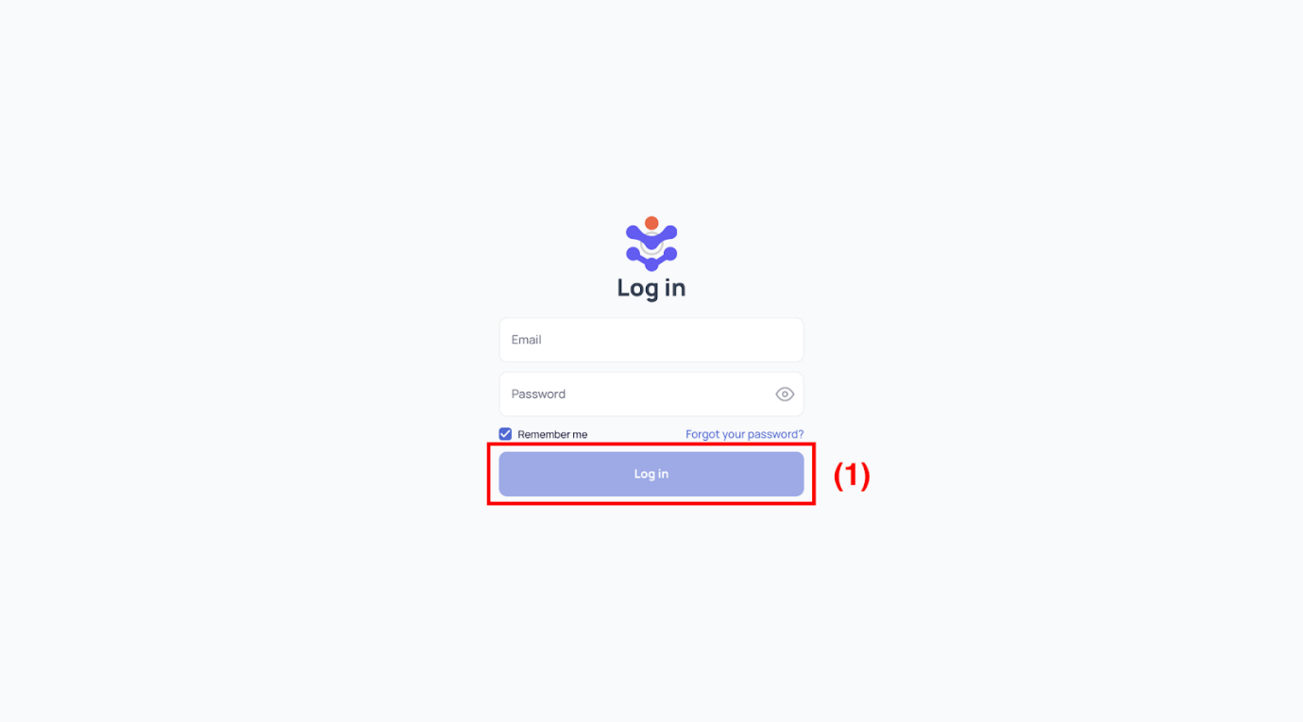

[Figure 145 - Login](https://drive.google.com/file/d/14ckP39drSdEKoQ9NcTRpckaW3OdcU95d/view?usp=sharing)

*Step 2. Fill in account’s email and password*

*Step 3. Click “Login” button (1)*

###### b1.2 Forgot Password

*Step 1. User visits this site:* [*https://avcar.netlify.app/*](https://avcar.netlify.app/)

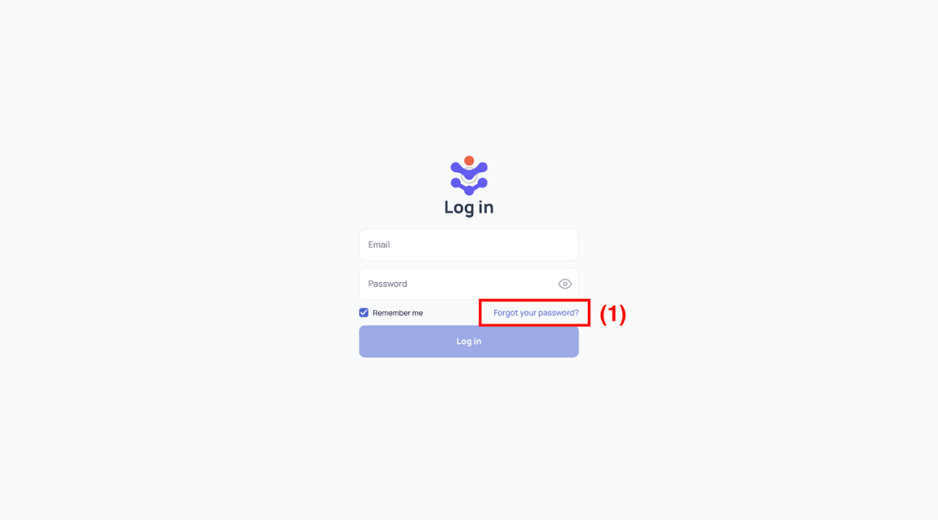

[Figure 146 - Login](https://drive.google.com/file/d/14ckP39drSdEKoQ9NcTRpckaW3OdcU95d/view?usp=sharing)

*Step 2. Click “Forgot your password” button (1)*

*Step 3. Fill in account’s email*

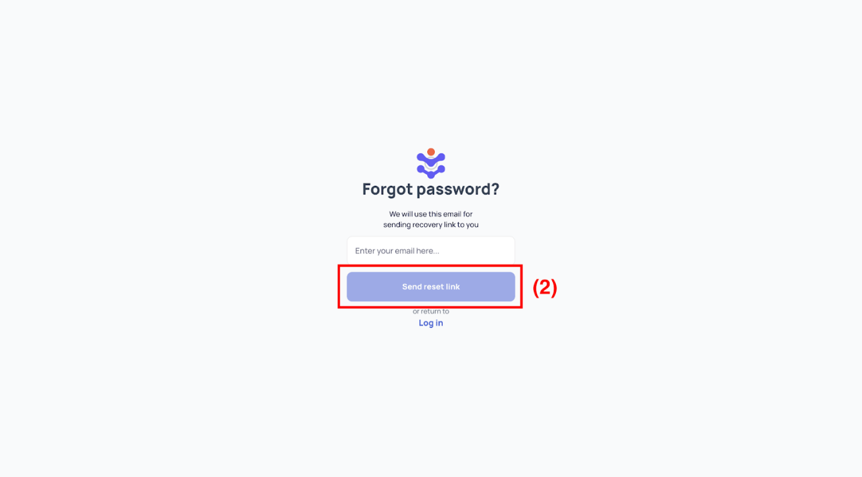

[Figure 147 - Forgot Password](https://drive.google.com/file/d/17MnNqGxlRQ98Yz9tnLcdKehsDs8_64IJ/view?usp=sharing)

*Step 4. Click “Send reset link” button (2)*

*Step 5. Open your mailbox, copy the security key, or click the “Reset Password” button in your email to continue.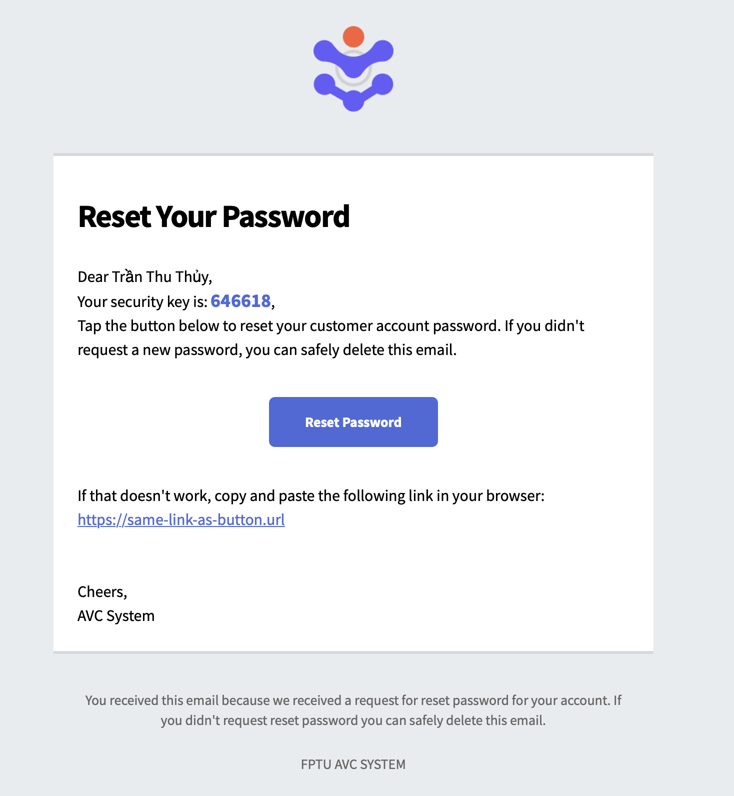*

*Step 6. Fill in your security key, your new password and the confirm password.*

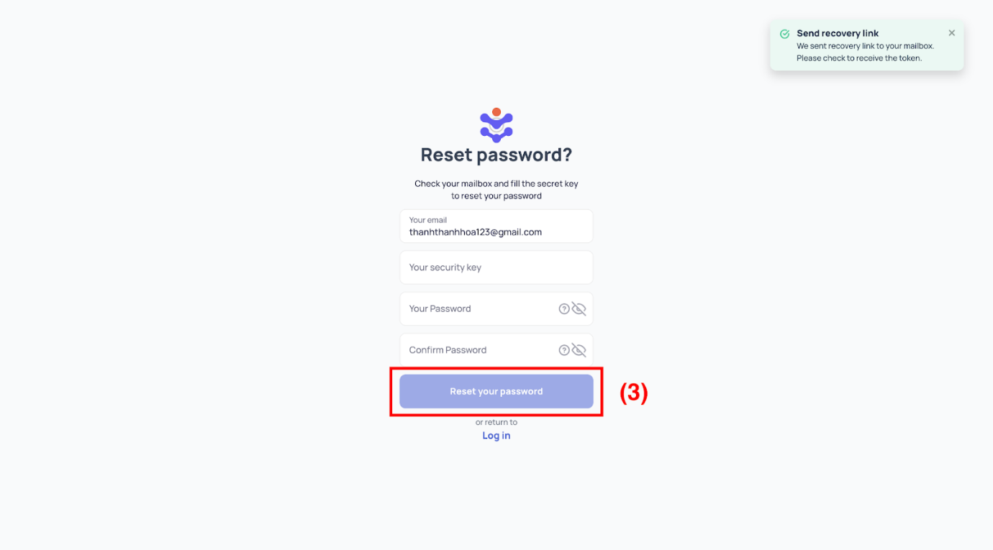

[Figure 148 - Reset Password](https://drive.google.com/file/d/1w5u4Ls39BGlmW7lKHBItUEGgHe-xq_mX/view?usp=sharing)

*Step 7. Click “Reset your password” button (3)*

###### b.13 View Dashboard

Allow Admin to manage system actors through diagrams, charts, and statistics.

*Step 1. User logs in with Admin account*

*Step 2. User visits this site:* [*https://avcar.netlify.app/*](https://avcar.netlify.app/)

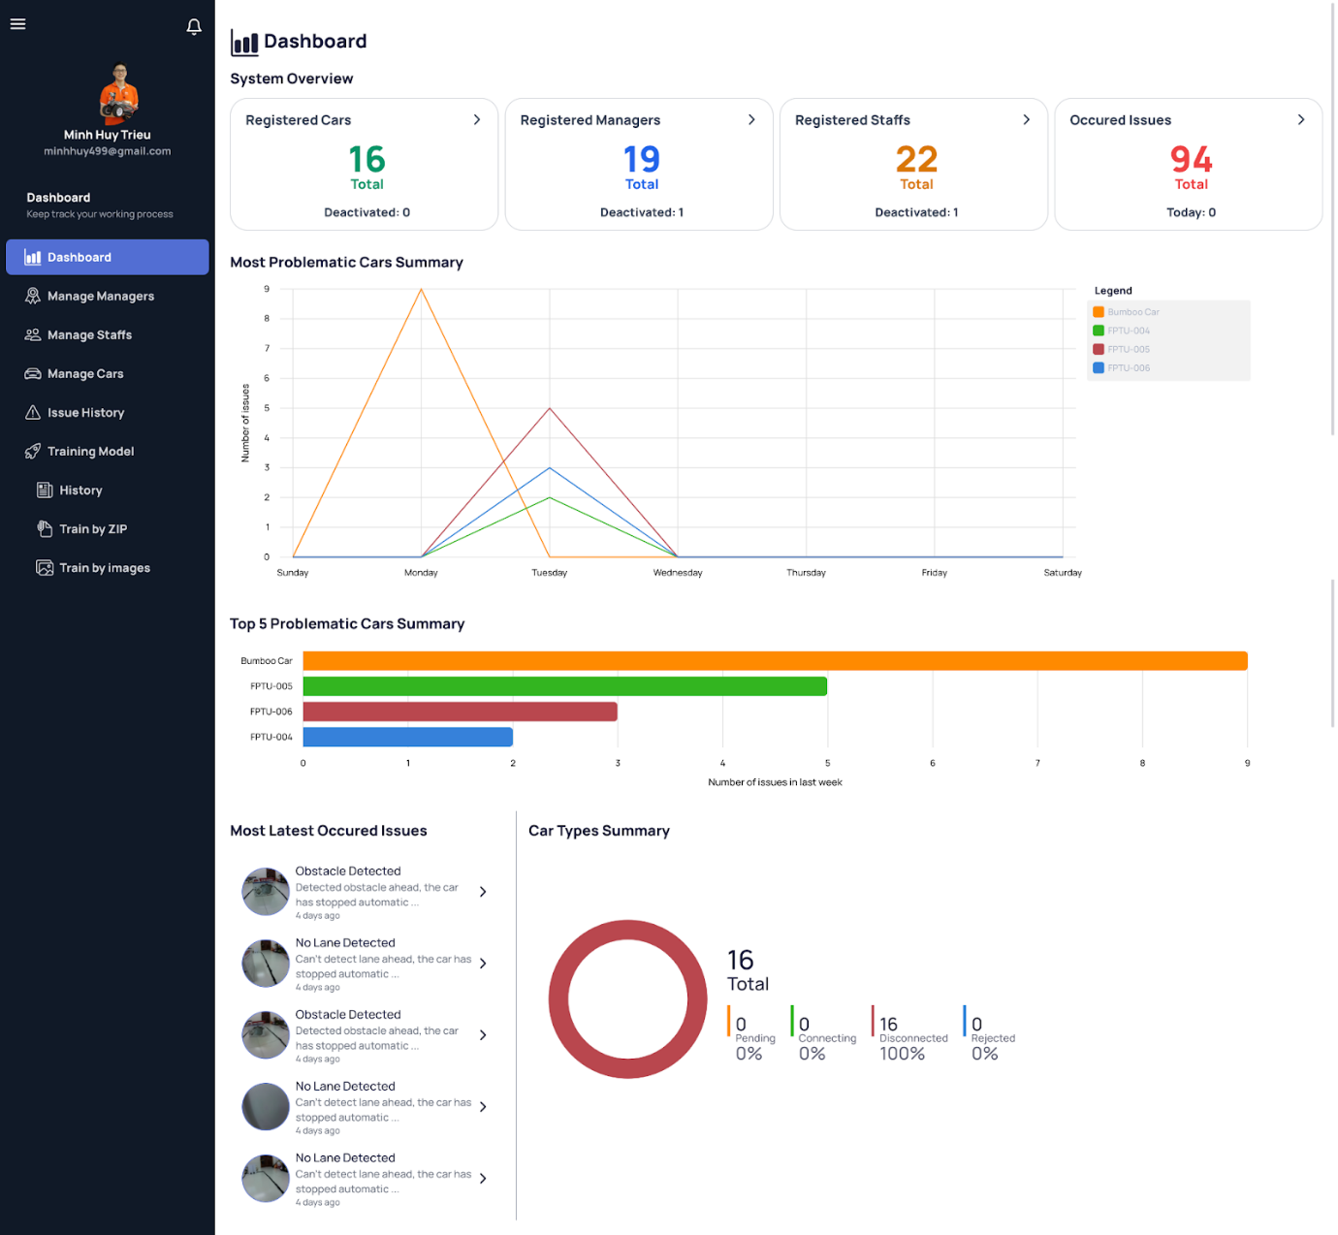

[Figure 149 - Dashboard](https://drive.google.com/file/d/186xYMnj_d7TT3vvvU_8pRCpoPEpU7ciM/view?usp=sharing)

###### b1.4 View Manager List

*Step 1. User logs in with Admin account*

*Step 2. User visits this site:* [*https://avcar.netlify.app/manager*](https://avcar.netlify.app/manager)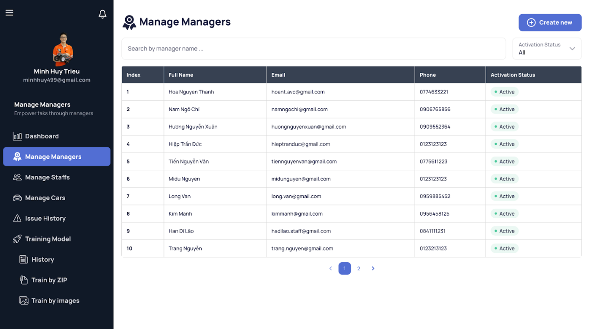

[Figure 150 - View Manager List](https://drive.google.com/file/d/1Frq3V4ZWcv8-Ru6c4Mcs0VjVwm-4d4vl/view?usp=sharing)

###### b1.5 View Manager Detail

*Step 1. User logs in with Admin account*

*Step 2. User visits this site:* [*https://avcar.netlify.app/manager*](https://avcar.netlify.app/manager)

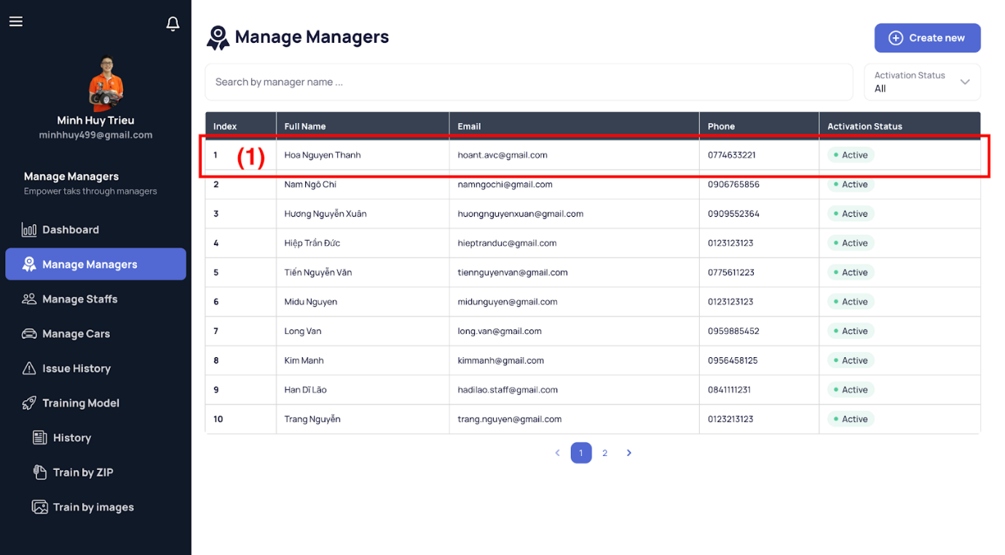

[Figure 151 - View Manager List](https://drive.google.com/file/d/1Frq3V4ZWcv8-Ru6c4Mcs0VjVwm-4d4vl/view?usp=sharing)

*Step 3. Select a manager item (1) in the table and then the details of that manager appear on the right side.*

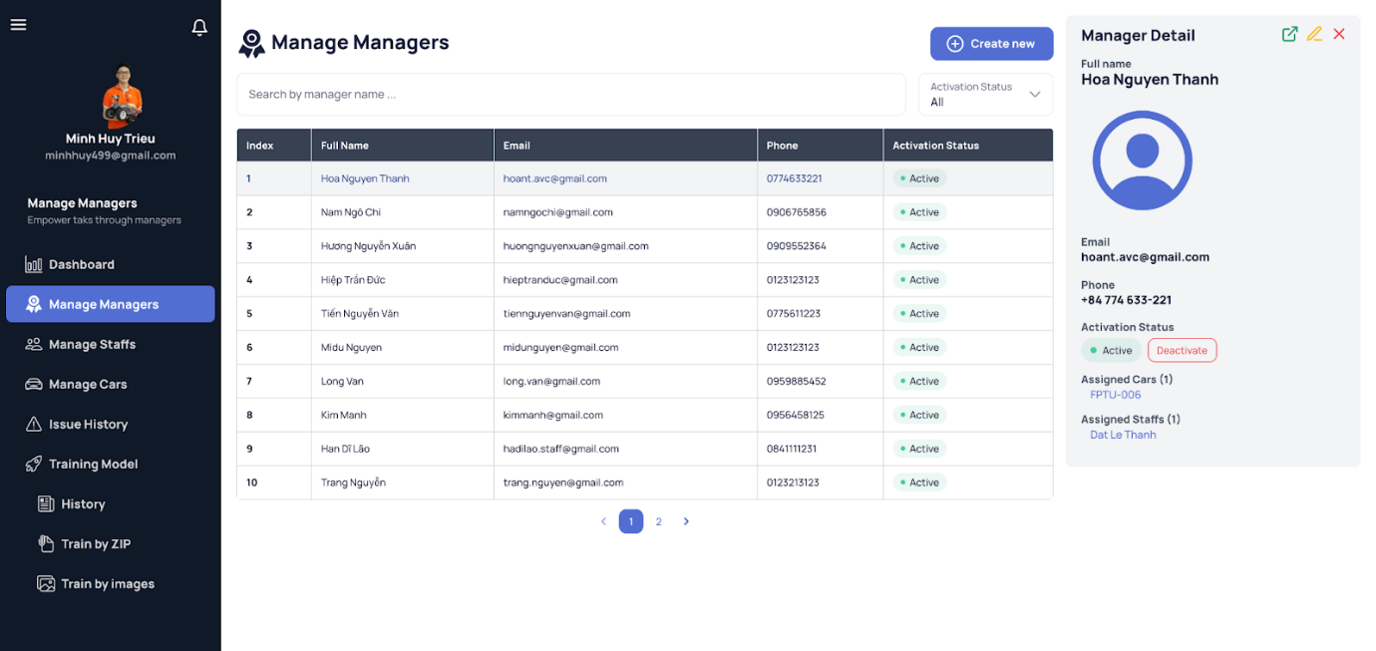

[Figure 152 - View Manager Detail](https://drive.google.com/file/d/1Dx_-L6NjTBd9SMsY20JsAbh13GWPsybu/view?usp=sharing)

###### b1.6 View Manager Detail Expand

*Step 1. User logs in with Admin account*

*Step 2. View manager detail follows the above steps.*

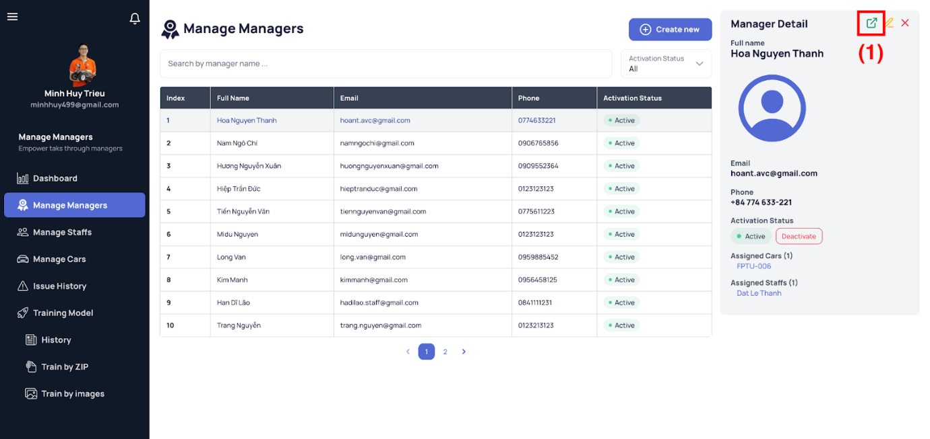

[Figure 153 - View Manager Detail](https://drive.google.com/file/d/1Dx_-L6NjTBd9SMsY20JsAbh13GWPsybu/view?usp=sharing)

*Step 3. Click the expand icon on the top-right corner of the sidenav.*

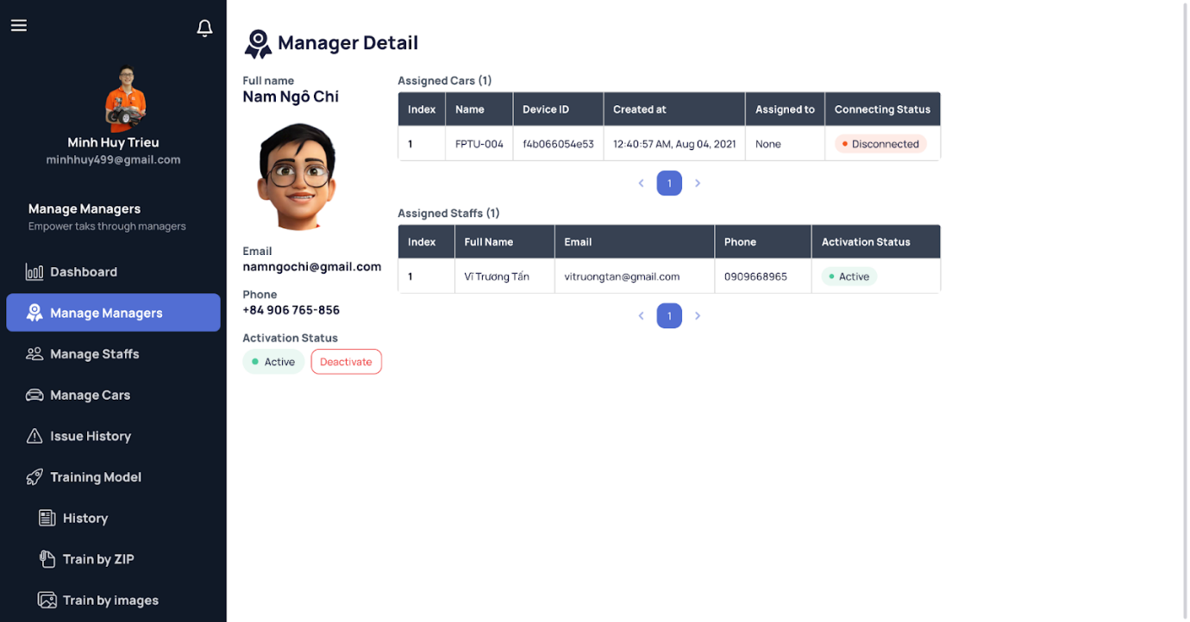

[Figure 154 - View Manager Detail Expand](https://drive.google.com/file/d/1-q9A-RZ2SFJebXt-LJeTyAfuqoBsV_C3/view?usp=sharing)

###### b1.7 Create Manager

*Step 1. User logs in with Admin account*

*Step 2. User visits this site:* [*https://avcar.netlify.app/manager*](https://avcar.netlify.app/manager)

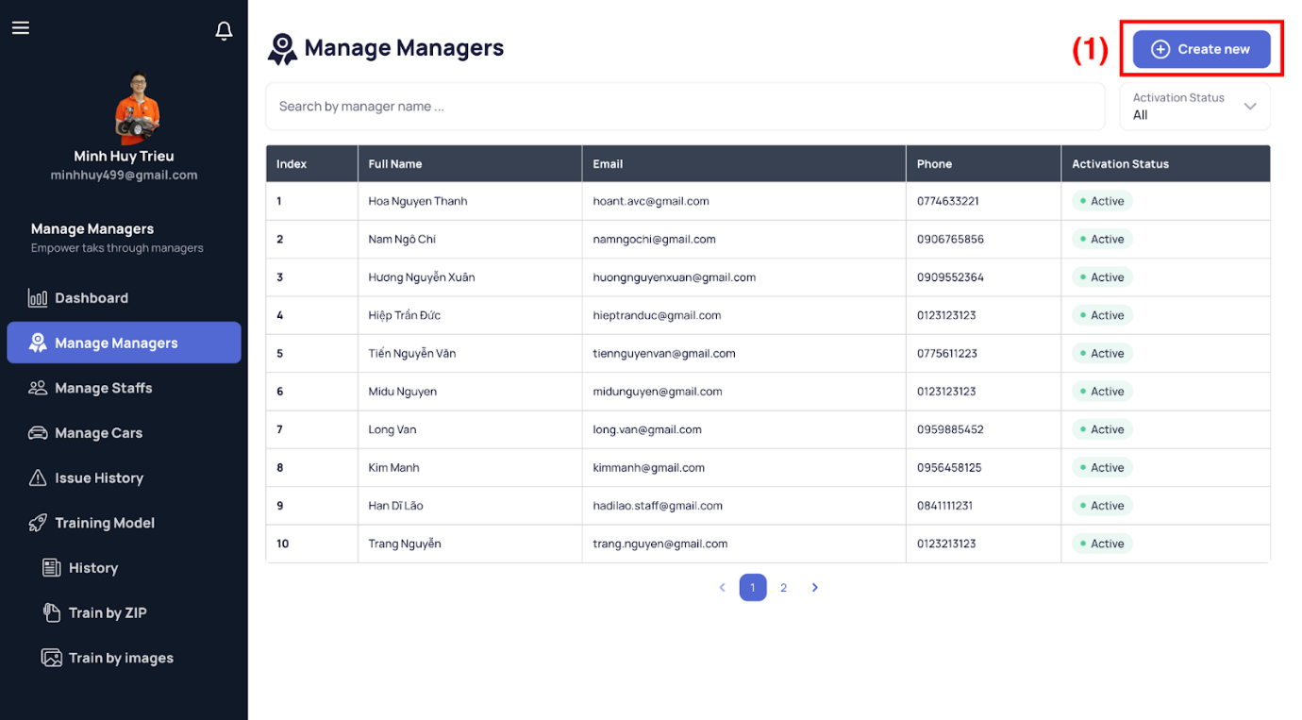

[Figure 155 - View Manager List](https://drive.google.com/file/d/1Frq3V4ZWcv8-Ru6c4Mcs0VjVwm-4d4vl/view?usp=sharing)

*Step 3. Click “Create new” button (1) on the top-right and then the manager create form appears on the right side.*

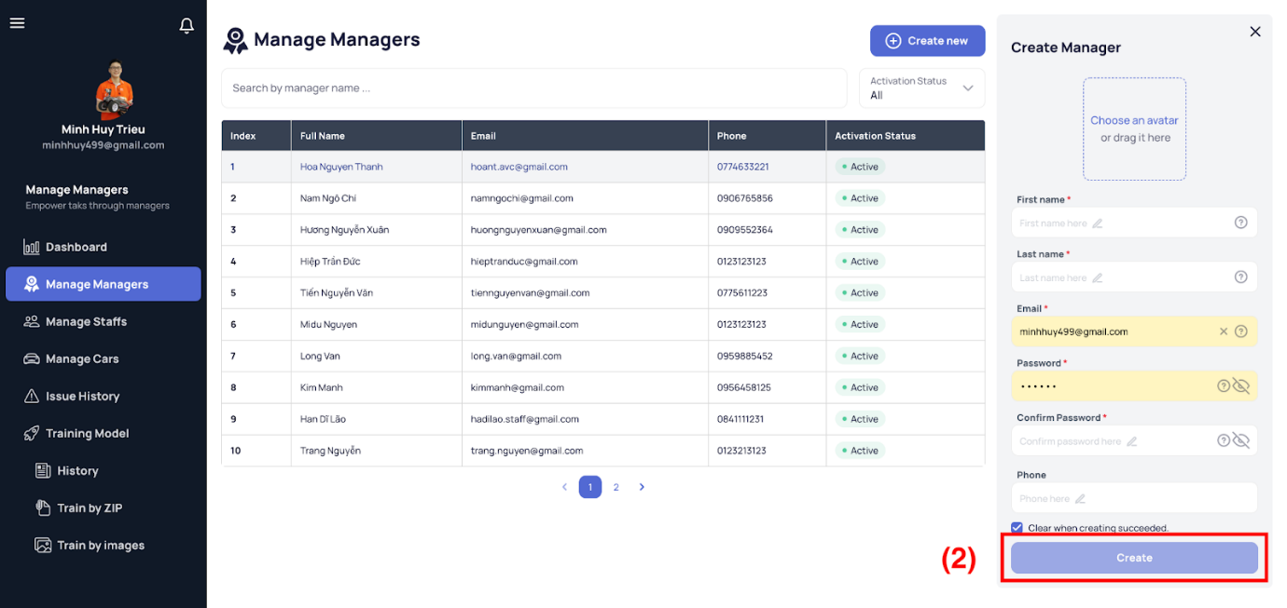

[Figure 156 - Create Manager](https://drive.google.com/file/d/18_sIgxxdtE9I2_l9Sf8d3QcFS6g6FZz9/view?usp=sharing)

*Step 4. Fill manager information*

*Step 5. Click the “Create” button (2) to create new manager*

###### b1.8 Update Manager

*Step 1. User logs in with Admin account*

*Step 2. View manager detail follows above steps.*

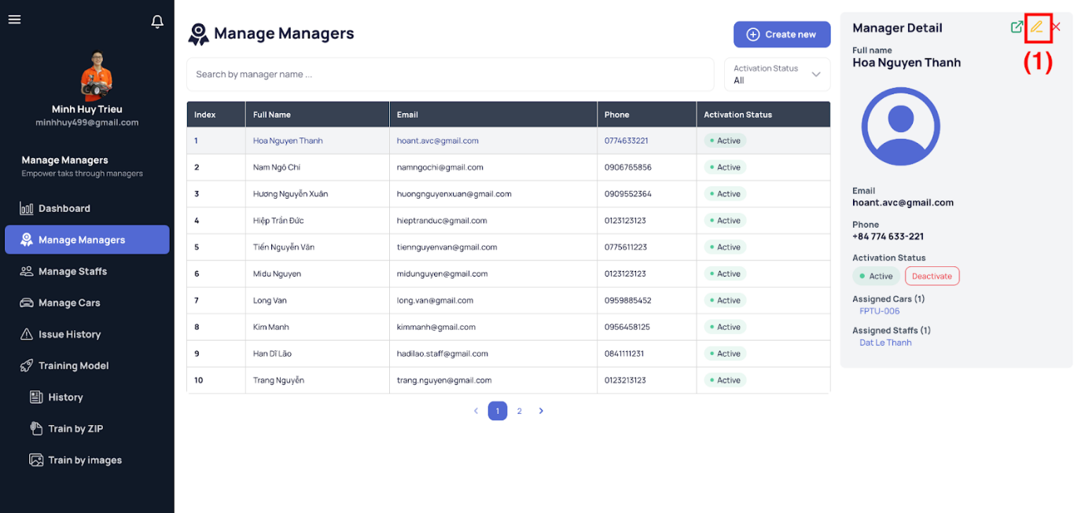

[Figure 157 - View Manager Detail](https://drive.google.com/file/d/1Dx_-L6NjTBd9SMsY20JsAbh13GWPsybu/view?usp=sharing)

*Step 3. Click the pencil icon on the top-right corner of the sidenav and then the update manager replaces the current detail sidenav.*

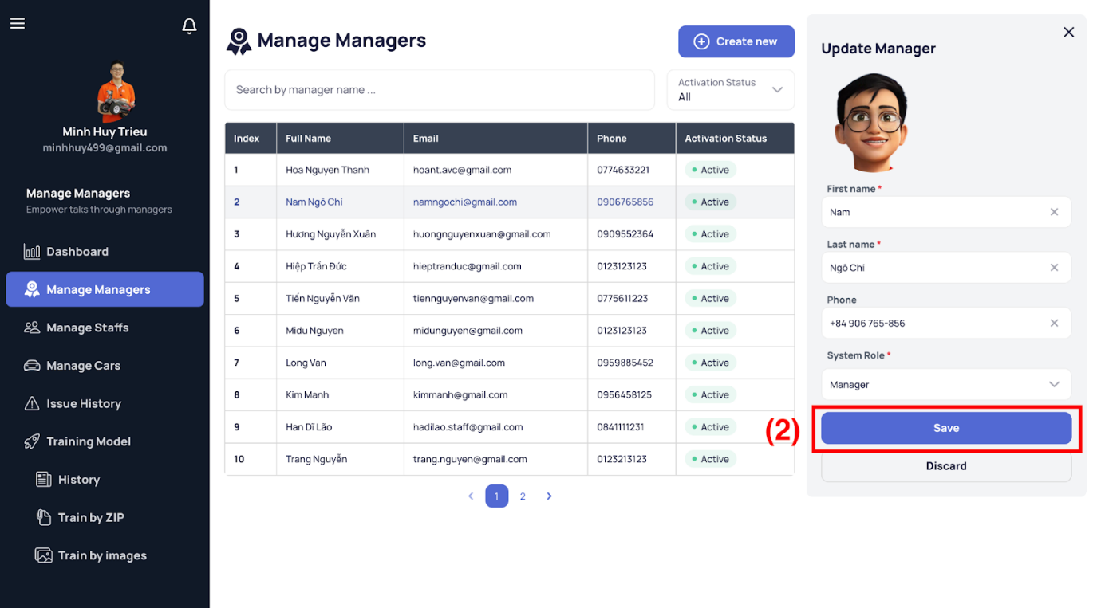

[Figure 158 - Update Manager](https://drive.google.com/file/d/1W0d5fSoBf2DGjasQrvohTkNjTGfsKARA/view?usp=sharing)

*Step 4. Edit on demand*

*Step 5. Click the “Save” button (2) to save all changes or “Discard” button to return the manager detail view.*

###### b1.9 Deactivate/Reactivate Manager

*Step 1. User logs in with Admin account*

*Step 2. View manager detail follows above steps.*

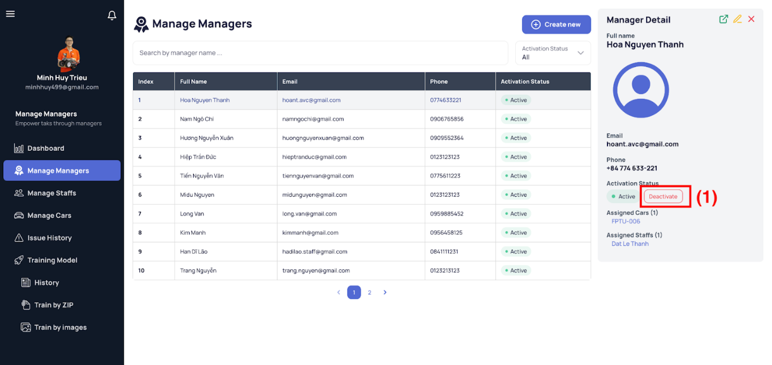

[Figure 159 - View Manager Detail](https://drive.google.com/file/d/1Dx_-L6NjTBd9SMsY20JsAbh13GWPsybu/view?usp=sharing)

*Step 3. Click the “Deactivate/Reactivate” button and then the confirmation dialog shows up.*

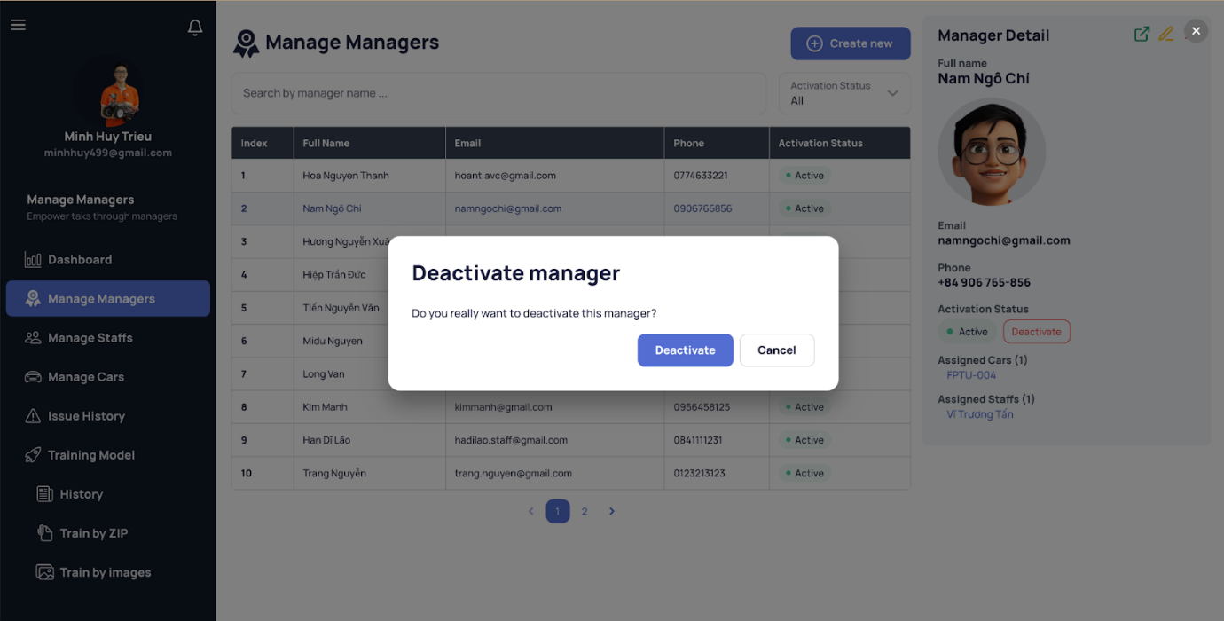

[Figure 160 - Deactivate Manager](https://drive.google.com/file/d/1grZaEyAEVR1uEcCJgpYtnM6KF7E1zrkM/view?usp=sharing)

*Step 4. Click the “Deactivate” to deactivate that manager account or the “Cancel” as a rethinked option.*

###### b1.10 View Staff List

*Step 1. User logs in with Admin or Manager account*

*Step 2. User visits this site:* [*https://avcar.netlify.app/staff*](https://avcar.netlify.app/staff)

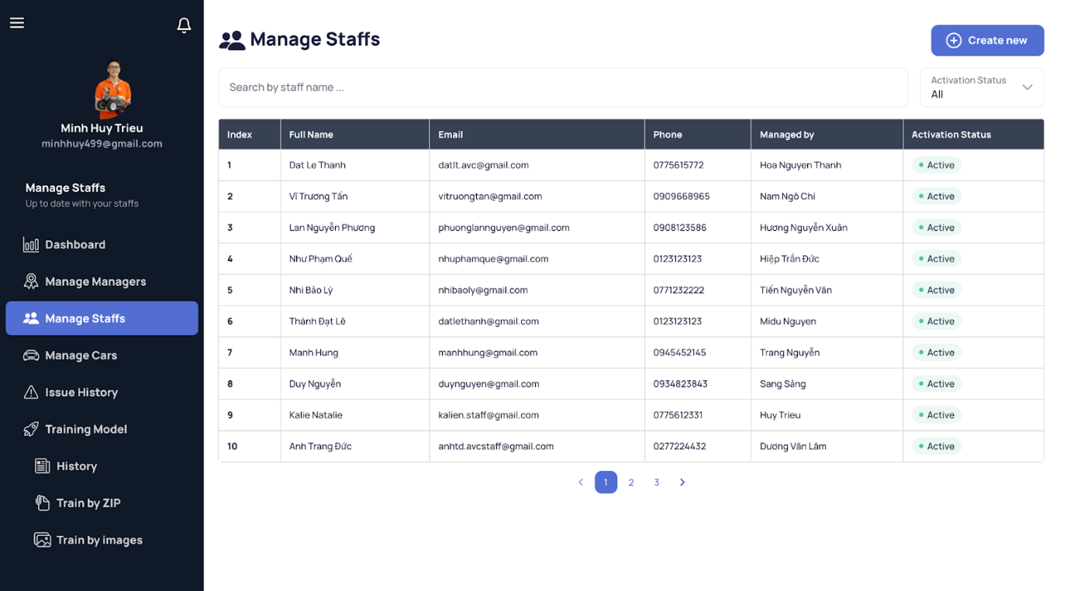

[Figure 161 - View Staff List](https://drive.google.com/file/d/1r90rh1UHPWVKCf6Ne1N6TgPbyci0yxaY/view?usp=sharing)

###### b1.11 View Staff Detail

*Step 1. User logs in with Admin or Manager account*

*Step 2. User visits this site:* [*https://avcar.netlify.app/staff*](https://avcar.netlify.app/manager)

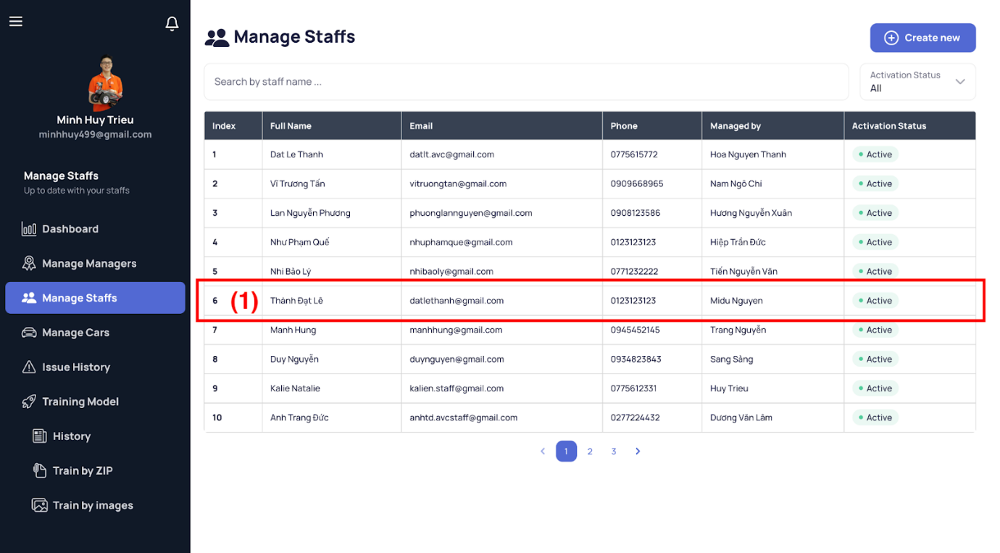

[Figure 162 - View Staff List](https://drive.google.com/file/d/1Frq3V4ZWcv8-Ru6c4Mcs0VjVwm-4d4vl/view?usp=sharing)

*Step 3. Select a staff item (1) in the table and then the details of that staff appear on the right side.*

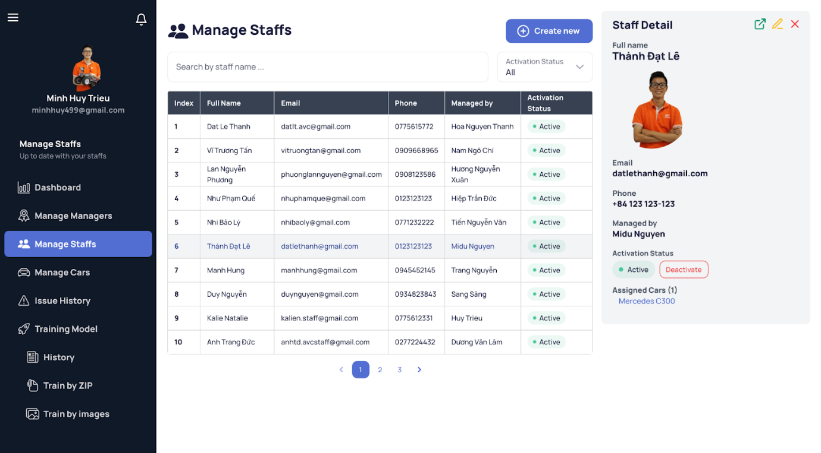

[Figure 163 - View Staff Detail](https://drive.google.com/file/d/1T2LNEBBcJt7ytEVhVkFmJgFtvt5qokO5/view?usp=sharing)

###### b1.12 View Staff Detail Expand

*Step 1. User logs in with Admin or Manager account*

*Step 2. View staff detail follows the above steps.*

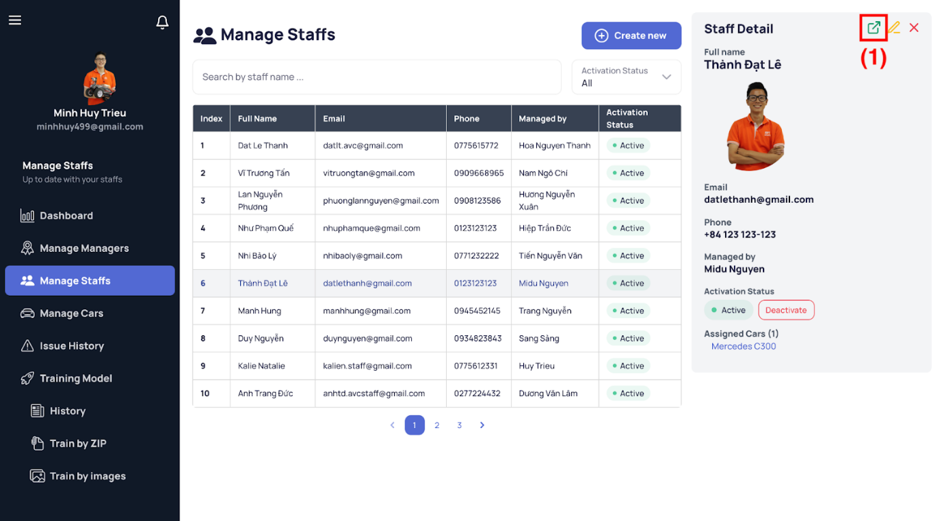

[Figure 164 - View Staff Detail](https://drive.google.com/file/d/1T2LNEBBcJt7ytEVhVkFmJgFtvt5qokO5/view?usp=sharing)

*Step 3. Click the expand icon on the top-right corner of the sidenav.*

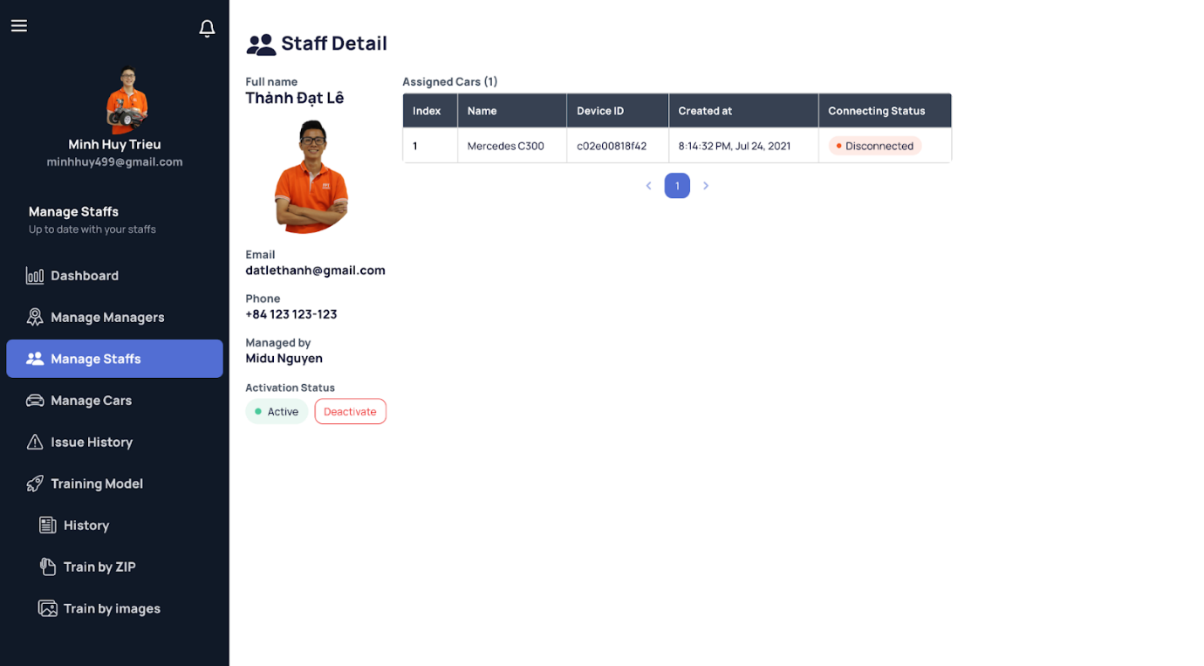

[Figure 165 - View Staff Detail Expand](https://drive.google.com/file/d/14-mkuA8ZhCT0yRmvweVTe6sFVS4Ya1Bv/view?usp=sharing)

###### b1.13 Create Staff

*Step 1. User logs in with Admin account*

*Step 2. User visits this site:* [*https://avcar.netlify.app/staff*](https://avcar.netlify.app/manager)

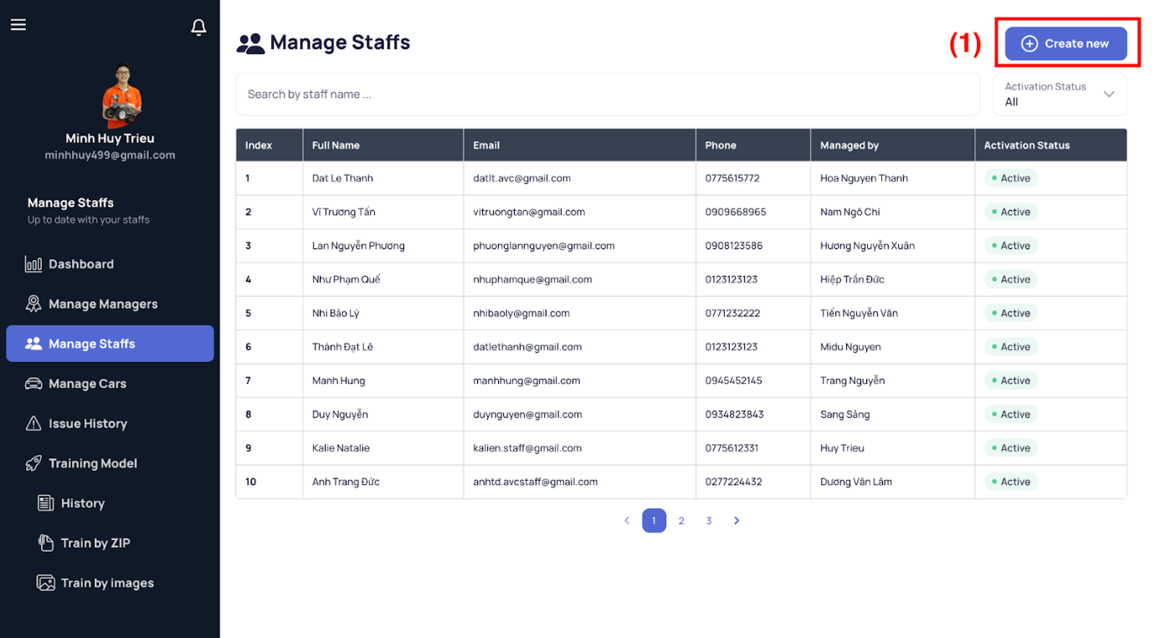

[Figure 166 - View Staff List](https://drive.google.com/file/d/1Frq3V4ZWcv8-Ru6c4Mcs0VjVwm-4d4vl/view?usp=sharing)

*Step 3. Click “Create new” button (1) on the top-right and then the staff create form appears on the right side.*

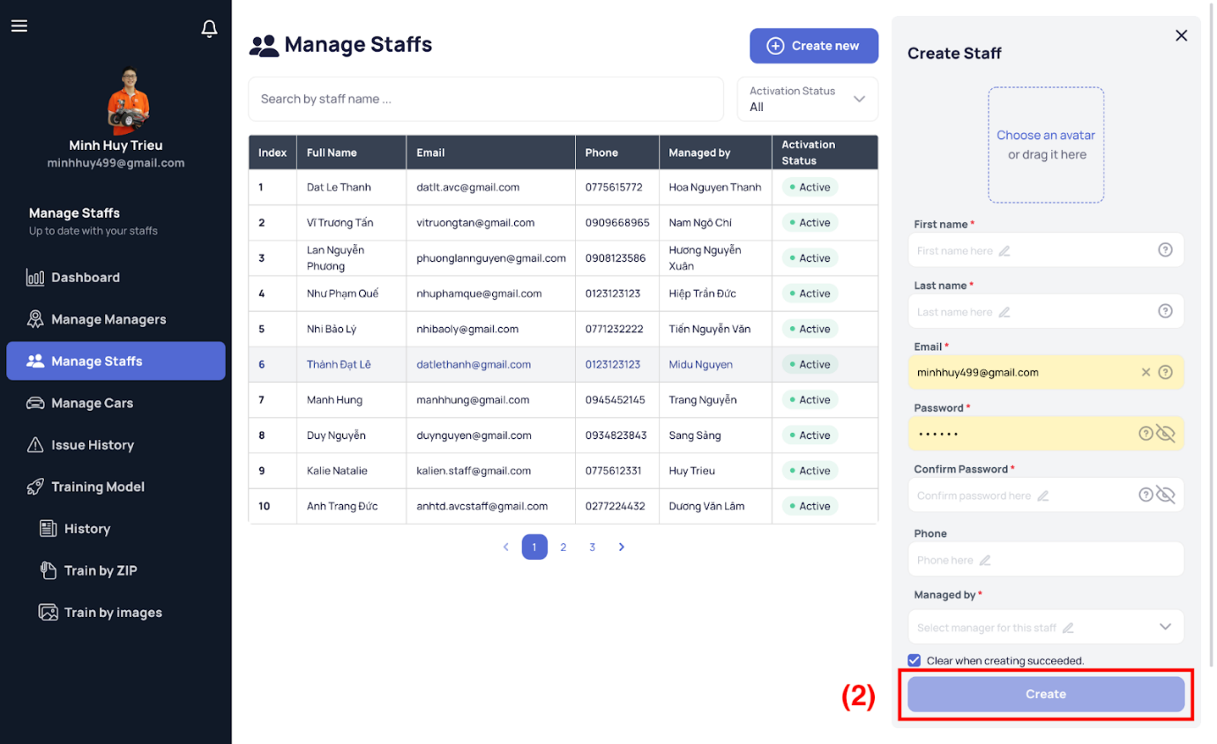

[Figure 167 - Create Staff](https://drive.google.com/file/d/1o7wgShvHhvUMZOE-jWd-it20pwT97oZQ/view?usp=sharing)

*Step 4. Fill staff information*

*Step 5. Click the “Create” button (2) to create new staff*

###### b1.14 Update Staff

*Step 1. User logs in with Admin account*

*Step 2. View staff detail follows the above steps.*

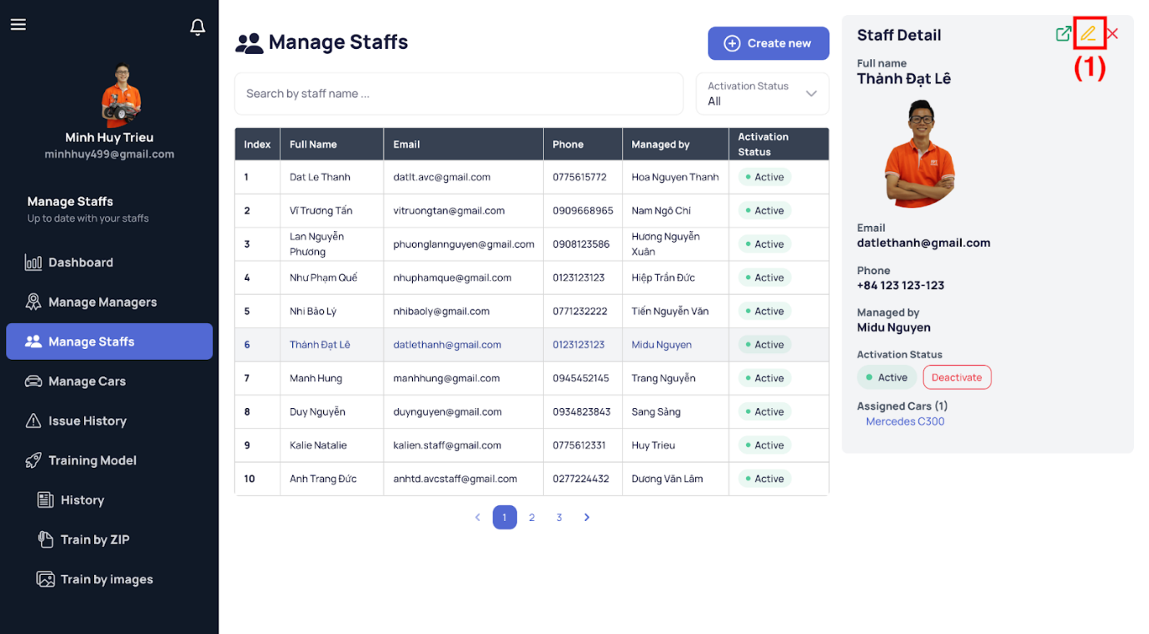

[Figure 168 - View Staff Detail](https://drive.google.com/file/d/1Dx_-L6NjTBd9SMsY20JsAbh13GWPsybu/view?usp=sharing)

*Step 3. Click the pencil icon on the top-right corner of the sidenav and then the update staff replaces the current detail sidenav.*

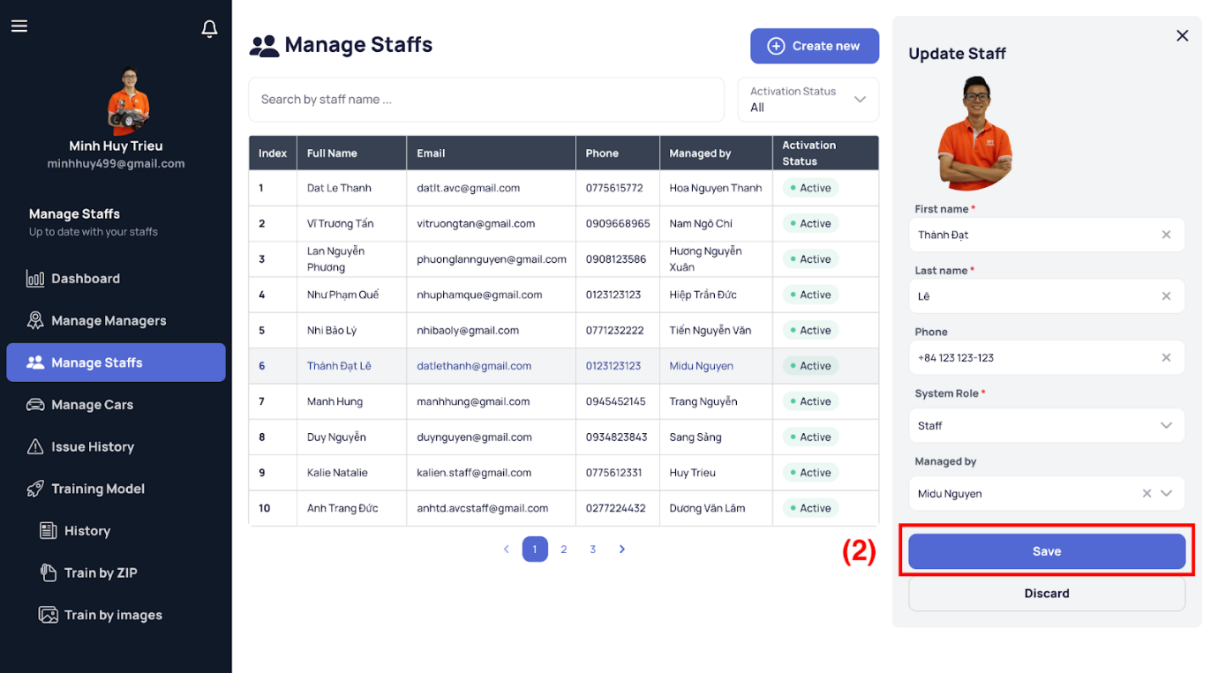

[Figure 169 - Update Staff](https://drive.google.com/file/d/1r3nQLFkOTniVhRVglHczNppCQ0S-_vTY/view?usp=sharing)

*Step 4. Edit on demand*

*Step 5. Click the “Save” button (2) to save all changes or “Discard” button to return the staff detail view.*

###### b1.15 Deactivate/Reactivate Staff

*Step 1. User logs in with Admin account*

*Step 2. View staff detail follows the above steps.*

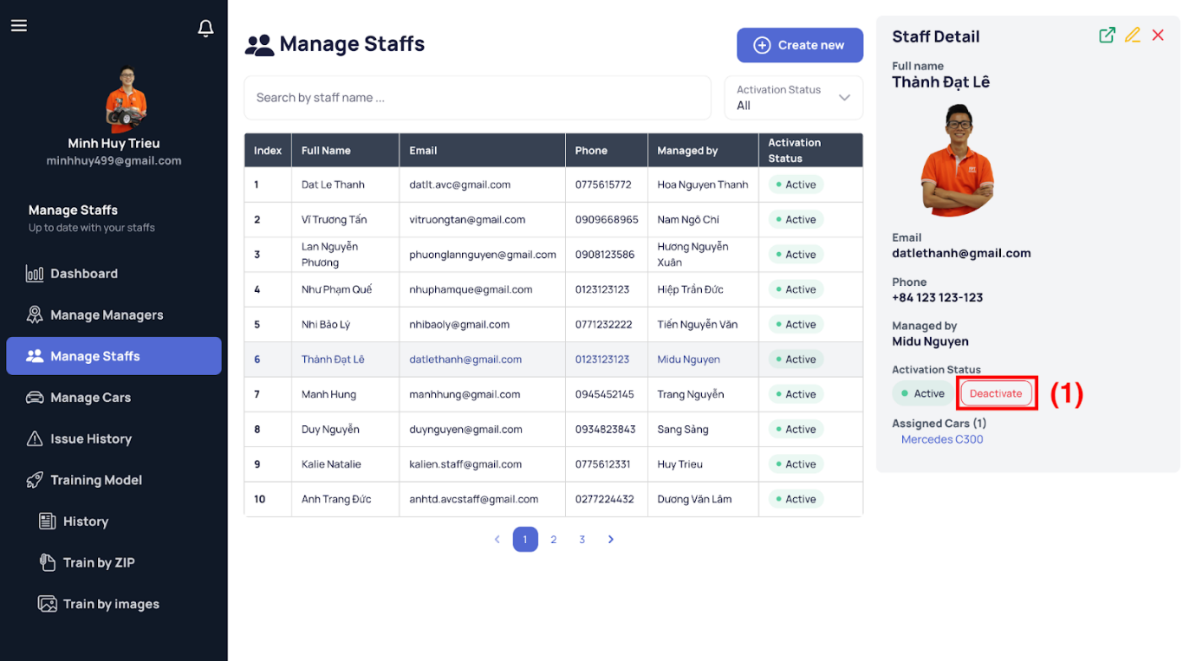

[Figure 170 - View Staff Detail](https://drive.google.com/file/d/1Dx_-L6NjTBd9SMsY20JsAbh13GWPsybu/view?usp=sharing)

*Step 3. Click the “Deactivate/Reactivate” button and then the confirmation dialog shows up.*

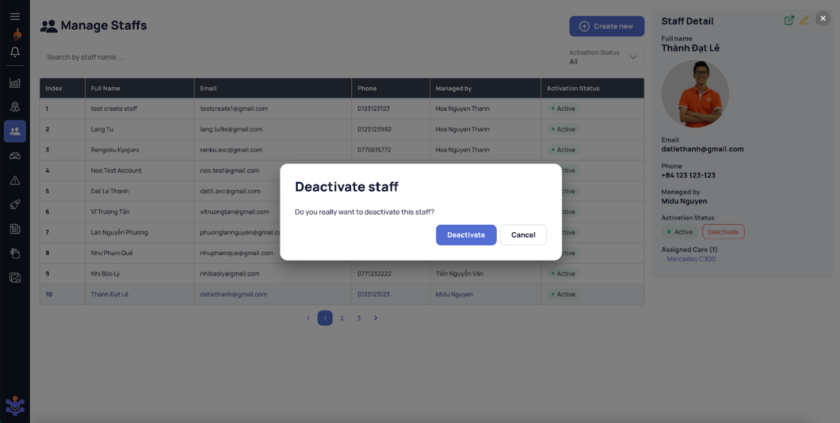

[Figure 171 - Deactivate Staff](https://drive.google.com/file/d/1hedLT3yFP8SgtI5kNxvisIP1FSfxd0mc/view?usp=sharing)

*Step 4. Click the “Deactivate” to deactivate that staff account or the “Cancel” as a rethinked option.*

###### b1.16 View Car List

*Step 1. User logs in with Admin or Manager account*

*Step 2. User visits this site:* [*https://avcar.netlify.app/car*](https://avcar.netlify.app/car)

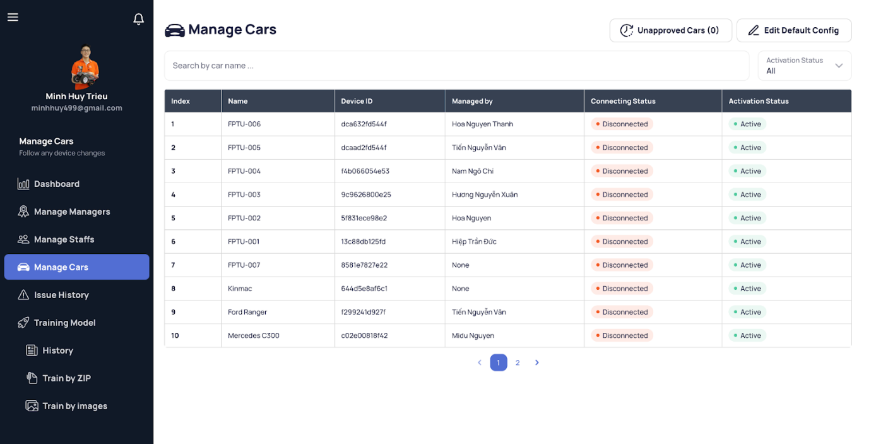

[Figure 172 - View Car List](https://drive.google.com/file/d/1xjwnRHLJ8BSisiUsYyijutUDhEZr8RX4/view?usp=sharing)

###### b1.17 View Car Detail

*Step 1. User logs in with Admin or Manager account*

*Step 2. User visits this site:* [*https://avcar.netlify.app/car*](https://avcar.netlify.app/car)

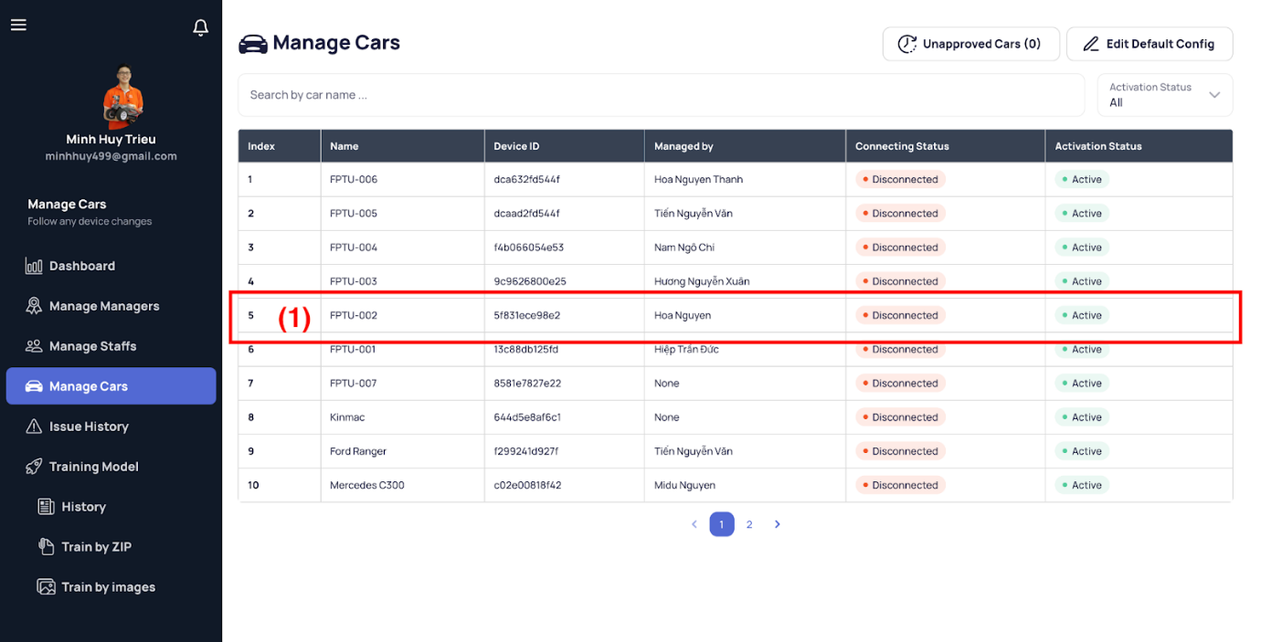

[Figure 173 - View Car List](https://drive.google.com/file/d/1xjwnRHLJ8BSisiUsYyijutUDhEZr8RX4/view?usp=sharing)

*Step 3. Select a car item (1) in the table and then the details of that car appear on the right side.*

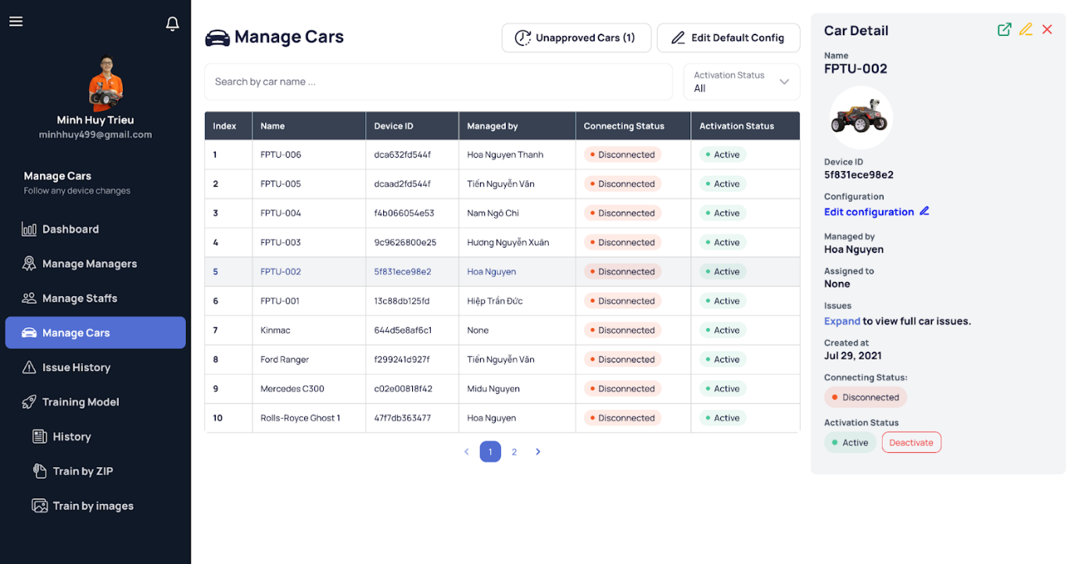

[Figure 174 - View Car Detail](https://drive.google.com/file/d/1L4B6zHw9BfDYvPDryp7frpQoGPz_uk6G/view?usp=sharing)

###### b1.18 View Car Detail Expand

*Step 1. User logs in with Admin or Manager account*

*Step 2. View car detail follows the above steps.*

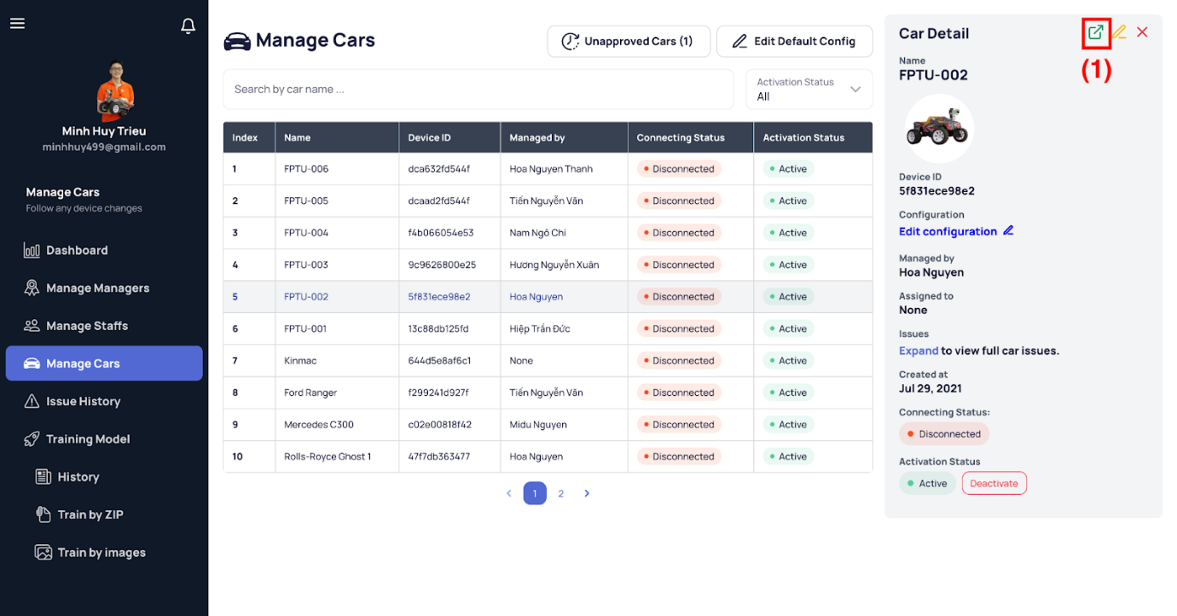

[Figure 175 - View Car Detail](https://drive.google.com/file/d/1L4B6zHw9BfDYvPDryp7frpQoGPz_uk6G/view?usp=sharing)

*Step 3. Click the expand icon (1) on the top-right corner of the sidenav.*

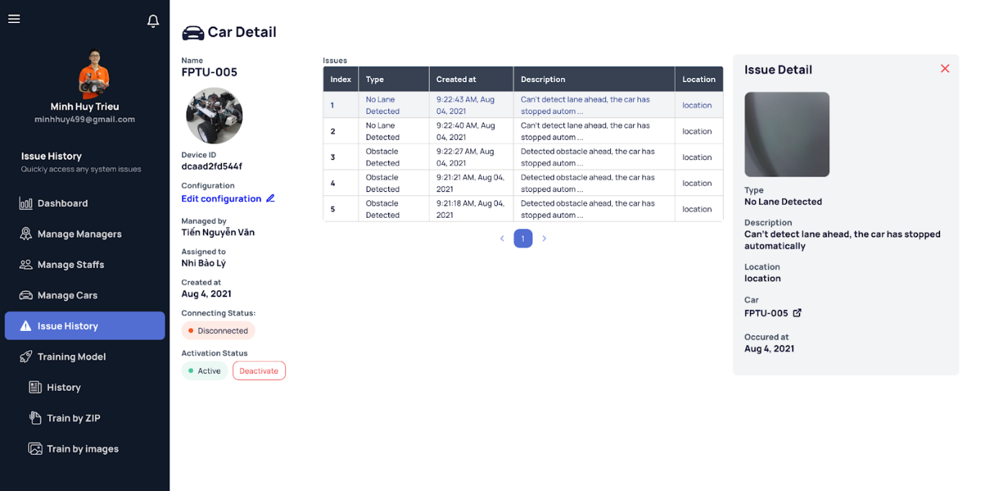

[Figure 176 - View Car Detail Expand](https://drive.google.com/file/d/1temaOG7QVjfTD8ym2lXdIkB-rOBsj7t8/view?usp=sharing)

###### b1.19 View Unapproved Cars

*Step 1. User logs in with Admin account*

*Step 2. User visits this site:* [*https://avcar.netlify.app/car/unapproved*](https://avcar.netlify.app/car/unapproved)

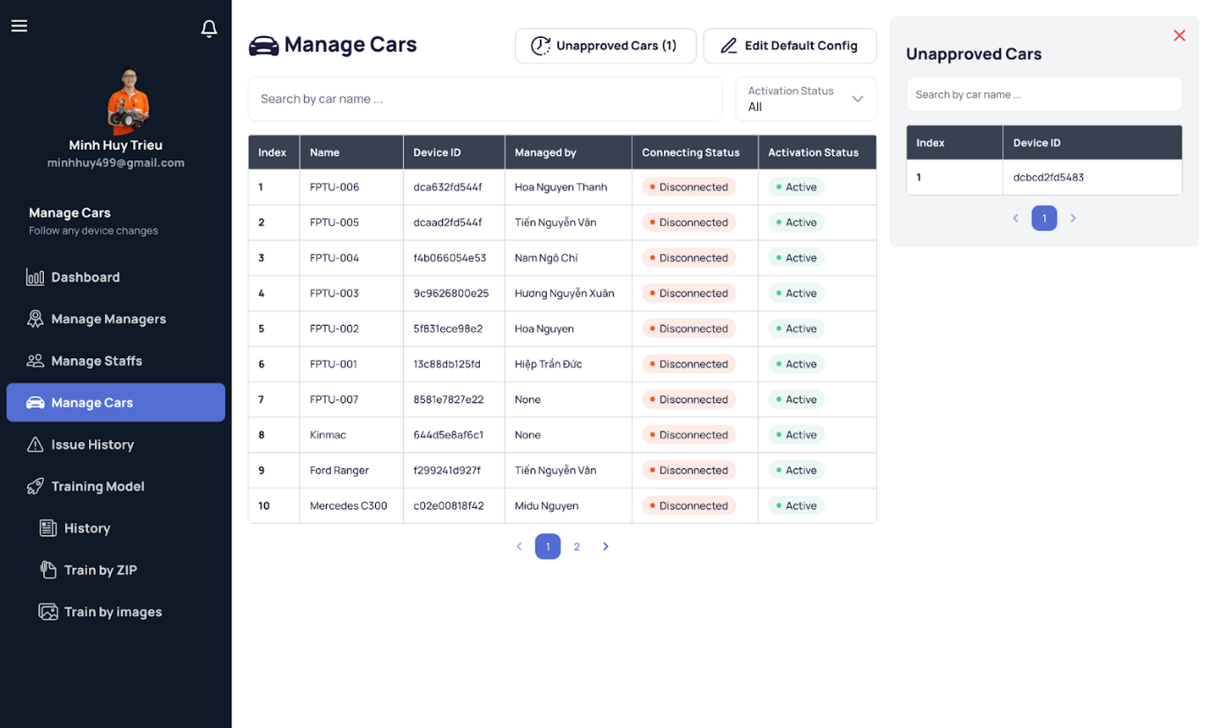

[Figure 177 - View Unapproved Cars](https://drive.google.com/file/d/1E62Z_F6vKfdAwB5XDutqkjPj9Gaata9i/view?usp=sharing)

###### b1.20 Approve/Reject Car

*Step 1. User logs in with Admin account*

*Step 2. User visits this site:* [*https://avcar.netlify.app/car/unapproved*](https://avcar.netlify.app/car/unapproved)

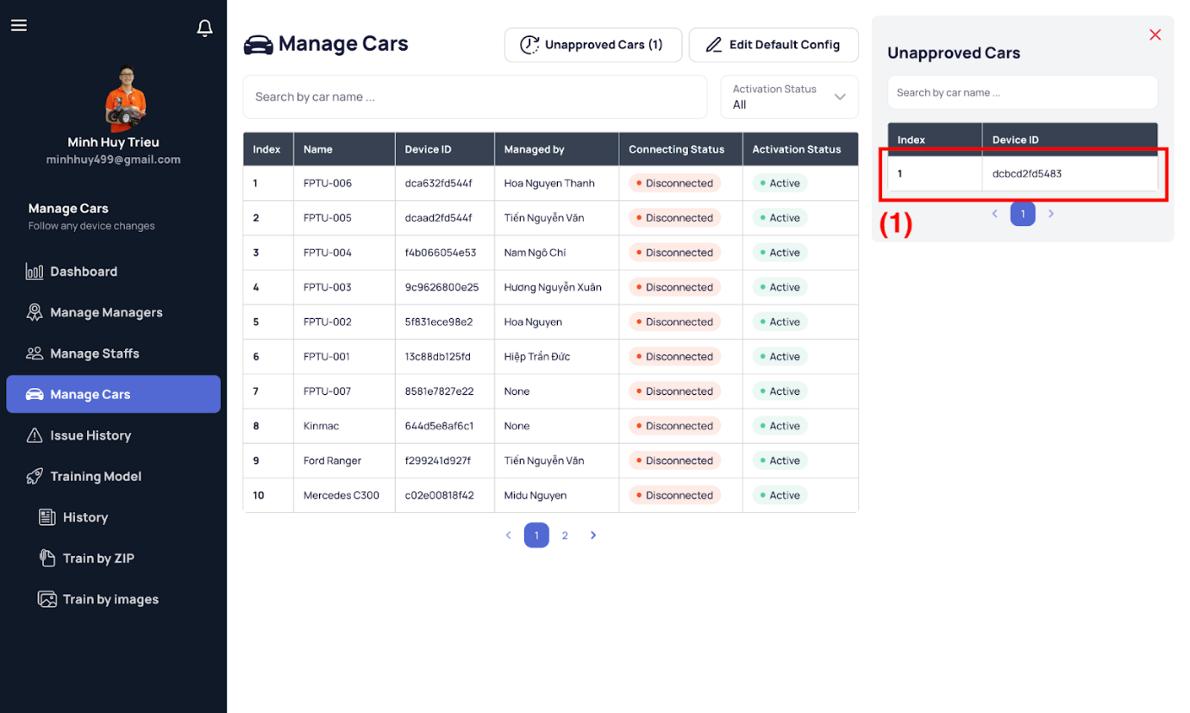

[Figure 178 - View Unapproved Cars](https://drive.google.com/file/d/1E62Z_F6vKfdAwB5XDutqkjPj9Gaata9i/view?usp=sharing)

*Step 3. Select an item (1) in the table on the sidenav and then the unapproved detail car appears, replacing the previous unapproved cars sidenav.*

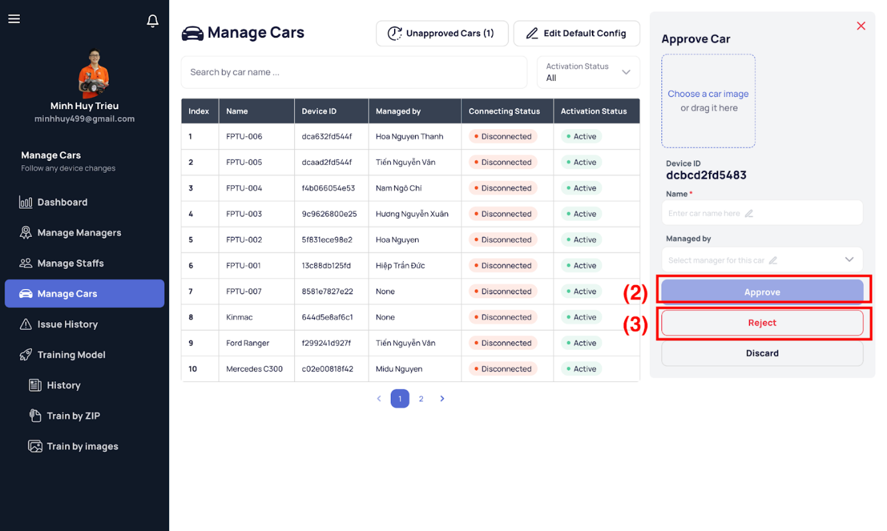

[Figure 179 - Approve/Reject Car](https://drive.google.com/file/d/1jvEE9Px2hAaazMeJkIywL361W_fglxNp/view?usp=sharing)

*Step 4. Fill in the information and click the “Approve” button (2) for approval or click the “Reject” button (3) directly to reject that car from the system.*

###### b1.21 Update Car

*Step 1. User logs in with Admin or Manager account*

*Step 2. View car detail follows the above steps.*

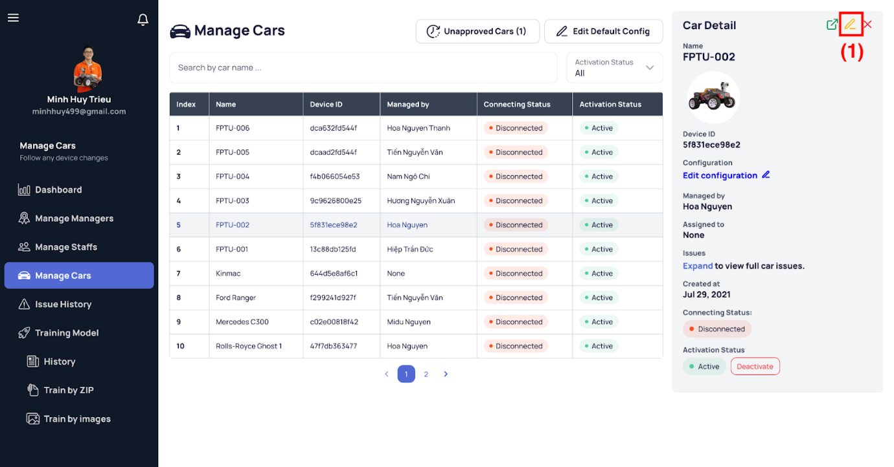

[Figure 180 - View Car Detail](https://drive.google.com/file/d/1L4B6zHw9BfDYvPDryp7frpQoGPz_uk6G/view?usp=sharing)

*Step 3. Click the pencil icon (1) on the top-right corner of the sidenav and then the update car replaces the current detail sidenav.*

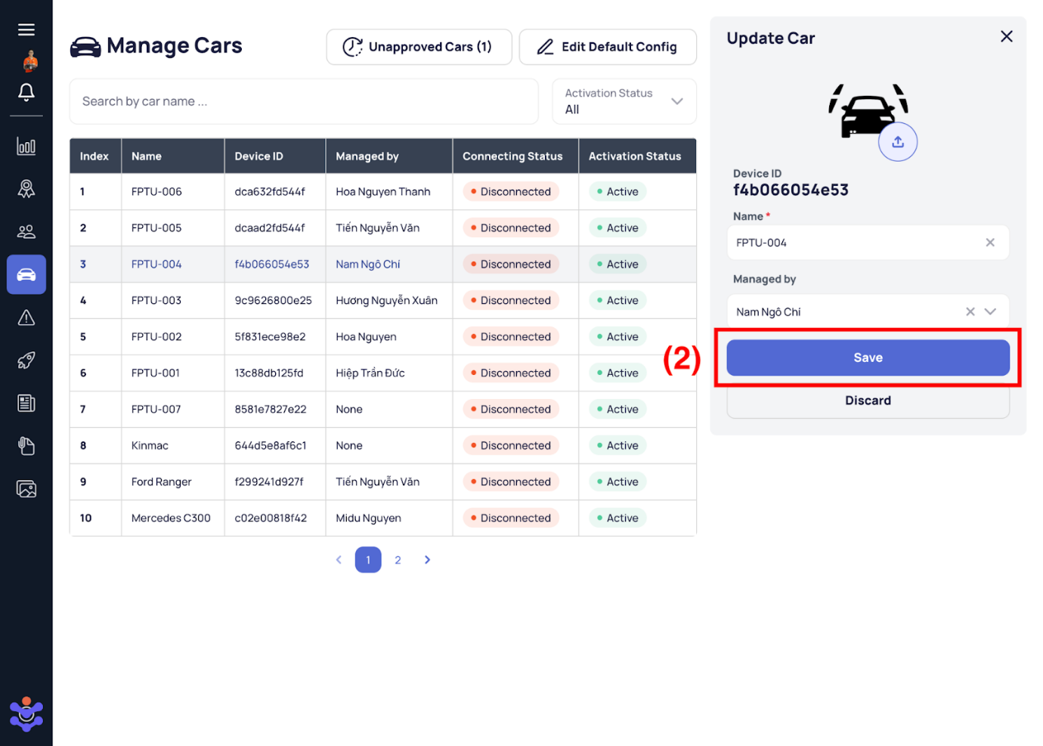

[Figure 181 - Update Car](https://drive.google.com/file/d/1vS81vywaEWO2OF5VqZ5MNfIKLRCsXj28/view?usp=sharing)

*Step 4. Edit on demand.*

*Step 5. Click the “Save” button (2) to save all changes or “Discard” button to return the detail view.*

###### b1.22 Edit Default Car Configuration

*Step 1. User logs in with Admin account*

*Step 2. User visits this site:* [*https://avcar.netlify.app/car/edit-default-config*](https://avcar.netlify.app/car/edit-default-config)

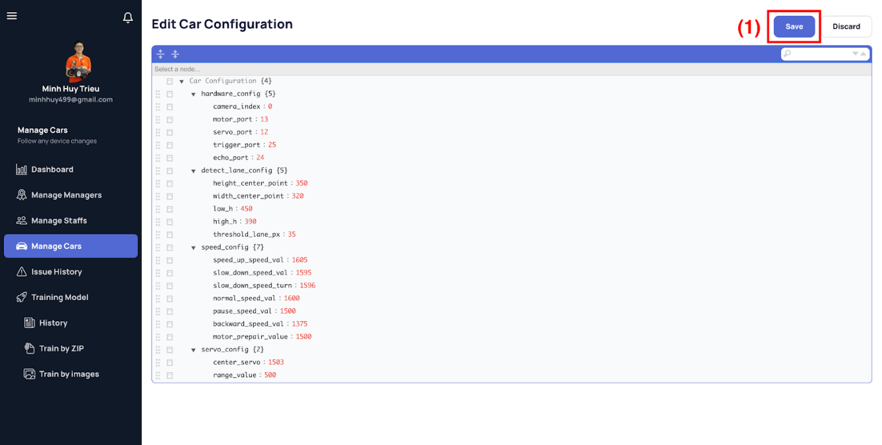

[Figure 182 - Edit Configuration of Car](https://drive.google.com/file/d/1rFUQLdizOII-9hKKjMZRM-cSIkh3BTF0/view?usp=sharing)

*Step 3. Edit on demand*

*Step 4. Click the “Save” button (1) to save all changes.*

###### b1.23 Edit Specific Car Configuration

*Step 1. User logs in with Admin account*

*Step 2. View car detail follows the above steps.*

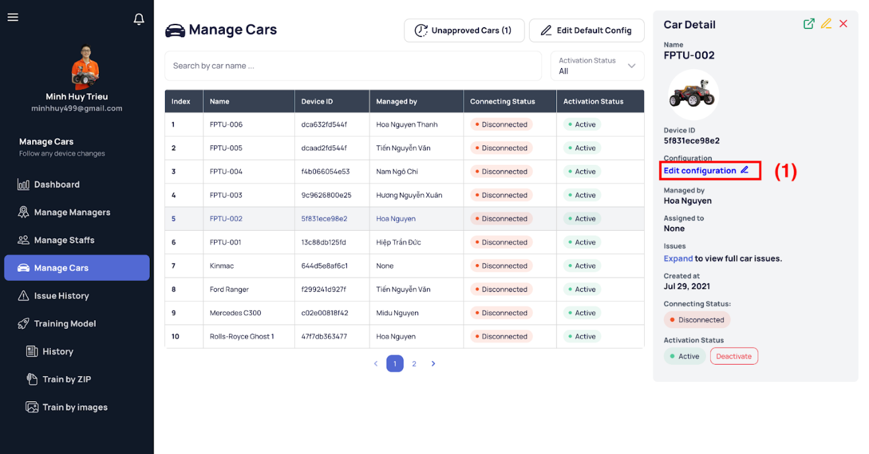

[Figure 183 - View Car Detail](https://drive.google.com/file/d/1L4B6zHw9BfDYvPDryp7frpQoGPz_uk6G/view?usp=sharing)

*Step 3. Click the “Edit configuration” button (1) to switch to the edit configuration page.*

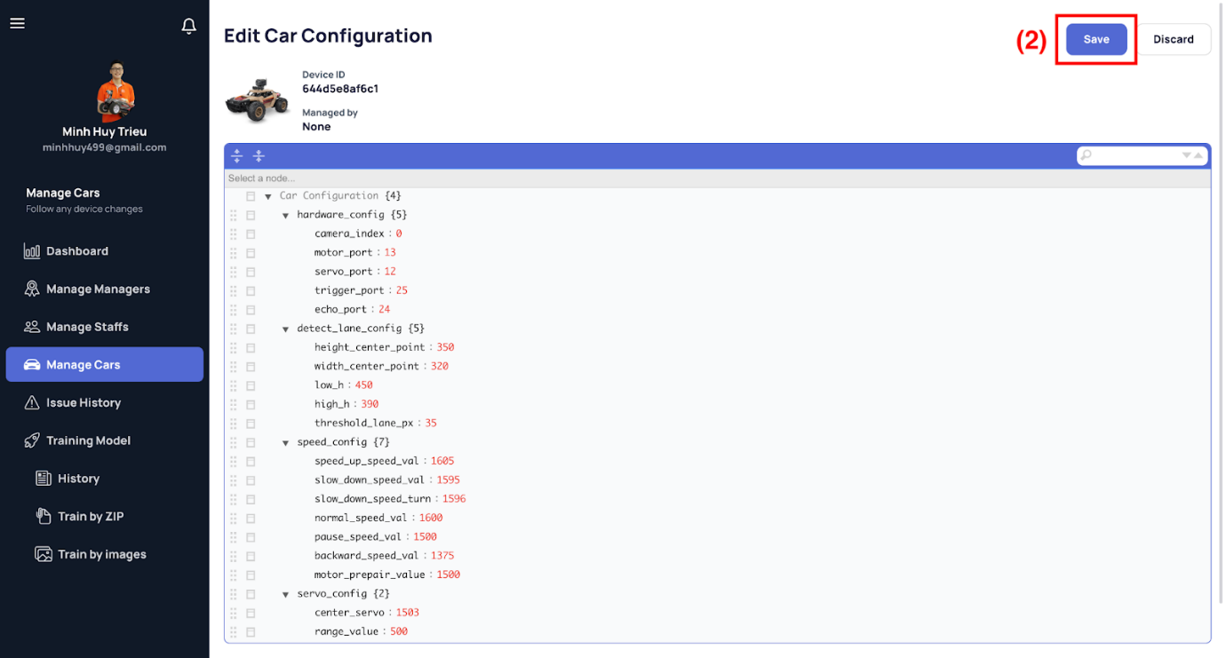

[Figure 184 - Edit Configuration of Car](https://drive.google.com/file/d/1rFUQLdizOII-9hKKjMZRM-cSIkh3BTF0/view?usp=sharing)

*Step 3. Edit on demand*

*Step 4. Click the “Save” button (2) to save all changes.*

###### b1.24 Deactivate/Reactivate Car

*Step 1. User logs in with Admin account*

*Step 2. View car detail follows the above steps.*

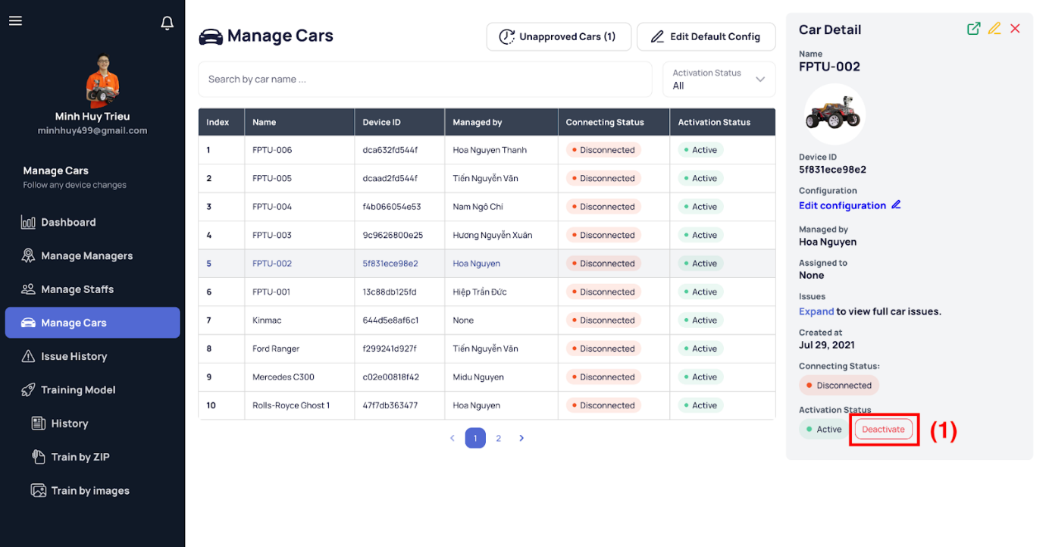

[Figure 185 - View Car Detail](https://drive.google.com/file/d/1L4B6zHw9BfDYvPDryp7frpQoGPz_uk6G/view?usp=sharing)

*Step 3. Click the “Deactivate/Reactivate” button (1) and then the confirmation dialog shows up.*

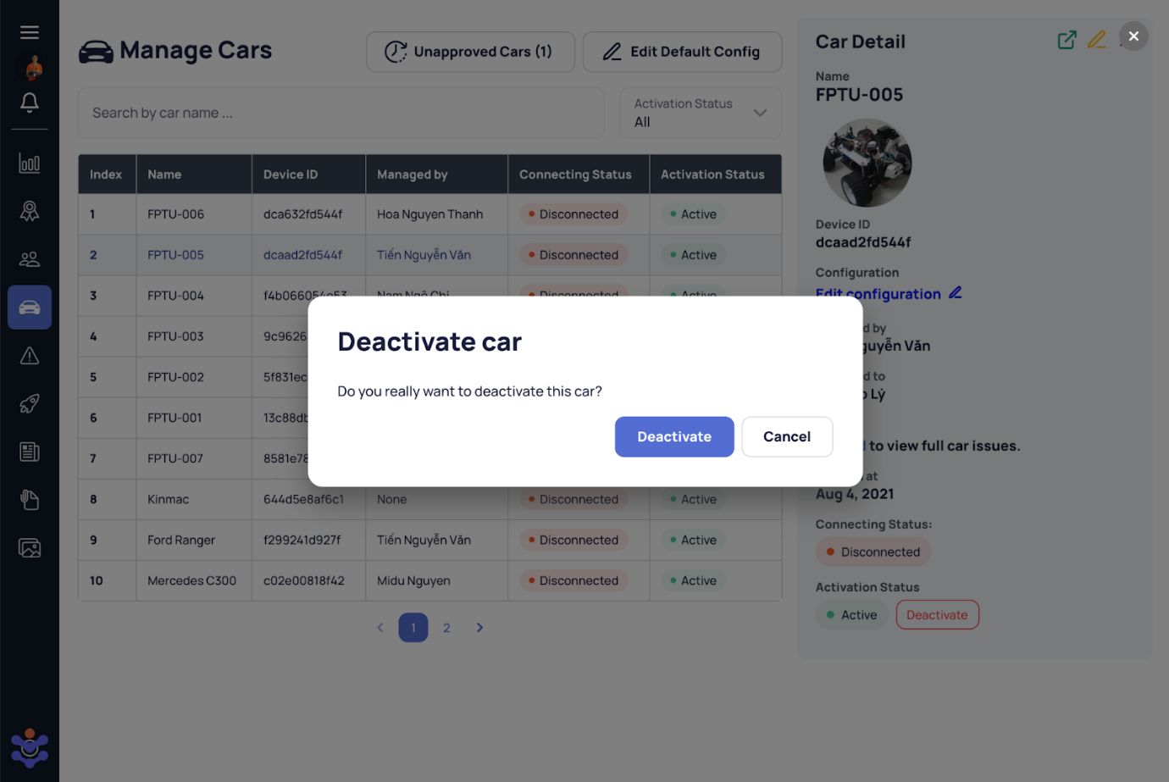

[Figure 186 - Deactivate Car](https://drive.google.com/file/d/1OOuiPd23wxfqBRTgq0dDGr185UGK8pTw/view?usp=sharing)

*Step 4. Click the “Deactivate” to deactivate that car account or the “Cancel” as a rethanked option.*

###### b1.25 View Issue List

*Step 1. User logs in with Admin account*

*Step 2. User visits this site:* [*https://avcar.netlify.app/issue*](https://avcar.netlify.app/issue)

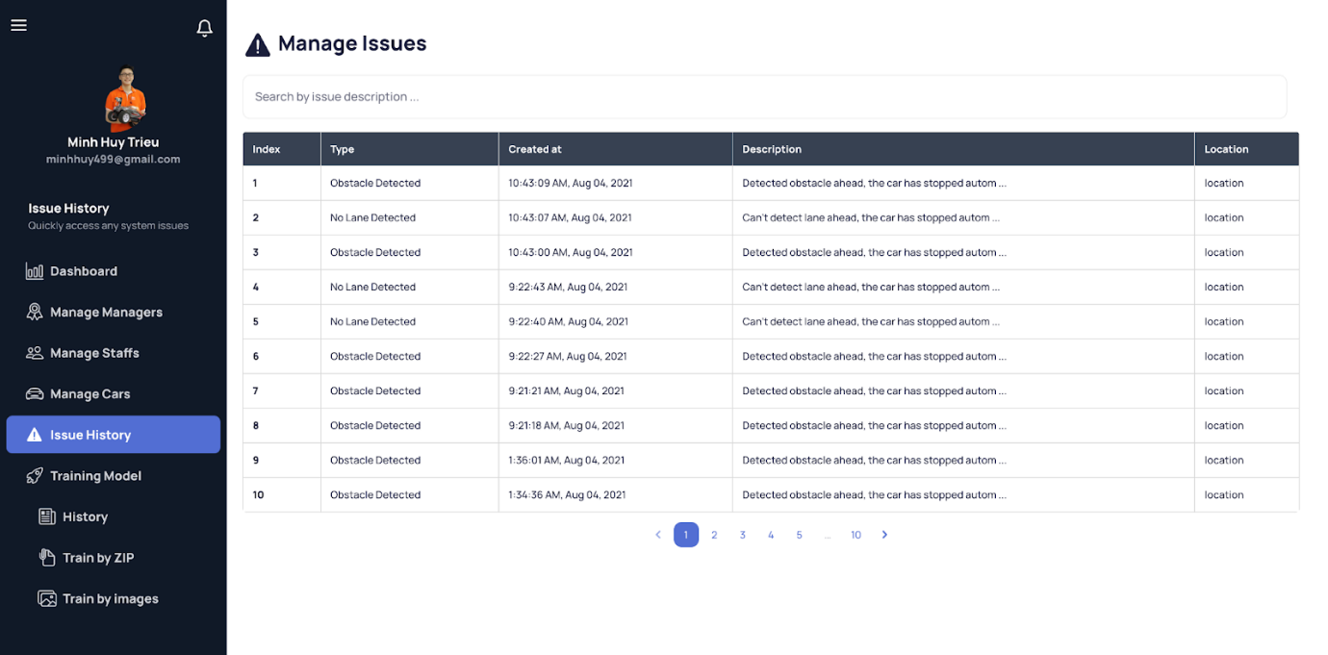

[Figure 187 - View Issue List](https://drive.google.com/file/d/11HxgRnq1WyHJBAOXFMKrEGlaqtg3AmHQ/view?usp=sharing)

###### b1.26 View Issue Detail

*Step 1. User logs in with Admin account*

*Step 2. User visits this site:* [*https://avissue.netlify.app/issue*](https://avcar.netlify.app/car)

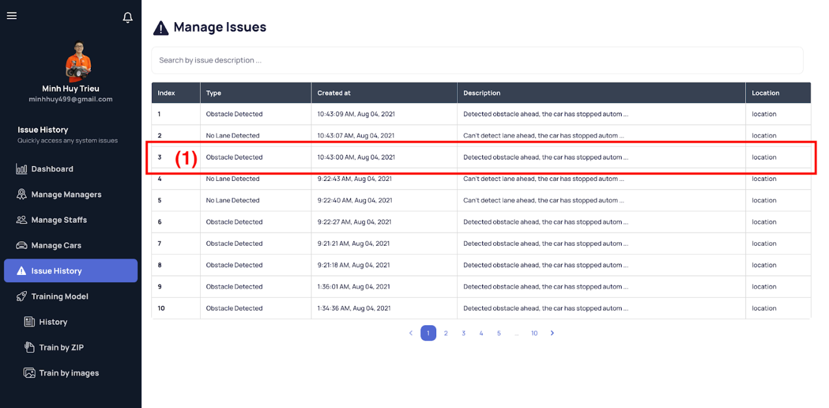

[Figure 188 - View Issue List](https://drive.google.com/file/d/11HxgRnq1WyHJBAOXFMKrEGlaqtg3AmHQ/view?usp=sharing)

*Step 3. Select an issue item (1) in the table and then the details of that issue appear on the right side.*

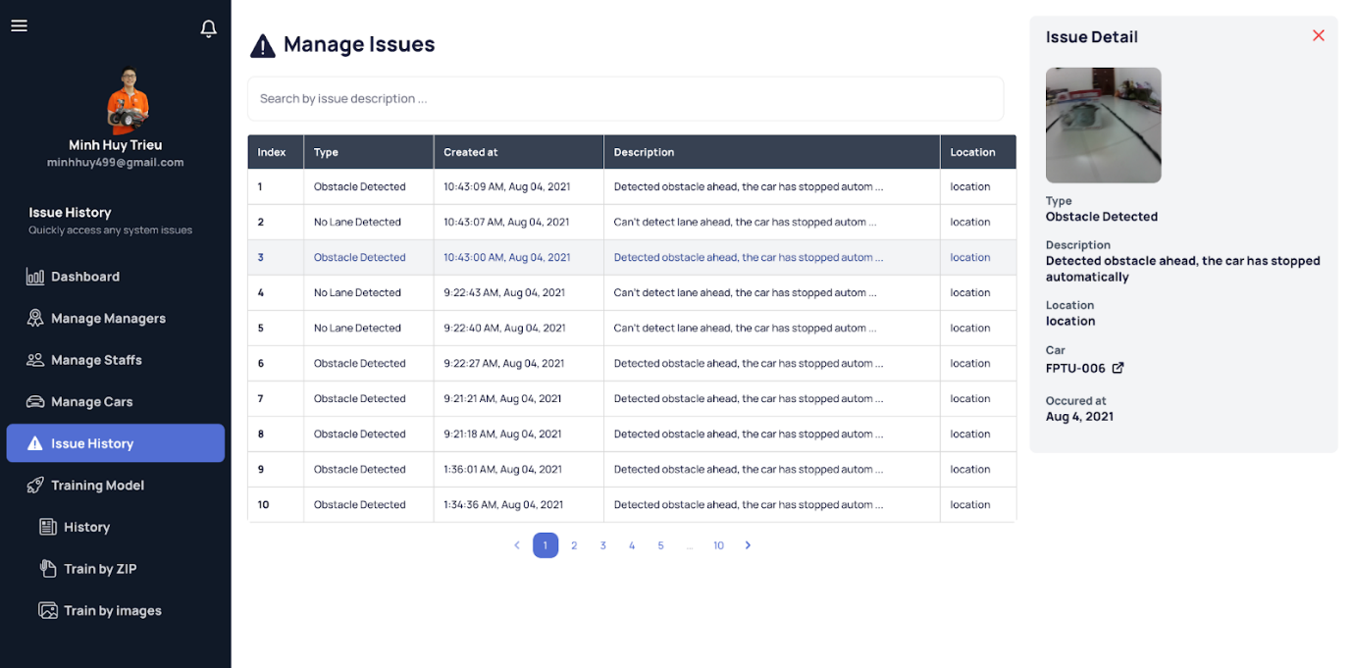

[Figure 189 - View Issue Detail](https://drive.google.com/file/d/1ragrCh6zKzcnZBemxhCgHBzhbtIM9qbB/view?usp=sharing)

*Step 3. Click the issue image if needed to open it in a large dialog.*

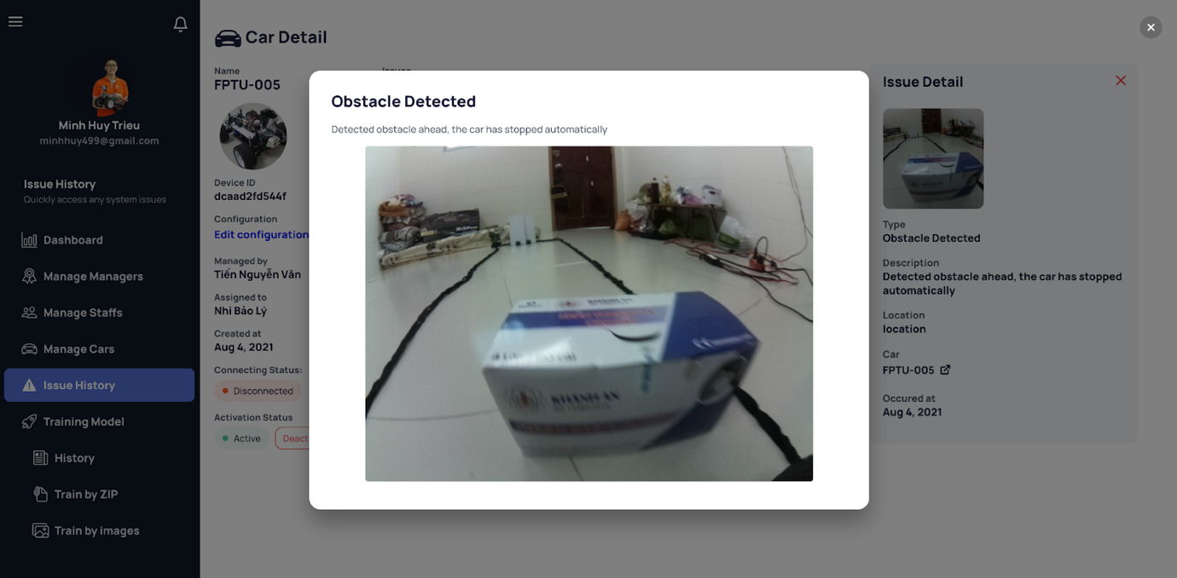

[Figure 190 - View Issue Detail Image Dialog](https://drive.google.com/file/d/1GwGxLj6_DKirr6aAtU_K4yea8wvkCFkH/view?usp=sharing)

###### b1.27 View Training History List

*Step 1. User logs in with Admin account*

*Step 2. User visits this site:* [*https://avcar.netlify.app/training/history*](https://avcar.netlify.app/training/history)

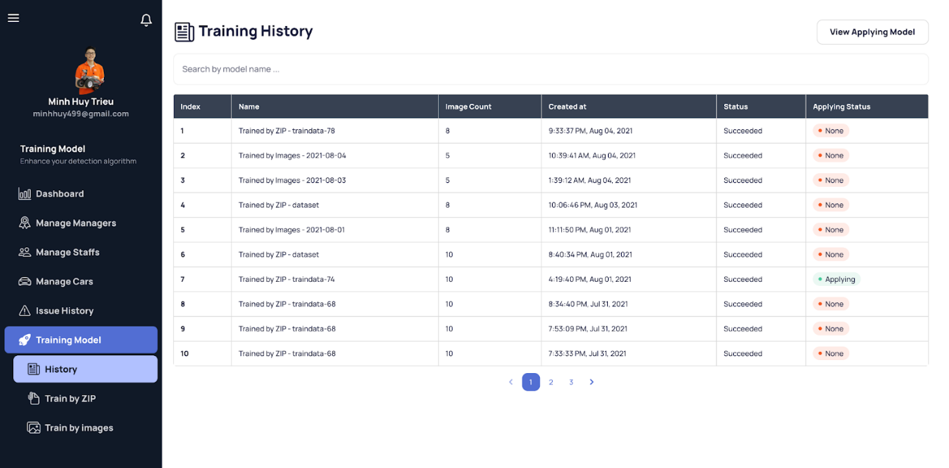

[Figure 191 - View Train History List](https://drive.google.com/file/d/1w7xYkx3jH4PJ3AOTRfIunz_VfIK0f1e5/view?usp=sharing)

###### b1.28 View Training History Detail

*Step 1. User logs in with Admin account*

*Step 2. User visits this site:* [*https://avcar.netlify.app/training/history*](https://avcar.netlify.app/training/history)

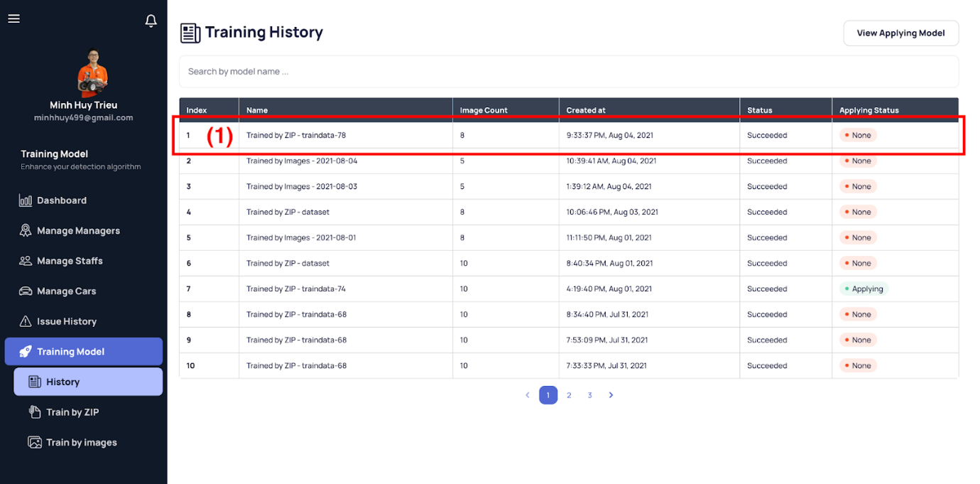

[Figure 192 - View Train History List](https://drive.google.com/file/d/1w7xYkx3jH4PJ3AOTRfIunz_VfIK0f1e5/view?usp=sharing)

*Step 3. Select a model item (1) in the table and then the details of that model appear on the right side.*

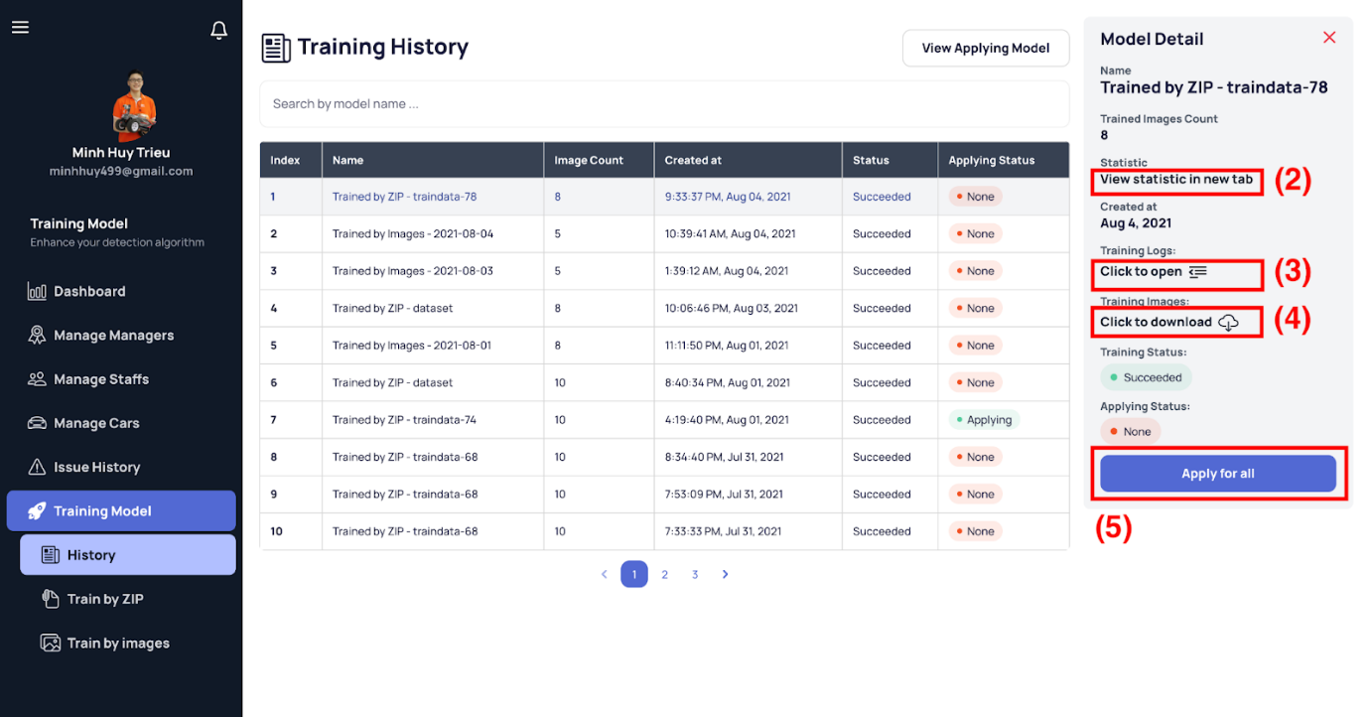

[Figure 193 - View Train History Detail](https://drive.google.com/file/d/1n3XFmjtaw_q5W3vQcWewCxs_z_KGO82f/view?usp=sharing)

*Step 3.1. Click the “Click to view statistic” button (2) (only show after the model training successfully) to check the statistic with the current applying model.*

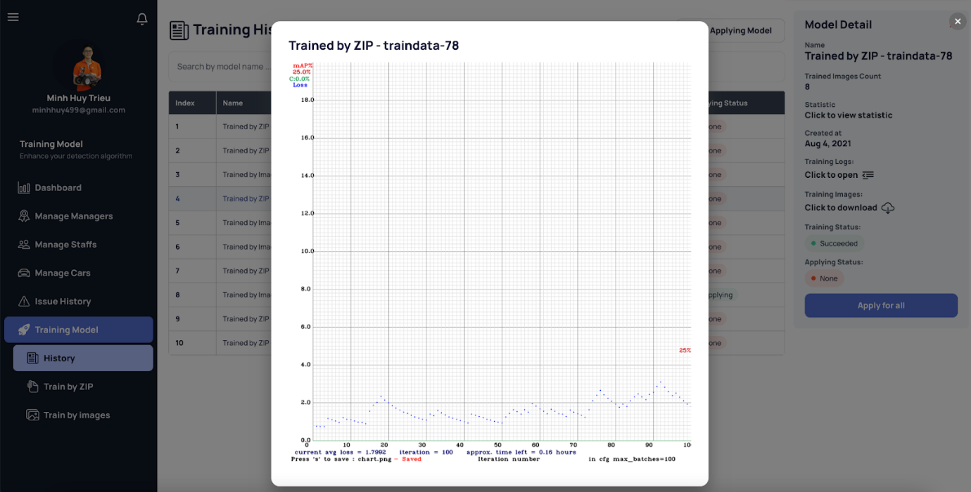

[Figure 194 - View Train History Detail - Statistic](https://drive.google.com/file/d/17y4fLUqei4R590VS0zMv6rHM4ptAvNQh/view?usp=sharing)

*Step 3.2. Click the “Click to open” button (3) (only show after the model training progress started) to keep track of the training progress and it is downloadable if needed.*

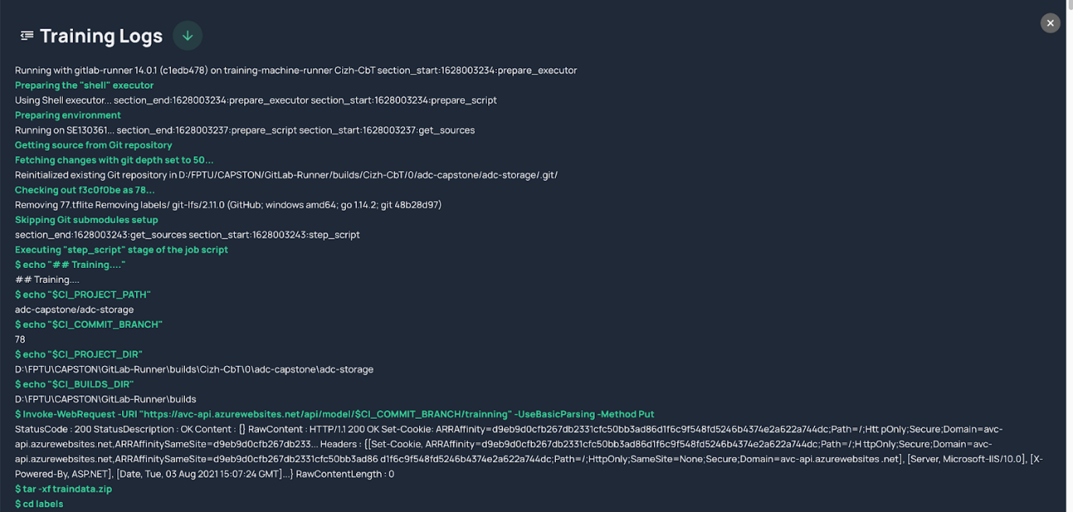

[Figure 195 - View Train History Detail - Train Log](https://drive.google.com/file/d/17y4fLUqei4R590VS0zMv6rHM4ptAvNQh/view?usp=sharing)

*Step 3.3. Click the “Click to download” button (4) (only show after the model training progress started) to download the dataset for that training time.*

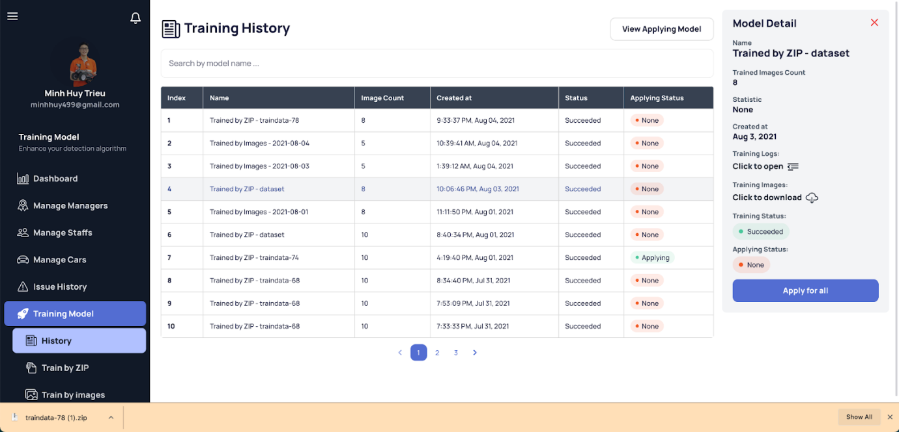

[Figure 196 - Train History Detail - Download Train Images](https://drive.google.com/file/d/1uCSuQQIsE0l9KzdTI9WLP9lillp81b-k/view?usp=sharing)

*Step 3.3. Click the “Apply for all” button (5) (only show after the model training successfully) to apply the new model to all system cars.*

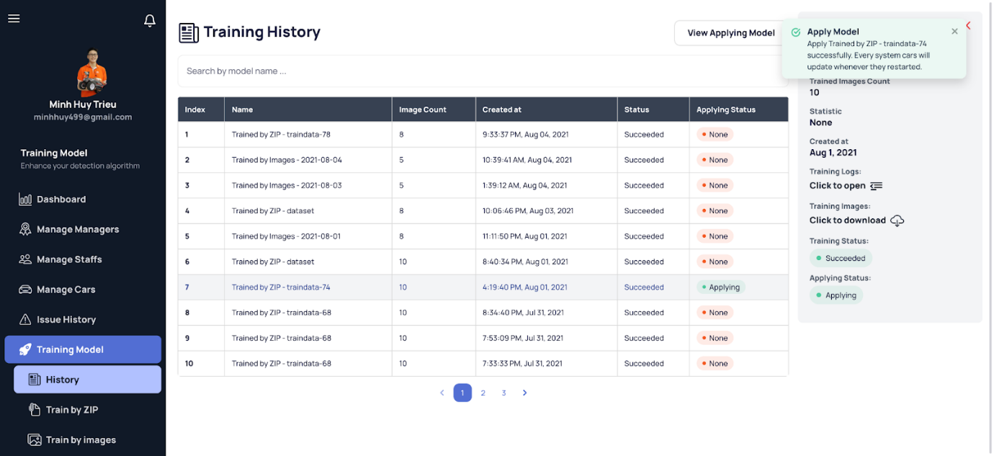

[Figure 197 - Apply new model](https://drive.google.com/file/d/1b3o6M7HKT6PavgZdv6d8Ar7ugXJC2LSW/view?usp=sharing)

###### b1.29 Train model by images

*Step 1. User logs in with Admin account*

*Step 2. User visits this site:* [*https://avcar.netlify.app/training/images/upload-image*](https://avcar.netlify.app/training/images/upload-image)

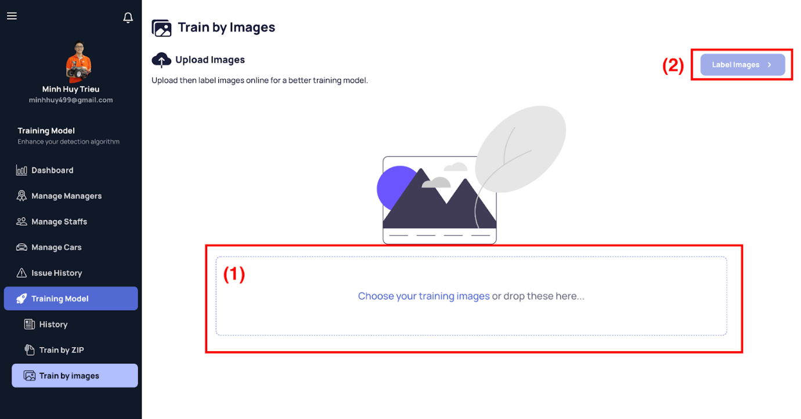

[Figure 198 - Train by Images - Upload Images](https://drive.google.com/file/d/1fMvLe_IqcU6O0Xv11hKPEEZHL0g-yqN6/view?usp=sharing)

*Step 3. Click to upload images or drop those images to the signed rectangle (1).*

*Step 4. After uploading images, you can click the “Label images” button to label those images.*

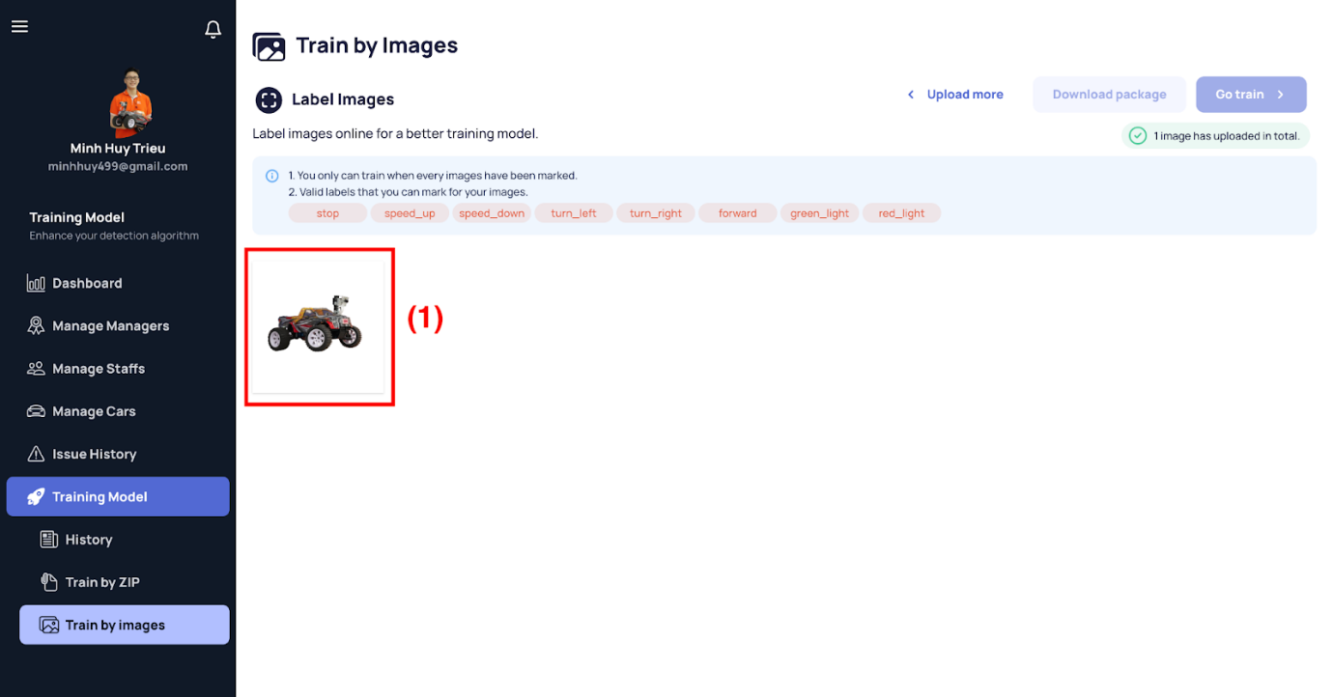

[Figure 199 - Train by Images - Label Images](https://drive.google.com/file/d/1u8D7rqCJpa3OUS_kVZ-ae3otqsBb7qa4/view?usp=sharing)

*Step 4. Select an image to label (1) and then a large dialog will show up.*

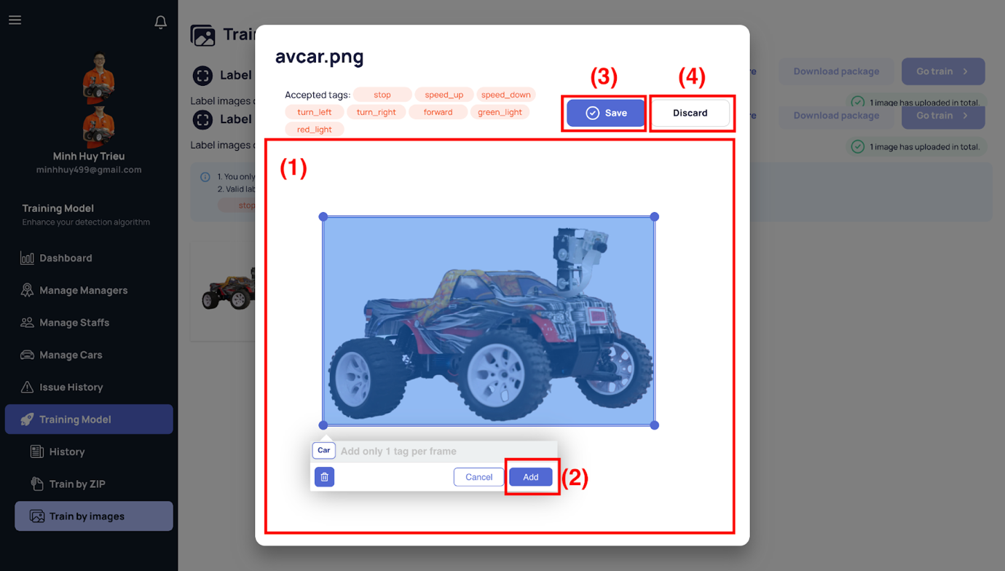

[Figure 200 - Train by Images - Label Image Dialog](https://drive.google.com/file/d/1JOV_iTkD51YzPqE3otW4EG7Z8DKd4sau/view?usp=sharing)

*Step 5. Drag anywhere on the space containing your image (1), the small popup will show to type the label into it.*

*Step 6. Click the “Add” button (2) to confirm the tag you marked.*

*Step 7. Click the “Save” button (3) to save labels that belong to the image or “Discard” to unsave anything and back to Label Image Page.*

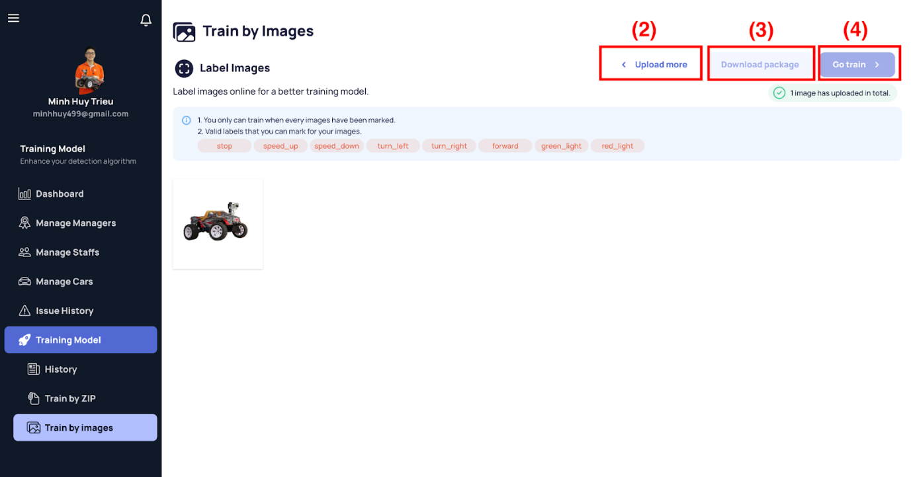

*Step 8. When all images labelled, you are be able to click the “Go train” button (4) to start training a new model.*

*Step 8.1. You can click the “Upload more” button (2) to upload more images.*

*Step 8.2. You can click the “Download package” button (3) to download the images and labelled that you marked recently,*

###### b1.30 Train model by ZIP

*Step 1. User logs in with Admin account*

*Step 2. User visits this site:* [*https://avcar.netlify.app/training/zip*](https://avcar.netlify.app/training/zip)

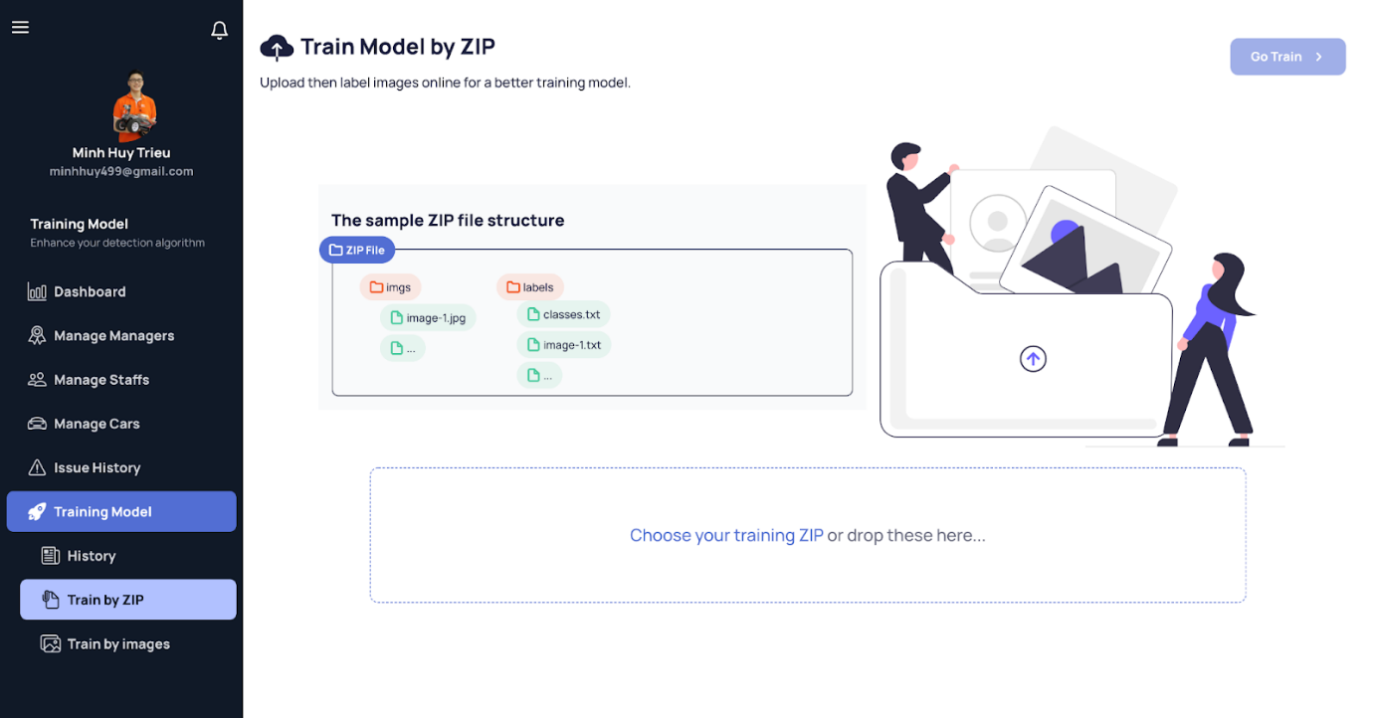

[Figure 201 - Train by ZIP](https://drive.google.com/file/d/1HFXKyv9bMTwATYiSPfpPkIsxTAwOymtw/view?usp=sharing)

*Step 3. Click to upload images or drop those images to the signed rectangle as above.*

*Step 4. When your zip satisfies the ZIP format structure, you are able to click “Go train” to start training a new model.*

###### b1.31 Manage Profile

*Step 1. User logs in with Admin or Manager account*

*Step 2. User visits any site in* [*https://avcar.netlify.app*](https://avcar.netlify.app/training/zip)

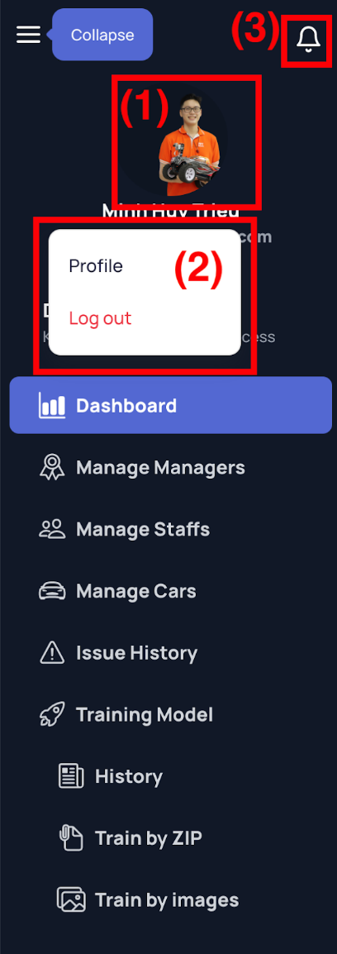

*Step 3. Click the user avatar on the sidenav (1) and then a small dialog will show up as (2).*

*Step 4. Click the “Profile” button inside that small dialog and then the new medium dialog shows up at the center of your screen.*

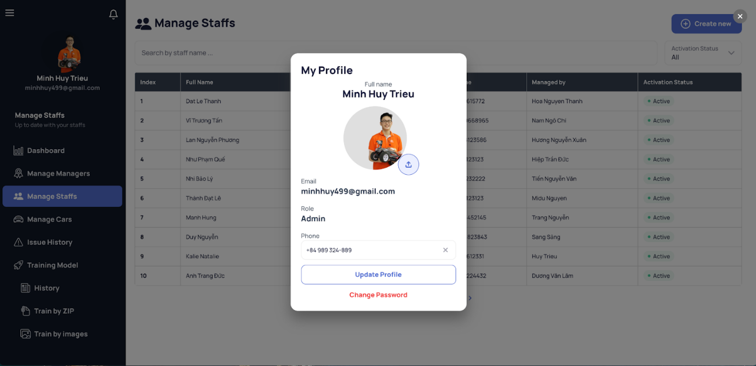

[Figure 202 - View & Update Profile](https://drive.google.com/file/d/1nA6NyPTJpiQ1L550i8BUGV4gmJ1Apcql/view?usp=sharing)

*Step 5. Edit on demand*

*Step 6. Click “Update Profile” to update your profile*

*Step 7. You also can click the “Change Password” button at the bottom of the dialog to change password and a new dialog will appear on the top of the old one.*

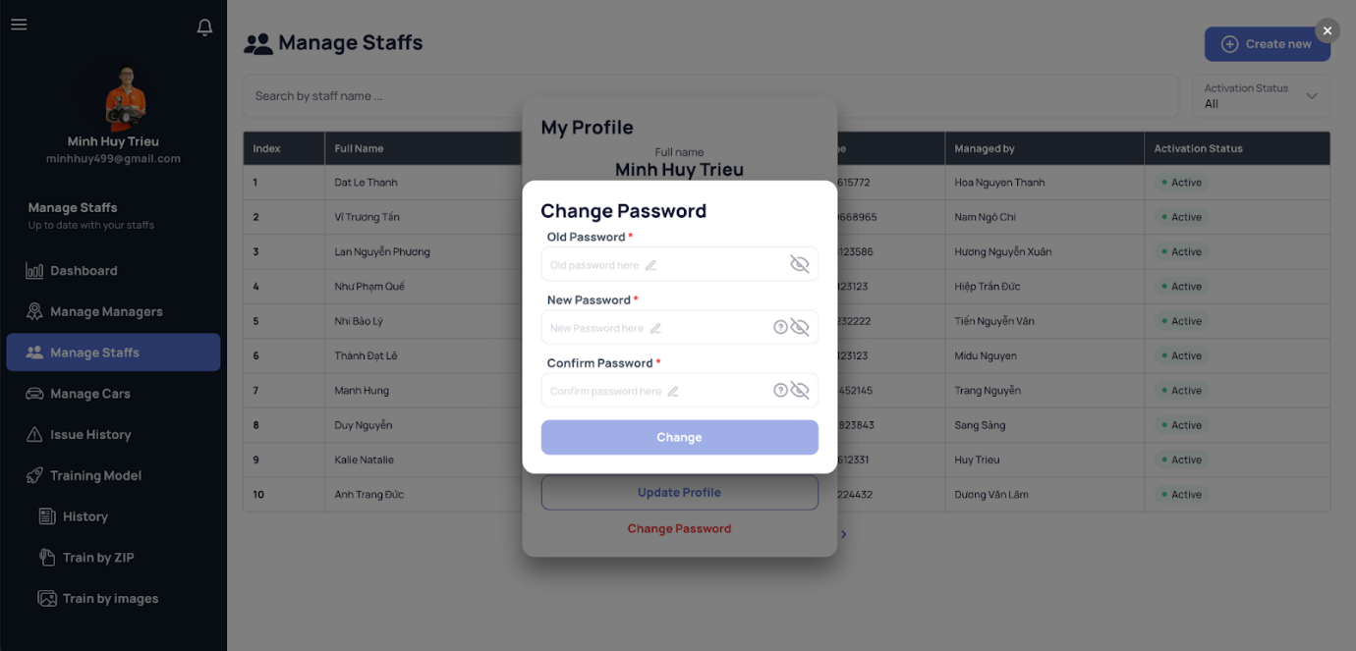

[Figure 203 - Change Password](https://drive.google.com/file/d/1n-O5Uj8Gdcc_OmvEVolzEKs5-prkkGcD/view?usp=sharing)

*Step 8. Fill your old password, new password with its confirmation.*

*Step 9. Click the “Change” to update your password.*

###### b1.32 View Notifications

Allow Admin, Manager to view newest notifications (includes train notifications, assignment, …)

*Step 1. User logs in with Admin or Manager account*

*Step 2. User visits any site in* [*https://avcar.netlify.app*](https://avcar.netlify.app/training/zip)



*Step 3. Click the bell icon on the sidenav (3) and then a small dialog will show up as the image below.*

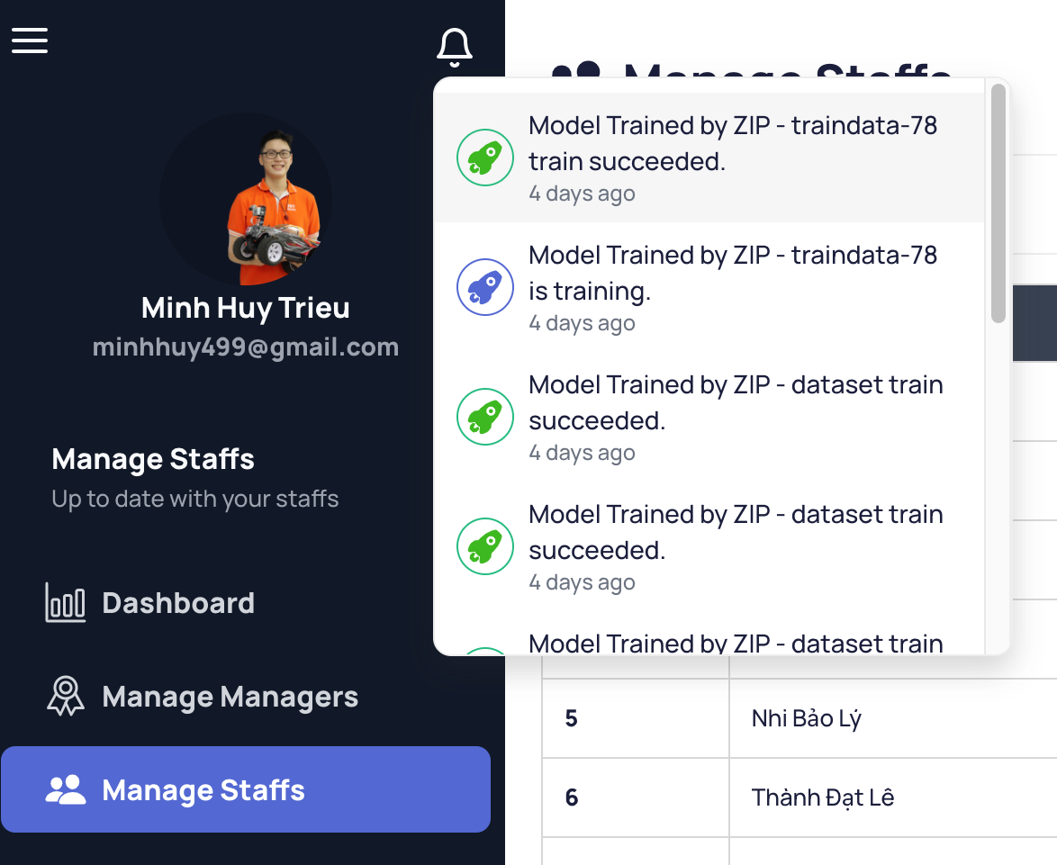

[Figure 204 - View notifications](https://drive.google.com/file/d/1wTgPTAm9b17psfjLUaqi0hvZIHhhbqZE/view?usp=sharing)

###### b1.33 Log out

*Step 1. User logs in with Admin or Manager account*

*Step 2. User visits any site in* [*https://avcar.netlify.app*](https://avcar.netlify.app/training/zip)



*Step 3. Click the user avatar on the sidenav (1) and then a small dialog will show up as (2).*

*Step 4. Click the “Log out” button inside that small dialog and then the new medium dialog shows up at the center of your screen.*

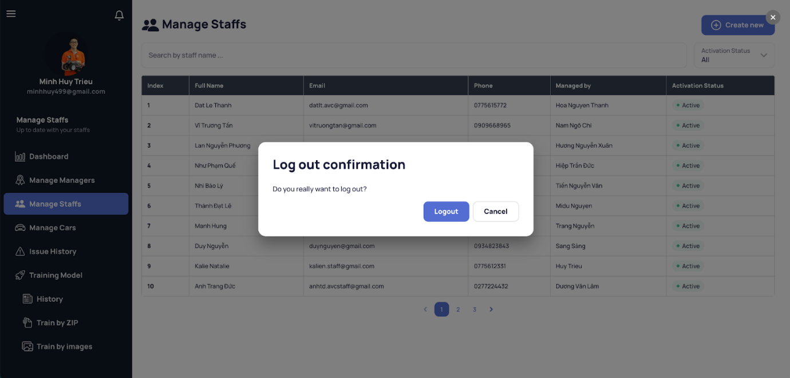

[Figure 205 - Log out confirmation](https://drive.google.com/file/d/1NdonM5tr0-ALOIrFUuuV31egasNN8Crg/view?usp=sharing)

*Step 5. Click the “Logout” button inside the new dialog to log out.*

##### b2. Mobile Application

###### b2.1 Login

*Step 1. User open AVC mobile application*

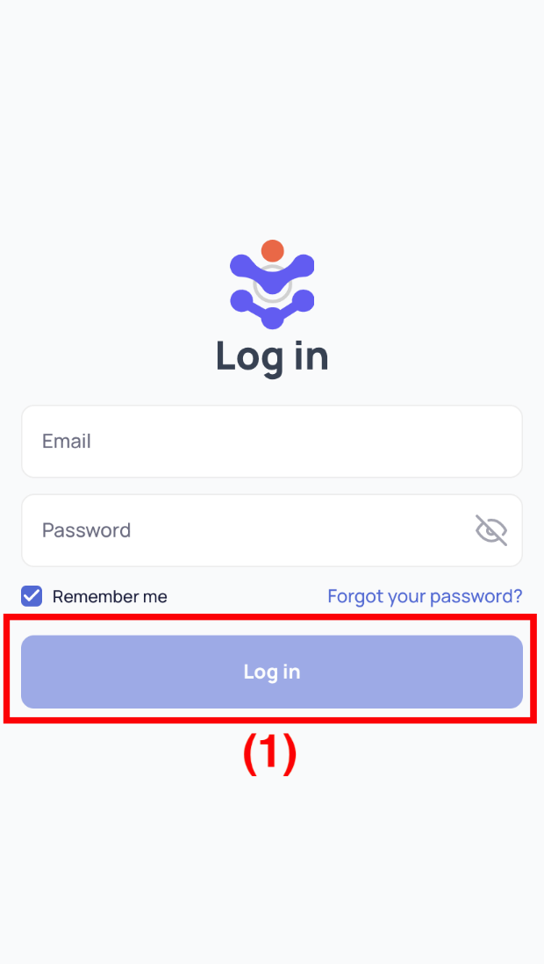

[Figure 206 - Login](https://drive.google.com/file/d/1ZBHhAkV06WNCV5KYqoxXoqJn5dfxERjm/view?usp=sharing)

*Step 2. Fill in account’s username and password*

*Step 3. Click “Login” button (1)*

###### b2.2 Forgot Password

*Step 1. User opens AVC mobile application*

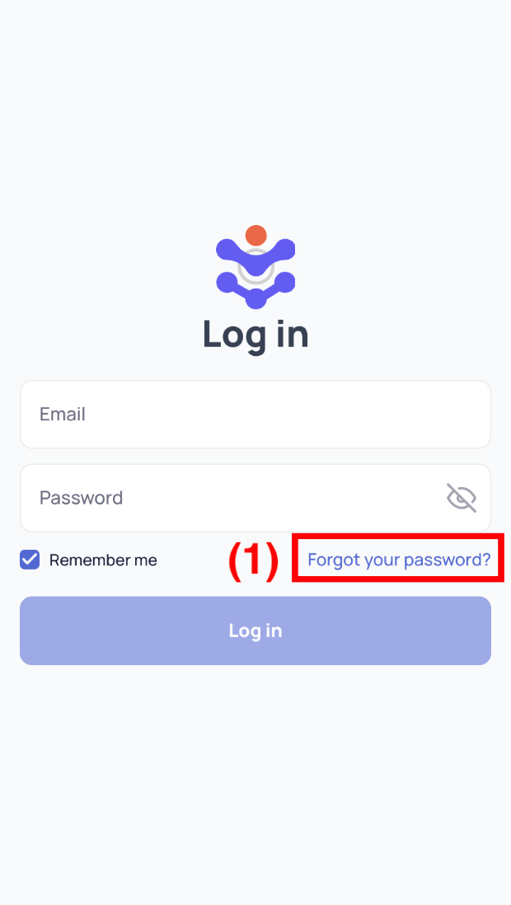

[Figure 207 - Login](https://drive.google.com/file/d/1ZBHhAkV06WNCV5KYqoxXoqJn5dfxERjm/view?usp=sharing)

*Step 2. Click “Forgot your password” button (1)*

*Step 3. Fill in account’s email*

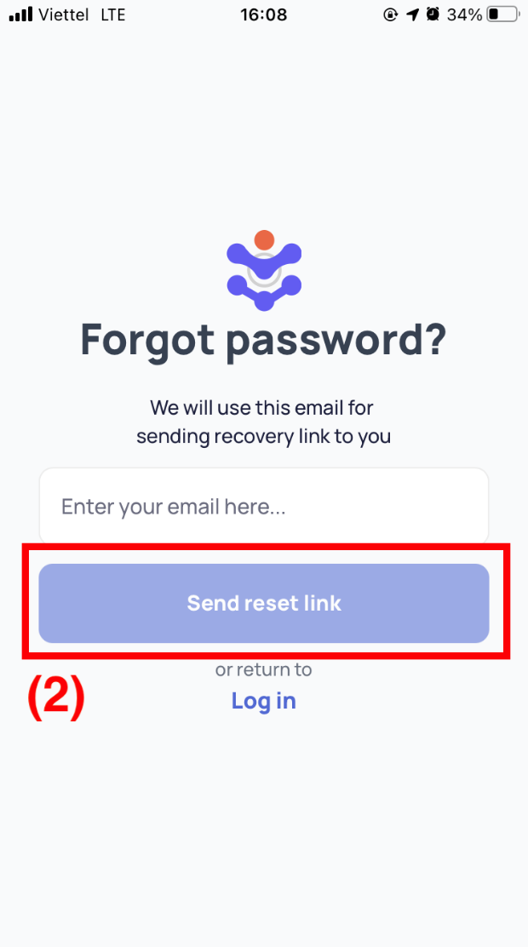

[Figure 208 - Forgot Password](https://drive.google.com/file/d/1sNBhg0Z838qsnzFk4SVFkg6vPlwW7ugG/view?usp=sharing)

*Step 4. Click “Send reset link” button (2)*

*Step 5. Open your mailbox, copy the security key to continue.*

*Step 6. Fill in your security key, your new password and the confirm password.*

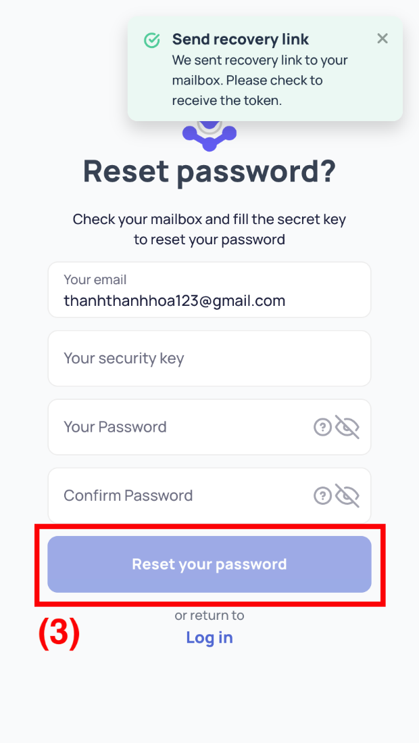

[Figure 209 - Reset Password](https://drive.google.com/file/d/1DncqnABcTo7gfxVjqZb5IFTYzKY1Un4N/view?usp=sharing)

*Step 7. Click “Reset your password” button (3)*

###### b2.3 View Assigned Car List

*Step 1. User logs in with Staff account*

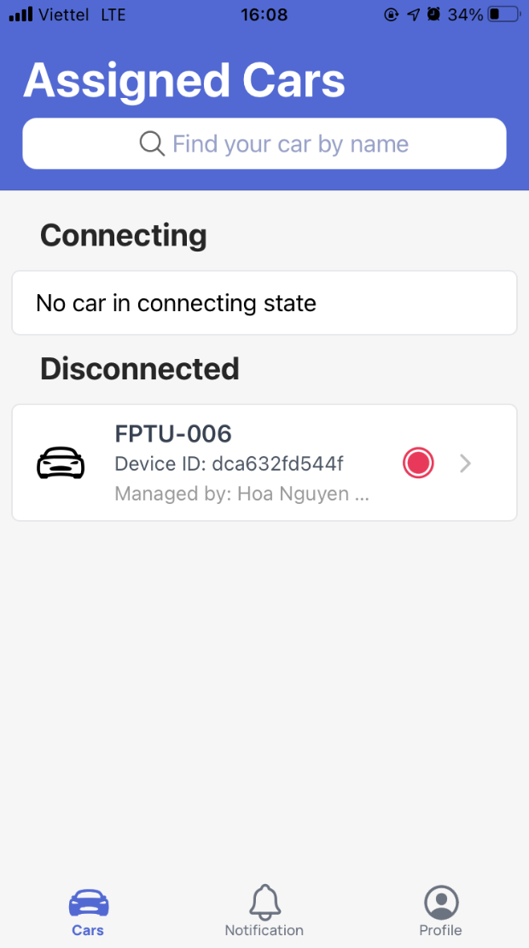

[Figure 210 - View Car List](https://drive.google.com/file/d/1xE-S6Jv6IHF7EM4S-5fFB_AWYP8RV7_i/view?usp=sharing)

###### b2.4 View Car Detail

*Step 1. User logs in with Staff account*

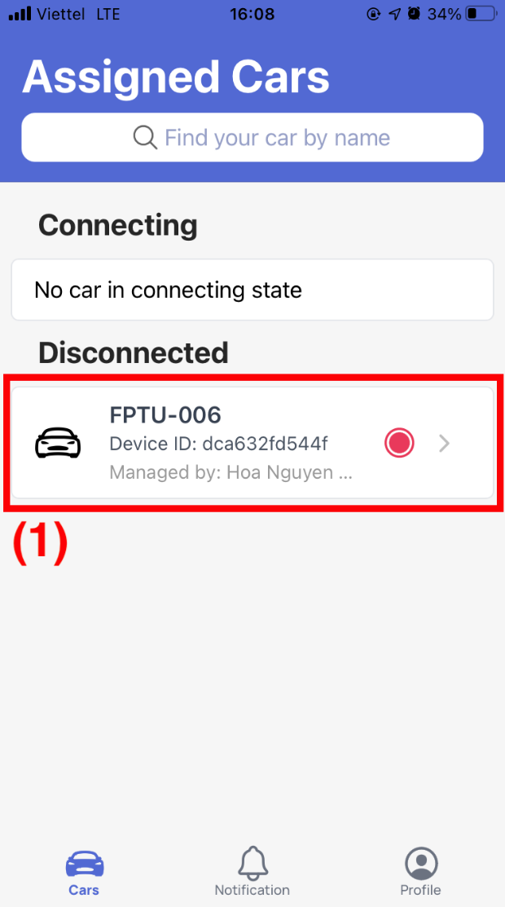

[Figure 211 - View Car List](https://drive.google.com/file/d/1xE-S6Jv6IHF7EM4S-5fFB_AWYP8RV7_i/view?usp=sharing)

*Step 2. Select a car item (1)*

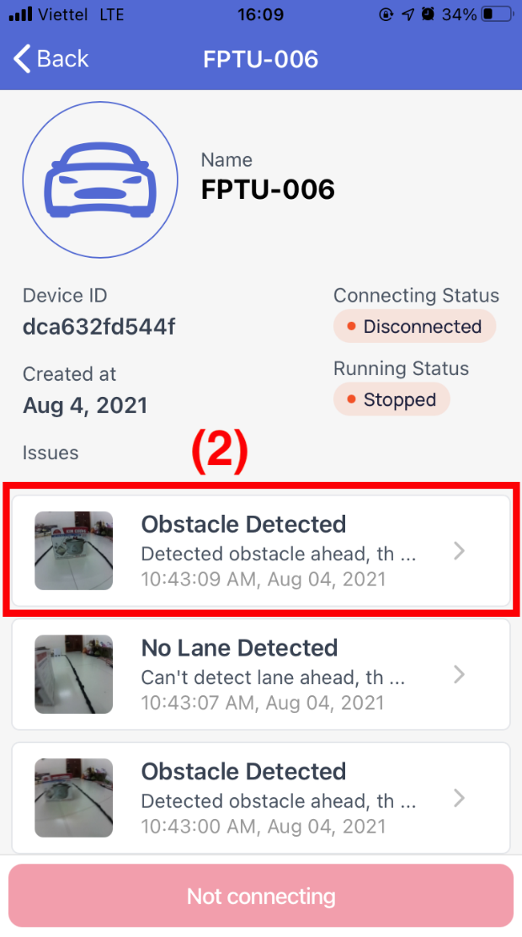

[Figure 212 - View Car Detail](https://drive.google.com/file/d/1Z6QJhDk7oqPOH4N1PX-MQBH2Yhyj5bRN/view?usp=sharing)

*Step 3. Select an issue item (2) to check the issue details.*

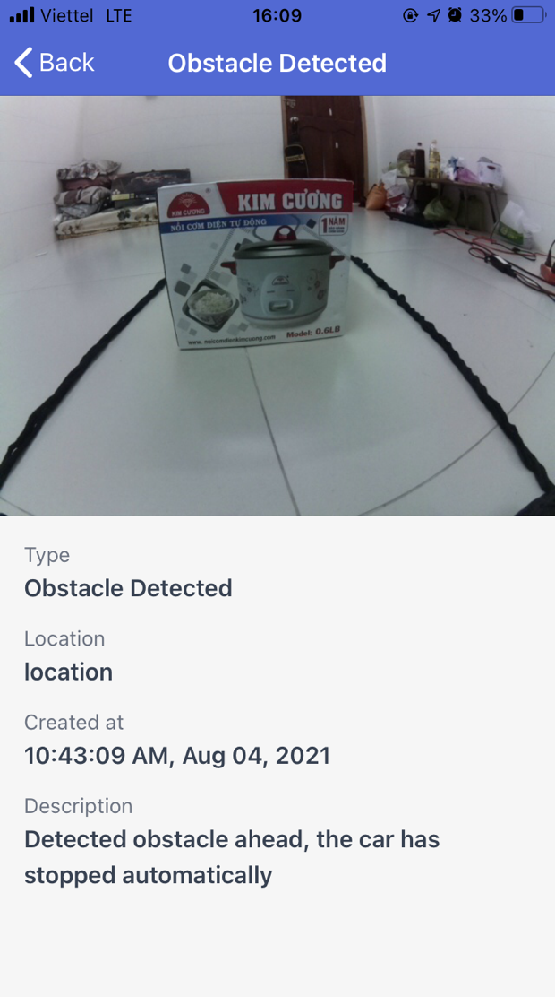

[Figure 213 - View Car Detail - Issue Detail](https://drive.google.com/file/d/1H2B3Os4bJTbIcWpqd41nVusHGOJ1LpLJ/view?usp=sharing)

*Step 4. When the car is connected (3), you can start the car by clicking on the “Start” button (4) as below.*

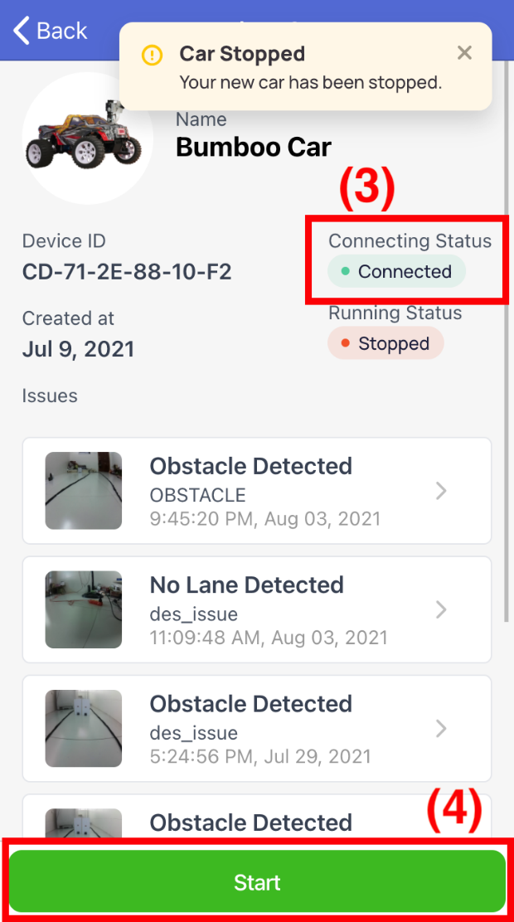

[Figure 214 - View Car Detail - Stop Car](https://drive.google.com/file/d/1seV-kYF8wlP6hBy0t1NXhF3L5RsPzuEj/view?usp=sharing)

*Step 5. When the car is running (5), you can stop the car by clicking on the “Stop” button (6) as below.*

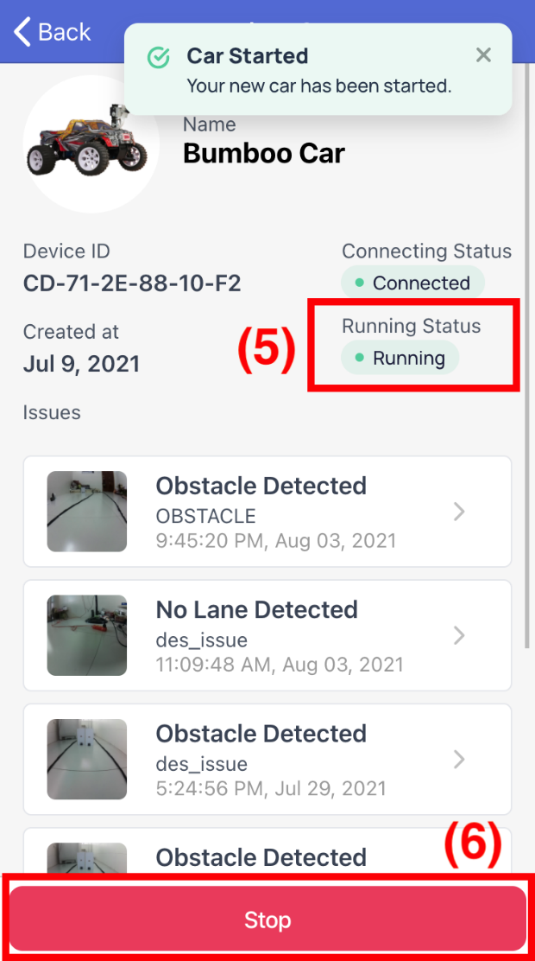

[Figure 215 - View Car Detail - Start Car](https://drive.google.com/file/d/14c6mGl--oClxsYkcBZaGWv2oHNMD7wvk/view?usp=sharing)

*Step 7. When the car has an issue (7), the car has been stopped automatically. You can continue to start the car by clicking on the “Start” button (8) as below.*

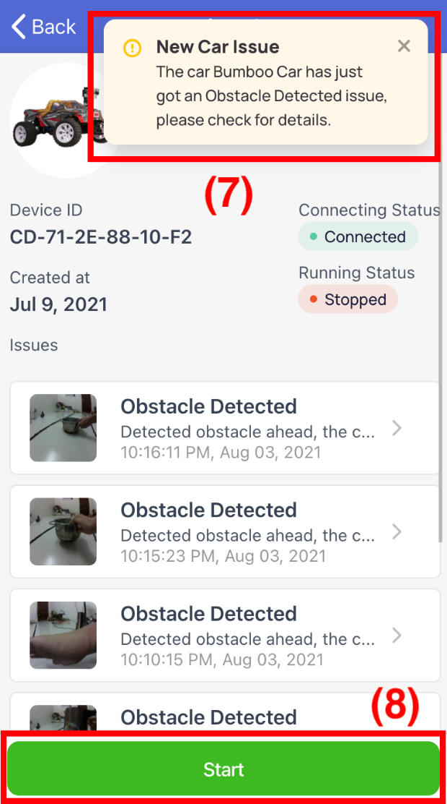

[Figure 216 - View Car Detail - Receive real-time issue notification](https://drive.google.com/file/d/1IBzJ-xHKBJKGVySK8XgeA-UrEOHq6-6N/view?usp=sharing)

###### b2.5 View Notification

Allow Staff to receive and check notifications (includes assignment, deactivation, issue from cars)

*Step 1. User logs in with Staff account*

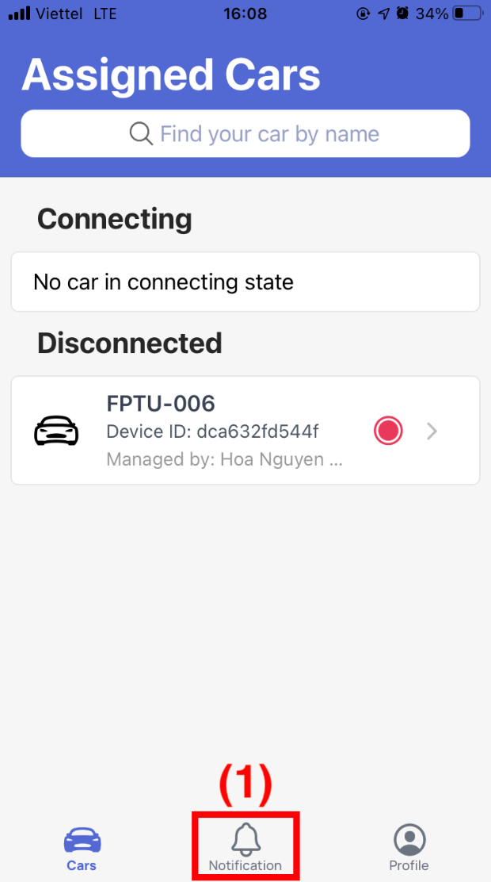

[Figure 217 - View Car List](https://drive.google.com/file/d/1xE-S6Jv6IHF7EM4S-5fFB_AWYP8RV7_i/view?usp=sharing)

*Step 2. User clicks the bell icon in the center of the bottom bar (1)*

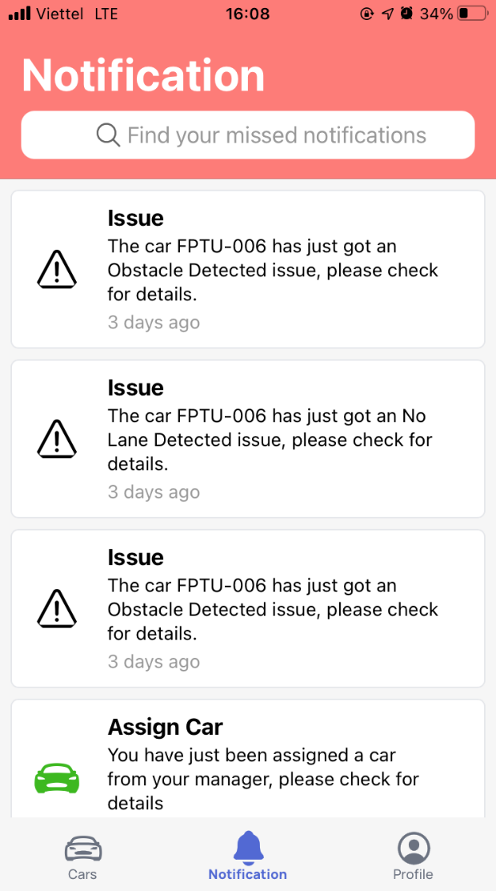

[Figure 218 - View Notifications](https://drive.google.com/file/d/1UMP7d9pCc_R6IaETghqBd3Avzsmus2Ar/view?usp=sharing)

###### b2.6 View Car Detail

*Step 1. User logs in with Staff account*

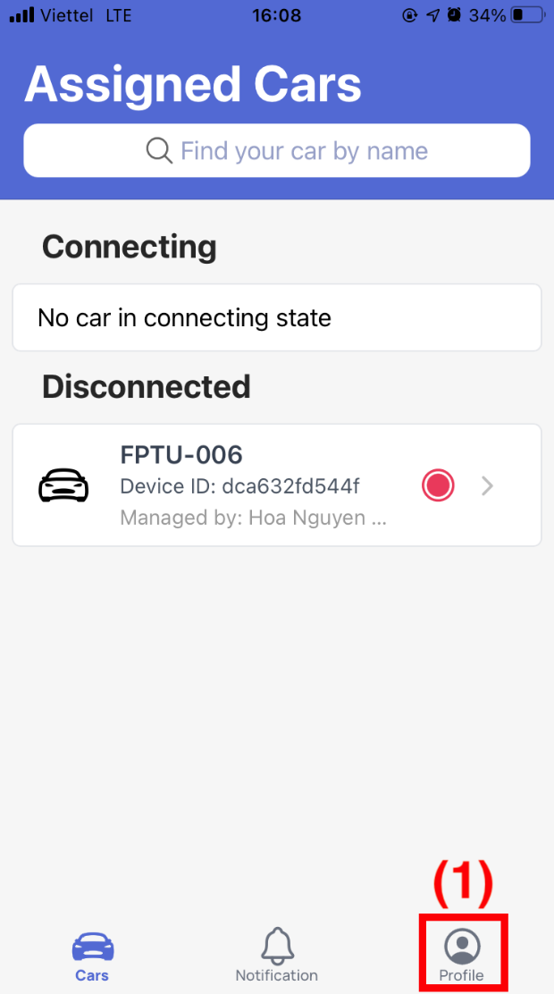

[Figure 219 - View Car List](https://drive.google.com/file/d/1xE-S6Jv6IHF7EM4S-5fFB_AWYP8RV7_i/view?usp=sharing)

*Step 2. User clicks the person icon in the right of the bottom bar (1)*

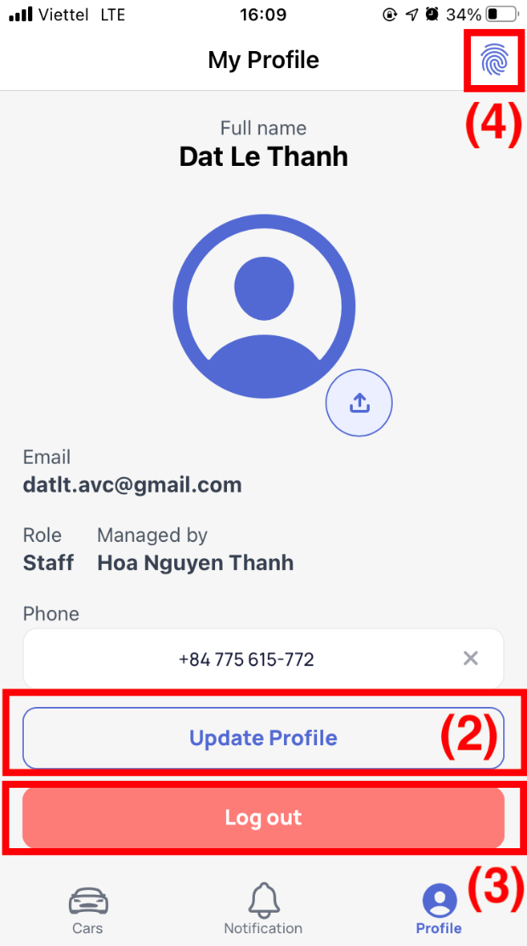

[Figure 220 - View & Update Profile](https://drive.google.com/file/d/1ojzeAELQp2aFiSr770Flr0KbtKHGvalk/view?usp=sharing)

*Step 3. Update on demand.*

*Step 4. User clicks the “Update Profile” button (2) to update your profile.*

*Step 5. User clicks the “Log out” button (3) and then a new dialog shows up.*

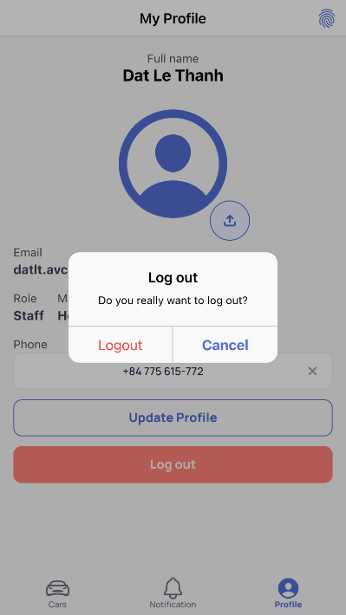

[Figure 221 - Log out confirmation](https://drive.google.com/file/d/1s5-4E4TZycKUm76l8Sj6Eq_Wg5MLkfoW/view?usp=sharing)

*Step 6. User clicks the “Logout” button in the popup to log out or the “Cancel” button to cancel.*

**

[Figure 222 - View & Update Profile](https://drive.google.com/file/d/1ojzeAELQp2aFiSr770Flr0KbtKHGvalk/view?usp=sharing)

*Step 7. User clicks the fingerprint icon (4) to change password.*

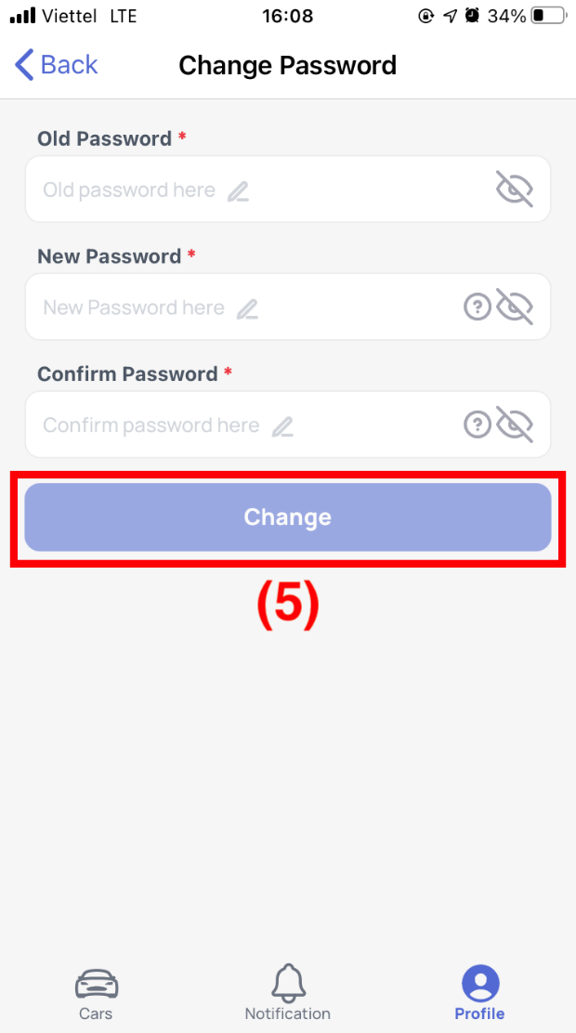

[Figure 223 - Change Password](https://drive.google.com/file/d/1tBwpz_qPZF31tMIminQ9LaAm6E4MQR00/view?usp=sharing)

*Step 7. User fills in the old password, the new password and the confirmation.*

*Step 8. User clicks the “Change” button (5) to change the password.*

### 3.4 Troubleshooting

#### a. Notification

Notification about the car may not reach the staff mobile app due network connection interrupted.

* **First occurrence:**
* During testing time when the internet is lower than expected.
* **Problem:**
* Staff cannot receive notification at that time.
* **Solution:**
* Staff login in AVC mobile app.
* Staff click the notification icon on the bottom bar to check the latest notifications.

#### b. Car can’t connect

* **First occurrence:**
* During testing time when the internet is lower than expected or no network detected.
* **Problem:**
* Car can’t connect to the server and can’t do any action also.
* **Solution:**
* Check your Wi-Fi connection whether in range of the Process Controller of the car.
* Reset the hardware if the network connection was checked and there was a long time delay.

# VII. Appendix

## 1. Glossary

See section Definition and Acronyms.

## 2. References

1. [Khoa học dữ liệu (phamdinhkhanh.github.io)](https://phamdinhkhanh.github.io/2020/03/09/DarknetAlgorithm.html?fbclid=IwAR3KCv5tQySa8V9BOVpW-FHveQRIyUVZrf_87KLYAYCi9KU1Z4eS27_K5eQ)
2. <https://nx.dev/>
3. <http://angular-material.fusetheme.com/>
4. <https://angular.io/>
5. <https://ionic.io/>
6. <https://www.ngxs.io/>
7. <https://azure.microsoft.com/en-gb/services/signalr-service/#features>
8. [Convolutional neural network - Wikipedia](https://en.wikipedia.org/wiki/Convolutional_neural_network?fbclid=IwAR0iB0qSWoAW5Sx1YvsgJU__fg7DcWufDyNKs3eOUmi_8AFR06adeIgY-zI)
9. <http://www.gauravpande.in/Object-Detection/>
10. <https://nttuan8.com/bai-6-convolutional-neural-network/>
11. <https://ai.plainenglish.io/pooling-layer-beginner-to-intermediate-fa0dbdce80eb>
12. <https://medium.com/@pallawi.ds/ai-starter-build-your-first-convolution-neural-network-in-keras-from-scratch-to-perform-a059eaa6d4ff>
13. <https://phamdinhkhanh.github.io/2020/03/09/DarknetAlgorithm.html>
14. [Unified Modeling Language (UML) description, UML diagram examples, tutorials and reference for all types of UML diagrams - use case diagrams, class, package, component, composite structure diagrams, deployments, activities, interactions, profiles, etc. (uml-diagrams.org)](https://www.uml-diagrams.org/)
15. [Tải Windows 10 | Microsoft](https://www.microsoft.com/vi-vn/windows/get-windows-10)
16. [Download .NET 5.0 (Linux, macOS, and Windows) (microsoft.com)](https://dotnet.microsoft.com/download/dotnet/5.0)
17. [SQL Server 2019 | Microsoft](https://www.microsoft.com/en-us/sql-server/sql-server-2019)
18. [SQL Server Downloads | Microsoft](https://www.microsoft.com/en-US/sql-server/sql-server-downloads)
19. [Download | Node.js (nodejs.org)](https://nodejs.org/en/download/)
20. [Firebase (google.com)](https://firebase.google.com/?hl=vi)
21. [Download Python | Python.org](https://www.python.org/downloads/)
22. [DevOps Tutorial for Beginners: Learn Now (Training Course) (guru99.com)](https://www.guru99.com/devops-tutorial.html)
23. [What is Agile Testing? Methodology, Process & Life Cycle (guru99.com)](https://www.guru99.com/agile-testing-a-beginner-s-guide.html)
24. [Use Case Diagram và 5 sai lầm thường gặp | Thinhnotes.com](https://thinhnotes.com/chuyen-nghe-ba/use-case-diagram-va-5-sai-lam-thuong-gap/)
25. [Thiết Kế Chức Năng Với Sequence Diagram Có Phức Tạp Không? (codelearn.io)](https://codelearn.io/sharing/sequence-diagram-trong-uml)
26. [Bản vẽ hoạt động - Activity Diagram - iViettech](https://iviettech.vn/blog/1066-activity-diagram-ban-ve-hoat-dong.html)
27. [What is Package Diagram? (visual-paradigm.com)](https://www.visual-paradigm.com/guide/uml-unified-modeling-language/what-is-package-diagram/)
28. [Tìm hiểu về cách thiết kế Class Diagram (viblo.asia)](https://viblo.asia/p/tim-hieu-ve-cach-thiet-ke-class-diagram-L4x5xLyY5BM)
29. [Bản vẽ sơ đồ lớp - Class Diagram - iViettech - iViettech](https://iviettech.vn/blog/813-classs-diagarm-ban-ve-ve-classlop.html)
30. [ERD là gì? | Thinhnotes.com](https://thinhnotes.com/chuyen-nghe-ba/erd-la-gi/)

## 3. Appendix